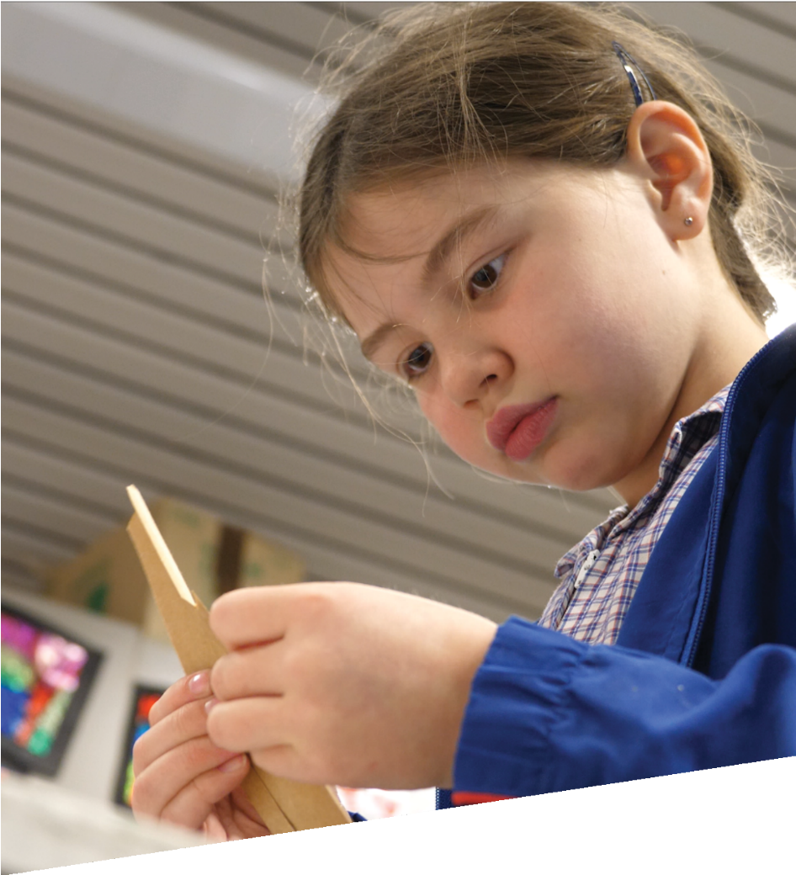

CURRICULUM RESOURCE MODULE
The long walk
YEAR 3

Acknowledgements
The STEM Learning Project respectfully acknowledges the Traditional Custodians of the lands upon which our students and teachers live, learn and educate.

The STEM Learning Project is funded by the Western Australian Department of Education (the Department) and implemented by a consortium in STEM education comprising the Educational Computing Association of Western Australia, the Mathematical Association of Western Australia, the Science Teachers Association of Western Australia and Scitech. We acknowledge and thank the teachers and schools who are the co-creators of these resources.

Copyright and intellectual property
The copyright and intellectual property of this module remain the property of the Department.

Any Western Australian Curriculum content in this resource is used with the permission of the School Curriculum and Standards Authority (the Authority); this permission does not constitute Authority endorsement of the resource. The Authority accepts no liability for any errors or damages arising from reliance on its content.

The Western Australian Curriculum content may be freely copied, or communicated on an intranet, for non-commercial purposes in educational institutions, provided that the Authority is acknowledged as the copyright owner. Copying or communication for any other purpose can be done only within the terms of the Copyright Act 1968 or with prior written permission of the Authority. Any Australian Curriculum content in the Western Australian Curriculum is used by the Authority under the terms of the Creative Commons Attribution NonCommercial 3.0 Australia licence. Any content on the www.scsa.wa.edu.au domain that has been derived from the Australian Curriculum may be used under the terms of Creative Commons Attribution-NonCommercial 3.0 Australia licence.

Appendix 2: General capabilities continuums are adapted from ACARA, © Australian Curriculum, Assessment and Reporting Authority (ACARA) 2009 to present, unless otherwise indicated. This material was downloaded from the ACARA website (www.acara.edu.au) (accessed December 2015) and was not modified. The material is licensed under CC BY 4.0 (https://creativecommons.org/licenses/by/4.0/). ACARA does not endorse any product that uses ACARA material or make any representations as to the quality of such products. Any product that uses material published on this website should not be taken to be affiliated with ACARA or have the sponsorship or approval of ACARA. It is up to each person to make their own assessment of the product.

This resource includes references and examples of iOS, Android and other apps. The Department does not endorse or recommend any commercial products and simply provides these as examples for teachers.

The Department is committed to providing quality information to its customers. Whilst every effort has been made to ensure accuracy, currency and reliability of the information within these documents, the Department accepts no responsibility for errors, omissions or amendments made since the time of publishing. Confirmation of information may be sought from the Department or the originating bodies providing the information. The Department has no control over the content of material published on websites to which users are referred in this resource. It is the responsibility of the internet user to make their own decision as to the relevancy, accuracy, currency and reliability of information found on those sites.

Attributions: Microsoft PowerPoint, Padlet, Google Earth, Seesaw, Keynote, iMovie, eBook, Sketchup, Tinker Cad, Skype, View Pure, Pages, Class Dojo.

Table of contents
The STEM Learning Project 2
Overview 3
Activity sequence and purpose 7
Background 8
Activity 1: The long walk 11
Activity 2A: Our shoes features 17
Activity 2B: Testing materials 25
Activity 3: I am a designer 30
Activity 4: Sharing findings 35
Appendix 1A: Links to the Western Australian Curriculum 39
Appendix 1B: Mathematics proficiency strands 41
Appendix 2: General capabilities continuums 42
Appendix 3: Materials list 45
Appendix 4: Design process guide 46
Appendix 4B: Drawing in the design process 47
Appendix 5: Reflective journal 48
Appendix 6: Student activity sheet 1.0: Journal checklist 49
Appendix 7: Teacher resource sheet 1.1: Cooperative learning – Roles 50
Appendix 8: Teacher resource sheet 1.2: Cooperative learning – Think, Pair, Share 51
Appendix 9: Student activity sheet 1.3: I see, I think, I wonder 52
Appendix 10: Student activity sheet 1.4: Refugee camps and shoes 53
Appendix 11: Student activity sheet 1.5: Literacy activity – Being a refugee 54
Appendix 12: Student activity sheet 2.2: Testing materials for making shoes 58
Appendix 13: Student activity sheet 2.3: After testing – Evaluating our predictions 59
Appendix 14: Student activity sheet 3.1: Designing – my shoes 60
Appendix 15: Teacher resource sheet 3.2: Construction skills 61
Appendix 16: Teacher resource sheet 4.1: 3 – 2 – 1 Reflection 65
Appendix 17: Teacher resource sheet 4.2: Evaluation 66

The STEM Learning Project
The aim of the STEM Learning Project is to generate students’ interest, enjoyment and engagement with STEM (Science, Technology, Engineering and Mathematics) and to encourage their ongoing participation in STEM both at school and in subsequent careers. The curriculum resources will support teachers to implement and extend the Western Australian Curriculum and develop the general capabilities across Kindergarten to Year 12.
Why STEM?
A quality STEM education will develop the knowledge and intellectual skills to drive the innovation required to address global economic, social and environmental challenges.
STEM capability is the key to navigating the employment landscape changed by globalisation and digital disruption. Routine manual and cognitive jobs are in decline whilst non-routine cognitive jobs are growing strongly in Australia. Seventy-five per cent of the jobs in the emerging economy will require critical and creative thinking and problem solving, supported by skills of collaboration, teamwork and literacy in mathematics, science and technology. This is what we call STEM capability. The vision is to respond to the challenges of today and tomorrow by preparing students for a world that requires multidisciplinary STEM thinking and capability.
The approach
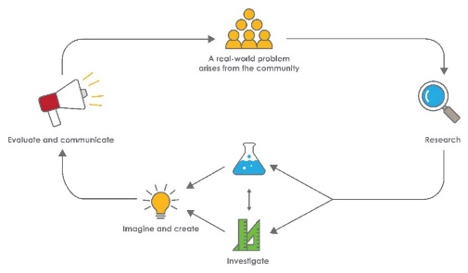
STEM capabilities are developed when students are challenged to solve open-ended, real-world problems that engage students in the processes of the STEM disciplines.

Year 3 – The long walk

Overview
According to the United Nations Refugee Agency (UNHCR), 65 million people have been forced from their homes. Many of these refugees are children who have few personal belongings.
In this module, students develop an understanding of refugee camps and the problems associated with the loss of personal belongings such as shoes.
Students use collaborative learning and problem-solving skills to:
- identify and test materials that might be found in refugee camps that could be repurposed to make shoes
- establish and test design criteria
- create a design for a wearable pair of shoes made from repurposed materials
- share their designs with peers and members of the community
- Refugee Week may be a suitable time and context in which to introduce this module.
What is the context?
For people in refugee camps, shoes can be key to comfort and good health, but are hard to source. When refugees arrive at refugee camps they have few personal possessions. Many everyday items, including shoes, are made from found materials.
What is the problem?
How can you design shoes using recycled materials?
How does this module support integration of the STEM disciplines?
Science
Students use Science understandings (ACSSU049: Heat can be produced in many ways and can move from one object to another) and Science inquiry skills (ACSIS053: With guidance, identify questions in familiar contexts that can be investigated scientifically and make predictions based on prior knowledge; ACSIS054: With guidance, plan and conduct scientific investigations to find answers to questions, considering the safe use of appropriate materials and equipment; and ACSIS215: Compare results with predictions, suggesting possible reasons for findings) to investigate materials that can be used to make shoes. Students work collaboratively to make predictions, test materials and document observations.
Technology
Students engage with design processes from the Technologies curriculum to make shoes. Digital technologies are used in representing and communicating the design to an audience (WATPPS17: Develop and communicate ideas using labelled drawings and appropriate technical terms).
The Design process guide is included as a resource to provide assistance to teachers in understanding the complete design process as developed in the technologies curriculum.
Mathematics
During this module students identify questions and plan methods of data collection and recording regarding the features of shoes (ACMSP068: Identify questions or issues for categorical variables. Identify data sources and plan methods of data collection and recording). They collect and organise data into categories and, with teacher support, interpret and compare their data by creating a Venn diagram as well as simple column or bar graphs and (ACMSP069: Collect data, organise into categories and create displays using lists, tables, picture graphs and simple column graphs, with and without the use of digital technologies; and ACMSP070: Interpret and compare data displays).
When designing their shoes, they measure and compare lengths in centimetres (ACMMG061: Measure, order and compare objects using familiar metric units of length, mass and capacity).

General capabilities
There are opportunities for the development of general capabilities and cross-curriculum priorities as students engage with The long walk. In this module, students:
- Develop problem solving skills as they research the problem and its context (Activity1); investigate parameters impacting on the problem (Activity 2); imagine and develop solutions (Activity 3); and evaluate and communicate their solutions to an audience (Activity 4).
- Utilise creative thinking as they generate possible design solutions; and critical thinking, numeracy skills and ethical understanding as they choose between alternative approaches to solving the problem.
- Utilise personal and social capability throughout the module as they develop socially cohesive and effective working teams; collaborate in generating solutions; adopt group roles; and reflect on their group work capabilities.
- Utilise a range of literacies and information and communication technologies (ICT) capabilities as they collate records of work completed throughout the module in a journal; represent and communicate their solutions to an audience using digital technologies in Activity 4

What are the pedagogical principles of the STEM learning modules?
The STEM Learning Project modules develop STEM capabilities by challenging students to solve real-world problems set in authentic contexts. The problems engage students in the STEM disciplines and provide opportunities for developing higher order thinking and reasoning, and the general capabilities of creativity, critical thinking, communication and collaboration.
The design of the modules is based on four pedagogical principles:
- Problem-based learning
This is an underlying part of all modules with every module based around solving an initial problem. It is supported through a four-phase instructional model: research the problem and its context; investigate the parameters impacting on the problem; design and develop solutions to the problem; and evaluate and communicate solutions to an authentic audience.
- Developing higher order thinking
Opportunities are created for higher order thinking and reasoning through questioning and discourse that elicits students' thinking, prompts and scaffolds explanations and requires students to justify their claims. Opportunities for making reasoning visible through discourse are highlighted in the modules with the icon shown here.
- Collaborative learning
This provides opportunities for students to develop teamwork and leadership skills, challenge each other’s ideas, and co-construct explanations and solutions. Information that can support teachers with aspects of collaborative learning is included in the resource sheets.
- Reflective practice
Recording observations, ideas and one’s reflections on the learning experiences in some form of journal fosters deeper engagement and metacognitive awareness of what is being learned. Information that can support teachers with Journaling is included in the resource sheets.
These pedagogical principles can be explored further in the STEM Learning Project online professional learning modules located in Connect Resources.

Activity sequence and purpose
The long walk
Students develop an understanding of refugee camps and the problems associated with the loss of personal belongings such as shoes. Students compare the life of a refugee child to their own.
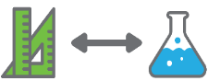 | Shoe features, testing materials  This activity is split into two. In Activity 2A, students use a survey to identify the features of shoes that are important.  In Activity 2B, students test materials to see how appropriate they are for making shoes. This information is used to create shoe design criteria.
I am a designer
Students use the design criteria established in Activity 2B to create an annotated shoe design, including relevant measurements in centimetres. Students use this design to build a model of a shoe from repurposed materials.
Sharing findings
Students reflect on the design process and analyse their shoes. Students communicate their designs to an audience beyond the classroom through a chosen form of digital media.

Background
Expected learning | At the completion of this module students will be able to:  - Establish the purpose and questions for a survey about shoe features, and plan and conduct the survey.  - Collate, tabulate and graph the shoe survey data and interpret the findings of the survey.  - Formulate a question for investigating the properties of materials for making shoes and make predictions based on prior knowledge.  - Follow safe procedures to test materials and document observations.  - Compare results with predictions and justify their choice of materials for making shoes.  - Identify ways in which heat can be produced.  - Explain that if heat is transferred to an object it makes it hotter.  - Create a design plan for a shoe and explain how the design meets criteria.  - Measure lengths using a centimetre tape measure.  - Understand a Venn diagram with teacher support.  - Use digital technologies to organise and present information about the shoe design and the design process.
Vocabulary | This module uses subject-specific terminology. The list below contains terms that need to be understood, either before the module commences or developed as they are used.  camp, conduction, conductor, data, design criteria, design process, displaced, durable, features, force, friction, graph, heat, insulator, recyclable, refugee, resistant, survey, sustainability, tally, waterproof.
Timing | There is no prescribed duration for this module. The module is designed to be flexible enough for teachers to adapt. Activities do not equate to lessons; one activity may require more than one lesson to implement.
Consumable materials | A Materials list is provided for this module. The list outlines materials outside of normal classroom equipment that will be needed to complete the activities.
Safety notes | Content warning  When planning for the delivery of this topic, it is important to consider the backgrounds and experiences of the students in your class as content may cause distress for some students. If necessary notify parents, alert students and provide alternative lesson content.  Access to online material  Access to online information should be controlled. Using a web based service such as View pure or similar program to access YouTube videos enables teachers to have greater control over what students see. Strategies for making images and stories from the internet available in another environment, like Connect will also restrict the content students can see and minimise the risk of students finding inappropriate material.  Safety hazards  There are potential hazards inherent in these activities and with the equipment being used, and a plan to mitigate any risks will be required.  Potential hazards specific to this module include but are not limited to:  - Testing materials such as plastic, rubber and foam.  - Construction tools  - Trips and slips associated with wearing the shoes they have designed.
Assessment | The STEM modules have been developed to provide students with learning experiences to solve authentic real-world problems using science, technology, engineering and mathematics capabilities.  While working through the module, the following assessment opportunities will arise:  - Anecdotal records from observations and conversations  - Student’s survey and graph work  - Student’s science investigation work  - Student’s annotated diagrams of their design  - Student’s presentations of their designs.  Evidence of learning from journaling, presentations and anecdotal notes can contribute towards the larger body of evidence gathered throughout a teaching period and can be used to make on-balance judgements about the quality of learning demonstrated by the students.  Appendix 1 indicates how the activities are linked to the Western Australian Curriculum.  Students can further develop the general capabilities of Information and communication technology (ICT) capability, Critical and creative thinking and Personal and social capability. Continuums for these are included in the General capabilities continuums but are not intended to be for assessment purposes.

Activity 1: The long walk
Activity focus | This activity is designed to develop students’ understanding of refugee camps and the problems associated with the loss of personal belongings such as shoes. Students compare the lifestyle of a refugee child to their own lifestyle.
Background information | The United Nations Refugee Agency (UNHCR) reports that over 65 million people have been forcibly displaced from their homes. Many of these people come from Somalia, Afghanistan and Syria and have designated refugee status.  Refugees often walk long distances to find places of refuge and are unable to carry many personal belongings. Refugee camps are established to provide refugees with basic and urgent needs including food, water, shelter, clothing and medical aid.
Instructional procedures | Content warning:  When planning for the delivery of this topic, it is important to consider the backgrounds and experiences of the students as content may cause distress for some students. It may be necessary to notify parents, alert students and provide alternative lesson content.  Students should not research refugee camps without supervision due to the sensitivity of the content.  Students will explore A Long Walk by photo journalist Shannon Jensen. Some of stories in A Long Walk refer to war and violence. These should only be read if deemed suitable. Some students may be refugees, or know someone who is, so sensitivity to their needs is important.  Student thinking from all activities should be recorded in a reflective journal. The journal can be either digital or physical. See Reflective journal for more support.
Expected learning | Students will be able to:  - Use information from images to make predictions about the lives of children in refugee camps.  - Identify features of shoes that could be important to a refugee.  - Recognise how a Venn Diagram can be used to sort and compare categorical information (mathematics).
Equipment required | For the class:  Whiteboard or interactive whiteboard  Device loaded with videos and images  Ensure students have access to Student activity sheet 1.3: I see, I think, I wonder and Student activity sheet 1.4: Refugee camps and shoes.
Preparation | Download or print the stimulus pictures and stories from A Long Walk by photo journalist Shannon Jensen (see Digital resources).  Download or print suitable images of refugee camps.  Use Google Earth to show the location of selected refugee camps (optional).
Activity parts | Part 1: I see, I think, I wonder  Working in small groups, students view the images of worn out shoes from A Long Walk and use Student activity sheet 1.3: I see, I think, I wonder to explore the thinking and questions they have when they view the images.  Prompt questions can include:  - What do you see when you look at these images?  - What are you thinking about as you look at these images? Why? ... Because …  - What are your wonderings (questions)?  A think-pair-share activity (see Teacher resource sheet 1.2: Cooperative learning – Think, Pair, Share) prior to a whole class discussion may encourage a greater depth of responses.
Part 2: Listen to stories
Students view the stories from A Long Walk and discuss the stories to see if their predictions about who owned the shoes from Part 1 were accurate.
Introduce the concept of refugees and refugee camps using images from A Long Walk and the digital images provided (see Digital resources). Students record their
thinking using Student activity sheet 1.4: Refugee camps and shoes.
Students compare the lives of students living in a refugee camp to their own lives using a Venn diagram.
If students have not already learned how information can be represented in a Venn diagram, this activity provides an opportunity to develop understanding of how overlapping categories are sorted and arranged. The following is a suggested approach.
Have students brainstorm aspects of their own life, stimulating their ideas with questions like the following. Ask students:
- What do you live in?
- What are your sleeping arrangements?
- What types of foods do you eat?
- What types of shoes do you wear?
- What types of clothes do you wear?
- What games do you play?
- Where do you go for outings?
- What do you do during the week?
- What is your school like?
Write responses on a sticky notes and display in a group on one side of the white board.
Use the same set of questions to brainstorm what they have learned about refugee children’s lives, showing relevant video clips to assist their thinking. Write these responses on sticky notes and display in a group on the other side of the white board, leaving a space between the groups.
With support from students, separate the common aspects of both their own and refugee childrens’ lives and place those post-its together between the first two groups. When sorted draw a circle around all the aspects of their lives, including the common aspects. Ask:
- How can we draw around the refugee group to show that some aspects are common (or the same) for you and refugee children?

Draw the second circle to overlap and enclose the common aspects. Ask:
- Which aspects are only experienced by you?
- Which aspects are only experienced by refugee children?
- Which are the aspects of life that both you and refugee children experience?
- Can you think of an aspect of life that neither you nor refugee children experience?
- Where could you put those things in our Venn Diagram? (i.e. they would be placed outside both circles)
Part 3: Additional learning opportunities
- Students view information on refugee homes on the Better Shelter website (www.bettershelter.org/product). This may give students an idea of the problem and the design criteria needed for housing in a camp. This is an engaging way for students to think about the design criteria for the shoes they will be creating.
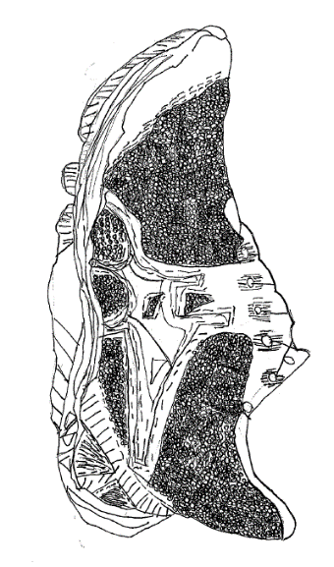
- A literacy activity to complement learning has been included in Student activity sheet 1.5: Literacy activity: The experience of being a refugee. Additional resources are in literacy resources.
- Students create a contour drawing of their own shoes or a crayon rubbing of the soles of their shoes.
A student work sample of a sketched shoe

Part 4: Reflection
Students record their thinking and responses to the following questions in their reflective journals:
- How would you explain how people become refugees?
- How would you describe life as a refugee?
Thinking can be represented through drawings, photos, mind maps or structured sentences.
Resource sheets | Teacher resource sheet 1.2: Cooperative learning – Think, Pair, Share  Student activity sheet 1.3: I see, I think, I wonder  Student activity sheet 1.4: Refugee camps and shoes  Student activity sheet 1.5: Literacy activity – Being a refugee
Digital resources | A Long Walk images by photo journalist Shannon Jensen (Daily Pennsylvanian Alumni Association, 2017)  www.dpalumni.com/assets/news_images/2013/alongwalkgrid.jpg
A Long Walk images and stories by photo journalist Shannon Jensen (Open Society Foundations, 2017)
www.opensocietyfoundations.org/moving-walls/21/long-walk
UNHCR UN refugee agency images
www.flickr.com/photos/unhcr
Aerial picture of a typical refugee camp (UNHCR)
www.unhcr.org/thumb1/4f75593a6.jpg
Children playing in refugee camp (The Washington Post, 2013)
www.washingtonpost.com/rf/image_606w/2010-2019/WashingtonPost/2013/12/29/Foreign/Images/South_Sudan_Refugee_Camp-0429f.jpg
Better Shelter and IKEA Foundation refugee homes
www.bettershelter.org/product/
Book reading: The Little Refugee by Anh Do and Suzanne Do (Edge Gutz, 2015)
www.youtube.com/watch?v=4z0O8Q40skI
Book reading: Four Feet, Two Sandals by Karen Lynn Williams and Khadra Mohammed (Amanda Hazen, 2015)
www.youtube.com/watch?v=qGwRkPX8ETY
Further reading on displacement: Worldwide displacement hits all-time high as war and persecution increase (UNHCR, 2015)
www.unhcr.org/news/latest/2015/6/558193896/worldwide-displacement-hits-all-time-high-war-persecution-increase.html
Literary resources | An activity to complement the literacy resources mentioned below has been included in Student activity sheet 1.5: Literacy activity.
 | The Treasure Box by Margaret Wild and Freya Blackwood
 | The Little Refugee by Anh Do and Suzanne Do
 | Four Feet, Two Sandals by Karen Lynn Williams and Khadra Mohammed

Activity 2A: Our shoes features
Activity focus | Activity 2 has two parts.  In Activity 2A students use a survey to identify shoe features they consider important. Students conduct a survey to collect, analyse and present data on shoe features.
Background information | Many refugees walk hundreds of kilometres to find places of refuge. Some of the refugees featured in A Long Walk walked for almost a month to reach their destination. People fleeing their homes may walk for over 50 days and cover over 2,000 kilometres. As such, it is important that shoes are very durable and comfortable.  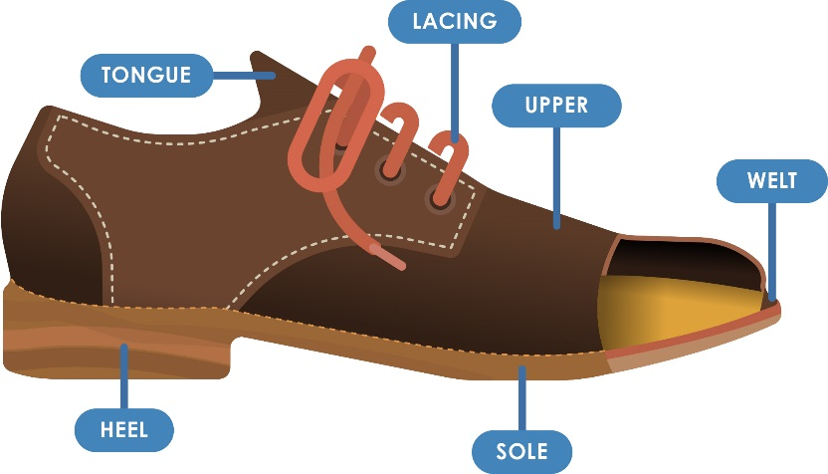  Many of the features of modern shoes relate to culture and fashion rather than designs that optimise the health and safety of feet.  A labelled diagram of a shoe  Images showing the parts of a shoe are available online. Images like the one above will help students identify shoe parts.  One purpose of shoes is to protect feet from the hot ground in summer. Thongs are made from rubber because it is a poor conductor of heat and slows the transfer of heat from the ground to the foot. The upper surface of the foot gets hot as heat from the Sun is carried by radiation to the foot.  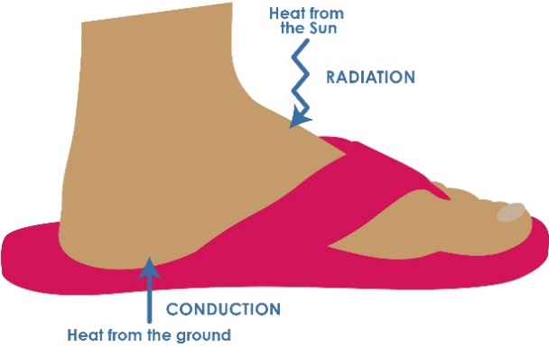  A diagram illustrating the effects of heat.
Instructional procedures | It is recommended that students work in small groups of three to four for Activities 2 – 4. Mixed ability groups encourage peer tutoring and collaboration in problem solving. Collaboration is an important STEM capability.  Throughout these activities students should be involved in creating the tables and graphs used to collect and display data. When guided to generate their own tables and graphs, opportunities are presented for students to build mathematical reasoning. While this will usually require more time than using prepared templates, students will need to wrestle with the concepts and in doing so develop a deeper understanding.  If students are not confident with constructing graphs, a class activity to collect and present data as a pictograph (see example below) is a good stepping stone towards constructing bar graphs.  When a scale is constructed for the number (frequency) of shoe features, students need to ensure the scale starts at zero, includes the full range of numbers, and that the scale increases in equal intervals. The graph will require a title and the axes labelled with the variables.  In the following activities, Bloom’s question stems could be used to scaffold questioning and encourage higher order thinking and reasoning.
Expected learning | Students will be able to:  - Establish the purpose and questions for a survey about shoe features, contribute to planning and conducting the survey (Mathematics).  - Collate, tabulate and graph the shoe survey data and interpret the findings of the survey (Mathematics).
Equipment required | For the class:  Interactive whiteboard  If students are collecting data digitally, appropriate resources will need to be sourced.  For the students:  Digital devices if required for data collection.  Sticker dots if students are creating a class tally chart.
Preparation | Ensure students have access to Student activity sheet 2.1: Shoe features – survey and graph.
Activity parts | Part 1: Survey  Students engage in a class brainstorm to establish a list of shoe features. An app such as Padlet can be used to record student ideas.  Students determine the most popular shoe features by taking a class survey. Discuss planning for the survey by asking:  - What does ‘most popular’ mean?  - Could it mean those features on most of your shoes?  - Could it mean those features most of you would like to have on your shoes?  - What are some ways we could find out which features are most popular?  Suggest the following ways of finding the ‘most popular’ shoe features, and ask students to think about how these different ways of obtaining data might affect the results of their survey. Suggest that we could:  - Brainstorm the features of shoes and list them. Students then ‘vote’ for their top feature.  - Each student lists three or four features they particularly like and then count to find out the features named most often.  - Ask the question: Which shoe feature do you like most of all in shoes?  - Ask the question: Which shoe feature do you think is most important in shoes?  - Ask everyone brings in their favourite shoe and then list the features of the shoes that are the same in most of them.  It is important for students to recognise that the kinds of questions asked and the way surveys are conducted (e.g. open or closed questions), can result in different data and different conclusions, and should be considered in advance.  Provide an opportunity for students to try different ways of surveying their class and compare the results.  After exploring the different ways surveys could be conducted, assist the class to decide on a single format that can be conducted in their own and another class.  Students conduct a survey to determine which shoe features are most important. They record information using a tally and then survey another class to add to their data.  Assist students to organise the survey data in different ways:  - What kinds of features have been mentioned?  - How could all the different features be combined into categories (e.g. how they look; what they are made of; how they feel on your foot; how long they last)?  - What differences might categories make to the results, compared to counting the responses separately for every individual feature?  Ask students if they could rearrange the survey data into different categories. Decide whether the new categories show something different.  - Which category or set of categories best helps us to answer our question?  - Do you think the data collected would be true for all students in Western Australia? Why? Why not?  Assist students to understand that this data can only tell us about the students they surveyed and cannot tell us about what other students might think. The data could be similar or it could be different – we can’t say for sure from our data.  Students could use a tally to record numbers.  An alternative method for recording frequencies is to use sticker dots (see example below). Ask students:  - How is this like a graph? How is it not like a graph?  Students should suggest that you would need to line up the dots in even rows to make it easy to see which category has more responses.  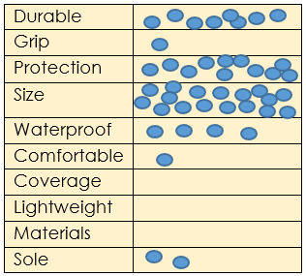  A representation of data collected  Discuss how the survey results could be displayed to best show what they have discovered from the data. This will depend on the range of graph types the students have been taught.  Stimulus questions could include:  - Why might a pictograph be appropriate or not for this data?  The categories are not easily represented by pictures e.g. size, comfort.  - Why might a bar or column graph be more helpful than a table with numbers of responses?  Easier to compare different results at a glance.  - Why might combining features into categories make results easier to analyse?  Too many small results make it difficult to see patterns.  If students are new to setting up a formal graph with axes, this activity provides opportunity to model a bar or column graph either manually or using graphing software.
Part 2: Graphing
Student ability to construct a graph from the data will depend on their previous experience with graph types.
It may be necessary to model the construction of a bar or column graph using either grid paper or a computer graphing program.
If students have some graphing experience they could, in small groups, work together to construct a bar or column graph from the class tally on grid paper.
Students name their graph and label the axes appropriately. Help students choose the axis that lists the categories and then colour the correct number of squares (i.e. one square per vote).
Show them the axis that is the number line used to represent quantities. Explain that the number line scale represents the number of votes and matches the number of squares in the column or bar, so there is no need to count every square.
- How can we see the number of squares without counting them?
To extend students, show them how every mark on the scale does not need to be labelled. Note that at this level, every unit needs to be marked, but only every second, fifth or tenth mark could be labelled with a numeral. For a scale with every second mark labelled, ask:
- Which mark indicates three votes?
- Which mark indicates seven votes?
Alternatively, represent data digitally using appropriate software. The example below has been completed using an app on a tablet. Please note, this illustrates only one way that this data could be modelled for students. At year three they would not be expected to construct a complex graph.

A digital representation of data
Part 3: Analyse data
Students identify patterns in the data. Questions to stimulate thinking can include:
- What feature was selected most often? How do we know?
- Is this the most important feature of a shoe? Why or why not?
- Which feature was selected least often? Is this feature less important? Why or why not?
- Can you identify patterns in the data?
- Do you think this is the best way to represent data? What other ways could be used?
Working in small groups, students compare the features of their own shoes with features that would be important for a refugee. They reflect on images from Activity 1, looking at the environment of the camps and making connections with necessary shoe features.

Part 4: Reflection
Students record what they have learnt in their reflective journals and begin to brainstorm the types of materials they might use in their design solution. Ask students:
- How can you use your data in your conclusion about shoe features?
Digital resources | Padlet  padlet.com

Activity 2B: Testing materials
Activity focus | In Activity 2B, students test the properties of various materials to determine their suitability for different parts of shoes.
Background information | Shoes  Archaeologists have discovered remains of early forms of shoes made from leaves, fibres, wood, animal skins and leather. The earliest forms of shoes, often found in colder climates, consist of a bag-shaped piece of leather.  Most types of shoes have a sole that protects the feet from the ground and an upper that connects the shoe to the foot. Materials used to make soles are ideally waterproof, durable and resist abrasion from the ground. The upper needs to be made of material that is more flexible than the sole so it can be shaped to fit the foot.  Heat transfer  Heat energy moves from regions of high temperature to regions of low temperature. Heat energy can be transferred by radiation (e.g., from the Sun to objects on Earth), by conduction from a hot object to a cooler one when they are touching (e.g., from the hot ground to a bare foot) and by convection when currents in air or liquids carry heat from regions of high temperature to regions of low temperature. Materials that transfer heat efficiently, such as metals, are good conductors of heat. Materials that are poor conductors of heat, such as cardboard, are called insulators.  Metals absorb and transfer (conduct) heat better than many other materials. Some materials that conduct heat poorly (insulators) include wood and Styrofoam.  The Mechanisms of Heat Transfer: Conduction, Convection & Radiation video can be used to support the science understanding of heat transfer (see Digital resources).  Further science activities to develop the understanding of heat transfer can be found at ScienceWeb Australia scienceweb.asta.edu.au/years-3-4/unit1/overview/yr34-unit1-overview.html  Fair testing  An investigation is a fair test when one variable is changed (the independent variable), one variable is measured or observed (dependent variable) and all other variables are kept constant (controlled variables).  https://k10outline.scsa.wa.edu.au/home/p-10-curriculum/curriculum-browser/science-v8/overview/glossary#f
Instructional procedures | Students continue to work in small groups of three or four to provide opportunities for collaboration and shared problem solving.  It is recommended that eight stations be established for students to test how materials respond to four different conditions.  Stations 1 and 2 – Heat conductivity  Students can test for conductivity by placing materials on a hot or cold surface (ie concrete, bitumen or ice) for a period of time and then hold to see if they can feel a temperature change on the other side.  Stations 3 and 4 – Water  Students can immerse the material in water for one minute.  Stations 5 and 6 – Friction  Students can rub the material against various surfaces such as carpet, grass and bitumen for one minute and see if there is an effect on the material.  Stations 7 and 8 – Force  Students can stand on the material for 30 seconds.
Expected learning | Students will be able to:  - Formulate a question for investigating the properties of materials and make predictions based on prior knowledge (Science).  - Follow safe procedures to test materials and document observations (Science).  - Compare results with predictions and justify their choice of materials (Science).  - With guidance, explain how heat transferred to an object makes it hotter (Science).
Equipment required | For the class:  See the Materials list provided.  A bucket half full of water.
Preparation | Collect materials and ensure there are enough for all groups.  Arrange the testing stations in the classroom.  Before starting the activity, provide students with access to Student activity sheet 2.2: Testing materials for making shoes and create a class testing guide to outline learning activities and expectations for each station.
Activity parts | Part 1: Materials  Students revisit the images of refugee camps from Activity 1 and as a class brainstorm a list of the materials available in camps that could be used to make shoes.
Part 2: Questioning
Refer to the list of shoe features created in Activity 2A and encourage students to discuss how the available materials might be affected by each test.
Prompt questions could include:
- Which materials might be damaged by force, heat water or friction? Why?
- Which materials would be best for making shoes? Which parts? Why?
- Predict what would happen if…?
Students could use the Think- pair- share strategy to discuss predictions see Teacher resource sheet 1.2: Cooperative learning – Think, Pair, Share.
Part 3: Testing materials
Students will need support to formulate an appropriate question for investigation. When students complete the prediction box on Student activity sheet 2.2: Testing materials for making shoes use 'why' as a prompt to encourage students to justify their claims or explain reasons for their predictions.
In small groups, students move through the stations and record their observations.
Additional learning opportunities
As a literacy integration opportunity, introduce students to the book The Hottest Boy Who Ever Lived by Anna Fienberg.
Student participation in a science investigation would further develop their understanding of heat transfer. Two resources that use the 5E approach can be found here:
www.powersleuth.org/docs/EHM%20Lesson%205%20FT.pdf
scienceweb.asta.edu.au/years-3-4/unit1/overview/yr34-unit1-overview.html
Part 4: Reflection
Students engage in a class discussion on the test results.
Prompt questions include:
- Which predictions were accurate? Why?
- Which materials did not conduct heat? How do you know?
- In this test, what was the source of the heat?
- How was the heat carried to the materials?
- Which materials were changed by force or friction?
- Which materials did not soak up water?
- Which material would be good for the sole of a shoe? Why?
Students select the materials they would use for the sole, upper and fastenings of their shoes. Students record their reasons using the Student activity sheet 2.3: After testing – Evaluating our predictions.
Students discuss the thinking behind the materials they selected for their shoe design.
Students add this worksheet to their journals with further reflections, including their own description to explain how heat is transferred.
Resource sheets | Student activity sheet 2.2: Testing materials for making shoes  Student activity sheet 2.3: After testing: Evaluating our predictions
Digital resources | Transfer of heat (ScienceWeb Australia, Australian Science Teachers Association, 2017)  scienceweb.asta.edu.au/years-3-4/unit1/overview/yr34-unit1-overview.html
Conduction, Convection, Radiation (Utah Education Network, 1999)
www.uen.org/Lessonplan/preview?LPid=1801
Mechanisms of Heat Transfer: Conduction, Convection & Radiation (The Madsenscience, 2017)
www.youtube.com/watch?v=U3ee3rSg7xs
Image of child with tyre (iStock, 2012)
www.istockphoto.com/au/photo/kids-play-on-a-street-in-juba-south-sudan-gm468573275-34564928
Image of children filling plastic bottles with water (iStock, 2016)
www.istockphoto.com/au/photo/children-filling-water-bottles-gm514770480-88252029
Image of rubbish in refugee camp (iStock, 2013)
www.istockphoto.com/au/photo/water-pollution-in-refugee-camps-gm182742761-12863127
Literary resources | The Hottest Boy Who Ever Lived by Anna Fienberg

Activity 3: I am a designer
Activity focus | In this activity, students use their findings about shoe features and suitable materials established in Activity 2 to create and annotate a shoe design, including relevant measurements in centimetres. Students use this design to build a shoe using repurposed materials.
Background information | This is a good opportunity to discuss the limited availability of resources in refugee camps i.e., if students are making their own glue the availability of flour and water could be limited to make them more aware of resource limitations.  Photographs or videos of the construction processes should be taken for the digital presentations in Activity 4.  The design process is a series of steps that guides the development of a solution to a problem. The core steps in the process are the same whether applied in engineering or areas such as software design. These steps are:  - Define the problem: What is the need?  - Research and gather information.  - Analysis: Imagine: Brainstorm ideas.  - Ideation: Plan: Pick the best idea, how will it work? Draw a diagram, identify materials or tools required?  - Development/ production: Build the solution and test it.  - Evaluation: Improve: What works, what doesn’t, what could work better? Repeat the cycle.  Refer to the Design process guide and Drawing in the design process for further information on design in the technologies curriculum.  Students should be encouraged to create initial design sketches using pencil and paper as there will be many changes. Once they have finalised their design, they can draw the design digitally using Computer-aided design (CAD) software. Students will need opportunities to learn to use CAD technology.  Negotiation, critical thinking and reasoning skills will be displayed by the students as they work on their designs. Problem solving in collaborative situations is a STEM capability that students need to exercise. Allowing students to negotiate amongst themselves will encourage the development of this skill.  Content warning:  When planning for the delivery of this topic, it is important to consider the backgrounds and experiences of the students as content may cause distress for some students. It may be necessary to notify parents, alert students and provide alternative lesson content.
Instructional procedures | Children will need assistance with cutting and joining skills. Parent help or buddy class support will need to be arranged. Refer to Teacher resource sheet 3.2: Construction skills for tips on joining and binding items.  The purpose of this activity is to engage students in designing shoes that could be made by refugees using the materials available to them in a refugee camp. Care needs to be taken that students do not get the impression that shoes of a lesser quality than they wear are adequate for refugees. The shoes made in a refugee camp will be of lesser quality because of the limited resources available to make them.  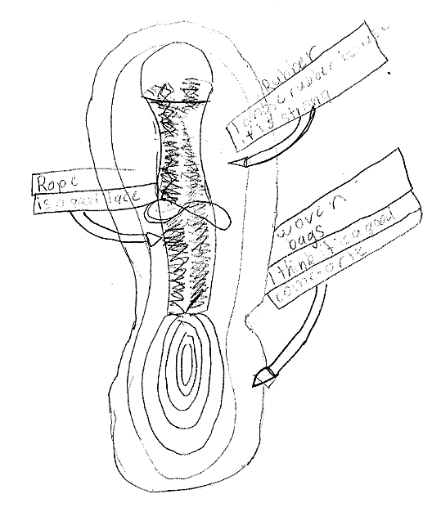  Student drawn and labelled diagram of a shoe
Expected learning | Students will be able to:  - Create a design plan for a shoe and explain how the design meets the functions to be performed by shoes (Technologies).  - Measure lengths using a centimetre tape measure (mathematics).  - Write a set of procedural steps for making the shoes (Technologies).
Equipment required | For the class:  See the Materials list provided.  Construction supplies such as tape, scissors, cutting mats, glue sticks, PVA glue, hot glue guns (to be used by adults)  Materials that may be readily available in refugee camps such as hessian bags, plastic bottles, rubber, wood, fabric, tarps, rope, polystyrene boxes and cardboard  Paper, ruler, coloured pencils or markers, centimetre tape measures.
Preparation | Organise an area in the classroom where students can work on their design plans using the materials provided. Ensure there is enough space to store materials between lessons.  Ensure students have access to Student activity sheet 3.1: Designing – my shoes.
Activity parts | Part 1: Ideation  Students work collaboratively to develop a design plan using the materials investigated in Activity 2B.  Using Student activity sheet 3.1: Designing – my shoes, students draw a design plan, labelling the parts of the shoe and naming the materials used for each part.  Students consider the kinds of measurements they would need to ensure their shoe would fit. Assist them to label their design with relevant measurements, using a standard centimetre tape measure to transfer the various measurements to the appropriate part of their diagram. Ask:  - How do you know the shoes you are designing will fit your feet?  - What measurements would you need to take to make sure the shoe will fit?  - How can you show this on your design drawing?  - How can you show that the measurement is in centimetres.  Students should discover that they need to know both the length and the width of their foot to check if a piece of material is big enough for the soles of their shoes.  Students justify why they have chosen each material in their design. Prompt students thinking using questioning such as:  - Why do you plan to use this material for this part of the shoe?  - How will the materials enhance the functionality of the shoe?  - How will you join the parts together? See Teacher resource sheet 3.2: Construction skills  Additional learning experience  To incorporate digital technologies, students can represent their design plan digitally with a computer assisted drawing tool such as SketchUp or Tinkercad (see Drawing in the design process).
Part 2: Materials
Students list the materials (eg hessian, rubber, plastic), including the size and quantity required of each type, using their design and measurements. They also choose the equipment (eg hammer and nails, glue, hole punch) needed to construct their shoe, recording information on Student activity sheet 3.1: Designing – my shoes.
To develop students’ understanding of the limited resources available in a refugee camp, each groups resources could be limited (eg each group receives a hammer, nails, length of string, amount of flour for glue etc).
Part 3: Create
Working in groups, students use their design from Part 1 to produce their shoe.
Question students about the process:
- How are you joining pieces? Why did you choose that method?
- How easy was it to follow your plan?
- Did you have to make changes? Why did you need to change your plan?
- How accurate were your measurements?
- Which measurements were most useful and which may not have been needed?
- What measurements did you need that you did not think of in advance?
- What problems have you had constructing your shoe?
- How did you solve your problems?
Encourage students to follow the design process as they construct their shoes. See Design process guide.
Support students to document their design process and capture digital images of the shoe construction using Student activity sheet 3.1: Designing – my shoes.
Part 4: Additional learning opportunity: Procedural writing
Students use appropriate vocabulary to write a set of simple instructions on how to make their shoes, describing how parts can be cut to shape and joined together.
Part 5: Evaluate
Students reflect on and evaluate the effectiveness of their design, justifying their choice of materials, shape and form, and the types of movement it allows.
Students record this information and their own reflections in their learning journals
Prompt student reflections with questioning:
- What worked? Because…
- What didn’t work – why?
- What would you do again? What would you not repeat? Why?
- Do you have any further recommendations for developing this idea?
Resource sheets | Student activity sheet 3.1: Designing – my shoes  Teacher resource sheet 3.2: Construction skills

Activity 4: Sharing findings
Activity focus | In this activity, students reflect on their completed shoes, justifying any changes to their design plan.  Students prepare a presentation to communicate the design process through a chosen form of digital media. Presentations are shared with the class and, where possible, an external audience.
Instructional procedures | The presentations provide a rich opportunity for assessing the students' understanding of the science and technology principles and processes, as well as literacies associated with speaking and listening. Including a visitor with an interest in design or shoes to the audience will increase students’ engagement and learning from the task.  Preparing the presentations  Students will need support and scaffolding to prepare for their presentation. Presentations could be prepared in groups of three to four students. To scaffold cooperative group work, each member of the group could have a role and responsibility. For example, one could be the Content Director, one the Media Director and a third the Presentation Director. All students would contribute to deciding on the content, preparing the media and giving the presentation whilst one student has overall responsibility for managing that phase of the task. See Teacher resource sheet 1.1: Cooperative learning – Roles for more information.  Using digital technology  Digital options for presentations include creating a comic strip, eBook, poster in Pages, Keynote or PowerPoint or iMovie (or similar). Photographs taken throughout the design process should be used in digital presentations.  The presentation can be shared through a platform such as Seesaw, Class Dojo or Connect, added to a class blog or shared on an interactive whiteboard. Students may require explicit instruction in using these apps.  Content warning:  When planning for the delivery of this topic, it is important to consider the backgrounds and experiences of students as content may cause distress for some students.  If necessary notify parents, alert students and provide alternative content.
Expected learning | Students will be able to:  - Use digital technologies to organise and present information about their shoe design and the design process (Technologies).  - Justify their choice of materials for parts of the shoe based on their properties (Science).
Equipment required | For the class:  A device with appropriate apps for creating a digital presentation (see Digital resources for suggestions)
Preparation | Charge and load devices with appropriate apps.  Provide students with access to the labelled shoe designs from Activity 3.  Schedule sufficient time for each group to present.
Activity parts | Part 1: Deciding on content  In their groups, students decide on the content of their presentation. Presentations should focus on choices of materials as outlined in their design plan. Students should justify any changes made during the construction process.  Students analyse their completed model, identify the materials used and compare this to their initial design plan.  Prompt questions can include:  - What materials were used and why?  - What wasn’t used? Why?  - Does your shoe match your design plan?  - Why did you change your design plan? Because…  Students record their comparisons in their reflective journals and share with the class.
Part 2: Choosing media and creating presentations
In their groups, students use a chosen form of digital media to communicate their design process. See Digital resources for suggestions.

Part 3: Sharing presentations
Students share their digital presentations with the class and give and receive feedback using Teacher resource sheet 4.1: 3 – 2 – 1 Reflection. This is a good opportunity to complete Teacher resource sheet 4.2: Evaluation.
Additional learning opportunity
Students pitch their design (either in person, by email or Skype) to an aid worker from an international refugee aid organisation (eg CARE Australia, Caritas Australia, UNICEF). Alternatively, the shoes and design drawings could be displayed for parents to view.
Resource sheets | Teacher resource sheet 1.1: Cooperative learning – Roles  Teacher resource sheet 4.1: 3 – 2 – 1 Reflection  Teacher resource sheet 4.2: Evaluation
Digital resources | Comic Life  itunes.apple.com/us/app/comic-life/id432537882?mt=8&ign-mpt=uo%3D4 Paid app
Canvas comic strip maker
www.canva.com/create/comic-strips/ (Free)
iBooks Author
www.apple.com/au/ibooks-author
Book Creator
itunes.apple.com/au/app/book-creator-for-ipad-create/id442378070?mt=8
iMovie
itunes.apple.com/au/app/imovie/id377298193?mt=8
Pages
itunes.apple.com/au/app/pages/id361309726?mt=8
Keynote
itunes.apple.com/au/app/keynote/id361285480?mt=8
Connect – the Department of Education’s integrated, online environment
connect.det.wa.edu.au
Seesaw Digital Portfolio
web.seesaw.me
Class Dojo
www.classdojo.com

Appendix 1A: Links to the Western Australian Curriculum
The long walk module provides opportunities for developing students’ knowledge and understandings in science, technologies and mathematics. The table below shows how this module aligns to the content of the Western Australian Curriculum and can be used by teachers for planning and monitoring.
THE LONG WALK  Links to the Western Australian Curriculum | ACTIVITY
 | 1 | 2 | 3 | 4
SCIENCE
SCIENCE UNDERSTANDING
Physical sciences: Heat can be produced in many ways and can move from one object to another (ACSSU049) |  | ●
SCIENCE INQUIRY SKILLS
Questioning and predicting: With guidance, identify questions in familiar contexts that can be investigated scientifically and make predictions based on prior knowledge (ACSIS053) |  | ●
Planning and conducting: With guidance, plan and conduct scientific investigations to find answers to questions, considering the safe use of appropriate materials and equipment (ACSIS054) |  | ●
Processing and analysing: Compare results with predictions, suggesting possible reasons for findings (ACSIS215) |  | ●
DESIGN AND TECHNOLOGIES
PROCESS AND PRODUCTION SKILLS
Designing: Develop and communicate ideas using labelled drawings and appropriate technical terms (WATPPS17) |  |  | ● | ●

THE LONG WALK | ACTIVITY
Links to the Western Australian Curriculum | 1 | 2 | 3 | 4
MATHEMATICS
MEASUREMENT AND GEOMETRY
Using units of measurement: Measure, order and compare objects using familiar metric units of length, mass and capacity (ACMMG061) |  |  | ●
STATISTICS AND PROBABILITY
Data representation and interpretation: Identify questions or issues for categorical variables. Identify data sources and plan methods of data collection and recording (ACMSP068) |  | ●
Data representation and interpretation: Collect data, organise into categories and create displays using lists, tables, picture graphs and simple column graphs, with and without the use of digital technologies (ACMSP069) |  | ●
Data representation and interpretation: Interpret and compare data displays (ACMSP070) | ● | ●

Further information about assessment and reporting in the Western Australian Curriculum can be found at: https://k10outline.scsa.wa.edu.au/homecurriculum-browser/technologies/technologies-overview/ways-of-assessing

Appendix 1B: Mathematics proficiency strands
Key ideas
In Mathematics, the key ideas are the proficiency strands of understanding, fluency, problem-solving and reasoning. The proficiency strands describe the actions in which students can engage when learning and using the content. While not all proficiency strands apply to every content description, they indicate the breadth of mathematical actions that teachers can emphasise.
Understanding
Students build a robust knowledge of adaptable and transferable mathematical concepts. They make connections between related concepts and progressively apply the familiar to develop new ideas. They develop an understanding of the relationship between the ‘why’ and the ‘how’ of mathematics. Students build understanding when they connect related ideas, when they represent concepts in different ways, when they identify commonalities and differences between aspects of content, when they describe their thinking mathematically and when they interpret mathematical information.
Fluency
Students develop skills in choosing appropriate procedures; carrying out procedures flexibly, accurately, efficiently and appropriately; and recalling factual knowledge and concepts readily. Students are fluent when they calculate answers efficiently, when they recognise robust ways of answering questions, when they choose appropriate methods and approximations, when they recall definitions and regularly use facts, and when they can manipulate expressions and equations to find solutions.
Problem-solving
Students develop the ability to make choices, interpret, formulate, model and investigate problem situations, and communicate solutions effectively. Students formulate and solve problems when they use mathematics to represent unfamiliar or meaningful situations, when they design investigations and plan their approaches, when they apply their existing strategies to seek solutions, and when they verify that their answers are reasonable.
Reasoning
Students develop an increasingly sophisticated capacity for logical thought and actions, such as analysing, proving, evaluating, explaining, inferring, justifying and generalising. Students are reasoning mathematically when they explain their thinking, when they deduce and justify strategies used and conclusions reached, when they adapt the known to the unknown, when they transfer learning from one context to another, when they prove that something is true or false, and when they compare and contrast related ideas and explain their choices.

Source:
www.australiancurriculum.edu.au/f-10-curriculum/mathematics/key-ideas/?searchTerm=key+ideas#dimension-content

Appendix 2: General capabilities continuums
The general capabilities continuums shown here are designed to enable teachers to understand the progression students should make with reference to each of the elements. There is no intention for them to be used for assessment.
Information and communication technology (ICT) capability learning continuum
Sub-element | Typically by the end of Year 2 | Typically by the end of Year 4 | Typically by the end of Year 6
Create with ICT  Generate ideas, plans and processes | use ICT to prepare simple plans to find solutions or answers to questions | use ICT to generate ideas and plan solutions | use ICT effectively to record ideas, represent thinking and plan solutions
Create with ICT  Generate solutions to challenges and learning area tasks | experiment with ICT as a creative tool to generate simple solutions, modifications or data representations for particular audiences or purposes | create and modify simple digital solutions, creative outputs or data representation/ transformation for particular purposes | independently or collaboratively create and modify digital solutions, creative outputs or data representation/transformation for particular audiences and purposes
Communicating with ICT  Collaborate, share and exchange | use purposefully selected ICT tools safely to share and exchange information with appropriate local audiences | use appropriate ICT tools safely to share and exchange information with appropriate known audiences | select and use appropriate ICT tools safely to share and exchange information and to safely collaborate with others

Critical and creative thinking learning continuum
Sub-element | Typically by the end of Year 2 | Typically by the end of Year 4 | Typically by the end of Year 6
Inquiring – identifying, exploring and organising information and ideas  Organise and process information | organise information based on similar or relevant ideas from several sources | organise information based on similar or relevant ideas from several sources | analyse, condense and combine relevant information from multiple sources
Generating ideas, possibilities and actions  Imagine possibilities and connect ideas | build on what they know to create ideas and possibilities in ways that are new to them | expand on known ideas to create new and imaginative combinations | combine ideas in a variety of ways and from a range of sources to create new possibilities
Generating ideas, possibilities and actions  Seek solutions and put ideas into action | investigate options and predict possible outcomes when putting ideas into action | experiment with a range of options when seeking solutions and putting ideas into action | assess and test options to identify the most effective solution and to put ideas into action
Reflecting on thinking and processes  Transfer knowledge into new contexts | use information from a previous experience to inform a new idea | transfer and apply information in one setting to enrich another | apply knowledge gained from one context to another unrelated context and identify new meaning

Personal and social capability learning continuum
Sub-element | Typically by the end of Year 2 | Typically by the end of Year 4 | Typically by the end of Year 6
Social management  Work collaboratively | identify cooperative behaviours in a range of group activities | describe characteristics of cooperative behaviour and identify evidence of these in group activities | contribute to groups and teams, suggesting improvements in methods used for group investigations and projects
Social management  Negotiate and resolve conflict | practice solving simple interpersonal problems, recognising there are many ways to solve conflict | identify a range of conflict resolution strategies to negotiate positive outcomes to problems | identify causes and effects of conflict, and practice different strategies to diffuse or resolve conflict situations
Social management  Develop leadership skills | discuss ways in which they can take responsibility for their own actions | discuss the concept of leadership and identify situations where it is appropriate to adopt this role | initiate or help to organise group activities that address a common need
Further information about general capabilities is available at:
k10outline.scsa.wa.edu.au/home/p-10-curriculum/general-capabilities-over/general-capabilities-overview/general-capabilities-in-the-australian-curriculum

Appendix 3: Materials list
The following materials are required to complete this module.
Equipment for testing materials:
- hairdryer
- buckets of water
- sandpaper and blocks.
Supplies that may be readily available in refugee camps such as:
- cardboard
- rope or string
- plastic – bottles and lids
- foam – packaging or Styrofoam
- hessian (woven) bags
- old tyres – rubber
- wood – pallets or kindling
- natural vines or reeds
- strapping
- tarp.
Supplies for building shoes:
- tape
- scissors
- tape measure
- blades
- cutting mats
- glue sticks
- PVA glue
- hot glue guns (to be used by the teacher)
- cornflour and water to make glue (optional).

Appendix 4: Design process guide
Safe production of the final design or multiple copies of the final design.
Fine tuning the production process, such as division of labour for batch or mass production.
Use of intended materials and appropriate tools to safely make the solution to the design problem.
Reflection on the process taken and the success of the design.
Evaluation can lead to further development or improvement of the design and can be a final stage of the design process before a conclusion is reached.
Could be formal or informal and verbal or written.
Ideation
Development
Development of the design ideas. Improvements, refinements, adding detail, making it better.
Activities such as detailed drawings, modelling, prototyping, market research, gaining feedback from intended user, further research – if needed – to solve an issue with the design, testing different tools or equipment, trialling production processes, measuring or working out dimensions, testing of prototypes and further refinement.
Idea generation – turning ideas into tangible forms so they can be organised, ordered and communicated to others.
Activities such as brainstorming, mind mapping, sketching, drawing diagrams and plans, collecting colour samples and/or material samples and talking through these ideas can help to generate more creative ideas.
Using the SCAMPER model can assist with this: www.mindtools.com/pages/article/newCT_02.htm
www.designorate.com/a-guide-to-the-scamper-technique-for- creative-thinking
Analysis
Finding useful and helpful information about the design problem.
Gathering information, conducting surveys, finding examples of existing solutions, testing properties of materials, practical testing.
Understanding the meaning of the research findings.
Analysing what the information means, summarising the surveys, judging the value of existing solutions, understanding test results.
Research
Production
Evaluation

Appendix 4B: Drawing in the design process
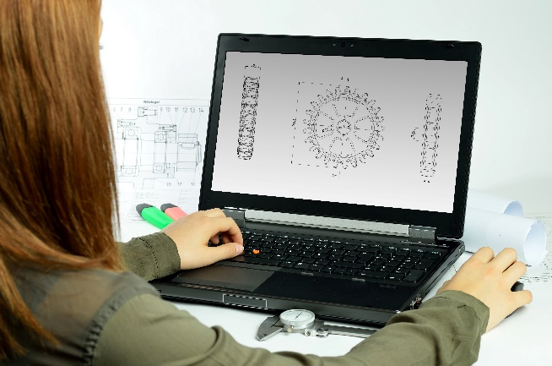
Incorporating the design process into the STEM modules will often result in the need for students to draw plans of their designs. This can be done at a simple level using hand drawn sketches or at a more technical level using computer-aided design (CAD).
By developing skills using industry standard software, students may be well-placed to explore future career pathways.
There are a number of CAD software options, two free examples are detailed below. Autodesk is a third package that is also free for educational use.
Tinkercad
- Format: Web-based app requiring internet access via a browser
- Purpose: A simple, online 3D design and 3D printing app
- Home: www.tinkercad.com
- Blog: blog.tinkercad.com
- Tutorials: www.tinkercad.com/learn
- Feature: Connects to 3D printing and laser cutting.
SketchUp
- Format: Can be downloaded and installed on devices, or used in a browser
- Purpose: Enables students to draw in 3D
- Home: www.sketchup.com 'Products' 'SketchUp for Schools'
- Help centre: help.sketchup.com/en
- Blog: blog.sketchup.com
- Tutorials: www.youtube.com/user/SketchUpVideo. From beginner tool tips to intermediate and advanced modelling techniques, the video tutorials help to build SketchUp skills.

Appendix 5: Reflective journal
When students reflect on learning and analyse their own ideas and feelings, they self-evaluate, thereby improving their metacognitive skills. When students self-monitor or reflect, the most powerful learning happens.
Journaling may take the form of a written or digital journal, a portfolio or a digital portfolio. Early childhood classrooms may use a class reflective floor book with pictures of the learning experience and scribed conversations.
Teachers can model the Journaling process by thinking aloud and showing students how they can express learning and thoughts in a variety of ways including diagrams, pictures and writing.
Journals are a useful tool that gives teachers additional insight into how students value their own learning and progress, as well as demonstrating their individual achievements.
The following links provide background information and useful apps for Journaling.
Kidblog – digital portfolios and blogging
kidblog.org/home
Edmodo – for consolidating and storing class notes and learning materials
www.edmodo.com
Explain Everything™ – a screen casting, video and presentation tool all in one
explaineverything.com/
Popplet – allows you to jot down your ideas and then sort them visually
Popplet.com
Seesaw – for capturing work completed by students in class, using a device’s camera function
web.seesaw.me
Connect – the Department of Education’s integrated, online environment
connect.det.wa.edu.au
Evernote (a digital portfolio app)
evernote.com
Digital portfolios for students (Cool tools for school)
cooltoolsforschool.wordpress.com/digital-student-portfolios

Appendix 6: Student activity sheet 1.0: Journal checklist
As an ongoing part of this module, you have been keeping a journal of your work.
Before submitting your journal to your teacher please ensure you have included the following information.
- Tick each box once complete and included.
- Write N/A for items that were not required in this module.

Your name and group member's names or photographs
An explanation of the problem you are solving
Your notes from Activity 1
Activity sheet 1.3: I see, I think, I wonder
Activity sheet 1.4: Refugee camps and shoes
Your notes from Activity 2
Activity sheet 2.1: Refugee camps and shoes – survey and graph
Activity sheet 2.2: Testing materials
Activity sheet 2.3: After testing
Your notes from Activity 3
Activity sheet 3.1 Planning – refugee shoes
Your notes from Activity 4
Activity sheet 4.1: 3 – 2 – 1 Reflection
Activity sheet 1.0: Journal checklist

Appendix 7: Teacher resource sheet 1.1: Cooperative learning – Roles
Cooperative learning frameworks create opportunities for groups of students to work together, generally to a single purpose.
As well as having the potential to increase learning for all students involved, using these frameworks can help students develop personal and social capability.
When students are working in groups, positive interdependence can be fostered by assigning roles to group members.
These roles could include:
- working roles such as Reader, Writer, Summariser, Time-keeper.
- social roles such as Encourager, Observer, Noise monitor, Energiser.
Teachers using the Primary Connections roles of Director, Manager and Speaker for their science teaching may find it effective to also use these roles for STEM learning.
Further to this, specific roles can be delineated for specific activities that the group is completing.
It can help students if some background to the purpose of group roles is made clear to them before they start, but at no time should the roles get in the way of the learning. Teachers should decide when or where roles are appropriate to given tasks.

Appendix 8: Teacher resource sheet 1.2: Cooperative learning – Think, Pair, Share
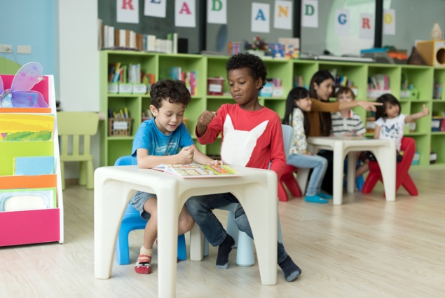
This resource sheet provides a brief outline of a cooperative learning strategy known as 'think – pair – share'.
Cooperative learning frameworks create opportunities for groups of students to work together, generally to a single purpose.
As well as having the potential to increase learning for all students involved, using these frameworks can help students develop personal and social capability.
In the 'think' stage, each student thinks silently about a question asked by the teacher.
In the 'pair' stage, students discuss their thoughts and answers to the question in pairs.
In the 'share' stage, the students share their answer, their partners answer or what they decided together. This sharing may be with other pairs or with the whole class. It is important also to let students 'pass'. This is a key element of making the strategy safe for students.
Think – pair – share increases student participation and provides an environment for higher levels of thinking and questioning.

Appendix 9: Student activity sheet 1.3: I see, I think, I wonder

What do you see when you look at this image?
What are you thinking about as you look at this image?
What are your wonderings (questions)?

Appendix 10: Student activity sheet 1.4: Refugee camps and shoes
After looking at images of the refugee camps in Sudan, write words in the box below that describe the environment of the camp.

Using the words in the box above write a few sentences about the camp.

What kinds of shoes would people need to wear in these camps to protect their feet? Draw a picture.

Appendix 11: Student activity sheet 1.5: Literacy activity – Being a refugee
Title: The Little Refugee Author: Anh Do and Suzanne Do
What do you think is the main idea of the story?  For you as a reader, what is the best part of the story?  Why? |  | List four things you would take with you if you had to leave Australia and never return.  1.  2.  3.  4.
Why did Anh have to leave Vietnam?

Draw a picture of Anh in the space below. Write some inside and outside character traits around his image. | How do you think Anh felt when he went to his new school?  Why did he feel that way?
Rate the story out of 5 stars: (colour in up to 5 for best)

Explain why you rated the story that way?

Why do you think Anh wrote the story?  How would you feel if you were Anh and had tried to travel on an old wooden boat from one country to another?  Why would you feel this way? |  | Compare this story to The Treasure Box by Margaret Wild and Freya Blackwood.  Write three things that are similar and three that are different.
 |  | Similar: |  | Different:
Look at the illustrations in the book. The colours range from sepia to brightly coloured drawings. Why do you think the illustrator did this?

What feelings or moods do the different colours in the illustration convey?
Give three examples:

1.

2.

3.

 | List three causes and effects in the story?
 | Because of . . . (cause)  1.  2.  3. |  | this happened . . . (effect)

Appendix 12: Student activity sheet 2.2: Testing materials for making shoes
Criteria: The shoes must be durable and comfortable. They should protect feet from the hot ground, water and sharp objects.
Investigation questions | eg Which materials will be best for making different parts of a shoe?
Predictions  (Teacher led whole class discussion) | Sole - Cushioning -  Laces - Other -  Outside covering -

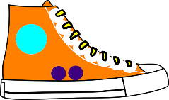 | Before testing  What does the material look like? | Heating or cooling  Hold the material against 3 different outdoor surfaces |  |  | Water  Immerse the material in water for 1 minute. | Friction  Rub material against carpet, bricks and grass |  |  | Force  Stand on the material for 30 seconds.
What you need to record (using words and phrases) | Describe the material before testing. | Describe the material after heating or cooling. |  |  | Describe the material after soaking. | Describe the material after rubbing. |  |  | Describe the material after standing on it.
Rubber
Cardboard
Rope
Plastic
Styrofoam
Fabric
Wood
Foam or sponge

Appendix 13: Student activity sheet 2.3: After testing – Evaluating our predictions
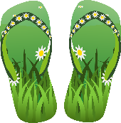 | After testing  What material would you use for each part of your shoes?
Shoe part |  | Material | Reasons why | Is this what you predicted?
Sole
Straps or laces
Cushioning
Outside covering

Appendix 14: Student activity sheet 3.1: Designing – my shoes
My shoe design  Clearly draw and label your design. Include measurements. |  |  |  |  | My shoe design
The steps
Record each step of the design process.
 |  |  |  |  | 1.
 |  |  |  |  | 2.
 |  |  |  |  | 3.
 |  |  |  |  | 4.
 |  |  |  |  | 5.
 |  |  |  |  | 6.
 |  |  |  |  | 7.
 |  |  |  |  | 8.
 |  |  |  |  | 9.
 |  |  |  |  | 10.
Materials, equipment and quantities needed
List all the required materials and equipment. Take a photograph of the materials and quantities.

Appendix 15: Teacher resource sheet 3.2: Construction skills
Construction skills help students to generate and produce solutions for real-world problems. This resource develops students' skills in design and technologies.
This resource can be used as a visual stimulus to prompt students to develop solutions to design problems. The cards can be printed out to create stations.
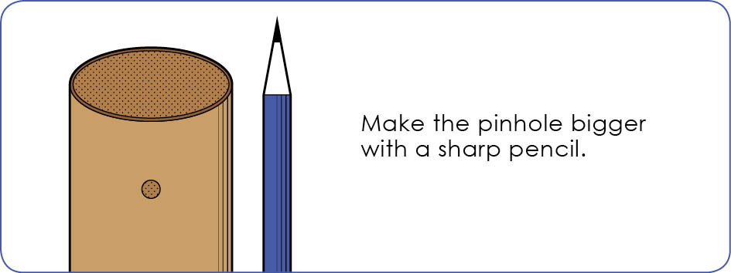
Poke a hole with a pin.
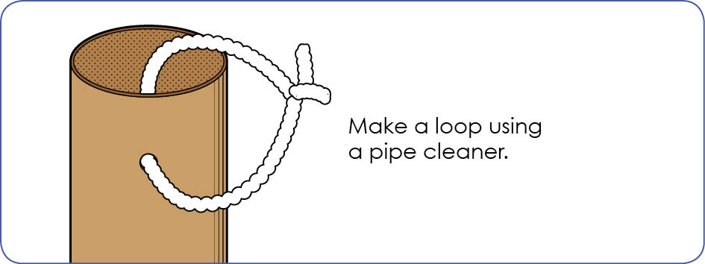

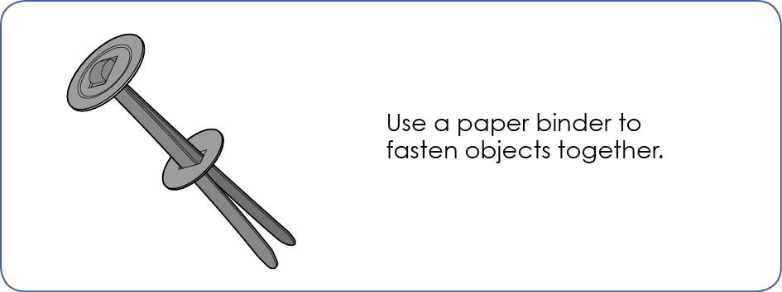

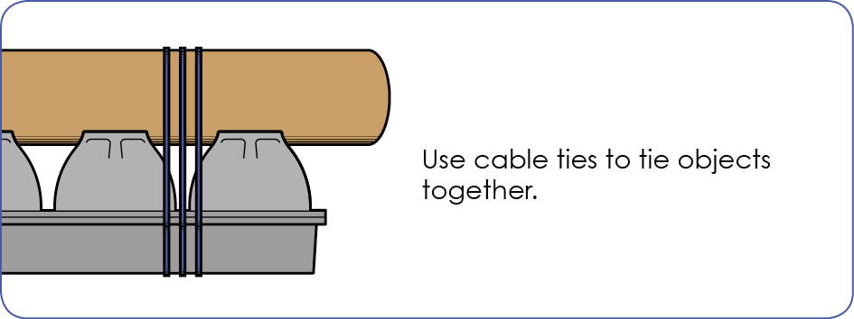

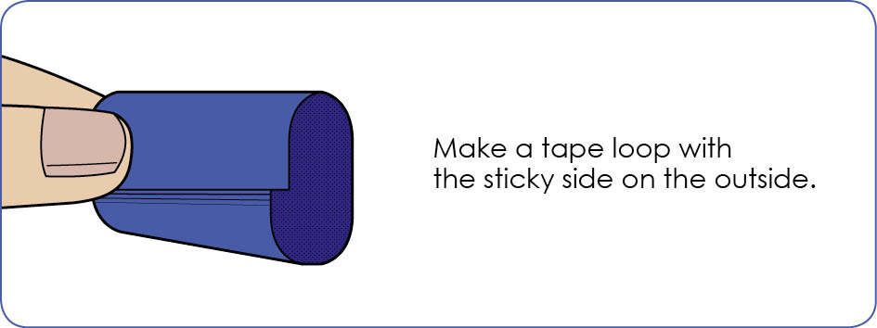

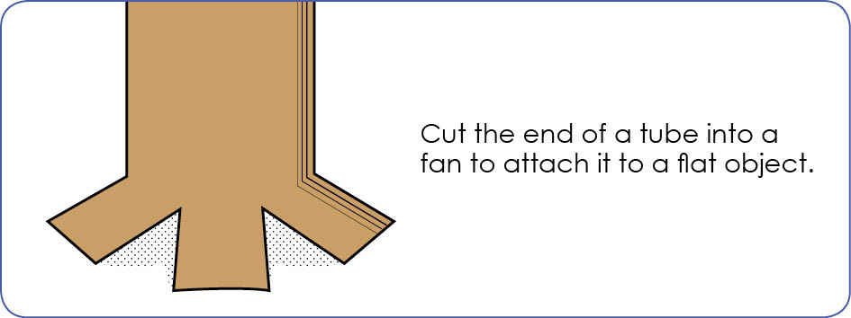

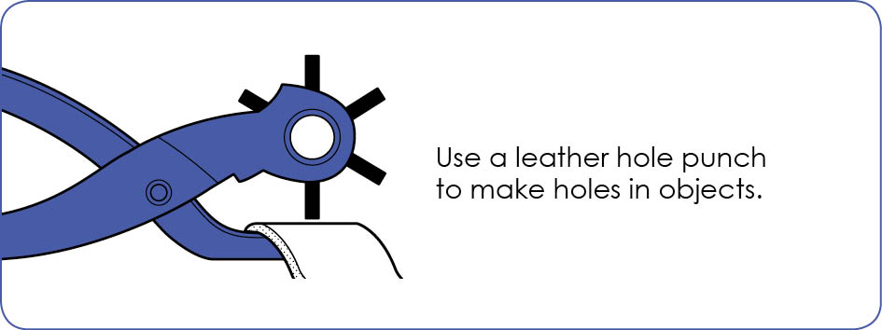

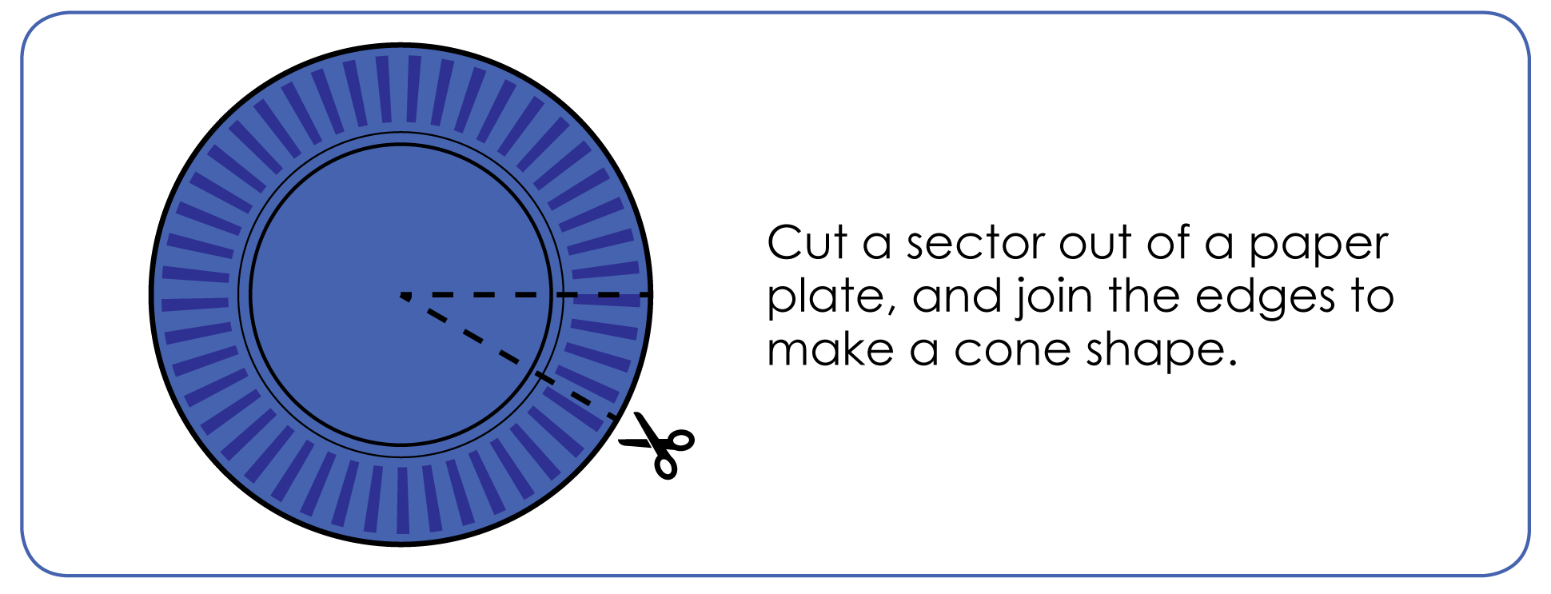

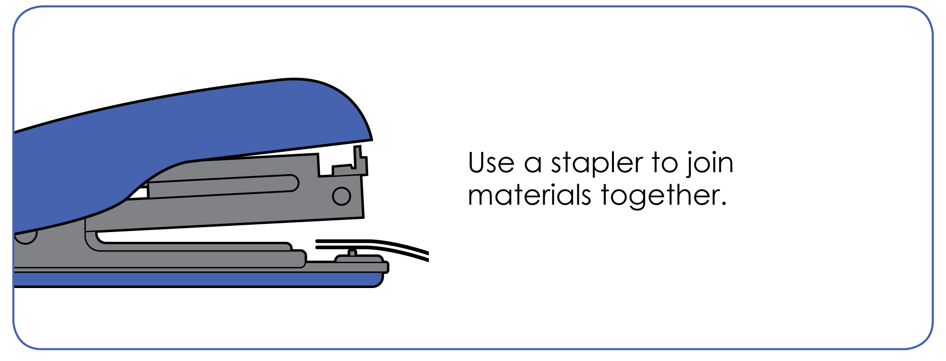

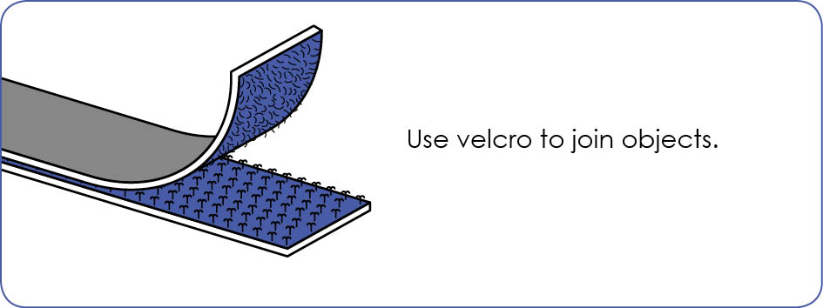

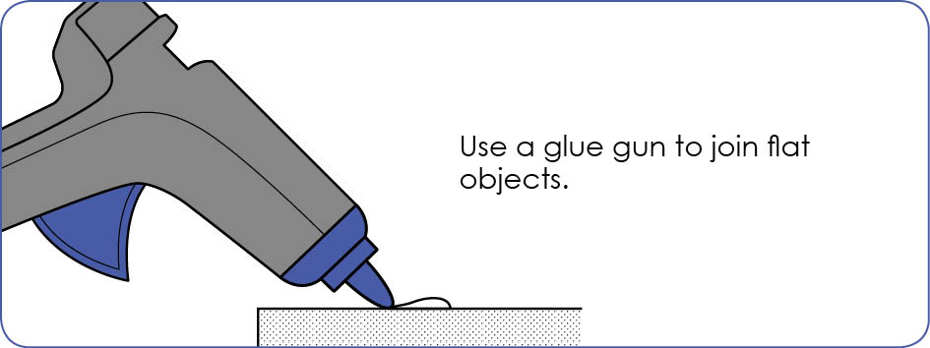

Appendix 16: Teacher resource sheet 4.1: 3 – 2 – 1 Reflection
Name | 3 things I learnt | 2 things I found interesting | 1 thing I found difficult
For example:  Abby | How to make shoes.  How to measure another way.  How to write instructions. | Making all the bits of the shoe.  Drawing shoes. | Making the shoes because we had to nail things and we didn’t have enough equipment.

Appendix 17: Teacher resource sheet 4.2: Evaluation
Key:  - Satisfactory/Usually  - Very good/Consistently  - Excellent/Independently | Student name
Remains focused on tasks presented
Completes set tasks to best of their ability
Works independently without disrupting others
Manages time effectively
Cooperates effectively within the group
Contributes to group discussions
Shows respect and consideration for others
Uses appropriate conflict resolution skills
Actively seeks and uses feedback

Notes
________________________________________________________________________________________________________________________________________________________________________________________________________________________________________________________________________________________________________________________________________________________________________________________________________________________________________________________________________________________________________________________________________________________________________________________________________________________________________________________________________________________________________________________________________________________________________________________________________________________________________________________________________________________________________________________________________________________________________________________________________________________________________________________________________________________________________________________________________________________________________________________________________________________________________________________________________________________________________________________________________________________________________________________________________________________________________________________

