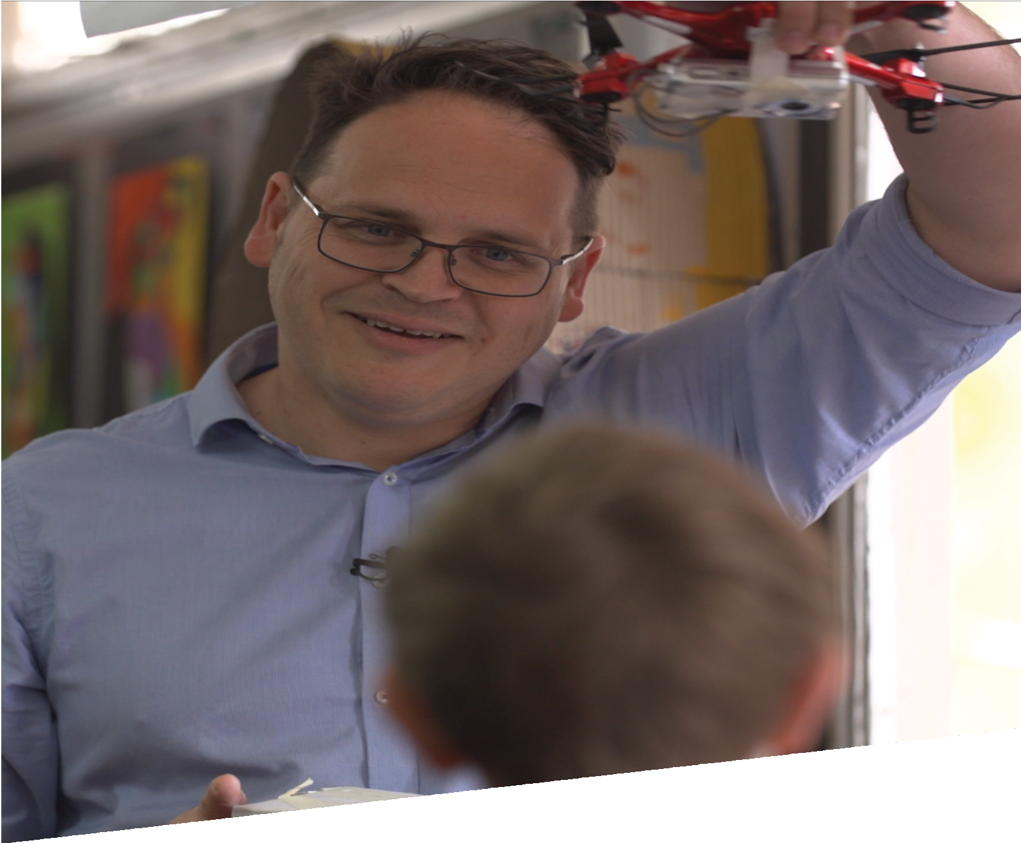

CURRICULUM RESOURCE MODULE
Mini robot garden
YEAR 4
Acknowledgements

The STEM Learning Project respectfully acknowledges the Traditional Custodians of the lands upon which our students and teachers live, learn and educate.

The STEM Learning Project is funded by the Western Australian Department of Education (the Department) and implemented by a consortium in STEM education comprising the Educational Computing Association of WA, the Mathematical Association of WA, the Science Teachers Association of WA and Scitech. We acknowledge and thank the teachers and schools who are the co-creators of these resources.

Copyright and intellectual property

The copyright and intellectual property of this module remain the property of the Department.

Any Western Australian Curriculum content in this resource is used with the permission of the School Curriculum and Standards Authority (the Authority); this permission does not constitute Authority endorsement of the resource. The Authority accepts no liability for any errors or damages arising from reliance on its content.

The Western Australian Curriculum content may be freely copied, or communicated on an intranet, for non-commercial purposes in educational institutions, provided that the Authority is acknowledged as the copyright owner. Copying or communication for any other purpose can be done only within the terms of the Copyright Act 1968 or with prior written permission of the Authority. Any Australian Curriculum content in the Western Australian Curriculum is used by the Authority under the terms of the Creative Commons Attribution-NonCommercial 3.0 Australia licence. Any content on the www.scsa.wa.edu.au domain that has been derived from the Australian Curriculum may be used under the terms of Creative Commons Attribution-NonCommercial 3.0 Australia licence.

Appendix 2: General capabilities continuums is adapted from ACARA, © Australian Curriculum, Assessment and Reporting Authority (ACARA) 2009 to present, unless otherwise indicated. This material was downloaded from the ACARA website (www.acara.edu.au) (accessed December 2015) and was not modified. The material is licensed under CC BY 4.0 (https://creativecommons.org/licenses/by/4.0/). ACARA does not endorse any product that uses ACARA material or make any representations as to the quality of such products. Any product that uses material published on this website should not be taken to be affiliated with ACARA or have the sponsorship or approval of ACARA. It is up to each person to make their own assessment of the product.

This resource includes references and examples of iOS, Android and other apps. The Department does not endorse or recommend any commercial products and simply provides these as examples for teachers.

The Department is committed to providing quality information to its customers. Whilst every effort has been made to ensure accuracy, currency and reliability of the information within these documents, the Department accepts no responsibility for errors, omissions or amendments made since the time of publishing. Confirmation of information may be sought from the Department or the originating bodies providing the information. The Department has no control over the content of material published on websites to which users are referred in this resource. It is the responsibility of the internet user to make their own decision as to the relevancy, accuracy, currency and reliability of information found on those sites.
This resource contains various images from Getty Images, iStock and Pixabay used under license.

Attributions: Adobe Spark Popplet, iMovie, Clips, Do Ink - Green Screen, Chatterpix Kids, Raspberry Pi, Hummingbird Robotic Kits, SketchUp, Tinkercad, Keynote, Microsoft PowerPoint, Word, Forms and Paint, eBook, Comic Book, Canva, Pages, Minecraft, Garage Band, Little Bits, Makey Makey, Micro;bit, Scratch, Scratch Jr, Hopscotch, Lego, Kidblog, Explain Everything, Seesaw, Evernote, Edmodo, Cool tools for school, Autodesk, Survey Monkey, Kahoot, Survey Gizmo.

Table of contents

The STEM Learning Project 3
Overview 4
Activity sequence and purpose 8
Background 9
Activity 1: What is a robot? 12
Activity 2: Investigating robots and plant growth 20
Activity 3: Finding a robotic solution 33
Activity 4: Robotics today 39
Appendix 1A: Links to the Western Australian Curriculum 43
Appendix 1B: Mathematics proficiency strands 46
Appendix 2: General capabilities continuums 47
Appendix 3: Glossary 50
Appendix 4: Materials list 51
Appendix 5: Design process guide 52
Appendix 5B: Drawing in the design process 53
Appendix 6: Reflective journal 54
Appendix 7: Student activity sheet 1.0: Journal checklist 55
Appendix 8: Teacher resource sheet 1.1: Cooperative learning – Roles 56
Appendix 9: Teacher resource sheet 1.2: Cooperative learning – Jigsaw 57
Appendix 10: Teacher resource sheet 1.3: Cooperative learning – Placemat 58
Appendix 11: Teacher resource sheet 1.4: Cooperative learning – Think, Pair, Share 59
Appendix 12: Student activity sheet 1.5: What is a robot? 60
Appendix 13: Teacher resource sheet 1.6: Picture stimulus – Robots in society 62
Appendix 14: Student activity sheet 1.7: Primary industry robots (Retrieval chart) 63
Appendix 15: Student activity sheet 2.1: Parts of a 3D printer 64
Appendix 16: Student activity sheet 2.2: Venn diagram 66
Appendix 17:Teacher resource sheet 2.3: Picture stimulus – Growing vegetables 67
Appendix 18: Student activity sheet 2.4: I see, I think, I wonder 68
Appendix 19: Student activity sheet 2.5: Mind map 69
Appendix 20: Student activity sheet 2.6: Plants investigation 70
Appendix 21: Student activity sheet 2.7: Storyboarding 74
Appendix 22: Student activity sheet 3.1: Prototype troubleshooting 75
Appendix 23: Student activity sheet 3.2: Design review 76
Appendix 24: Teacher resource sheet 4.1: Example flyer 77
Appendix 25: Teacher resource sheet 4.2: Question prompts 78
Appendix 26: Teacher resource sheet 4.3: Peer or parent feedback 79
Appendix 27: Teacher resource sheet 4.4: Student evaluation 80
Appendix 28: Student activity sheet 4.5: Self-evaluation 81

The STEM Learning Project
The aim of the STEM Learning Project is to generate students’ interest, enjoyment and engagement with STEM (Science, Technology, Engineering and Mathematics) and to encourage their ongoing participation in STEM both at school and in subsequent careers. The curriculum resources will support teachers to implement and extend the Western Australian Curriculum and develop the general capabilities across Kindergarten to Year 12.
Why STEM?
A quality STEM education will develop the knowledge and intellectual skills to drive the innovation required to address global economic, social and environmental challenges.
STEM capability is the key to navigating the employment landscape changed by globalisation and digital disruption. Routine manual and cognitive jobs are in decline whilst non-routine cognitive jobs are growing strongly in Australia. Seventy-five per cent of the jobs in the emerging economy will require critical and creative thinking and problem-solving, supported by skills of collaboration, teamwork and literacy in mathematics, science and technology. This is what we call STEM capability. The vision is to respond to the challenges of today and tomorrow by preparing students for a world that requires multidisciplinary STEM thinking and capability.
The approach
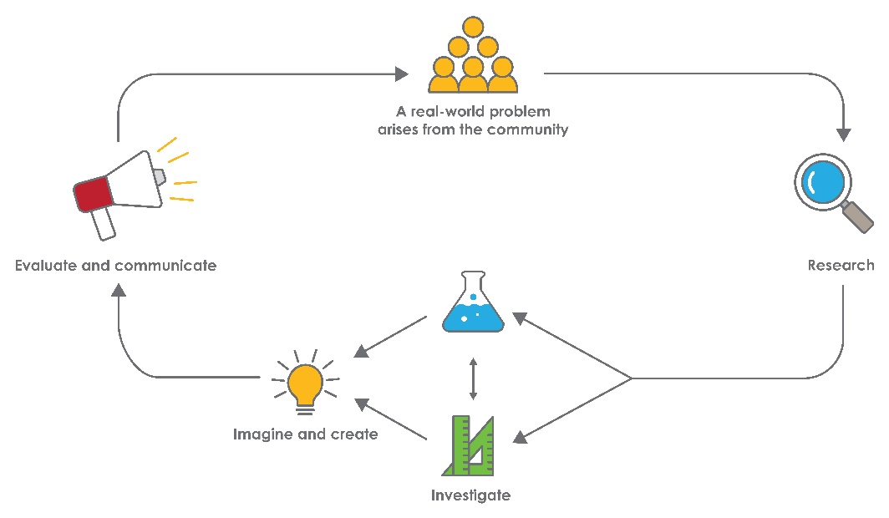
STEM capabilities are developed when students are challenged to solve open-ended, real-world problems that engage students in the processes of the STEM disciplines.

Year 4 – Mini robot garden
STEM Consortium

Overview
Home gardeners can grow an amazing amount of healthy and delicious foods in their own backyards. These backyard vegetable gardens provide a range of benefits such as:
Nutrition
At the supermarket, the freshness of vegetables is largely out of the buyer’s control. However, if people grow their own fruit and vegetables, they have access to food that is high in nutrients, especially in phytochemicals, antioxidants, vitamin C, vitamin A and folate.
Organic produce
By growing their own fruit and vegetables, people can control the fertiliser, water and pest control used.
Financial
It is possible to save money by growing your own food. The price of a packet of seeds can be similar to the cost of a single vegetable or fruit.
Exercise
Gardening is a great way to engage in physical activity.
Over two-thirds of Australia’s population live in major cities and a lack of time and space make it increasingly difficult to develop and maintain backyard vegetable gardens. With the increased use of automation and robotics in agriculture, there are opportunities to automate the care of vegetable gardens at home.
In this module, students explore the role of robotics and automation in developing a mini vegetable garden.
What is the context?
In cities, people are living in houses with smaller yards as well as spending more time away from home. This gives them less time and space to maintain a backyard vegetable garden.
What is the problem?
How can we use automation to sustain a garden?

How does this module support integration of the STEM disciplines?
Science
Students engage in the Biological sciences strand of the Science syllabus while researching and investigating the conditions required to initiate and sustain plant growth (ACSSU072: Living things have life cycles). They develop an understanding of how living things depend on each other and the environment to survive (ACSSU073: Living things depend on each other and the environment to survive), and they are guided to identify questions, make predictions, plan and conduct an investigation on the factors needed for plant growth. Guided where necessary, students analyse and interpret their data and evaluate and communicate their findings to an authentic audience (ACSIS065: With guidance, plan and conduct scientific investigations to find answers to questions, considering the safe use of appropriate materials and equipment).
Technology
Students investigate, design, produce, evaluate and collaborate when designing their mini robot garden (WATPPS26: Work independently, or collaboratively when required, to plan, create and communicate ideas and information for solutions; WATPPS23: Develop and communicate design ideas and decisions using annotated drawings and appropriate technical terms; WATPPS25: Use criteria to evaluate and justify simple design processes and solutions). They research technological practices used by fruit and vegetable gardeners (ACTDEK012: Types of technologies used in food and fibre production or processing, including how they are used to help meet consumer needs) and represent their data in a variety of ways (ACTDIK008: Different types of data can be represented in different ways). Students develop computational thinking when writing algorithms that use branching to design their product (WATPPS21: Define a sequence of steps to design a solution for a given task and ACTDIP011: Use simple visual programming environments that include a sequence of steps (algorithm) involving decisions made by the user (branching)) and there are opportunities for students to engage in coding using software and peripheral devices (ACTDIK007: Digital systems and peripheral devices are used for different purposes and can store and transmit different types of data).
The Design process guide is included as a resource to help teachers understand the complete design process as developed in the Technologies curriculum.

Mathematics
The activities provide students with the opportunity to develop mathematical skills focusing on chance and data; specifically recording, interpreting and analysing data. Students work in groups to consider how they will collect data and how to display the data using diagrams, tables or graphs and will be required to explain their choices (ACMSP097: Evaluate the effectiveness of different displays in illustrating data features including variability). Students construct suitable data displays, with and without the use of digital technologies, including tables and column graphs (ACMSP096: Construct suitable data displays, with and without the use of digital technologies, from given or collected data. Include tables, column graphs and picture graphs where one picture can represent many data values). Students need time and support to evaluate their data so they can be confident in the conclusions they draw.
Students design and build prototypes of their mini robot gardens and use scaled instruments to measure and compare lengths, masses, capacities and/or temperatures (ACMMG084: Use scaled instruments to measure and compare lengths, masses, capacities and temperatures). When designing their garden beds, students use informal means to compare the areas of regular and irregular shapes (ACMMG087: Compare the areas of regular and irregular shapes by informal means). When developing an input system for their mini robot gardens, students use simple scales, legends and directions to interpret the information contained in basic maps (ACMMG090: Use simple scales, legends and directions to interpret information contained in basic maps).
General capabilities
There are opportunities for the development of general capabilities and cross-curriculum priorities as students engage with Mini robot garden. In this module, students:
- Develop problem-solving skills as they research the problem and its context (Activity 1); investigate parameters impacting on the problem (Activity 2); imagine and develop solutions (Activity 3); and evaluate and communicate their solutions to an audience (Activity 4).
- Utilise creative thinking as they generate possible design solutions; and critical thinking, numeracy skills and ethical understanding as they choose between alternative approaches to solving the problem of creating an automated system to look after a garden.
- Utilise personal and social capability as they develop socially cohesive and effective working teams; collaborate in generating solutions; adopt group roles; and reflect on their group work capabilities through self and peer evaluation.
- Utilise a range of literacies and information and communication technologies (ICT) capabilities as they collate records of work completed throughout the module in a journal; represent and communicate their solutions to an audience using digital technologies in Activity 4.
- Communicate and, using evidence, justify their group’s design to an authentic audience.
What are the pedagogical principles of the STEM learning modules?
The STEM Learning Project modules develop STEM capabilities by challenging students to solve real-world problems set in authentic contexts. The problems engage students in the STEM disciplines and provide opportunities for developing higher order thinking and reasoning, and the general capabilities of creativity, critical thinking, communication and collaboration.
The design of the modules is based on four pedagogical principles:
- Problem-based learning
This is an underlying part of all modules with every module based around solving an initial problem. It is supported through a four-phase instructional model: research the problem and its context; investigate the parameters impacting on the problem; design and develop solutions to the problem; and evaluate and communicate solutions to an authentic audience.
- Developing higher order thinking
Opportunities are created for higher order thinking and reasoning through questioning and discourse that elicits students' thinking, prompts and scaffolds explanations, and requires students to justify their claims. Opportunities for making reasoning visible through discourse are highlighted in the modules with the icon shown here.
- Collaborative learning
This provides opportunities for students to develop teamwork and leadership skills, challenge each other’s ideas, and co-construct explanations and solutions. Information that can support teachers with aspects of collaborative learning is included in the resource sheets.
- Reflective practice
Recording observations, ideas and one’s reflections on the learning experiences in some form of journal fosters deeper engagement and metacognitive awareness of what is being learnt. Information that can support teachers with journaling is included in the resource sheets.
These pedagogical principles can be explored further in the STEM Learning Project online professional learning modules located in Connect.

Activity sequence and purpose
What is a robot?
Students analyse the role robotic automation plays in society and research the role of robots in modern farming practices.
Investigating robots and plant growth
Students engage with systems thinking to understand how robots function and investigate the things plants need to thrive and grow.
Designing an automated solution
Students to engage with design and computational thinking to create a mini robot garden, build a prototype and develop an algorithm for programming the robot to care for the garden.
Robotics today
Students host an exhibition event showcasing their designs for a mini robot garden to a wider audience, then reflect on and evaluate their work.

Background
Expected learning | Students will be able to:  - Identify the conditions required to optimise plant growth.  - Plan and conduct a scientific investigation, represent, analyse and interpret data, and evaluate the investigation.  - Organise and communicate the findings of their investigation in the form of a multimedia presentation.  - Explain what a robot is and how robotic automation can improve lives.  - Engage in systems thinking by identifying how the parts of a 3D printer work together to form a system made up of sensors, motors, control systems and digital programs.  - Develop and communicate design action plans and designs using annotated drawings.  - Use a simple grid reference system, scales, legends and directional language to describe locations in a garden.  - Work collaboratively to design and develop a mini robot garden.  - Use simple programming techniques to make a robot perform a set task.  - Evaluate the effectiveness of their design processes and solutions using an agreed set of criteria and personal reflection strategies.  - Develop and communicate design ideas to an authentic audience.
Vocabulary | This module uses subject-specific terminology, some of which is shown in the Glossary. The list contains terms that need to be understood either before the module commences or developed as they are used.
Timing | There is no prescribed duration for this module. The module is designed to be flexible enough for teachers to adapt. Activities do not equate to lessons; one activity may require more than one lesson to implement.  Teachers should plan for the plant growth investigation in Activity 2 as this will require about three to four weeks.
Consumable materials | A Materials list is provided for this module. The list outlines materials outside of normal classroom equipment that will be needed to complete the activities.
Safety notes | There are potential hazards inherent in these activities and with the equipment being used, and a plan to mitigate any risks will be required.  Potential hazards specific to this module include but are not limited to:  - Possible exposure to cyber bullying, privacy violations and uninvited solicitations when using the internet  - Construction tools.
Enterprise skills | The Mini robot garden module focuses on higher order skills with significant emphasis on expected learning from the general capabilities and consideration of what are enterprise skills.  Enterprise skills include problem-solving, communication skills, digital literacy, teamwork, financial literacy, creativity, critical thinking and presentation skills.  Further background on this is available from the Foundation for Young Australians in the article The New Basics: Big data reveals the skills young people need for the New Work Order (Foundation for Young Australians, 2016)  www.fya.org.au/wp-content/uploads/2016/04/The-New-Basics_Web_Final.pdf
Assessment | The STEM modules have been developed to provide students with learning experiences to solve authentic real-world problems using science, technology, engineering and mathematics capabilities. While working through the module, the following assessment opportunities will arise:  - Interview with a vegetable  - Concept map  - Growing plants investigation  - Blueprint  - Reflection  Appendix 1 indicates how the activities are linked to the Western Australian Curriculum.  Evidence of learning from journaling, presentations and anecdotal notes from this module can contribute towards the larger body of evidence gathered throughout a teaching period and can be used to make on-balance judgements about the quality of learning demonstrated by the students in the science, technologies and mathematics learning areas.  Students can further develop the general capabilities of Information and communication technology (ICT) capability, Critical and creative thinking and Personal and social capability. Continuums for these are included in the General capabilities continuums but are not intended to be for assessment purposes.
Additional learning experience | School garden  After engaging in this module, students could apply their knowledge to collaborate and create a large robot garden in an agreed area in the school or add a robot to an existing vegetable garden.  Endemic plant species could be planted, including native 'bush tucker' foods. A local Aboriginal Elder could be invited to speak about traditional ways of using the local plant species - this could be about food plants as well as other plant uses such as soap, dye or rope.

Activity 1: What is a robot?
Activity focus | Students analyse the role automation plays in society and research the role robots are playing in modern farming practices.
Background information | What is a robot?  Science fiction has created a perception that robots look like people and have a mind of their own. In practice, however, robots come in many shapes and sizes depending on its purpose.  A robot is a machine, controlled by a computer program that acts as a substitute for a person and/or manually operated device, doing things it has been programmed to do. Robots can be programmed to perform routine tasks.  Components  Most robots have three essential components: sensors, a control system that runs the program and actuators.  Sensors detect environmental stimuli and send this information to the control system. The program within the control system acts on the information from the sensor and responds by switching on the actuators (servos, motors).  A robot also needs a source of electrical energy in order to function and a physical structure to hold the robot’s components.  Servo motors  Servo motors are small, energy-efficient motors that are used to operate remote or radio-controlled toys and in industrial settings such as automated manufacturing. A servo is generally an assembly of four things: a DC motor (a motor that uses DC current to convert electrical energy into mechanical energy), a gearing set, a control circuit and a position-sensor (usually a potentiometer). The position of servo motors can be controlled more precisely than those of standard DC motors. For more information see: www.jameco.com/jameco/workshop/howitworks/how-servo-motors-work.html  Why use robots?  As robots are automated machines, they can perform mechanical and repetitive jobs faster, more accurately and often more safely than people. As such, robotic automation is providing industry with benefits such as more consistent and increased product quality, as well as greater productivity.  Despite the benefits of automation, robots are limited in their capacity to write their own programs. Therefore, the rise of robotic automation has also seen an increased demand for a workforce with the capacity to code and develop software.  Robots in society  Robots are used by a variety of industries including manufacturing, primary industries, transport, medicine, science and defence. Examples of where robots are used include:  - Farming - Vehicle assembly - Packaging - Electronics - Automated, guided vehicles - Artificial limbs - Pharmaceuticals - Surgery - Bomb disposal - Mining - Space exploration  Robots in farming  Agriculture and horticulture can be labour-intensive industries and robotic automation has the potential to increase productivity and impact the way primary producers operate.  The University of Sydney’s Australian Centre for Field Robotics has produced experimental agricultural robots or ‘agbots’ that can carry out important farming tasks such as land preparation, seed sowing, irrigation, fertilising and harvesting. Some of these are:  RIPPA™  RIPPA™ (Robot for Intelligent Perception and Precision Application), is a production prototype for the horticulture industry. It is light and strong which makes it ideal for work in places such as vegetable crops or fruit orchards. RIPPA has been used for real-time fruit detection and is able to move easily between rows of trees and on uneven surfaces. Mounted on top of the RIPPA is the VIIPA™ (Variable Injection Intelligent Precision Applicator). VIIPA™ is used for high-speed, spot spraying of weeds found within a crop.  SwagBot  SwagBot is designed for livestock work and monitoring. It is an omnidirectional electric ground vehicle that can manage sloping, uneven terrain and avoid farm obstacles such as mud and trees. A major benefit on sprawling outback stations, SwagBot can herd cattle and keep them out of dangerous areas. Work is ongoing with SwagBot to enable it to do things such as monitor the health of livestock using temperature and motion sensors.  Ladybird  Ladybird is an omnidirectional robot powered by batteries and solar energy and can easily move across paddocks. Ladybird uses several sensing systems such as thermal, infrared and hyperspectral to monitor and evaluate plant growth. A robotic arm provides the ability to remove weeds or harvest crops.  Digital FarmHand  Digital FarmHand is a low-cost crop robot prototype. It can analyse row crops and automate basic farming chores. Digital FarmHand can be adapted to perform various farm tasks by using a hitch mechanism that can attach tools such as a weeder or seeder.  Source: confluence.acfr.usyd.edu.au/display/AGPub/Our+robots
Instructional procedures | Refer to Teacher resource sheet 1.4: Think, Pair, Share for more information relating to this cooperative strategy students will use in the activity.  Students use a jigsaw cooperative strategy when researching agricultural robots, see Teacher resource sheet 1.2: Cooperative Learning – Jigsaw.  Students use their research to create an Adobe Spark (or similar) web page using Student activity sheet 1.7: Primary industry robots (Retrieval chart). Using this software tool provides students with the opportunity to develop ICT skills useful in environments beyond the classroom.
Expected learning | Students will be able to:  - Explain what a robot is and how robots can improve lives (Technologies).  - Organise and display findings of research (Science and Technologies).  - Create and communicate ideas and information safely, using agreed protocols (Technologies).
Equipment required | For the class:  Whiteboard or interactive whiteboard  Digital devices or laptops  Teacher resource sheet 1.6: Picture stimulus - Robots in society
For the students:
Student activity sheet 1.5: What is a robot?
Student activity sheet 1.7: Primary industry robots (Retrieval chart)
Preparation | Ensure students have access to resource sheets and appropriate links provided in Digital resources.
Activity parts | Part 1: What is a robot?  Facilitate a class discussion about robots using prompt questions such as:  - What do you think about when you hear the word robot?  - Are all robots the same?  - What do robots do?  - Are robots smart? Why/Why not?  Record the discussion on the whiteboard and address any misconceptions.  Develop students’ understanding of the components of a robot and the terms ‘DC motor’ and ‘servo motor’. See Background information.  Investigate the analogy of a robot being like a human in that they need:  - Motors for movement  - Sensors for detecting a stimulus  - Arms, claws or other apparatus for interacting with the environment  - A control centre for processing inputs (from sensors) and outputs.  Students use the think-pair-share strategy to share ideas, see Teacher resource sheet 1.4: Cooperative learning – Think, Pair, Share, and in their pairs complete Student activity sheet 1.5: What is a robot?.
Part 2: Robots in society
Show students Teacher resource sheet 1.6: Picture stimulus – Robots in society and the Medical Robots Are the Future of Surgery video (see Digital resources).
Focus the students on the idea of robots helping humans. Ask students:
- Where can you see robots being used in everyday life?
- What are the benefits of using robots?
- Can you see any negatives?
Write the answers on the whiteboard for reference. Draw students’ attention to the positives of using robots such as increased productivity, quality, safety and cost-saving.
Introduce the students to the concept of primary industry robots:
- Could robots be used to do work on farms, market gardens or orchards?
- What about in dairy and fishing industries or in timber production? What could these robots do?
Working in small groups, students use their devices to research primary industry robots like those being developed in Japan and at the University of Sydney (see Digital resources).
Using a jigsaw, see Teacher resource sheet 1.2: Cooperative Learning – Jigsaw, students work in small groups to research one primary industry robot and record information to share with their peers. A video and voiceover could be used as an engaging way to record this information. Question prompts could include:
- What is it called?
- What function does it serve?
- How does it work?
- How does it benefit the user?
- Describe the structure of the robot?
- What do you notice about the inputs, outputs and peripheral devices, data (in and out as well as transmission) and connectivity?
Students collate the information from all groups using Student activity sheet 1.7: Primary industry robots (Retrieval chart) which will be used to create a web page in Part 3.
Part 3: Adobe Spark page
Discuss the following structural features of robots and identify those a farmer may want:
- Inputs/outputs:
  - Weeds detected/a claw that pulls weeds out
  - Birds detected/an alarm sound
  - Soil moisture/reticulation turned on or off
- Peripheral devices:
  - sensors (light, moisture, movement, pH etc)
  - cameras
  - waterproof keypad
  - solar panels
  - data display screens.
- Data transmission:
  - USB portholes in onboard computers in farm machinery;
  - Wi-fi transfer of data to and from onboard computers, hand held devices and laptops
  - Real time data transmission (soil moisture, milk production, harvest weights etc).
Continuing to work in groups, students use inspiration from their prior research to create a web page about a robot and the potential benefits it can offer farmers. Students can use Adobe Spark or similar software to create their web page. Information could be entered as text, drawings, photo, video or voice recording.
This is a good opportunity to discuss digital citizenship rules and behaviours for participating in an online environment (see Digital resources).

Part 4: Class reflection
Review student learning about robots and the role they play in society using focus questions such as:
- What is a robot?
- What are the major components of a robot?
- How do robots make our lives easier?
- Why are robots being introduced into agriculture?
- Student answers can be recorded digitally using a mind map tool such as Popplet.
Resource sheets | Teacher resource sheet 1.2: Cooperative learning – Jigsaw  Teacher resource sheet 1.4: Cooperative learning – Think, Pair, Share  Student activity sheet 1.5: What is a robot?  Teacher resource sheet 1.6: Picture stimulus – Robots in society  Student activity sheet 1.7: Primary industry robots (Retrieval chart)
Digital resources | Medical Robots Are the Future of Surgery (Motorward, 2018)  youtu.be/vugOOuq256M
Our Robots (Australian Centre for Field Robotics, University of Sydney, 2017)
confluence.acfr.usyd.edu.au/display/AGPub/Our+Robots
Seeding the Future with Robots: Agriculture Goes High-Tech (JVT.en, 2017)
youtu.be/Wj6Sq7Icon4
Robotic Facts (Idaho Public Television, n.d)
idahoptv.org/sciencetrek/topics/robots/facts.cfm
The Main Parts of a Robot (Frank B. Chavez III, Sciencing, 2018)
sciencing.com/main-parts-robot-7403157.html
Digital Citizenship (Office of the eSafety Commissioner, n.d)
www.esafety.gov.au/education-resources/classroom-resources

Digital Citizenship (Common Sense Media, n.d)
www.commonsense.org/education/digital-citizenship
Keynote
itunes.apple.com/au/app/keynote/id361285480?mt=8
Haiku Deck
itunes.apple.com/au/app/haiku-deck/id536328724?mt=8
Adobe Spark
itunes.apple.com/us/app/adobe-spark-page/id968433730?mt=8

Activity 2: Investigating robots and plant growth
Activity focus | In this activity students engage with systems thinking to understand how robots work and investigate what plants need to thrive and grow.
Background information | Robots  The 3D printer provides a useful illustration of the components of robots and the range of movements they can make. The FarmBot agricultural robot is based on the same principles as the 3D printer.  3D printer  3D printing is a process where three-dimensional solid objects are made using a digital file. Conventional printing occurs in only two dimensions, whereas three-dimensional printing adds a third dimension.  Objects are created by adding material layer by layer. To do this, the printer’s computational algorithms convert information from a digital file into many horizontal layers.  3D printers heat a material, usually plastic filament, and extrude it to form each layer. The layers fuse together to build a three-dimensional object.  Parts of a 3D printer include:  - Print head  - Pulley/belts  - Extruder  - Motors  - Cooling fan  - Print bed  - Filament  - User interface  - Power supply.  Motion control  Cartesian printers move one or two motors along each of the X, Y, and Z axes. The name was derived from the Cartesian coordinates system. They have a rectangular build area and the printers have a cube-like shape.  Delta 3D printers have three arms that come together in the centre to suspend the extruder above the build area. These printers also use a Cartesian coordinates system to move around, but instead of moving one motor per axis at a time, all three arms move at different rates or times to precisely move the nozzle.  FarmBot  FarmBot is a robotic backyard gardening product designed to provide people with small backyards and limited amounts of spare time with a way to grow a backyard garden.  The FarmBot is designed to work inside the space of a raised garden bed or garden box. The motion control of the FarmBot is like that of a Cartesian 3D printer. The robot works in three dimensions and moves using tracks on the sides of the box. It can go left to right, forward and backwards, and up and down.  However, unlike a 3D printer which extrudes materials to build 3D objects, the FarmBot uses this motion control to sow seeds, water plants and remove weeds using different attachments for each job.  The FarmBot is based on open source development program, meaning that the software and hardware are not licensed and are customisable for different uses.  Rory Aronson – the founder of Farmbot – explained the types of customisations you can make, "If you want to use pesticides, you can do that. If you don't, you don't have to. If you want to water your plants in a certain way – maybe with mister nozzles, versus a shower nozzle, you can do that."  Plant growth  Green plants make their own food. They do this by absorbing light energy from sunlight and use it to combine water and carbon dioxide to make sugars in the process of photosynthesis (photo – light; synthesis – making). The sugars can then be converted into other carbohydrates, fats and proteins the plant needs to grow. To successfully grow crops such as herbs, vegetables, fruit or cereals there is a range of growing conditions that need to be met. These include:  Water  Plants access water from the soil through root systems but may also supplement water through dew and raindrops deposited on leaves and stems. To optimise growth the individual requirements of the plant needs to be considered and used to inform watering needs.  Air  Plants absorb carbon dioxide from the air for photosynthesis. Oxygen, which is a product of photosynthesis is released back into the air and in turn used by other living things.  Nutrients and soils  Plants use nutrients such as nitrogen, phosphorous and potassium to make all the carbohydrates, fats and proteins they need to make new plant cells and to grow. In traditional agriculture, plants absorb nutrients from the soil and fertilisers are used to replenish the supply of nutrients to the soil. In hydroponic agriculture, the plants grow in a medium such as gravel and nutrient rich water trickles through to the plants.  Light  Plants need energy from sunlight for photosynthesis. When plants are grown in rows, lower leaves may be shaded and receive less sunlight. Too little light can reduce the productivity of plants, leading to less growth as well as fewer flowers and fruit.
Instructional procedures | The plants investigation needs careful planning to ensure that all the required materials will be available. The investigation may need to run for a few weeks to gather enough results for analysis.  The investigation provides rich opportunities for developing the inquiry skills associated with planning, conducting, analysing and evaluating investigations; and the mathematical processes associated with measuring, tabulating, graphing and analysing data.  When discussing ‘fair’ in science, students are likely to understand ‘fair’ in the context of a ‘fair share’, usually meaning each getting an equal amount of something. Students will need support to translate their understandings to a science context. A ‘fair test’ is about being sure that the experiment will answer the question being asked by controlling variables.  Students at this age will require examples to develop the ability to identify a fair test. Many examples can be provided in the Activities. For example, students can be questioned about the expected outcome of tests in which plants are in different locations or provided with different amounts of water.  Provide students with a minimal level of scaffolding for the collection and presentation of data. If the need arises, support students with the construction of tables and graphs to help them develop these skills.  It is recommended that students work in small groups. Mixed ability groups encourage peer tutoring and collaboration in problem-solving. Collaboration is an important STEM capability.  There is an opportunity to develop digital capabilities associated with the software students will use when producing their presentation. Editing software, such as iMovie or Clips, enables students to film and edit footage. Links to online tutorials for Green Screen technology have been included in Digital resources.
Expected learning | Students will be able to:  - Identify the conditions required to optimise plant growth (Science).  - Identify a question for their investigation and make a prediction based on prior knowledge (Science).  - Plan and conduct a science investigation (Science).  - Represent their observations in tabular and graphical form and identify patterns in data (Science, Mathematics).  - Organise and communicate the findings of their investigation in the form of a multimedia presentation (Science, Technologies).
Equipment required | For the class:  Whiteboard or interactive whiteboard  Digital devices or laptops  Graph paper (as required)  Teacher resource sheet 2.3: Picture stimulus – Growing vegetables
For the students:
Student activity sheet 2.1: Parts of a 3D printer
Student activity sheet 2.2: Venn diagram
Student activity sheet 2.4: I think, I see, I wonder
Student activity sheet 2.5: Mind map
Student activity sheet 2.6: Plants investigation
Students activity sheet 2.7: Storyboarding
Preparation | Prepare stimuli pictures.  Ensure students have access to resource sheets or appropriate technology.
Activity parts | Part 1: Introduction  Review the features of robots and why they have a role to play in agriculture:  - What are the main parts of a robot? What does each part do?  - How could robots be useful in growing crops? Why?  - What movements would a robot need to make to look after plants? Why?  Use ‘why’ and ‘because’ to prompt deeper thinking and to elicit reasons for answers. Practice increased wait time to allow students to think and reflect on answers.
Part 2: How does a 3D printer work?
A 3D printer is a robot and is a good illustration of the movements required for an agricultural robot.
Focus students on the idea of 3D printers by asking:
- What is a 3D printer? What is their function?
- How do you think it works?
- How can they assist us in our everyday lives?
Show students a video clip about how a 3D printer works. See links in Digital resources.
Engage students in systems thinking by asking them to examine or deconstruct a 3D printer and complete Student activity sheet 2.1: Parts of a 3D printer.
Working in small groups, students analyse how the parts work together within an X, Y, Z three-dimensional space. These three dimensions of movement are required for agricultural robots.
Students use their arms to represent the push-pull function of the motors and replicate the movement of a 3D printer.
Part 3: FarmBot
Show students the Meet FarmBot video in Digital resources.
Discuss the form and function of the FarmBot. Identify the FarmBot’s parts, paying attention to how it can move in a 3D space. Students identify the similarities and differences between the 3D printer and the FarmBot using Student activity sheet 2.2: Venn diagram.
Part 4: Growing vegetables
Show students Teacher resource sheet 2.3: Picture stimulus – Growing vegetables and use Student activity sheet 2.4: I see, I think, I wonder to explore the questions and ideas they have as they view the images. Alternatively, students could visit the school vegetable garden.
I see, I think, I wonder is a thinking routine that develops visual literacy and encourages students to make careful observations and thoughtful interpretations, stimulating curiosity and inquiry.
Students develop a concept map detailing what they know about growing vegetables including the inputs and outputs of a vegetable garden. Software such as Popplet or Student activity sheet 2.5: Mind map might be useful.
Part 5: Investigation: What plants need to grow
In Activity 3, students design a robotic (automated) garden solution. To ensure the needs of the plants are met, students first investigate those needs.
Planning the investigation
The investigation plan can be developed through class discussion, with the plan documented on the interactive whiteboard.
Students can record their findings on Student activity sheet 2.6: Plants investigation.
There are several variables students can investigate in order to determine the optimal conditions for plant growth. These include light, water, air, nutrients (fertiliser) and soil. The class could decide that all groups will investigate the same variable, or each group might choose a different variable.
Support students to identify a question for an investigation that refers to the variable being changed (the independent variable) and the variable being observed (dependent variable). For example: Is soil (the independent variable) necessary for plant growth (the dependent variable)?
Students can then make a prediction about what they think may happen in the investigation. For example, they might predict that: The plants will not grow without soil because soil provides food and water for the plants. In this case the prediction is in two parts connected by the word ‘because’. The first part predicts the outcome (the plants will not grow without soil) and the second part suggests a reason (soil provides food and water for the plants). This is an example of reasoning. Initiate class discussion by asking:
- What are we trying to find out?
- What do plants need to grow?
- Where do plants obtain these things?
- Can we write this as a question? What things do we need to say in the question?
- What do you think will happen? Can you make a prediction?
- Why do you think that will happen?
Challenge students to design a fair test to determine the factors that optimise plant growth.
Prompt student thinking about the plan for their investigation by asking:
- How will we investigate our question?
- What will we change? What will we keep the same to make it a fair test?
- What will we observe?
- How will we record our observations?
- How many plants will we need?
- What will we grow them in?
- Where will we grow them?
Conducting the investigation
To allow differences in growth to emerge, the investigation should occur over an extended period. Plants such as mung beans that germinate and grow quickly, or young seedlings, are good options. Explain to students they will work in their groups to investigate the effect of their factor on plant growth. Remind them that in a fair test investigation they only change one variable.

Assist students to understand that to decide whether or not a particular aspect of plant growth (e.g. water, soil, fertilizer or sunlight) results in improved plant growth, it is best to have several plants, rather than just the one.
There is opportunity to discuss variation and expected variation. You could use the variation in student heights at different ages to make the point that one example can be misleading. Ask:
- Why aren’t all Year 4 students exactly the same height?
- What about all Year 4 born in a single month, why might they still vary in height?
- Would you expect to see a Year 4 student as tall as the teacher, or as short as a kindergarten student?
- What is the expected variation in height in our Year 4 class?
Draw out that most Year 4 students fit within an expected range of height, some are a little shorter and some taller, but most Year 4 students are taller than most Year 3 students. Tell them it would be the same with plants, some seeds might grow a little faster and a little more than others, even if all of the factors are the same, so just experimenting with one plant with, and one without the independent variable, could be misleading. Students should decide to set up several plants in each category.
Discuss with students what data they might collect as part of their experiment and how they will measure their plants’ growth.
Support students to develop a method to record their observations about the investigation, building on ideas developed in the previous class discussion. Ask students to consider the information they will record and how they will do this in a way that is best for all users to understand.
Conclusions from student findings about the effect of light, water or nutrients on plant growth may lead students to decide it is best for certain plants to receive an application of fertiliser. Observations of growth could be made two days per week so that six sets of measurements are collected over three weeks which would be enough for analysis.
Plant growth has several attributes. The length of stems can be measured and recorded, and the number of leaves counted to provide quantitative measures of growth.
Plant stems are difficult to measure with a ruler. It is easier to use string to measure the lengths and then place the string against a ruler to obtain a measure in formal units. Quantitative data should be recorded in a table as it is collected. The colour of leaves gives an indication of the health of the plants and colours can be documented as descriptions or as digital images.
Analysing the observations
Tables and graphs can be used to represent data and enable students to identify differences and trends. An interactive whiteboard could be used to engage students in co-designing data tables and graphs.
Students need to decide on the best measure of plant growth. For example, if there are equal numbers of plants in the experimental and control groups, the lengths of individual plants could be summed to give total length. Similarly, the total number of leaves could be calculated.
The tabulated data can be used to compare the growth of plants in experimental and control groups to determine if their predictions about the needs of plants were supported by their observations.
The students’ data could then be re-represented as a graph so that the pattern of growth of the plants over time can be identified and described. Graphing could be a shared construction by the class or be completed by students.
At this age, students are exploring ways of presenting data and showing the results of investigations using many-to-one correspondence.
Students will have had experience with bar or column graphs. This context provides an opportunity for introducing two different types of graphs that would fit the data; side by side column graphs where data from the experimental and the control plants are compared in columns next to each other, and, line graphs where the base line is set up as a continuous number time line covering the length of the experiment. Students can be assisted to see why it makes sense to join the heights of a plant measured at different times to approximate what the height might have been at different times between the measurements.
Discuss with students which kinds of data are best shown in side by side column graphs (e.g. discrete date as in the number of leaves) and which kinds of data can be represented as line graphs (continuous data collected over time as in the overall height of the plants).
Spreadsheet and graphing programs can be used to collate data and construct graphs digitally, as a class demonstration or by students if they are experienced in their use.
The results of the student investigations will help inform the most important factors their automated solution would need to address. Using a 5-why strategy (asking why after each response for a total of 5 responses) will encourage students to think more critically about the growth of the plants. The following question prompts could be used as a stimulus for the 5-why strategy:
- Why do you think these plants had the most growth?
- Are there factors these plants have in common that contributed to their growth?
- What about the plants that experienced the least growth?
- How could identifying the commonalities help us in drawing conclusions about plant growth?
Encourage class discussion of the results by asking:
- Which factor/s caused the changes you observed?
- Which plants made the least/most growth? What does that tell you about plant requirements?
- Which of our predictions was supported by our observations? How do you know? … because…
- How can we answer our investigation question?
- What would you write as the answer to your question?
- Do you have enough data to form a conclusion? What is your conclusion?
Evaluating the investigation
This is a complex investigation that provides many opportunities for developing science inquiry skills and mathematical processes of representing and analysing numerical data.
A thorough debriefing of the investigation can help to clarify and extend students’ thinking. Prompt questions could include:
- Did your investigation go to plan? What worked well? Why? How could you have improved your plan?
- How effective was the design for your table? Why? …because…
- Was it difficult to draw your graph? Why?
- What made some graphs better for showing your data than others?
- What differences did you find between tables and graphs for showing your data?
- What did you find from your investigation? What was your conclusion? How do you know this to be true?
- What is the main thing you learnt from this activity?
Additional learning experience – Multimedia presentation
To communicate the findings of the experiment to a wider audience, students produce a multimedia presentation for a DIY gardening show called Interview with a vegetable.
Using the information from the science investigation and mind maps, students plan a multimedia presentation that includes the conditions for sustained plant growth – light, soil, water, air, nutrients.
Students work in small groups to storyboard their multimedia presentation using Students activity sheet 2.7: Storyboarding. Together they allocate roles, sketch out the dialogue and structure of the presentation including visuals, backgrounds (green screen), music and dialogue.
Students create their multimedia presentation using digital software such as Clips or iMovie and use Chatterpix Kids to animate vegetables communicating their needs.
Part 6: Class reflection
Use the following focus questions to review student learning about what is required to maintain plant growth:
- What do plants require to grow well? How do you know this?
- How can we use this new information to help us develop an automated garden solution?
Students add new learning from their investigation of robots, their science investigation and multimedia presentations to their mind maps from Activity 1.
Resource sheets | Student activity sheet 2.1: Parts a 3D printer  Student activity sheet 2.2: Venn diagram  Teacher resource sheet 2.3: Picture stimulus – Growing vegetables  Student activity sheet 2.4: I think, I see, I wonder  Student activity sheet 2.5: Mind map  Student activity sheet 2.6: Plants investigation  Student activity sheet 2.7: Storyboarding
Digital resources | CNN Explains 3D Printing (CNN, 2013)  youtu.be/e0rYO5YI7kA
Meet FarmBot (Farmbot, 2016)
youtu.be/uNkADHZStDE
What is 3D Printing and how does it work? – Mashable (Mashable, 2014)
youtu.be/Vx0Z6LplaMU
How does 3D printing work?|RMIT University (RMIT, 2013)
youtu.be/oiIby1GbXFQ
Explaining to a kid, How does 3D orienting work? (3drucken.ch, 2015)
youtu.be/-ydWVzjGOt8
The anatomy of a 3D printer / How a 3D printer’s movement works (MatterHackers, 2017)
youtu.be/kNLTGE61LOM
Anatomy of a 3D Printer (MatterHackers)
www.matterhackers.com/articles/anatomy-of-a-3d-printer
How to Start a Vegetable Garden (Bunnings)
www.bunnings.com.au/diy-advice/garden/planting-and-growing/how-to-start-a-vegetable-garden
Clips
itunes.apple.com/au/app/clips/id1212699939?v0=www-au-clips-app
iMovie
itunes.apple.com/us/app/imovie/id377298193?mt=8
Chatterpix Kids
itunes.apple.com/au/app/chatterpix-kids/id734046126?mt=8
Chatterpix – Tutorial (Duck Duck Moose, 2013)
youtu.be/7tBS9NyFV08
Green Screen by Do Ink
itunes.apple.com/au/app/green-screen-by-do-ink/id730091131?mt=8
Green Screen by Do Ink – Video Tutorial (Do Ink, 2016)
youtu.be/l4YVqbaWoDU
Popplet
itunes.apple.com/au/app/popplet/id374151636?mt=8
Popplet tutorial (Adam Bellow, 2011)
youtu.be/CxLDsWHsQ1g
Storyboarding (Khan Aacademy, 2018)
www.khanacademy.org/partner-content/pixar/storytelling/film-grammar/v/storyboarding-scene
Storyboard creator (Storyboardthat, 2018)
www.storyboardthat.com/storyboard-creator
How to storyboard a scene with Smurfs director Kelly Asbury - TIFF Kids 2017 (TIFF Originals, 2017)
youtu.be/wJXKRFgbnHA

Activity 3: Finding a robotic solution
Activity focus | This activity requires students to engage with design and computational thinking to design a garden, design and build a prototype robot and develop an algorithm for programming the robot to care for the garden.
Background information | To create a mini robot garden, students will need to engage with the design process.  The Design process guide is included as a resource to help teachers understand the complete design process as developed in the Western Australian Technologies curriculum.  Design thinking  This activity requires students to develop and follow a design brief, draw and annotate plans and construct a working prototype of the garden and robot that satisfies the design brief. The design brief should be jointly created by the students with teacher support and be made available to students to guide the design process.  Access to a 3D printer should be considered for final designs.  Coding and computational thinking  Students need to develop a way of programming their mini robot prototype. This can be done by using unplugged coding techniques which may require immersing the students in coding and computational thinking activities (see Digital resources).  Programs such as Raspberry Pi or Hummingbird Robotics Kits are examples of tools that students may choose to use to create a working robot. Video tutorials or online instructions would be helpful to students who are unfamiliar with the technology. See links in Digital resources.
Instructional procedures | Creating the design brief  The teacher should act as a facilitator during this activity and encourage students to collaboratively develop the design brief. This will give students ownership of the creative process and an opportunity to fully engage with the design process.  If students are using the school’s existing robot resources, they may need to use simulations to represent what a robot might do in particular circumstances. For example, if students want to design an obstacle-avoiding, weed killing robot which sprays a solution onto weeds, they could program a robot (eg Sphero) to be obstacle-avoiding and light up or spin around to simulate spraying a solution when it detects a ‘weed’.  Students could produce an accompanying diagram of their robot to explain how it works.
Expected learning | Students will be able to:  - Develop and communicate design action plans and designs using annotated drawings (Technologies).  - Use a simple grid reference system, scales, legends and directional language to describe locations in a garden (Mathematics).  - Work collaboratively to design and construct a mini robot garden (Technologies).  - Use simple programming (unplugged coding) techniques to program a robot (Technologies).
Equipment required | For the class:  Devices or digital cameras
For the students:
See Materials list
Student activity sheet 1.5: What is a robot?
Student activity sheet 3.1: Prototype troubleshooting
Student activity sheet 3.2: Design review
Preparation | Students will be participating in this task in groups. It may be necessary to consider group dynamics for this task.  Ensure students have access to resource sheets.  Gather a range of resources that students may use to create a classroom version of their robot. This might include:  - Robots from within the school  - Devices with apps such as Scratch or Hopscotch  - 3D printer  - Lego  - Woodwork or metalwork materials  - Construction materials – see Materials list  If students are building a working robot, the working parts will need to be sourced (eg servo, motor etc).
Activity parts | Part 1: Garden design  Explain to students that they are going to use the knowledge they have gained about automated systems and plant growth to design a garden with an automated maintenance solution.  The first task is to design a garden that could have an automated system installed. As a class, discuss the objectives of the task:  - What will the dimensions of your garden be?  - What could it be made from?  - What types of plants will you include?  Organise the students into groups and ask them to discuss their design ideas. Provide them with Student activity sheet 1.5: What is a robot? from Activity 1 to support them in the design process. As the students complete this activity, encourage them to explain and justify their choices.  After the groups have made decisions about their garden design, they create a plan and visual representation. Choices could include:  - A plan on grid paper  - A large-scale floor plan  - Microsoft PowerPoint or Paint design  - 3D design on TinkerCad or SketchUp  - Box construction.
Part 2: Integrating technology
Gather the class in their groups with their completed garden designs and inform them that the next task is to incorporate automation. Ask the students to discuss in their groups what role a robot (automated system) could play in maintaining their garden. Have students record their ideas in their learning journals. Encourage the groups to share their ideas with the class.
Possible robotic (automated) options could include:
- Watering system
- System to provide maximum sunlight throughout the day
- Soil moisture measuring robot
- Weed removing robot
- Seed planting robot.
Ask the groups to discuss the function they would like the robot (automated system) to perform. When they have made a collective decision, ask each group member to draw and annotate a diagram of their idea. The diagram should include the materials the parts will be made from and the specific functions the parts will perform. Next, have students share their designs with their group. Ask the students to discuss the best aspects of each other’s design. Continue this process and have the groups finalise a design incorporating the strong features of each group member’s design.
Explain to the groups that they have two tasks to complete:
- Create a final design of the robot (automated system) they intend to prototype
- Brainstorm a way they could create or build their robot in the classroom.
These tasks may be undertaken simultaneously or consecutively. To facilitate the second task, provide the students with a range of resources to spark ideas.
Part 3: Build and code prototype
In their groups, students create a representation of their garden and robot (automated system). Possible options for students to do this include:
- Creating a large-scale gridded floor plan of the garden and programming a robot to simulate the required maintenance
- Use Scratch/Scratch Jr. (with a grid overlay function) or a similar coding tool to simulate their garden and program a sprite to simulate their robot or automated system carrying out its functions
- Draw their garden on grid paper and modify an existing robot to carry out or simulate maintenance functions.
Students will need assistance to create a grid map.
Use this opportunity to teach students the difference between a grid reference system and a coordinate system.
In a grid reference system, the spaces between the grid lines are labelled alpha-numerically in order to identify cells in the grid. In contrast a coordinate system can identify individual points between the axes. This is because the axes are number lines meeting at zero.
Grid lines can be labelled at intervals using whole numbers, however, the use of fractions or decimals enables any point in those intervals to be identified. In this way, any point on one axis can be coordinated with any point on the second axis to locate individual points within the system. This represents the positive quadrant in the Cartesian Plane, the way longitude and latitude are measured, and the axes in line graphs or histograms.
These are important early learning experiences that will assist students to later understand the Cartesian Plane coordinates when introduced in Year 7 as well as many concepts students will encounter in Geography.
Part 4: Test and modify
Working in groups, students share their mini robot garden with the class and reflect on and evaluate the effectiveness of their design. They record their reflections in Student activity sheet 3.1: Prototype troubleshooting.
Prompt students with questioning:
- What worked?
- What didn’t work – why? How would you fix this?
- What would you do again? What would you not repeat? Why?
Students modify their designs to address any issues arising from the group reflections.
Part 5: Class reflection
Discuss the design process and how well the designs satisfied the design brief:
Our design brief required…
Prompt reflection with questions such as:
- What will people learn from your design?
- Has your solution been successful in addressing your design brief? Why or why not?
Students add new learning to their concept maps and reflections in their learning journals.
Resource sheets | Student activity sheet 1.5: What is a robot?  Student activity sheet 3.1: Prototype troubleshooting  Student activity sheet 3.2: Design review  Design process guide  Drawing in the design process
Digital resources | How to explain algorithms to kids (Tynker, 2018)  www.tynker.com/blog/articles/ideas-and-tips/how-to-explain-algorithms-to-kids
How to use Hummingbird Robot Kits in Schools (Travis Lape, 2015)
youtu.be/37IKi9qchJI
Animatronics (littleBits, 2018)
littlebits.com/challenges/animatronics
CS Unplugged
csunplugged.org/en/
CS Fundamentals Unplugged
code.org/curriculum/unplugged
Unplugged Activity: Computational Thinking (ABC Education, 2014)
education.abc.net.au/home#!/media/1618109/
Garden Robot: Code + Robots (Made with Code, n.d)
www.madewithcode.com/projects/robots
This robot keeps pests away and plants watered (Captain Gizmo, 2017)
youtu.be/6KVoHxOPc50
Wi-Fi Plant Watering System (with Particle Photon) (River’s Educational System, 2017)
youtu.be/_ysQVpQog3I
Make a Drip Irrigation System - Tinker Crate (KiwiCo, 2017)
youtu.be/aUUcq-DGKPQ
Arduino using a moisture system to water a pot plant (Southern Bolt, 2016)
youtu.be/pCxeZkLhqSE
Self-watering system for plants using waste plastic bottle (ujjwal mitra, 2017)
youtu.be/OJJvghf1E7A
The all-in-one plant spacing chart and planting guide (Garden In Minutes, 2015)
gardeninminutes.com/plant-spacing-chart-raised-bed-gardening

Activity 4: Robotics today
Activity focus | Students host an event that showcases their designs for an automated garden to a wider audience.
Instructional procedures | This activity provides an opportunity for cross-curriculum assessment of literacy, listening and speaking. It also provides a rich opportunity for assessing the students’ understanding of the science, mathematics and technology principles and processes.  Students will need support to prepare for the event. Some considerations include:  Venue  - Where will the event be held? Is there enough space?  - Will tables be required? How will they be arranged?  Invitations  - Who will be invited to attend?  - Which experts will you invite?  - How will you raise awareness of the event?  Example promotional materials have been included to give students some ideas. Refer to Teacher resource sheet 4.1: Example flyer.  Digital infrastructure  - Is there access to wi-fi and power supply?  - Is technology available and charged?  Presentation skills  Students will need support and scaffolding to prepare for their presentation. To scaffold cooperative group work, each member of the group could have a role and responsibility. For example, one could be the content director, one the media director and a third the presentation director. See Teacher resource sheet 1.1: Cooperative learning – Roles.  Students may need information about effective presentation skills such as voice clarity, projection, volume, pitch and tone.  Time should be taken to discuss how to give constructive feedback and how to receive feedback positively.  Following the event, students should be given time to make improvements to their work based on feedback. This will enable the completion of the design process. Improvements could be made in their groups or as a private reflection in learning journals.
Expected learning | Students will be able to:  - Work collaboratively to develop a presentation on their mini robot garden (Technologies).  - Evaluate the effectiveness of the design processes used and solutions, using an agreed set of criteria and personal reflection strategies (Technologies).  - Develop and communicate design ideas to an authentic audience (Technologies).
Equipment required | For the class:  Media for presentations
For the students:
Robot and garden prototypes
Digital photos
Preparation | Ensure appropriate technology is available and students have the required skills.  Information on developing presentation skills and teacher resources for scaffolding student learning can be sourced from the TED-Ed talks in the Digital resources section.  Students need to set up their event space and ensure they have the materials required to deliver their presentation.
Activity parts | Part 1: Preparing a presentation  Students work in their groups to develop a presentation to inform the audience about their mini robot garden.  Students decide on the content of their presentation:  - Why is there a need for an automated garden?  - What were we trying to achieve in our design?  - What decisions did we make as we developed our design?  - What types of movement will the robot make?  - How will the robot keep the plants alive? Discuss your system in detail.  - How did CAD help us develop our ideas?  - How did our mathematics knowledge help us develop our ideas?  Students decide on the way in which they will present their information to an audience. Options include:  - Using models  - Keynote, Microsoft PowerPoint presentations  - eBook, Comic Book  - Blog.
Part 2: Preparing for the event
Set up
Students identify where they want to hold the event and how they plan to set up their space.
Promotion
Students will need to develop promotional material in order to raise awareness of the event and promote participation from the wider school and local community. It should include:
- Event details (where, when, who, what etc.)
- Engaging typography and graphics.
Promotional material could be distributed around the school, in newsletters and on the school website. An example is provided Teacher resource sheet 4.1: Example flyer.
Encourage students to be creative. Promotional materials can be designed using graphic design software such as Canva, Microsoft Word or Pages.
Part 3: Event
Students make their presentations to the audience.
Following the presentations, participants are encouraged to walk through the event space and engage the students with questions about their mini robot gardens.
Example question prompts for participants can be found in Teacher resource sheet 4.2: Question prompts.
Part 4: Feedback
Set up a feedback book for the participants where they can write reflections and insights about their experience. See Teacher resource sheet 4.3: Peer and parent feedback. Alternatively, digital versions could be created using a tool such as Survey Monkey, Kahoot, Survey Gizmo or Microsoft Forms.
The teacher may use this opportunity to complete Teacher resource sheet 4.4: Student evaluation.
Part 5: Self-reflection and evaluation
Using the Six Thinking Hat structures, students individually reflect on their experience in their learning journals. Refer to Student activity sheet 4.5: Self-evaluation. These will include the following types of reflection:
- Yellow: Positive
- Black: Negative
- Red: Feelings
- Green: Recommendations for next time.
Students complete Student activity sheet 1.0: Journal checklist.
Additional learning experience | Students could apply their knowledge and collaborate to install an automated system into an existing school garden.
Resource sheets | Student activity sheet 1.0: Journal checklist  Teacher resource sheet 1.1: Cooperative learning – Roles  Teacher resource sheet 4.1: Example flyer  Teacher resource sheet 4.2: Question prompts  Teacher resource sheet 4.3: Peer and parent feedback.  Teacher resource sheet 4.4: Student evaluation  Teacher resource sheet 4.5: Self-evaluation
Digital resources | TED-Ed talks  phys.org/news/2014-01-kids-pitch-world-changing-ideas.html

Appendix 1A: Links to the Western Australian Curriculum
The Mini robot garden module provides opportunities for developing students’ knowledge and understandings in science, technologies and mathematics. The table below shows how this module aligns to the content of the Western Australian Curriculum and can be used by teachers for planning and monitoring.
MINI ROBOT GARDEN  Links to the Western Australian Curriculum | ACTIVITY
 | 1 | 2 | 3 | 4
SCIENCE
SCIENCE UNDERSTANDING
Biological sciences: Living things have life cycles (ACSSU072) | ●
Biological sciences: Living things depend on each other and the environment to survive (ACSSU073) |  | ●
SCIENCE INQUIRY SKILLS
Planning and conducting: With guidance, plan and conduct scientific investigations to find answers to questions, considering the safe use of appropriate materials and equipment (ACSIS065) |  | ●
DESIGN AND TECHNOLOGIES
KNOWLEDGE AND UNDERSTANDING
Food and fibre production: Types of technologies used in food and fibre production or processing, including how they are used to help meet consumer needs (ACTDEK012) | ● | ●
DIGITAL TECHNOLOGIES
KNOWLEDGE AND UNDERSTANDING
Digital systems: Digital systems and peripheral devices are used for different purposes and can store and transmit different types of data (ACTDIK007) | ● | ● | ●
Representation of data: Different types of data can be represented in different ways (ACTDIK008) |  | ● | ●
MINI ROBOT GARDEN  Links to the Western Australian Curriculum | ACTIVITY
 | 1 | 2 | 3 | 4
DIGITAL TECHNOLOGIES
PROCESSES AND PRODUCTION SKILLS
Digital implementation: Use simple visual programming environments that include a sequence of steps (algorithm) involving decisions made by the user (branching) (ACTDIP011) |  |  | ●
Investigating and defining: Define a sequence of steps to design a solution for a given task (WATPPS21) |  |  | ●
Designing: Develop and communicate design ideas and decisions using annotated drawings and appropriate technical terms (WATPPS23) |  |  | ● | ●
Collaborating and managing: Work independently, or collaboratively when required, to plan, create and communicate ideas and information for solutions (WATPPS26) |  |  | ● | ●
Evaluating: Use criteria to evaluate and justify simple design processes and solutions (WATPPS25) |  |  |  | ●
MINI ROBOT GARDEN  Links to the Western Australian Curriculum | ACTIVITY
 | 1 | 2 | 3 | 4
MATHEMATICS
MEASUREMENT AND GEOMETRY
Using units of measurement: Use scaled instruments to measure and compare lengths, masses, capacities and temperatures (ACMMG084) |  | ●
Shape: Compare the areas of regular and irregular shapes by informal means (ACMMG087) |  |  | ●
Location and transformation: Use simple scales, legends and directions to interpret information contained in basic maps (ACMMG090) |  |  | ●
STATISTICS AND PROBABILITY
Data representation and interpretation: Construct suitable data displays, with and without the use of digital technologies, from given or collected data. Include tables, column graphs and picture graphs where one picture can represent many data values (ACMSP096) |  | ●
Data representation and interpretation: Evaluate the effectiveness of different displays in illustrating data features including variability (ACMSP097) |  | ●
Further information about assessment and reporting in the Western Australian Curriculum can be found at: k10outline.scsa.wa.edu.au/home.

Appendix 1B: Mathematics proficiency strands
Key ideas
In Mathematics, the key ideas are the proficiency strands of understanding, fluency, problem-solving and reasoning. The proficiency strands describe the actions in which students can engage when learning and using the content. While not all proficiency strands apply to every content description, they indicate the breadth of mathematical actions that teachers can emphasise.
Understanding
Students build a robust knowledge of adaptable and transferable mathematical concepts. They make connections between related concepts and progressively apply the familiar to develop new ideas. They develop an understanding of the relationship between the ‘why’ and the ‘how’ of mathematics. Students build understanding when they connect related ideas, when they represent concepts in different ways, when they identify commonalities and differences between aspects of content, when they describe their thinking mathematically and when they interpret mathematical information.
Fluency
Students develop skills in choosing appropriate procedures; carrying out procedures flexibly, accurately, efficiently and appropriately; and recalling factual knowledge and concepts readily. Students are fluent when they calculate answers efficiently, when they recognise robust ways of answering questions, when they choose appropriate methods and approximations, when they recall definitions and regularly use facts, and when they can manipulate expressions and equations to find solutions.
Problem-solving
Students develop the ability to make choices, interpret, formulate, model and investigate problem situations, and communicate solutions effectively. Students formulate and solve problems when they use mathematics to represent unfamiliar or meaningful situations, when they design investigations and plan their approaches, when they apply their existing strategies to seek solutions, and when they verify that their answers are reasonable.
Reasoning
Students develop an increasingly sophisticated capacity for logical thought and actions, such as analysing, proving, evaluating, explaining, inferring, justifying and generalising. Students are reasoning mathematically when they explain their thinking, when they deduce and justify strategies used and conclusions reached, when they adapt the known to the unknown, when they transfer learning from one context to another, when they prove that something is true or false, and when they compare and contrast related ideas and explain their choices.

Source: ACARA - www.australiancurriculum.edu.au/f-10-curriculum/mathematics/key-ideas/?searchTerm=key+ideas#dimension-content

Appendix 2: General capabilities continuums
The general capabilities continuums shown here are designed to enable teachers to understand the progression students should make with reference to each of the elements. There is no intention for them to be used for assessment.
Information and communication technology (ICT) capability learning continuum
Sub-element | Typically by the end of Year 2 | Typically by the end of Year 4 | Typically by the end of Year 6
Create with ICT  Generate ideas, plans and processes | use ICT to prepare simple plans to find solutions or answers to questions | use ICT to generate ideas and plan solutions | use ICT effectively to record ideas, represent thinking and plan solutions
Create with ICT  Generate solutions to challenges and learning area tasks | experiment with ICT as a creative tool to generate simple solutions, modifications or data representations for particular audiences or purposes | create and modify simple digital solutions, creative outputs or data representation/ transformation for particular purposes | independently or collaboratively create and modify digital solutions, creative outputs or data representation/  transformation for particular audiences and purposes
Communicating with ICT  Collaborate, share and exchange | use purposefully selected ICT tools safely to share and exchange information with appropriate local audiences | use appropriate ICT tools safely to share and exchange information with appropriate known audiences | select and use appropriate ICT tools safely to share and exchange information and to safely collaborate with others

Critical and creative thinking learning continuum
Sub-element | Typically by the end of Year 2 | Typically by the end of Year 4 | Typically by the end of Year 6
Inquiring – identifying, exploring and organising information and ideas  Organise and process information | organise information based on similar or relevant ideas from several sources | collect, compare and categorise facts and opinions found in a widening range of sources | analyse, condense and combine relevant information from multiple sources
Generating ideas, possibilities and actions  Imagine possibilities and connect ideas | build on what they know to create ideas and possibilities in ways that are new to them | expand on known ideas to create new and imaginative combinations | combine ideas in a variety of ways and from a range of sources to create new possibilities
Generating ideas, possibilities and actions  Seek solutions and put ideas into action | investigate options and predict possible outcomes when putting ideas into action | experiment with a range of options when seeking solutions and putting ideas into action | assess and test options to identify the most effective solution and to put ideas into action
Reflecting on thinking and processes  Transfer knowledge into new contexts | use information from a previous experience to inform a new idea | transfer and apply information in one setting to enrich another | apply knowledge gained from one context to another unrelated context and identify new meaning

Personal and social capability learning continuum
Sub-element | Typically by the end of Year 2 | Typically by the end of Year 4 | Typically by the end of Year 6
Social management  Work collaboratively | identify cooperative behaviours in a range of group activities | describe characteristics of cooperative behaviour and identify evidence of these in group activities | contribute to groups and teams, suggesting improvements in methods used for group investigations and projects
Social management  Negotiate and resolve conflict | practise solving simple interpersonal problems, recognising there are many ways to solve conflict | identify a range of conflict resolution strategies to negotiate positive outcomes to problems | identify causes and effects of conflict, and practise different strategies to diffuse or resolve conflict situations
Social management  Develop leadership skills | discuss ways in which they can take responsibility for their own actions | discuss the concept of leadership and identify situations where it is appropriate to adopt this role | initiate or help to organise group activities that address a common need
Further information about general capabilities is available at:
k10outline.scsa.wa.edu.au/home/p-10-curriculum/general-capabilities-over/general-capabilities-overview/general-capabilities-in-the-australian-curriculum

Appendix 3: Glossary
Subject-specific vocabulary
Robot | A programmable machine capable of carrying out a complex series of actions autonomously.
Automation | The use or introduction of automatic equipment in a manufacturing or other process or facility.
Garden | A piece of ground adjoining a house in which grass, flowers, and shrubs may be grown.
Gantry | A bridge-like overhead structure with a platform supporting equipment such as a crane, signals or cameras.
Servo | A variable control motor which drives a moving part of a mechanism.
Sensor | A device which detects or measures a physical property and records, indicates or otherwise responds to it.
Nutrient | A substance that provides nourishment essential for the maintenance of life and for growth.
Solar | Relating to or denoting energy derived from the sun.
Motor | A machine that supplies the driving force for a device with moving parts.
Program | A series of coded software instructions to control the operation of a computer or other machine.
3D printer | A machine allowing the creation of a physical object from a three-dimensional digital model, typically by laying down many thin layers of a material in succession.

Appendix 4: Materials list
The following materials are required to complete this module.
Construction materials
Cardboard | Tape | Scissors
Rulers / Measuring tape | Paint | Glue
Butcher paper | Fishing line | Modelling clay
Cereal boxes | Toothpicks | Pipe-cleaners
Straws | String | Elastic bands
Construction paper | Wooden craft sticks | Cellophane
Balsa wood | Utility knife | Hot glue gun
Software
Popplet | Do Ink – Green Screen | Adobe Spark
iMovie | Garage Band | Chatterpix Kids
SketchUp | Tinkercad | Minecraft
Technology
Little Bits | Arduino Hummingbird | Makey Makey
Green Screen | Micro:bit | 3D Printer
Tablets/Computers | Digital camera | Interactive whiteboard
Items to make a simple motor
Battery | Insulated wire | Paper clips
Small magnet | Servo

Appendix 5: Design process guide
Safe production of the final design or multiple copies of the final design.
Fine tuning the production process, such as division of labour for batch or mass production.
Use of intended materials and appropriate tools to safely make the solution to the design problem.
Reflection on the process taken and the success of the design.
Evaluation can lead to further development or improvement of the design and can be a final stage of the design process before a conclusion is reached.
Could be formal or informal and verbal or written.
Ideation
Development
Development of the design ideas. Improvements, refinements, adding detail, making it better.
Activities such as detailed drawings, modelling, prototyping, market research, gaining feedback from intended user, further research – if needed – to solve an issue with the design, testing different tools or equipment, trialling production processes, measuring or working out dimensions, testing of prototypes and further refinement.
Idea generation – turning ideas into tangible forms so they can be organised, ordered and communicated to others.
Activities such as brainstorming, mind mapping, sketching, drawing diagrams and plans, collecting colour samples and/or material samples and talking through these ideas can help to generate fu creative ideas.
Using the SCAMPER model can assist with this: www.mindtools.com/pages/article/newCT_02.htm
www.designorate.com/a-guide-to-the-scamper-technique-for- creative-thinking
Analysis
Finding useful and helpful information about the design problem.
Gathering information, conducting surveys, finding examples of existing solutions, testing properties of materials, practical testing.
Understanding the meaning of the research findings.
Analysing what the information means, summarising the surveys, judging the value of existing solutions, understanding test results.
Research
Production
Evaluation

Appendix 5B: Drawing in the design process
Incorporating the design process into the STEM modules will often result in the need for students to draw plans of their designs. This can be done at a simple level using hand-drawn sketches or at a more technical level using computer-aided design (CAD).
istockphoto.com
By developing skills using industry-standard software, students may be well-placed to explore future career pathways.
There are several CAD software options; two free examples are detailed below. Autodesk is a third package that is also free for educational use.
Tinkercad
- Format: Web-based app requiring internet access via a browser
- Purpose: A simple, online 3D design and 3D printing app
- Home: www.tinkercad.com
- Blog: blog.tinkercad.com
- Tutorials: www.tinkercad.com/learn
- Feature: Connects to 3D printing and laser cutting.
SketchUp
- Format: Can be downloaded and installed on devices, or used in a browser
- Purpose: Enables students to draw in 3D
- Home: www.sketchup.com 'Products' 'SketchUp'
- Help centre: help.sketchup.com/en
- Blog: blog.sketchup.com
- Tutorials: www.youtube.com/user/SketchUpVideo. From beginner tool tips to intermediate and advanced modelling techniques, the video tutorials help to build SketchUp skills.

Appendix 6: Reflective journal
When students reflect on learning and analyse their own ideas and feelings, they self-evaluate, thereby improving their metacognitive skills. When students self-monitor or reflect, the most powerful learning happens.
istockphoto.com
Journaling may take the form of a written or digital journal, a portfolio or a digital portfolio. Early childhood classrooms may use a class reflective floor book with pictures of the learning experience and scribed conversations.
Teachers can model the journaling process by thinking aloud and showing students how they can express learning and thoughts in a variety of ways including diagrams, pictures and writing.
Journals are a useful tool that gives teachers additional insight into how students value their own learning and progress, as well as demonstrating their individual achievements.
The following links provide background information and useful apps for journaling.
Kidblog – digital portfolios and blogging
kidblog.org/home
Edmodo – for consolidating and storing class notes and learning materials
www.edmodo.com
Explain Everything™ – a screen casting, video and presentation tool all in one
explaineverything.com
Popplet – allows you to jot down your ideas and then sort them visually
popplet.com
Seesaw – for capturing work completed by students in class, using a device’s camera function
web.seesaw.me
Connect – the Department of Education’s integrated, online environment
connect.det.wa.edu.au
Evernote (a digital portfolio app)
evernote.com
Digital portfolios for students (Cool tools for school)
cooltoolsforschool.wordpress.com/digital-student-portfolios

Appendix 7: Student activity sheet 1.0: Journal checklist
As an ongoing part of this module, you have been keeping a journal of your work.
istockphoto.com
Before submitting your journal to your teacher please ensure you have included the following information.
- Tick each box once complete and included.
- Write N/A for items that were not required in this module.

Your name and group member's names or photographs
An explanation of the problem you are solving
Your notes from Activity 1
Your notes from Activity 2
Your notes from Activity 3
Your notes from Activity 4
Student activity sheet 1.5: What is a robot?
Student activity sheet 1.7: Primary industry robots (Retrieval chart)
Student activity sheet 2.1: Parts of a 3D printer
Student activity sheet 2.2: Venn diagram
Student activity sheet 2.5: Mind map
Student activity sheet 2.6: Plants investigation
Student activity sheet 2.7: Storyboarding
Student activity sheet 3.1: Prototype troubleshooting
Student activity sheet 3.2: Design review
Student activity sheet 4.5: Self-evaluation
Student activity sheet 1.0: Journal checklist

Appendix 8: Teacher resource sheet 1.1: Cooperative learning – Roles
Cooperative learning frameworks create opportunities for groups of students to work together, generally to a single purpose.
istockphoto.com
As well as having the potential to increase learning for all students involved, using these frameworks can help students develop personal and social capability.
When students are working in groups, positive interdependence can be fostered by assigning roles to group members.
These roles could include:
- Working roles such as Reader, Writer, Summariser, Time-keeper
- Social roles such as Encourager, Observer, Noise monitor, Energiser.
Teachers using the Primary Connections roles of Director, Manager and Speaker for their science teaching may find it effective to also use these roles for STEM learning.
Further to this, specific roles can be delineated for specific activities that the group is completing.
It can help students if some background to the purpose of group roles is made clear to them before they start, but at no time should the roles get in the way of the learning. Teachers should decide when or where roles are appropriate to given tasks.
istockphoto.com

Appendix 9: Teacher resource sheet 1.2: Cooperative learning – Jigsaw
Cooperative learning frameworks create opportunities for groups of students to work together, generally for a single purpose.
As well as having the potential to increase learning for all students involved, using these frameworks can help students develop personal and social capability.
The jigsaw strategy typically has each member of the group becoming an 'expert' on one or two aspects of a topic or question being investigated. Students start in their cooperative groups, then break away to form 'expert’ groups to investigate and learn about a specific aspect of a topic. After developing a sound level of understanding, the students return to their cooperative groups and teach each other what they have learnt.
Within each expert group, issues such as how to teach the information to their group members are considered.

Step 1 | Cooperative groups  (of four students) | 1 2 3 4 |  | 1 2 3 4
Step 2 | Expert groups  (size equal to the number of groups) | 1 1 | 2 2 | 3 3 | 4 4
Step 3 | Cooperative groups  (of four students) | 1 2 3 4 |  | 1 2 3 4

Appendix 10: Teacher resource sheet 1.3: Cooperative learning – Placemat
Cooperative learning frameworks create opportunities for groups of students to work together, generally for a single purpose.
istockphoto.com
As well as having the potential to increase learning for all students involved, using these frameworks can help students develop personal and social capability.
The placemat strategy involves students working collaboratively to record prior knowledge about a common topic and brainstorm ideas. It also allows teachers to readily see the contribution of each student. The diagram below shows a typical placemat template.
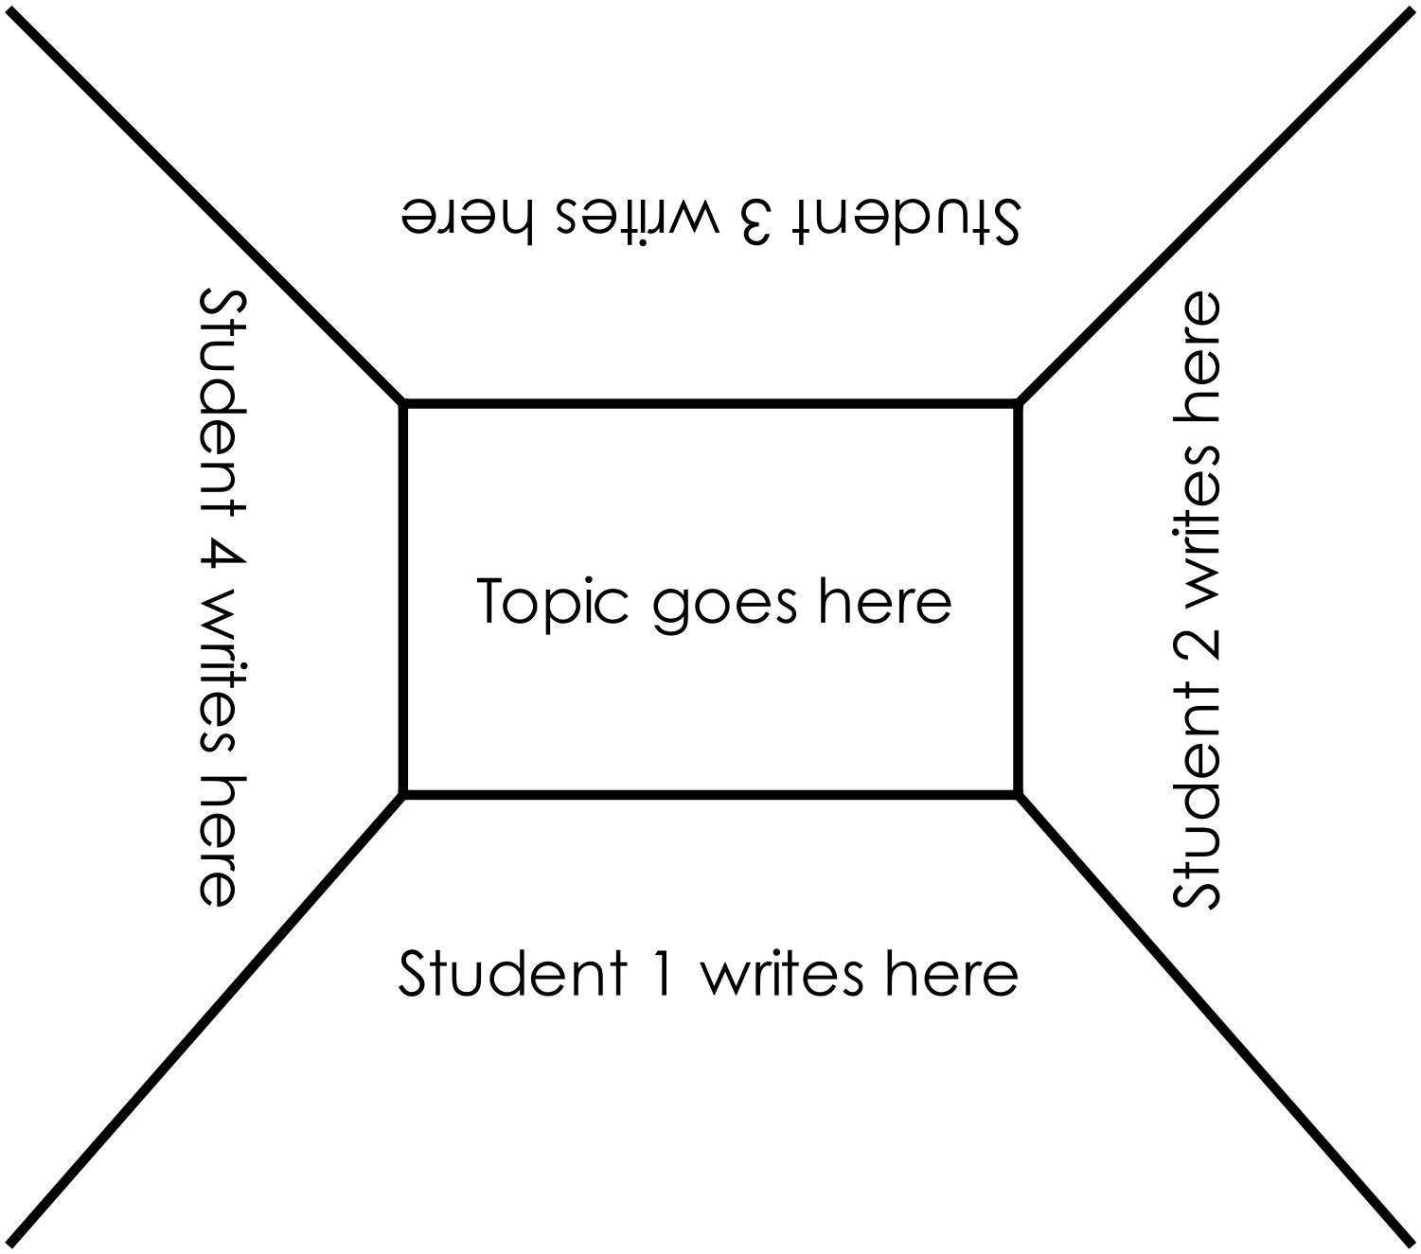
STEM Consortium

Appendix 11: Teacher resource sheet 1.4: Cooperative learning – Think, Pair, Share
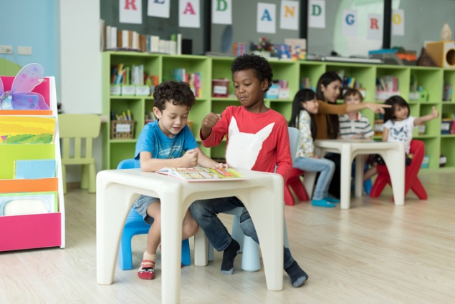
Cooperative learning frameworks create opportunities for groups of students to work together, generally to a single purpose.
istockphoto.com
As well as having the potential to increase learning for all students involved, using these frameworks can help students develop personal and social capability.
In the 'think' stage, each student thinks silently about a question asked by the teacher.
In the 'pair' stage, students discuss their thoughts and answers to the question in pairs.
In the 'share' stage, the students share their answer, their partner’s answer or what they decided together. This sharing may be with other pairs or with the whole class. It is important also to let students 'pass'. This is a key element of making the strategy safe for students.
Think-pair-share increases student participation and provides an environment for higher levels of thinking and questioning.
istockphoto.com

Appendix 12: Student activity sheet 1.5: What is a robot?
What is a robot?
A robot is…
Components of a robot:
Sensors
Motors
Program

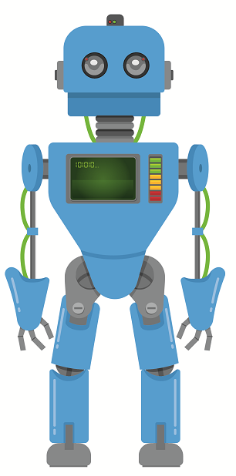
STEM Consortium

Answers
What is a robot?
A robot is…
Sensors
Light, noise, temperature, pressure, colour
Components of a robot
Motors
Actuators, servos
Power Supply
Solar, battery, electricity, wind

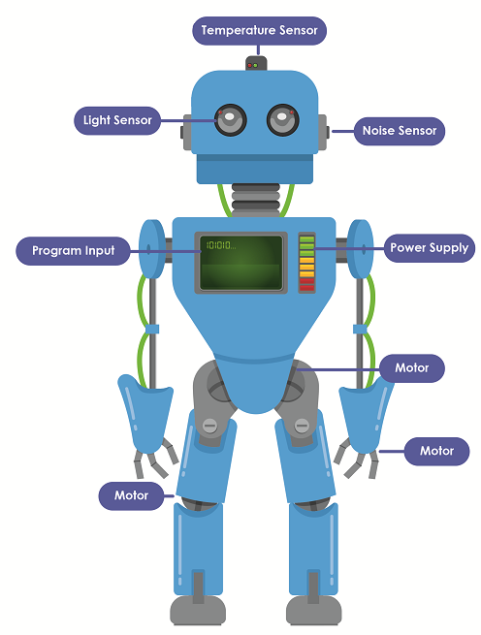

STEM Consortium

Appendix 13: Teacher resource sheet 1.6: Picture stimulus – Robots in society

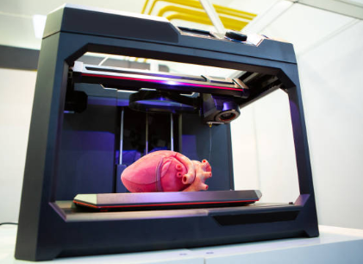
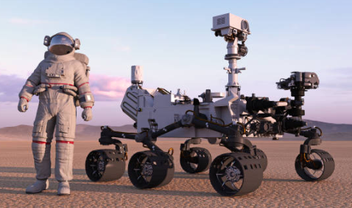
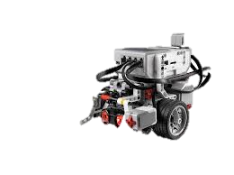

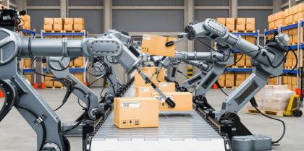
gettyimages.com.au
Transportation
Manufacturing
3D printing

Space exploration
Horticulture

pixabay.com
gettyimages.com.au
gettyimages.com.au
gettyimages.com.au
Mining
gettyimages.com.au

Appendix 14: Student activity sheet 1.7: Primary industry robots (Retrieval chart)
Primary industry robots
Name | Purpose | How does it work? | Benefits

Appendix 15: Student activity sheet 2.1: Parts of a 3D printer

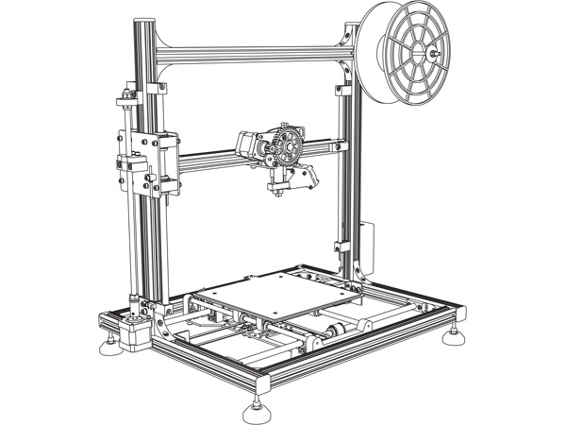
STEM Consortium

Answers

STEM Consortium
X Motor

Y Motor

Heat bed
Z Motor
Filament spool
Extruder
Gantry

Appendix 16: Student activity sheet 2.2: Venn diagram
FarmBot
3D printer

Appendix 17:

Teacher resource sheet 2.3: Picture stimulus – Growing vegetables
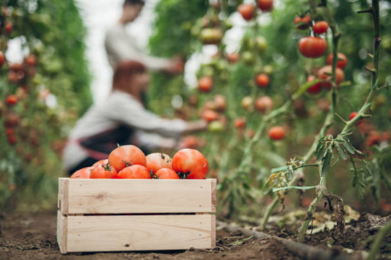
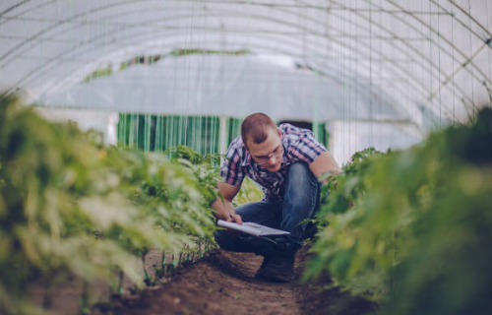

gettyimages.com.au
gettyimages.com.au
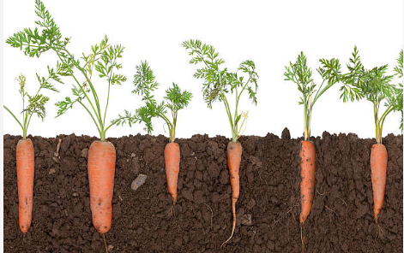

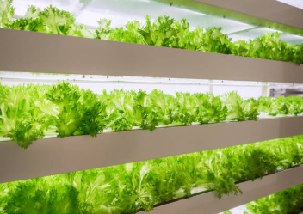
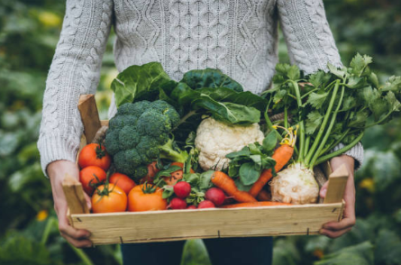
gettyimages.com.au
gettyimages.com.au
gettyimages.com.au
gettyimages.com.au

Appendix 18: Student activity sheet 2.4: I see, I think, I wonder

What do you see when you look at this image?
What are you thinking about as you look at this image?
What are your wonderings (questions)?

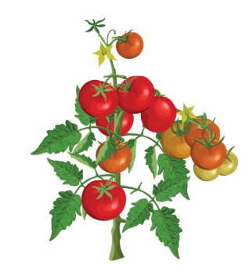
Appendix 19: Student activity sheet 2.5: Mind map
iStock.com
What do vegetable gardens look like?
What do they grow?
Where do you find them?
Interesting facts

STEM Consortium

Appendix 20: Student activity sheet 2.6: Plants investigation
Question and prediction
What is the question you will investigate?

What is your prediction?

Why do you think this will happen?

Planning for the investigation
What will you change? (eg with soil and without soil)

What will you observe and measure?

What will you keep the same to make it a fair test?

Draw a diagram to show how you will set up your investigation.

Conducting the investigation
How will you look after the plants during the investigation?

How will you record your data? Think about how this will look and sketch it below. Explain to your teacher why you have decided to record your data this way.

Do your plants look healthy? Why/ why not? Include a picture or a description of your plants.

Analysing your results

Which plants had the most growth?

Which plants had the least growth?

How much did the plants grow between the first and last days?

What does the data tell us about the growth of the plants?

What else did you notice about the growth of the plants?

Think about what you know about graphing. Is there a way you could display the data from your table to help you better understand it? Why?

Interpreting results and making a conclusion
Was your prediction supported by your results? How do you know?

What have you learnt from your investigation about the needs of plants?

What is your conclusion/answer to your question? How do you know this to be true?

Evaluating your investigation
Did the plan for your investigation work out well? Why was that?

How could your plan be improved?

What was the most important thing you learnt about conducting science investigations?

Appendix 21: Student activity sheet 2.7: Storyboarding

Scene 2

Scene 3

Scene 1

Props / Backgrounds
Music / FX

Appendix 22: Student activity sheet 3.1: Prototype troubleshooting

Problem | Reason for the problem | Possible changes to your design to solve the problem

Appendix 23: Student activity sheet 3.2: Design review
Things I would keep the same _________________________________________________________________________________________________________________________________________________________________________________________________________________________
Things I would change
________________________________________________________________________________________________________________________________________________________________________________________________________________________________________________________
Photograph or drawing

Appendix 24: Teacher resource sheet 4.1: Example flyer

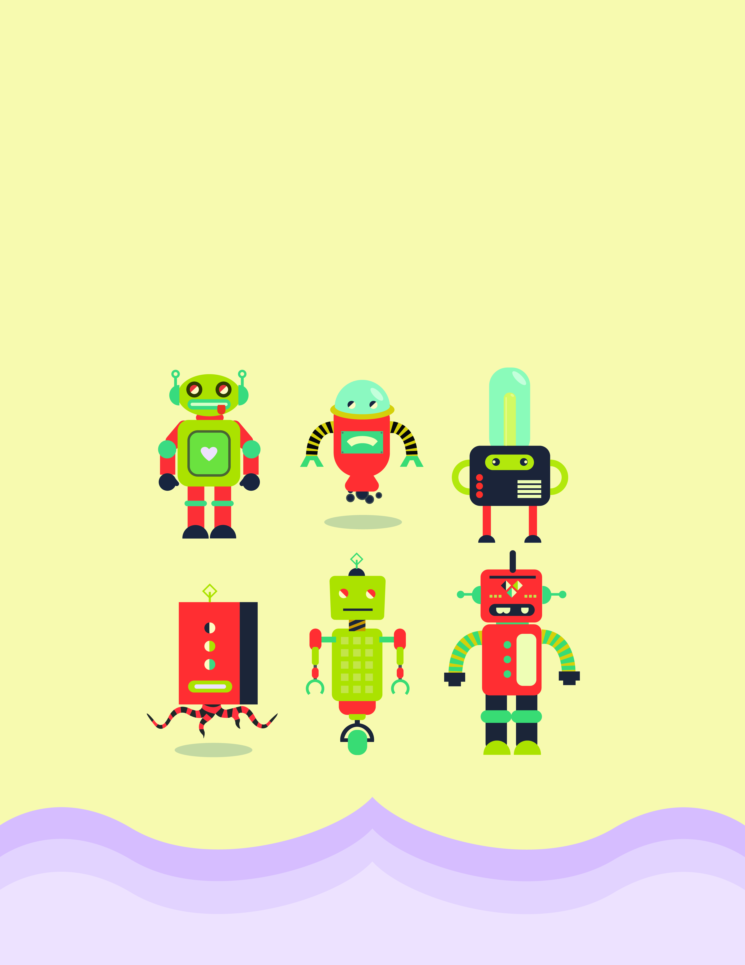
Insert event details here
STEM Consortium

Appendix 25: Teacher resource sheet 4.2: Question prompts
Pixabay.com
Robotics Today
- What is the purpose of your robot?
- How does it work?
- What parts make up the system?
- How is it powered?
- How do you program the robot?
Robotics Today
- What is the purpose of your robot?
- How does it work?
- What parts make up the system?
- How is it powered?
- How do you program the robot?
Robotics Today
- What is the purpose of your robot?
- How does it work?
- What parts make up the system?
- How is it powered?
- How do you program the robot?
Robotics Today
- What is the purpose of your robot?
- How does it work?
- What parts make up the system?
- How is it powered?
- How do you program the robot?

Appendix 26: Teacher resource sheet 4.3: Peer or parent feedback
Please provide some feedback about the mini robot garden you engaged with.
Did you have fun? What did you learn? What will you do with this new information?
Feedback 1 | Feedback 2 | Feedback 3
Feedback 4 | Feedback 4 | Feedback 6
Feedback 7 | Feedback 8 | Feedback 9

Appendix 27: Teacher resource sheet 4.4: Student evaluation
Key:  - Needs attention/ sometimes  - Very good/ consistently  - Excellent/ independently/ consistently | Student name
Remains focused on tasks presented
Completes set tasks to best of their ability
Manages time effectively
Cooperates effectively within the group
Contributes to group discussions
Shows respect and consideration for others
Uses appropriate conflict resolution skills
Actively seeks and uses feedback

Appendix 28: Student activity sheet 4.5: Self-evaluation
pixabay.com
Mini robot garden reflection
Photograph or drawing
What did you make? | How do you feel about your robotic solution?
 | pixabay.com
What do you like about your robotic solution? | What could you have done better?
pixabay.com | pixabay.com
What would you do differently?

pixabay.com

