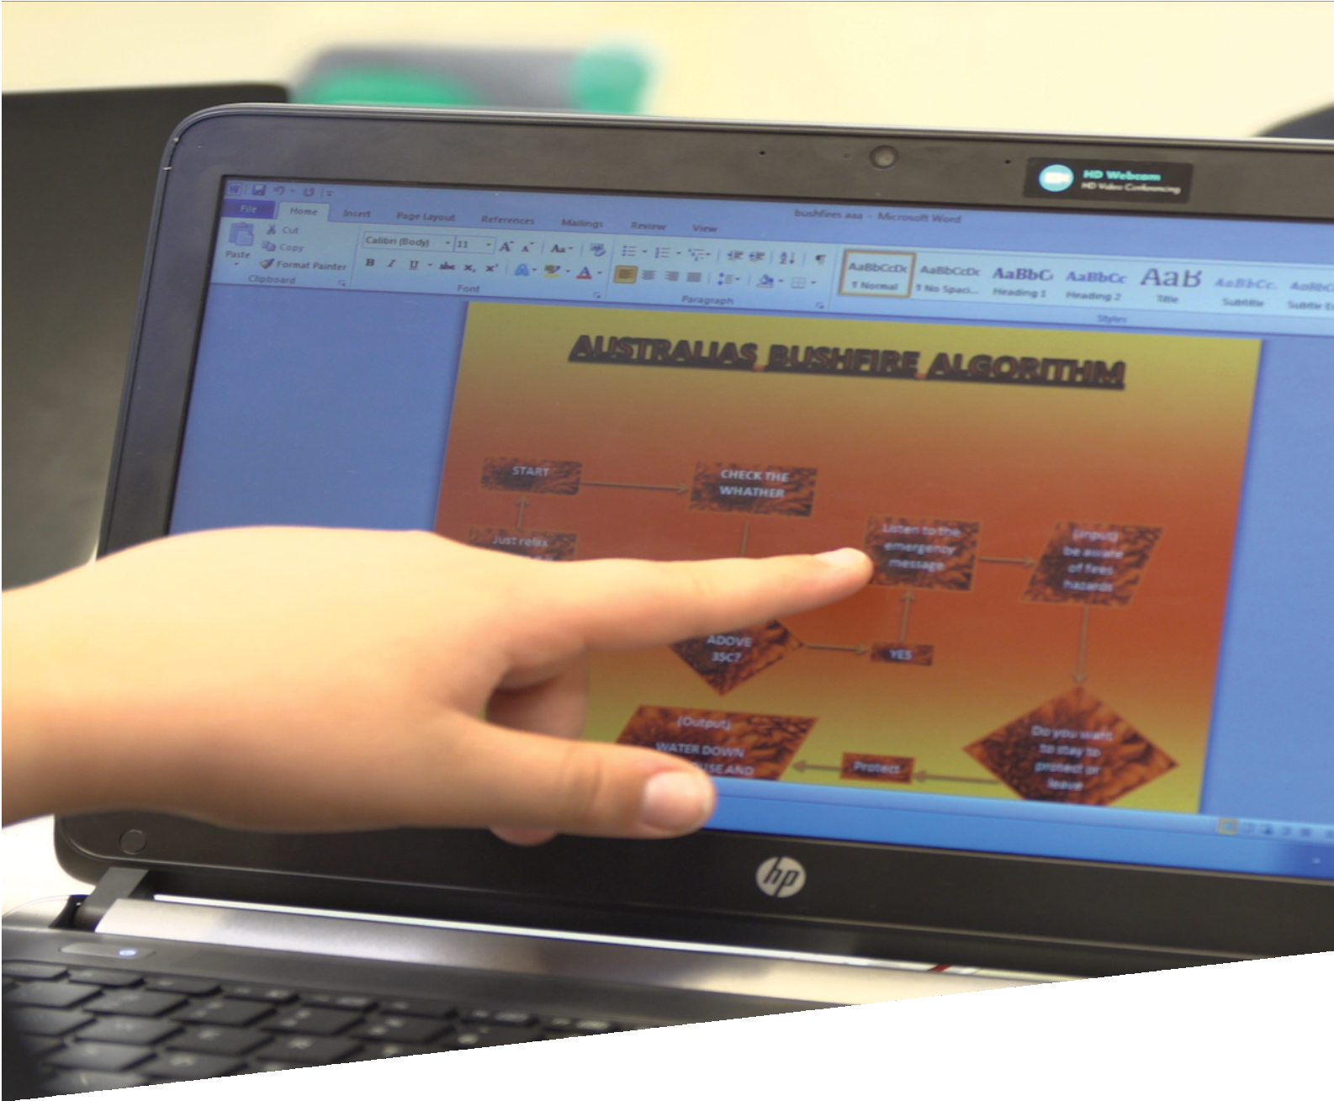

CURRICULUM RESOURCE MODULE
Bushfire risk warnings
YEAR 6

Acknowledgements
The STEM Learning Project respectfully acknowledges the Traditional Custodians of the lands upon which our students and teachers live, learn and educate.

The STEM Learning Project is funded by the Western Australian Department of Education (the Department) and implemented by a consortium in STEM education comprising the Educational Computing Association of Western Australia, the Mathematical Association of Western Australia, the Science Teachers Association of Western Australia and Scitech. We acknowledge and thank the teachers and schools who are the co-creators of these resources. We also acknowledge the use of materials from the Western Australian Department of Fire and Emergency Services and the Australian Bureau of Meteorology.

Copyright and intellectual property
The copyright and intellectual property of this module remain the property of the Department.

Any Western Australian Curriculum content in this resource is used with the permission of the School Curriculum and Standards Authority (the Authority); this permission does not constitute Authority endorsement of the resource. The Authority accepts no liability for any errors or damages arising from reliance on its content.

The Western Australian Curriculum content may be freely copied, or communicated on an intranet, for non-commercial purposes in educational institutions, provided that the Authority is acknowledged as the copyright owner. Copying or communication for any other purpose can be done only within the terms of the Copyright Act 1968 or with prior written permission of the Authority. Any Australian Curriculum content in the Western Australian Curriculum is used by the Authority under the terms of the Creative Commons Attribution NonCommercial 3.0 Australia licence. Any content on the www.scsa.wa.edu.au domain that has been derived from the Australian Curriculum may be used under the terms of Creative Commons Attribution-NonCommercial 3.0 Australia licence.

Appendix 2: General capabilities continuums are adapted from ACARA, © Australian Curriculum, Assessment and Reporting Authority (ACARA) 2009 to present, unless otherwise indicated. This material was downloaded from the ACARA website (www.acara.edu.au) (accessed December 2015) and was not modified. The material is licensed under CC BY 4.0 (https://creativecommons.org/licenses/by/4.0/). ACARA does not endorse any product that uses ACARA material or make any representations as to the quality of such products. Any product that uses material published on this website should not be taken to be affiliated with ACARA or have the sponsorship or approval of ACARA. It is up to each person to make their own assessment of the product.

This resource includes references and examples of iOS, Android and other apps. The Department does not endorse or recommend any commercial products and simply provides these as examples for teachers.

The Department is committed to providing quality information to its customers. Whilst every effort has been made to ensure accuracy, currency and reliability of the information within these documents, the Department accepts no responsibility for errors, omissions or amendments made since the time of publishing. Confirmation of information may be sought from the Department or the originating bodies providing the information. The Department has no control over the content of material published on websites to which users are referred in this resource. It is the responsibility of the internet user to make their own decision as to the relevancy, accuracy, currency and reliability of information found on those sites.
Attributions: Microsoft Word and PowerPoint, Gliffy, Padlet, iMovie, Scratch Jr, eBook.

Table of contents

The STEM Learning Project 2
Overview 3
Activity sequence and purpose 6
Background 7
Activity 1: Fire danger 9
Activity 2: Design an algorithm 14
Activity 3: Test the algorithm 20
Activity 4: Prepare and share presentation 23
Appendix 1A: Links to the Western Australian Curriculum 26
Appendix 1B: Mathematics proficiency strands 27
Appendix 2: General capabilities continuums 28
Appendix 3: Design process guide 31
Appendix 4: Student journal 32
Appendix 5: Student activity sheet 1.0: Journal checklist 33
Appendix 6: Teacher resource sheet 1.1: Cooperative learning – Roles 34
Appendix 7: Teacher resource sheet 1.2: Cooperative learning – Jigsaw 35
Appendix 8: Teacher resource sheet 1.3: Cooperative learning – Placemat 36
Appendix 9: Teacher resource sheet 1.4: Cooperative learning – Think, Pair, Share 37
Appendix 10: Teacher resource sheet 1.5: Bushfire terminology 38
Appendix 11: Teacher resource sheet 2.1: Flowcharting symbols 41
Appendix 12: Teacher resource sheet 2.2: Flowchart example 42
Appendix 13: Teacher resource sheet 2.3: Mathematical modelling 43
Appendix 14: Teacher resource sheet 3.1: BoM data sets 47
Appendix 15: Student activity sheet 4.1: Peer evaluation 71
Appendix 16: Student activity sheet 4.2: Self-evaluation 72

The STEM Learning Project
The aim of the STEM Learning Project is to generate students’ interest, enjoyment and engagement with STEM (Science, Technology, Engineering and Mathematics) and to encourage their ongoing participation in STEM both at school and in subsequent careers. The curriculum resources will support teachers to implement and extend the Western Australian Curriculum and develop the general capabilities across Kindergarten to Year 12.
Why STEM?
A quality STEM education will develop the knowledge and intellectual skills to drive the innovation required to address global economic, social and environmental challenges.
STEM capability is the key to navigating the employment landscape changed by globalisation and digital disruption. Routine manual and cognitive jobs are in decline whilst non-routine cognitive jobs are growing strongly in Australia. Seventy-five per cent of the jobs in the emerging economy will require critical and creative thinking and problem solving, supported by skills of collaboration, teamwork and literacy in mathematics, science and technology. This is what we call STEM capability. The vision is to respond to the challenges of today and tomorrow by preparing students for a world that requires multidisciplinary STEM thinking and capability.
The approach
STEM capabilities are developed when students are challenged to solve open-ended, real-world problems that engage students in the processes of the STEM disciplines.
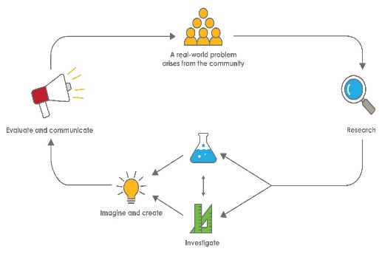
Year 6 – Bushfire risk warnings

Overview
Bushfires are one of the most frequently occurring natural disasters in Australia. They are responsible for damage to land, property and loss of life. Effective warning systems are extremely important for minimising the impact of bushfires.
This module connects students to this real-world problem, engaging their science understandings and inquiry skills, design process skills and mathematical computational thinking and reasoning to create an algorithm that provides information on the likelihood of a bushfire.
Timing this module so it is current with the bushfire season in the school's local area will increase its relevance and context and potentially provide engagement through relevant media coverage.
Students will collaborate, reflect, and give and receive feedback. They will also have the opportunity to present their algorithm to their peers and, where possible, a local expert.
What is the context?
Bushfires are a real and significant threat in Australia.
What is the problem?
How do you determine the risk of a bushfire occurring in order to issue an appropriate warning?
How does this module support integration of the STEM disciplines?
Science
Students will develop science understandings of the weather and other environmental factors that create the conditions under which bushfires occur (ACSSU096: Sudden geological changes and extreme weather events can affect Earth’s surface) and develop their understanding of the impact of bushfires on living things (ACSSU094: The growth and survival of living things are affected by physical conditions of their environment), infrastructure and communities (ACSHE100: Scientific knowledge is used to solve problems and inform personal and community decisions) and share these understandings(ACSIS012: Share observations and ideas).
Technology
Digital Technologies are also used in representing and communicating the algorithm to an audience.
The Design process guide is included as a resource to provide assistance to teachers in understanding the complete design process as developed in the technologies curriculum.
Mathematics
Mathematical computational thinking (ACMNA123: Select and apply efficient mental and written strategies and appropriate digital technologies to solve problems involving all four operations with whole numbers) and Digital Technologies algorithmic logic (ACTDIP019: Design, modify, follow and represent both diagrammatically, and in written text, simple algorithms (sequence of steps) involving branching (decisions) and iteration (repetition)) are used in the development of an algorithm. Students plan the sequence of steps and decisions required to go from input values (environmental factors) to output values (warnings). Students analyse tabular displays of Bureau of Meteorology (BoM) data (ACMSP147: Interpret and compare a range of data displays, including side-by-side column graphs for two categorical variables), complete calculations, and engage in pre-algebraic thinking to run and test their algorithms against real-world data.
General capabilities
There are opportunities for the development of general capabilities and cross-curriculum priorities as students engage with Bushfire risk warnings. In this module, students:
- Develop problem solving skills as they research the problem and its context (Activity1); investigate parameters impacting on the problem (Activity 2); imagine and develop solutions (Activity 3); and evaluate and communicate their solutions to an audience (Activity 4).
- Utilise creative thinking as they generate possible design solutions; and critical thinking, numeracy skills and ethical understanding as they choose between alternative approaches to solving the problem.
- Utilise personal and social capability throughout the module as they develop socially cohesive and effective working teams; collaborate in generating solutions; adopt group roles; and reflect on their group work capabilities through self and peer evaluation.
- Utilise a range of literacies and information and communication technology (ICT) capabilities as they collate records of work completed throughout the module in a journal and represent and communicate their solutions to an audience using digital technologies in Activity 4.
- Communicate and, using evidence, justify their group’s design to the class or a local expert.
What are the pedagogical principles of the STEM learning modules?
The STEM Learning Project modules develop STEM capabilities by challenging students to solve real-world problems set in authentic contexts. The problems engage students in the STEM disciplines and provide opportunities for developing higher order thinking and reasoning, and the general capabilities of creativity, critical thinking, communication and collaboration.
The design of the modules is based on four pedagogical principles:
- Problem-based learning
This is an underlying part of all modules with every module based around solving an initial problem. It is supported through a four-phase instructional model: research the problem and its context; investigate the parameters impacting on the problem; design and develop solutions to the problem; and evaluate and communicate solutions to an authentic audience.
- Developing higher order thinking
Opportunities are created for higher order thinking and reasoning through questioning and discourse that elicits students' thinking, prompts and scaffolds explanations and requires students to justify their claims. Opportunities for making reasoning visible through discourse are highlighted in the modules with the icon shown here.
- Collaborative learning
This provides opportunities for students to develop teamwork and leadership skills, challenge each other’s ideas, and co-construct explanations and solutions. Information that can support teachers with aspects of collaborative learning is included in the resource sheets.
- Reflective practice
Recording observations, ideas and one’s reflections on the learning experiences in some form of journal fosters deeper engagement and metacognitive awareness of what is being learned. Information that can support teachers with journaling is included in the resource sheets.
These pedagogical principles can be explored further in the STEM Learning Project online professional learning modules located in Connect Resources.

Activity sequence and purpose
Fire danger
To capture students’ interest and engage them with the problem, identify the causes of bushfires and discuss the significance of bushfires in their community.
Design an algorithm
To investigate and design an algorithm to determine risk warnings for bushfires.
Test the algorithm
Test the algorithm using real world data and refine to improve its prediction accuracy.
Prepare and share presentation
Create a presentation outlining the algorithm. The presentation will be given to the class and, if possible, a local expert such as a member of the local fire brigade or forecaster from the BoM.
Review and reflect through peer assessment.

Background
Expected learning | Students will be able to:  - Explain the factors that impact on bushfire risk and describe the impacts of bushfires.  - Analyse BoM data and identify numerical values for risk variables indicating the degree of risk.  - Design, test and explain an algorithm and its mathematical model for predicting the risk of bushfires.  - Use digital devices to source information and construct a multimodal presentation.
Vocabulary | This module uses subject specific terminology which is shown in Teacher resource sheet 1.5: Bushfire terminology.  The following vocabulary list contains other terms that need to be understood, either before the module commences, or developed as they are used.  adaptations, curing, fuel load, habitat, humidity, ignition, lignotubers, prescribed burn, relative humidity, mean, severity, topography, variable, wind speed,
Timing | There is no prescribed duration for this module. The module is designed to be flexible enough for teachers to adapt. Activities do not equate to lessons; one activity may require more than one lesson to implement.
Safety notes | There are potential hazards inherent in these activities and with the equipment being used, and a plan to mitigate any risks will be required.  Potential hazards specific to this module include but are not limited to:  - Possible exposure to cyber bullying, privacy violations and uninvited solicitations when using the internet.  - Teachers should consider the potential for emotional responses from students with recent fire experiences. Consider notifying parents before starting the module.
Assessment | The STEM modules have been developed to provide students with learning experiences to solve authentic real-world problems using science, technology, engineering and mathematics capabilities.  While working through the module, the following assessment opportunity will arise:  - Students will produce three pieces of work; an algorithm (one per group), a presentation (one per group) and a journal (one per student).  Appendix 1 indicates how the activities are linked to the Western Australian Curriculum  Evidence of learning from journaling, presentations and anecdotal notes from this module can contribute towards the larger body of evidence gathered throughout a teaching period and can be used to make on-balance judgements about the quality of learning demonstrated by the students in the Science, Technologies and Mathematics learning areas.  Students can further develop the general capabilities. Continuums for these are included in the General capabilities continuums but are not intended to be for assessment purposes.
Additional learning opportunities
Students could:
- employ a variety of resources to build a warning system in the form of an app or interactive game
- develop more advanced mathematical models for fire risk warnings
- create a weather station prototype (engineering) to measure the variables that inform their warning system
- devise bushfire mitigation strategies specific to their location
- devise a strategy for communicating bushfire warnings
- investigate fire oxygen levels and ignition temperatures as part of an additional science activity.
Inspiration resource: stem-works.com/subjects/5-extreme-weather/activities
Excursion and incursion
Department of Fire and Emergency Services (DFES) Education and Heritage Centre, Perth.
BoM (Bureau of Meteorology) staff participate in the Scientists in Schools program.

Activity 1: Fire danger
Activity focus |  | To consider the causes and impacts of bushfires, engage students with material describing bushfire events and patterns in their region and search for information about bushfire warnings.
Background information |  | All fires need fuel, oxygen and a source of ignition. Fuel loads accumulate after high winter rainfall and when no recent natural or prescribed burns have taken place. Prescribed burns reduce the amount of available fuel such as branches, grass and leaf litter. Bushfires can be ignited naturally by lightning strikes or by human activity. The likelihood and severity of bushfires is strongly influenced by weather conditions and topography. The risk, severity and rate of spread of a fire increases with high temperatures, low humidity and high wind speeds. Steeply sloping ground can also increase the rate of spread of a fire.  The impact of bushfires on vegetation depends on the heat of the fire. Mild burns can release nutrients from leaf litter, encouraging new plant growth. Hot burns can kill all plant life above ground. Many Australian trees have special adaptations to protect them from fire and enable them to regrow from seeds or lignotubers. Fire can destroy habitat and food sources for animals and leave soil prone to erosion. In severe fires, communities can lose livestock, pets, houses and other infrastructure.  Fire is important in Aboriginal culture and fire management is one way in which Aboriginal people care for country.  Before Europeans arrived Aboriginal people were practising a form of fire management that in some respects was more successful than that which has been practised since – Prime Minister Tony Abbott (2013). See links in Digital resources for further information.  Bushfire danger rating systems are based on input variables which generate output variables. Key inputs include temperature, humidity and wind speed. Outputs refer to the level of warning generated by a system and include low, medium, high and extreme.
Instructional procedures |  | Student thinking from all activities should be recorded in a reflective journal. The journal can be either digital or physical. See Student journal for more support.  Content warning:  When planning for the delivery of this topic, it is important to consider the backgrounds and experiences of the students as content may cause distress for some students. It may be necessary to notify parents, alert students and provide alternative lesson content.
Expected learning |  | Students will be able to:  - Explain how fuel load, temperature, humidity, ignition source and wind influence the risk of a bushfire (Science).  - Describe the impacts of bushfires on vegetation, animals, infrastructure and communities (Science).  - Use digital devices to source relevant information about bushfire risk (Technologies).
Equipment required |  | For the class:  Interactive whiteboard or display screen to view bushfire videos.
For the students:
Digital device (optional), butcher paper.
Preparation |  | Preload webpage links to a common drive to ensure all students have access to the material.
Activity parts |  | Part 1: Prior knowledge  To determine students’ prior knowledge of bushfire events in Australia, students discuss the following questions through a think-pair-share activity, recording answers using a method of choice such as a brainstorm or concept map.  - What is a bushfire?  - When do bushfires occur?  - What kinds of places are bushfires likely to occur?  - What else do you know about bushfires?  Students will add to this document as they work through the module. It can be an individual or shared document, depending on the needs of the students.
Part 2: Bushfire effects
View bushfire videos (see links in Digital resources).
Ask students if they have been affected or know someone who has been affected by a bushfire. Students may wish to share their experiences.
Content warning:
Consider the backgrounds and experiences of the students as content may cause distress for some students. It may be necessary to notify parents, alert students and provide alternative lesson content.
Part 3: Brainstorm
Students work in four groups to brainstorm about bushfires.
Write the following questions on four separate pieces of butcher paper and place them on tables around the room.
- How do people know when they are in danger of a bushfire?
- What factors cause a bushfire to be severe?
- What is the impact of bushfires? On community? On flora and fauna?
- What can a community do to minimise the impact of a bushfire?
Separate students into four groups and assign each group to a piece of butcher paper. Each group should allocate one student to scribe.
Encourage students to write down anything that comes to mind about the topic within a two-minute period. The scribe should number each idea as it is written down.
After two minutes, groups rotate clockwise, read what was written by the previous group and add additional ideas.
The process should continue until each group is back at their starting point.
Other cooperative learning techniques that may be suitable for this group exercise include the jigsaw and placemat set up. Further details on these techniques can be found in the Teacher resource sheets 1.1 to 1.4: Cooperative learning.

Part 4: Class review
As a class, discuss the group brainstorms, identifying the stand out ideas. Students work in pairs to add this information to their document from Part 1.
Part 5: Research
Working collaboratively, students use devices to further research points 1-4 from Part 3: Brainstorm, as well as:
- factors (input variables) that influence the risk of fires,
- bushfire warning terminology, which is used to inform people about the level of fire risk (output variables),
- methods used to warn communities of fire risk.
See links in Digital resources.
Students add this information to their document from Part 1.
If the pairs regroup into larger groups of eight, a jigsaw strategy could be used for this activity. See Teacher resource sheet 1.2: Cooperative learning – Jigsaw.
Resource sheets |  | Teacher resource sheets 1.1 to 1.4: Cooperative learning  Teacher resource sheet 1.5: Bushfire terminology
Digital resources | Yarloop bushfire videos  www.youtube.com/watch?v=zIw07JuZRY0  www.youtube.com/watch?v=X1-qTG_yfyA
Australia Firestorm on BBC My Country Documentary (four part series).
The teacher may view this lengthy documentary before starting the module to identify the most relevant sections.
www.youtube.com/watch?v=UMmGE5RNrR4
Digital resources including fact sheets, videos and tools relevant to Western Australia
www.dfes.wa.gov.au/safetyinformation/warningsystems/Pages/default.aspx#4
Indigenous weather knowledge (BOM 2014)
www.bom.gov.au/iwk/climate_culture/Indig_seasons.shtml
Aboriginal fire management (Creative Spirits 2018)
www.creativespirits.info/aboriginalculture/land/aboriginal-fire-management
Free classroom resources for teachers including curriculum links, news reports, informational posters, interactives and statistics from Western Australia
www.dfes.wa.gov.au/schooleducation/schools/BushfirePatrol/DFES_BushfirePatrol-UpperPrimary.pdf
Padlet is an app which can be used to compile student learning in real time.
www.padlet.com
Literary resources | The Barrumbi Kids by Leonie Norrington  Fire by Jackie French

Activity 2: Design an algorithm
Activity focus | Students create an algorithm that provides the desired level of risk warning for a potential bushfire when weather input variables are entered.
Background information | An algorithm is a sequence of steps that is followed to solve a problem. People use algorithms every day to solve problems and complete tasks. For example, baking a cake or getting dressed.  A flowchart is a diagrammatic representation of an algorithm. A flowchart can take the form of a branching set of shapes with decision-making steps. The shapes used in a flowchart are shown in Teacher resource sheet 2.1: Flowcharting symbols and an example of a possible flowchart is shown in Teacher resource sheet 2.2: Flowchart example.  In its most developed form, an algorithm can be converted to computer code or generalised with a mathematical model.  The fire risk algorithm developed in this module may be extended to include a mathematical model allowing the risk associated with high temperature, low humidity and high wind speed to give a numerical rating of bushfire risk.  In this example, three measurements of input variables are converted to ratings:  Temperature (°C) < 30 = 0 30 – 35 = 1 > 35 = 2  Humidity (%) > 25 = 0 25 – 20 = 1 < 20 = 2  Wind speed (km/h) < 40 = 0 40 – 60 = 1 > 60 = 2  Based on this model, when the ratings (0, 1 or 2) are summed, a score of six would equate to an extreme risk rating, while a score of zero would equate to a low fire risk.  Another mathematical model involves the summing of the raw measurements for temperature, relative humidity and wind speed (eg 30°, 55%, 25 km/h). However, there is an inverse relationship between humidity and fire risk (high humidity = low risk). A better model to account for this is risk = t – h + w.  More detail on these types of mathematical models is included in Teacher resource sheet 2.3: Mathematical modelling.  Information regarding the influence of humidity, wind and rainfall on fire danger can be found on the website of the Bureau of Meteorology.  Negotiation, critical thinking and reasoning skills will be displayed by the students as they work on their designs. Problem solving in collaborative situations is a STEM capability that students need to exercise. Allowing students to negotiate amongst themselves will encourage them to develop this skill.  Facilitated by the teacher, students follow the design process (see Design process guide) to refine and enhance their model. The steps of ideation, development and production are followed in this activity. Students are encouraged to build resilience and embrace the design cycle.
Instructional procedures | This task is designed to allow for differentiation, and algorithms may be simple or complex depending on a student’s thinking. Teachers should provide the scaffolding for students to problem-solve but it is advisable not to show students the included examples of bushfire algorithms.
Expected learning | Students will be able to:  - Identify the features and processes of decision-making algorithms (Technologies).  - Identify variables that impact bushfire risk, and assign them numerical values (Science and Mathematics).  - Design an algorithm that uses risk factors (input variables) to determine levels of warning (output variables) (Mathematics).  - Compare and evaluate alternative algorithms (Technologies).
Equipment required | For the class:  Whiteboard or interactive whiteboard.
For the students:
Coloured pencils, pens, A3 paper, calculators, devices.
Activity parts | Part 1: Outlining the task  Explain to students that they will create an algorithm that predicts the risk of a bushfire. The purpose of the algorithm is to give a community warning so they can prepare for a fire and minimise its impact.
Part 2: Algorithms and flowcharts discussion
Discuss the meaning of an algorithm and flowchart. Relate this to the scenario in everyday life of buying a new pair of red shoes.
Using the example below, discuss how to alter an algorithm based on different scenarios. Discussion questions may include:
- How would you change the algorithm if you could only spend $80?
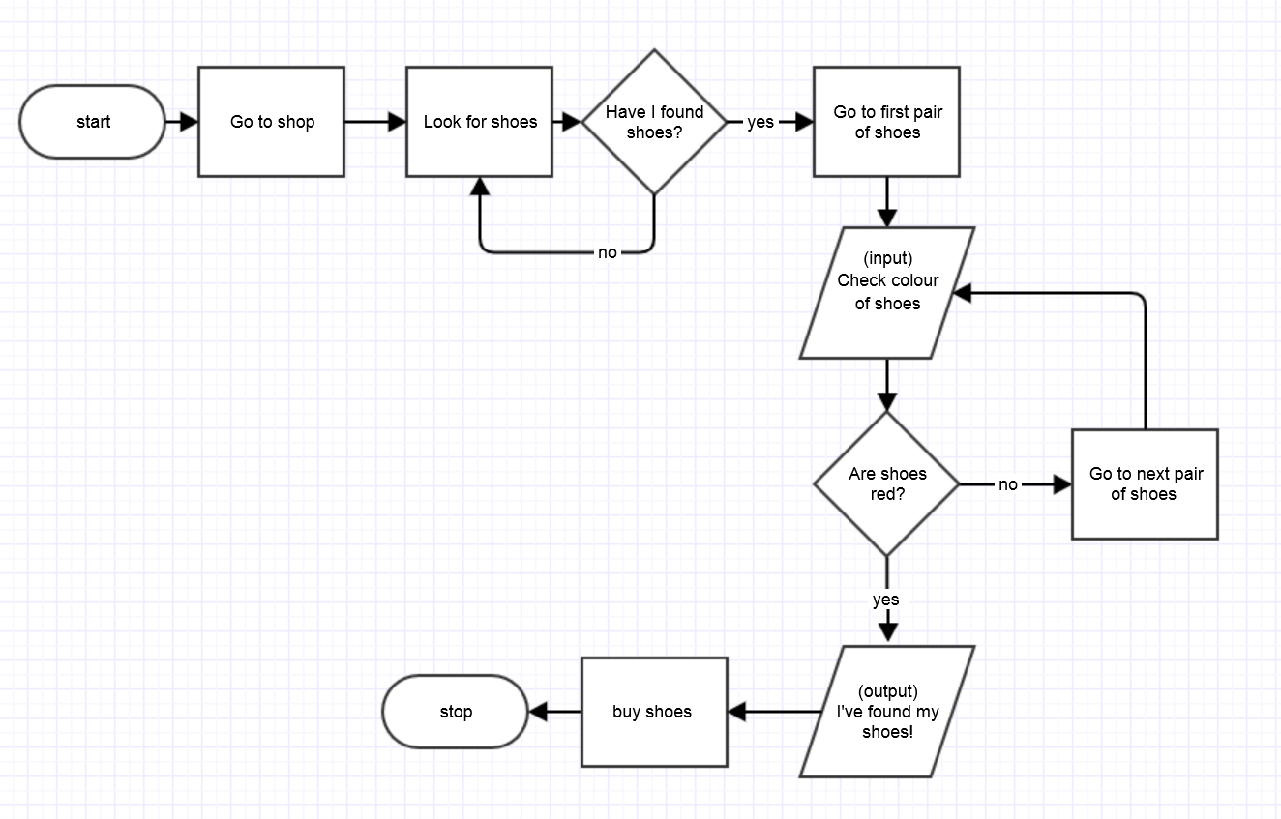
- Can you extend the algorithm to consider shoe size?
Part 3: Algorithms and flowcharts video
Watch the Khan Academy video, What is an algorithm and why should you care?
See Digital resources for the link.

Part 4: Flowchart symbols
Explain the meaning of the shapes and flowlines that construct the flowchart of an algorithm. The basic shapes are shown in Teacher resource sheet 2.1: Flowcharting symbols.
A full set of flowcharting symbols is available in Microsoft Word using the ‘insert, shapes’ function.
Part 5: Fire terminology
Review the terminology relating to weather, fire risk and fire danger ratings. In particular, focus on wind speed, temperature and humidity. Refer to Teacher resource sheet 1.5: Bushfire terminology.
It may be useful to note that some sources give wind speed in knots. A knot is one nautical mile per hour and is equivalent to about 1.85 km/h.
Part 6: Developing algorithms
Discuss with the class how an algorithm using weather conditions as inputs could give bushfire risk warnings as an output.
Students separate into small groups and begin to design an algorithm based on the discussion and previous learning. This algorithm could be in the form of a flowchart, a table, written instructions or a numerical model. Refer to:
Teacher resource sheet 2.1: Flowcharting symbols
Teacher resource sheet 2.2: Flowchart example
Providing students with enough time, and the opportunity to struggle, is important in the problem solving process. Scaffolding should be minimal at first to encourage student thinking. Encouragement rather than information is advised for this stage of problem solving.
Part 7: Feedback
When groups have progressed as far as they can, it may be helpful to facilitate a class discussion that supports their current thinking and leads them further.
Focus questions at this point could include:
- What form is your algorithm?
- What input variables are you using?
- Does your algorithm allow for the input of all of these variables?
- What outputs are you using?
- Does your algorithm lead to one of these outputs?
- If you are using a numerical model, how are you representing the variables?
Ask groups to share their thinking with the class and encourage other groups to provide verbal feedback.
Where appropriate, challenge students to consider how a numerical calculation could help combine the risks associated with temperature, humidity and wind speed to give an appropriate rating of fire risk. See Teacher resource sheet 2.3: Mathematical modelling for information that will help you support groups.
Allow time for groups to further develop their algorithms. Support here needs to vary depending on the complexity of the algorithm. Focusing on the purpose of an algorithm (a sequence of steps that is followed to solve a problem) will allow for many types of solutions.
Part 8: Journaling
Students reflect on their learning. Student journal notes may include:
- When they learnt something new
- What they learnt
- When they were challenged and how they overcame the challenge
- When they made changes to their approach or their design and why.
Resource sheets | Teacher resource sheet 2.1: Flowcharting symbols  Teacher resource sheet 2.2: Flowchart example  Teacher resource sheet 2.3: Mathematical modelling

Digital resources | Khan Academy, What is an algorithm and why should you care?  www.khanacademy.org/computing/computer-science/algorithms/intro-to-algorithms/v/what-are-algorithms
Algorithms: Plugged & Unplugged
docs.google.com/presentation/d/1K-6F3yYRf2lkwkU1C2-yLxveV9Zt8RtyrVBfEzB0qS8/edit#slide=id.g13ec2dcc77_1_67
Algorithm definition and pictorial example
www.tynker.com/blog/articles/ideas-and-tips/how-to-explain-algorithms-to-kids/
Legend of symbols used in an algorithm
1.bp.blogspot.com/_-n5ew-cmW7o/TU6u0Mt768I/AAAAAAAAAIE/9PB0Vy0BeJU/s1600/flowchart-symbols.gif
Bushfire weather
www.bom.gov.au/weather-services/bushfire/about-bushfire-weather.shtml

Activity 3: Test the algorithm
Activity focus | Use real-world data to determine whether the algorithm developed in Activity 2 gives an appropriate fire risk warning. Then refine and modify the algorithm to improve the accuracy of outputs.
Background information | An example showing input variables for different days is shown below.  Yarloop fire Summer day Winter day  Mean maximum temperature (°C) 40+ 30.6 16.8  Mean wind speed (km/h) 60 13.4 10.4  Mean relative humidity (%) 20 54 82
Instructional procedures | Real-world data can be found via the DFES or BoM websites. For ease of use, an extract from this data has been included in the Teacher resource sheet 3.1: BoM data sets. These are complex and may need simplifying or scaffolding.  It is also possible to obtain data from a school weather station (which could be set up) or via the BoM Twitter feed.  A digital option for flowcharting is Gliffy www.gliffy.com  Guide students to follow the steps of the design process (see Design process guide) to refine and enhance their model.  The steps of ideation, development and production are followed in this activity. Students are encouraged to build resilience and embrace the design cycle.  Negotiation, critical thinking and reasoning skills will be required by the students as they work on their designs. Problem solving in collaborative situations is a STEM capability that students need to exercise. Allowing students to negotiate amongst themselves will encourage them to develop this skill.
Additional learning experience
Analyse rainfall and evaporation (these are included in the provided data sets). Other factors such as lightning activity, curing (how dry the fuel is) and fuel load could also be investigated.
Expected learning | Students will be able to:  - Analyse BoM data to identify values for risk factors on days when bushfires occurred and in seasons with no fires (Science).  - Substitute risk factor values into their algorithm to test the outputs generated, and evaluate the effectiveness of their model (Mathematics).  - Revise their algorithm based on feedback from testing (Technologies).
Equipment required | For the class:  Students will need access to real world data. These may be accessed (in order of complexity) through the Teacher resource sheet 2.3: Mathematical modelling, Teacher resource sheet 3.1: BoM Data sets, or BoM observations.
For the students:
Paper, coloured pencils, textas, calculators.
Access to a computer or device (optional).
Preparation | Arrange access to real-world data. This data could be accessed through devices or printed as handouts.
Activity parts | Part 1: Fire history  Students identify the dates and locations of at least two bushfires in Australia. The Yarloop fires may be a good starting point for students.
Part 2: Low risk days
Students identify the dates and locations of two low fire risk days, for example, the middle of winter. Discuss with students their reasoning behind choosing these days.

Part 3: Weather data
Use the BoM link or data provided in the Teacher resource sheet 3.1: BoM data sets to find the weather readings for the low risk days and the days when fires occurred. Data for a summer’s day without a bushfire may also be useful to use for testing the algorithms. Examples of suitable data are given in the Background information.
Part 4: Testing data
Students input the weather values from Part 3 into their algorithms and calculate the outputs for the different weather conditions.
Part 5: Evaluating algorithms
Students should consider:
- Is your algorithm giving appropriate warnings?
- Do the warning levels provide increases as expected?
- What parts of your algorithm could you change to improve the validity of the outputs?
As part of the design process, students retest and refine their algorithm until appropriate warnings are provided.
Students test and evaluate each other’s algorithms.
Part 6: Journaling
Students make notes in their journals about creating and redesigning their algorithm, recording:
- When they learnt something new
- What they learnt
- When they were challenged and how they overcame their challenge
- When they changed their design and why.
Digital resources | Free classroom resources from DFES for teachers  www.dfes.wa.gov.au/schooleducation/schools/BushfirePatrol/DFES_BushfirePatrol-UpperPrimary.pdf
Real-world data and information. BoM observations (all information for any given day is provided)
www.bom.gov.au/climate/data/index.shtml

Activity 4: Prepare and share presentation
Activity focus | Students will compile their journal notes to make a group multimedia presentation about the development of their algorithm. Students will then give an oral presentation to the class or a local expert. Finally, students will reflect on the effectiveness of their algorithm with peer feedback.
Instructional procedures | The presentations provide a rich opportunity for assessing the students' understanding of the science and technology principles and processes, as well as literacies associated with speaking and listening. Including a visitor with an interest in the topic to the audience will increase students’ engagement and learning from the task.  Preparing the presentations  Students will need support and scaffolding to prepare for their presentation. To scaffold cooperative group work, each member of the group could have a role and responsibility. For example, one could be the Content Director, one the Media Director and a third the Presentation Director. All students contribute to all aspects of the presentation, with one student overall responsibility for managing that phase of the task. See Teacher resource sheet 1.1: Cooperative learning – Roles for more information.  Using Information and communication technology (ICT)  Digital options for presentations include creating a comic strip, eBook, poster in Pages, Keynote or PowerPoint or iMovie (or similar). Photographs taken throughout the design process should be used in digital presentations.  The presentation will be shared through a platform such as Seesaw, Class Dojo or Connect, added to a class blog or shared on an interactive whiteboard. Students may require explicit instruction in using these apps.  If digital technology is not accessible, students could share their work using a traditional poster, recount or book.  Content warning:  When planning for the delivery of this topic, it is important to consider the backgrounds and experiences of students as content may cause distress for some students. If necessary notify parents, alert students and provide alternative content.
Expected learning | Students will be able to:  - Use digital technology to create a multimodal presentation, communicating information about bushfire risk and their algorithm (Technologies).  - Explain how fuel load, temperature, humidity, wind and ignition source influence the risk of a bushfire (Science).  - Explain their algorithm design, mathematical model and its reliability in predicting bushfire risk (Mathematics and Technologies).
Equipment required | For the class:  Interactive whiteboard or whiteboard.  Multimedia specific to students’ presentation requirements.
For the students:
Digital devices loaded with appropriate apps for multimedia presentations.
Student activity sheet 4.1: Peer evaluation
Preparation | Ensure the technology and media are available.  Invite a local community expert, such as a firefighter, State Emergency Service volunteer or weather forecaster to view the final student presentations.
Activity parts | Part 1: Introduction  Explain to students that they will create a multimedia presentation to describe their algorithm, justify its design and effectiveness and highlight options for further enhancements.
Part 2: Choosing media and creating presentations
In groups, students use a chosen form of digital media to communicate their design process and final solution. See Digital resources for suggestions.
Part 3: Delivering presentations
Students share their digital presentations with the class. The class should discuss how each algorithm differs. If possible, a local expert could give feedback on the algorithms and presentations, and discuss the importance of warning systems from an industry or community perspective.
Part 4: Feedback
Students should provide peer feedback on group work skills using the Student activity sheet 4.1: Peer evaluation. If possible, multiple students should test and review each algorithm design, leaving notes for the group. A 3-2-1 strategy would work well; students identify 3 things they discovered, 2 things they found interesting and 1 question they still have for the group. Feedback could be recorded on a printed copy of the algorithm or on a separate page and photocopied for each group member to paste into their learning journals.
Part 5: Journaling
Students reflect on feedback and their learning experience in their journals.
Resource sheets | Student activity sheet 1.0: Journal checklist  Student activity sheet 4.1: Peer evaluation  Student activity sheet 4.2: Self-evaluation
Digital resources | iMovie  www.apple.com/au/imovie/
eBook
www.ebooks.com/
Scratch
www.scratch.mit.edu
splash.abc.net.au/home#!/digibook/2427023/introduction-to-scratch

Appendix 1A: Links to the Western Australian Curriculum
The Bushfire risk warnings module provides opportunities for developing students’ knowledge and understandings in science, technologies and mathematics. The table below shows how this module aligns to the content of the Western Australian Curriculum and can be used by teachers for planning and monitoring.
BUSHFIRE RISK WARNINGS  Links to the Western Australian Curriculum | ACTIVITY
 | 1 | 2 | 3 | 4
SCIENCE
SCIENCE UNDERSTANDING
Earth and space sciences: Sudden geological changes and extreme weather events can affect Earth’s surface (ACSSU096) | ● |  |  | ●
Biological sciences: The growth and survival of living things are affected by physical conditions of their environment (ACSSU094) | ●
SCIENCE AS A HUMAN ENDEAVOUR
Use and influence of science: Scientific knowledge is used to solve problems and inform personal and community decisions (ACSHE100) | ● |  |  | ●
Communicating: Share observations and ideas (ACSIS012) |  |  |  | ●
DIGITAL TECHNOLOGIES
PROCESS AND PRODUCTION SKILLS
Digital implementation: Design, modify, follow and represent both diagrammatically, and in written text, simple algorithms (sequence of steps) involving branching (decisions) and iteration (repetition) (ACTDIP019) |  | ● | ●
MATHEMATICS
NUMBER AND ALGEBRA
Number and place value: Select and apply efficient mental and written strategies and appropriate digital technologies to solve problems involving all four operations with whole numbers (ACMNA123) |  | ● | ● | ●
STATISTICS AND PROBABILITY
Data representation and interpretation: Interpret and compare a range of data displays, including side-by-side column graphs for two categorical variables (ACMSP147) |  |  | ● | ●
Further information about assessment and reporting in the Western Australian Curriculum can be found at: https://k10outline.scsa.wa.edu.au/home

Appendix 1B: Mathematics proficiency strands
Key ideas
In Mathematics, the key ideas are the proficiency strands of understanding, fluency, problem-solving and reasoning. The proficiency strands describe the actions in which students can engage when learning and using the content. While not all proficiency strands apply to every content description, they indicate the breadth of mathematical actions that teachers can emphasise.
Understanding
Students build a robust knowledge of adaptable and transferable mathematical concepts. They make connections between related concepts and progressively apply the familiar to develop new ideas. They develop an understanding of the relationship between the ‘why’ and the ‘how’ of mathematics. Students build understanding when they connect related ideas, when they represent concepts in different ways, when they identify commonalities and differences between aspects of content, when they describe their thinking mathematically and when they interpret mathematical information.
Fluency
Students develop skills in choosing appropriate procedures; carrying out procedures flexibly, accurately, efficiently and appropriately; and recalling factual knowledge and concepts readily. Students are fluent when they calculate answers efficiently, when they recognise robust ways of answering questions, when they choose appropriate methods and approximations, when they recall definitions and regularly use facts, and when they can manipulate expressions and equations to find solutions.
Problem-solving
Students develop the ability to make choices, interpret, formulate, model and investigate problem situations, and communicate solutions effectively. Students formulate and solve problems when they use mathematics to represent unfamiliar or meaningful situations, when they design investigations and plan their approaches, when they apply their existing strategies to seek solutions, and when they verify that their answers are reasonable.
Reasoning
Students develop an increasingly sophisticated capacity for logical thought and actions, such as analysing, proving, evaluating, explaining, inferring, justifying and generalising. Students are reasoning mathematically when they explain their thinking, when they deduce and justify strategies used and conclusions reached, when they adapt the known to the unknown, when they transfer learning from one context to another, when they prove that something is true or false, and when they compare and contrast related ideas and explain their choices.
Source: www.australiancurriculum.edu.au/f-10-curriculum/mathematics/key-ideas/?searchTerm=key+ideas#dimension-content

Appendix 2: General capabilities continuums
The general capabilities continuums shown here are designed to enable teachers to understand the progression students should make with reference to each of the elements. There is no intention for these to be used for assessment.
Information and communication technology (ICT) capability learning continuum
Sub-element | Typically by the end of Year 4 | Typically by the end of Year 6 | Typically by the end of Year 8
Create with ICT  Generate ideas, plans and processes | use ICT to generate ideas and plan solutions | use ICT effectively to record ideas, represent thinking and plan solutions | use appropriate ICT to collaboratively generate ideas and develop plans
Create with ICT  Generate solutions to challenges and learning area tasks | create and modify simple digital solutions, creative outputs or data representation/ transformation for particular purposes | independently or collaboratively create and modify digital solutions, creative outputs or data representation/ transformation for particular audiences and purposes | design and modify simple digital solutions, or multimodal creative outputs or data transformation for particular audiences and purposes following recognised conventions
Communicating with ICT  Collaborate, share and exchange | use appropriate ICT tools safely to share and exchange information with appropriate known audiences | select and use appropriate ICT tools safely to share and exchange information and to safely collaborate with others | select and use appropriate ICT tools safely to lead groups in sharing and exchanging information, and taking part in online projects or active collaborations with appropriate global audiences

Critical and creative thinking learning continuum
Sub-element | Typically by the end of Year 4 | Typically by the end of Year 6 | Typically by the end of Year 8
Inquiring – identifying, exploring and organising information and ideas  Organise and process information | collect, compare and categorise facts and opinions found in a widening range of sources | analyse, condense and combine relevant information from multiple sources | critically analyse information and evidence according to criteria such as validity and relevance
Generating ideas, possibilities and actions  Imagine possibilities and connect ideas | expand on known ideas to create new and imaginative combinations | combine ideas in a variety of ways and from a range of sources to create new possibilities | draw parallels between known and new ideas to create new ways of achieving goals
Generating ideas, possibilities and actions  Seek solutions and put ideas into action | experiment with a range of options when seeking solutions and putting ideas into action | assess and test options to identify the most effective solution and to put ideas into action | predict possibilities, and identify and test consequences when seeking solutions and putting ideas into action
Reflecting on thinking and processes  Transfer knowledge into new contexts | transfer and apply information in one setting to enrich another | apply knowledge gained from one context to another unrelated context and identify new meaning | justify reasons for decisions when transferring information to similar and different contexts

Personal and social capability learning continuum
Sub-element | Typically by the end of Year 4 | Typically by the end of Year 6 | Typically by the end of Year 8
Social management  Work collaboratively | describe characteristics of cooperative behaviour and identify evidence of these in group activities | contribute to groups and teams, suggesting improvements in methods used for group investigations and projects | assess the extent to which individual roles and responsibilities enhance group cohesion and the achievement of personal and group objectives
Social management  Negotiate and resolve conflict | identify a range of conflict resolution strategies to negotiate positive outcomes to problems | identify causes and effects of conflict, and practise different strategies to diffuse or resolve conflict situations | assess the appropriateness of various conflict resolution strategies in a range of social and work-related situations
Social management  Develop leadership skills | discuss the concept of leadership and identify situations where it is appropriate to adopt this role | initiate or help to organise group activities that address a common need | plan school and community projects, apply effective problem-solving and team-building strategies, and make the most of available resources to achieve goals
Access to this information is via the link here:
k10outline.scsa.wa.edu.au/home/p-10-curriculum/general-capabilities-over/general-capabilities-overview/general-capabilities-in-the-australian-curriculum

Appendix 3: Design process guide
Safe production of the final design or multiple copies of the final design.
Fine tuning the production process, such as division of labour for batch or mass production.
Use of intended materials and appropriate tools to safely make the solution to the design problem.
Reflection on the process taken and the success of the design.
Evaluation can lead to further development or improvement of the design and can be a final stage of the design process before a conclusion is reached.
Could be formal or informal and verbal or written.
Ideation
Development
Development of the design ideas. Improvements, refinements, adding detail, making it better.
Activities such as detailed drawings, modelling, prototyping, market research, gaining feedback from intended user, further research – if needed – to solve an issue with the design, testing different tools or equipment, trialling production processes, measuring or working out dimensions, testing of prototypes and further refinement.
Idea generation – turning ideas into tangible forms so they can be organised, ordered and communicated to others.
Activities such as brainstorming, mind mapping, sketching, drawing diagrams and plans, collecting colour samples and/or material samples and talking through these ideas can help to generate more creative ideas.
Using the SCAMPER model can assist with this: www.mindtools.com/pages/article/newCT_02.htm
www.designorate.com/a-guide-to-the-scamper-technique-for- creative-thinking
Analysis
Finding useful and helpful information about the design problem.
Gathering information, conducting surveys, finding examples of existing solutions, testing properties of materials, practical testing.
Understanding the meaning of the research findings.
Analysing what the information means, summarising the surveys, judging the value of existing solutions, understanding test results.
Research
Production
Evaluation

Appendix 4: Student journal
When students reflect on learning and analyse their ideas and feelings, they self-evaluate, thereby improving their metacognitive skills.
These modules encourage students to self-reflect and record the stages of their learning in a journal. This journal may take the form of a written journal, a portfolio or a digital portfolio.
Using digital portfolios can help develop students’ Information and Communication Technology (ICT) capability.
Reflective practice and recording can be supported in classrooms by creating opportunities for students to think about and record their learning through notes, drawings or pictures. Teachers should encourage students to revisit earlier journal entries to help them observe the progress of their thoughts and understanding.
Journals are a useful tool that gives teachers additional insight into how students value their own learning and progress, as well as demonstrating their individual achievements.
The following links provide background information and useful apps for journaling.
Reflective journal (University of Technology Sydney)
www.uts.edu.au/sites/default/files/reflective_journal.pdf
Reflective writing (University of New South Wales Sydney))
student.unsw.edu.au/reflective-writing
Balancing the two faces of ePortfolios (Helen Barrett, 2009)
electronicportfolios.org/balance/Balancing.jpg
Digital portfolios for students (Cool tools for school)
cooltoolsforschool.wordpress.com/digital-student-portfolios
Kidblog – digital portfolios and blogging
kidblog.org/home
Evernote (a digital portfolio app)
evernote.com
Weebly for education (a drag and drop website builder)
education.weebly.com
Connect – the Department of Education’s integrated, online environment
connect.det.wa.edu.au

Appendix 5: Student activity sheet 1.0: Journal checklist
As an ongoing part of this module, you have been keeping a journal of your work.
Before submitting your journal to your teacher please ensure you have included the following information.
- Tick each box once complete and included.
- Write N/A for items that were not required in this module.

Your name and group member's names or photographs.
An explanation of the problem you are solving.
Your notes from Activity 1
Your notes from Activity 2
Your notes from Activity 3
Your notes from Activity 4
Student activity sheet 4.1: Peer-evaluation
Student activity sheet 4.2: Self-evaluation
Student activity sheet 1.0: Journal checklist

Appendix 6: Teacher resource sheet 1.1: Cooperative learning – Roles
Cooperative learning frameworks create opportunities for groups of students to work together, generally to a single purpose.
As well as having the potential to increase learning for all students involved, using these frameworks can help students develop personal and social capability.
When students are working in groups, positive interdependence can be fostered by assigning roles to group members.
These roles could include:
- working roles such as Reader, Writer, Summariser, Time-keeper.
- social roles such as Encourager, Observer, Noise monitor, Energiser.
Teachers using the Primary Connections roles of Director, Manager and Speaker for their science teaching may find it effective to also use these roles for STEM learning.
Further to this, specific roles can be delineated for specific activities that the group is completing.
It can help students if some background to the purpose of group roles is made clear to them before they start, but at no time should the roles get in the way of the learning. Teachers should decide when or where roles are appropriate to given tasks.

Appendix 7: Teacher resource sheet 1.2: Cooperative learning – Jigsaw
This resource sheet provides a brief outline of a collaborative learning strategy known as 'jigsaw'.
Cooperative learning frameworks create opportunities for groups of students to work together, generally for a single purpose.
As well as having the potential to increase learning for all students involved, using these frameworks can help students develop personal and social capability.
The jigsaw strategy typically has each member of the group becoming an 'expert' on one or two aspects of a topic or question being investigated. Students start in their cooperative groups, then break away to form 'expert’ groups to investigate and learn about a specific aspect of a topic. After developing a sound level of understanding, the students return to their cooperative groups and teach each other what they have learnt.
Within each expert group, issues such as how to teach the information to their group members are considered.

Step 1 | Cooperative groups  (of four students) | 1 2 3 4 |  | 1 2 3 4
Step 2 | Expert groups  (size equal to the number of groups) | 1 1 | 2 2 | 3 3 | 4 4
Step 3 | Cooperative groups  (of four students) | 1 2 3 4 |  | 1 2 3 4

Appendix 8: Teacher resource sheet 1.3: Cooperative learning – Placemat
This resource sheet provides a brief outline of a cooperative learning strategy known as 'placemat'.
Cooperative learning frameworks create opportunities for groups of students to work together, generally for a single purpose.
As well as having the potential to increase learning for all students involved, using these frameworks can help students develop personal and social capability.
The placemat strategy involves students working collaboratively to record prior knowledge about a common topic and brainstorm ideas. It also allows teachers to readily see the contribution of each student. The diagram below shows a typical placemat template.

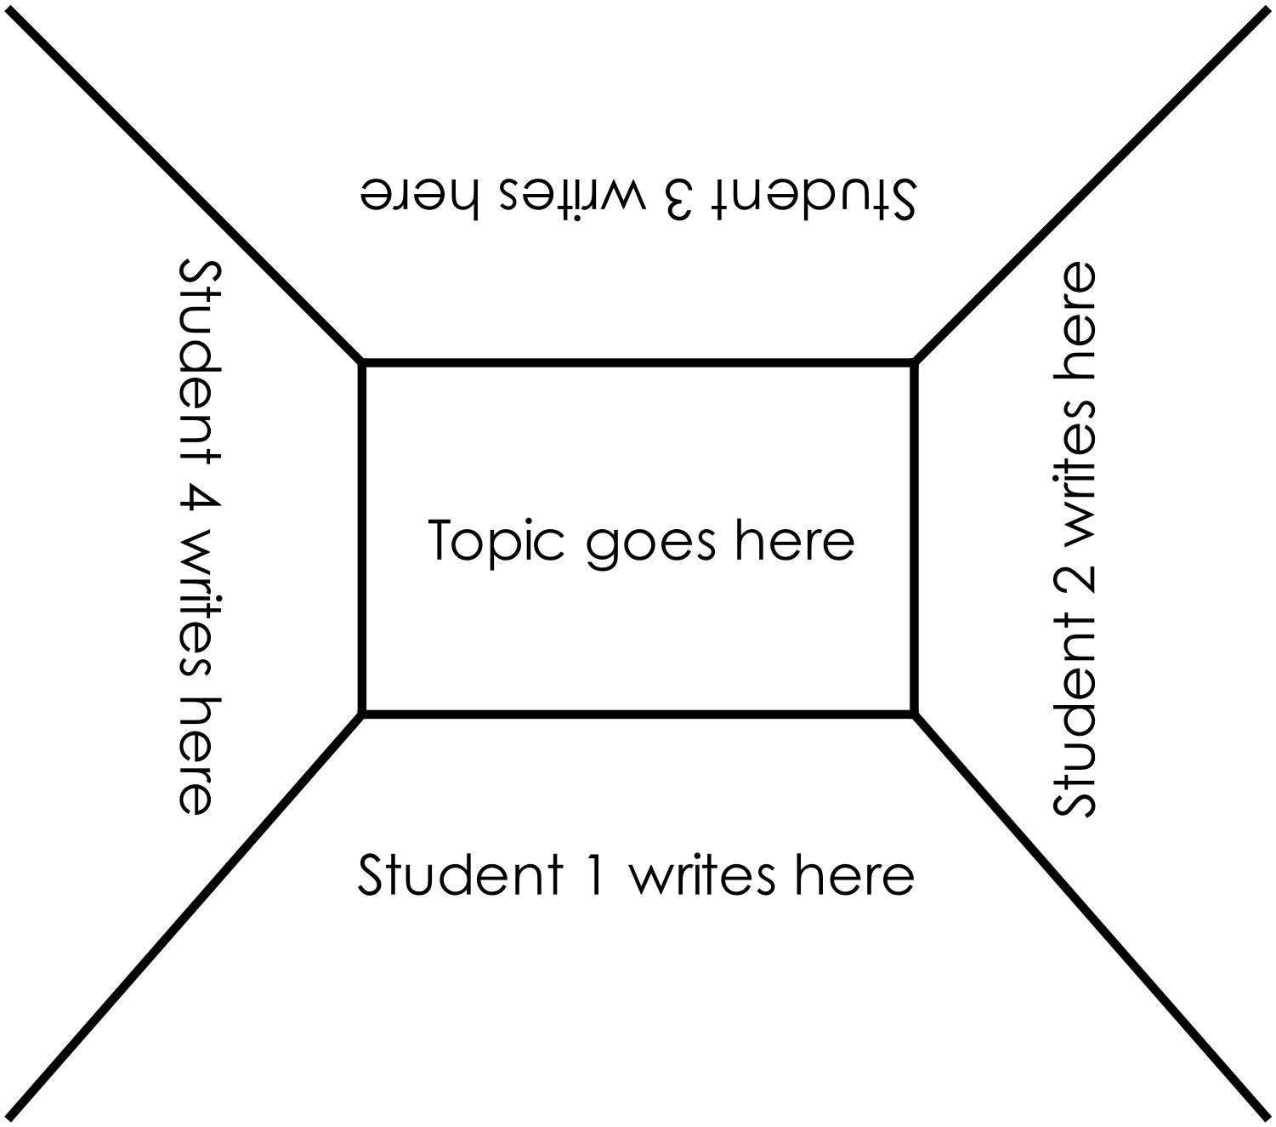

Appendix 9: Teacher resource sheet 1.4: Cooperative learning – Think, Pair, Share
This resource sheet provides a brief outline of a cooperative learning strategy known as 'think – pair – share'.
Cooperative learning frameworks create opportunities for groups of students to work together, generally to a single purpose.
As well as having the potential to increase learning for all students involved, using these frameworks can help students develop personal and social capability.
In the 'think' stage, each student thinks silently about a question asked by the teacher.
In the 'pair' stage, students discuss their thoughts and answers to the question in pairs.
In the 'share' stage, the students share their answer, their partners answer or what they decided together. This sharing may be with other pairs or with the whole class. It is important also to let students 'pass'. This is a key element of making the strategy safe for students.
Think – pair – share increases student participation and provides an environment for higher levels of thinking and questioning.

Appendix 10: Teacher resource sheet 1.5: Bushfire terminology
Weather conditions
It is a dry and very hot day.
Weather conditions
It is a hot and windy day.
Bushfire Danger Rating
It is a high fire danger rating day.

Bushfire Danger Rating
It is a medium fire danger rating day.
Weather Conditions
It is a warm day with no wind.

Bushfire Danger Rating
It is a low fire danger rating day.

Bushfire Danger Rating
It is an extreme fire danger rating day.

Weather conditions
It is a hot and dry day, where there has been little rainfall for some time.

Acknowledgement: Department of Fire and Emergency Services
www.dfes.wa.gov.au

Fire Danger Rating
Red + lines  Red  Orange  Yellow  Blue  Green | = catastrophic bushfire risk  = extreme bushfire risk  = severe bushfire risk  = very high bushfire risk  = high bushfire risk  = low bushfire risk
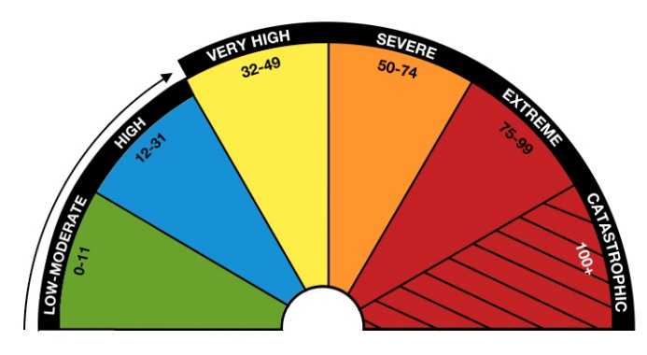
A Low-Moderate and High Bushfire Danger Rating may possibly indicate an unsafe fire time.
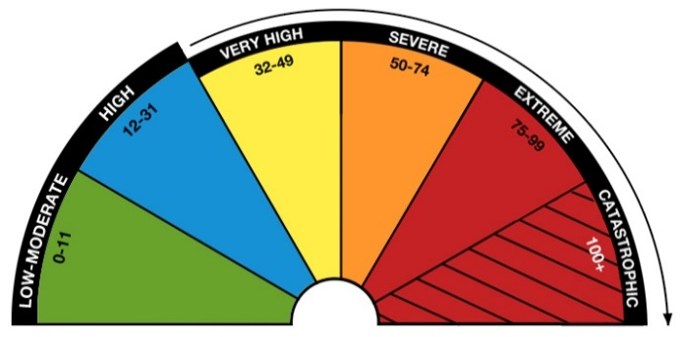
Increasing hot temperatures, dryness and wind bring a much greater bushfire risk. Campfires are banned when the Fire Danger Rating is Very High and above.
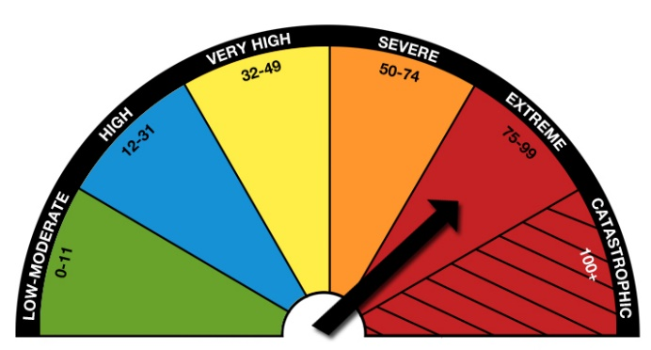
This day has an extreme fire danger rating and has an extreme bushfire risk.

Acknowledgement: Department of Fire and Emergency Services
www.dfes.wa.gov.au

Alert Level | Bushfire Warning - EMERGENCY WARNING
EMERGENCY WARNING  for western Prepareville | Bushfire risk:  You are danger. There is a threat to lives and homes.
What to do:
- You need to take immediate action.
- Close all doors and windows, and turn off evaporative air conditioners; but keep water running through the system if possible, so the pads remain wet and don’t catch on fire.
- If the way is clear, leave now for a safer place.
- If you cannot leave, you need to get ready to shelter in your home and actively defend it.
- If you are not at home, it is too dangerous now to return.
Alert Level | Bushfire Warning - WATCH AND ACT
WATCH AND ACT for southern Prepareville | Bushfire risk:  A bushfire is nearby and heading in your direction.
What to do:
- Put your bushfire survival plan into action. Do not wait for further warnings before you act.
- There is ember attack ahead of the fire, so close all doors and windows, and turn off evaporative air conditioners but keep water running through the system if possible.
- Leave now with your family for a safer place and take your emergency kit with you.

Alert Level | Bushfire Warning - ADVICE
ADVICE  for Makeaplan | Bushfire risk:  A bushfire has started. There is no immediate danger.
What to do:
- Stay alert and monitor your surroundings.
- Watch for signs of a bushfire, especially smoke and flames.
- Read through your bushfire survival plan.
Acknowledgement: Department of Fire and Emergency Services
www.dfes.wa.gov.au

Appendix 11: Teacher resource sheet 2.1: Flowcharting symbols
A flowchart is a diagrammatic representation of an algorithm. It can take the form of a branching set of shapes with decision-making steps. The shapes used in a flowchart are shown here with explanations of their purpose.

Terminator
This symbol is used to represent the start and end of a flowchart.
Process
This symbol is used to represent one or more instructions or things to do.
Data
This symbol is used to represent the input or output of any information.
Decision
This symbol is used to represent a point in the flowchart where a decision is made and from which two or more paths could be followed.
Flowline
This symbol is used to show the direction of the process or data flow.

Appendix 12: Teacher resource sheet 2.2: Flowchart example
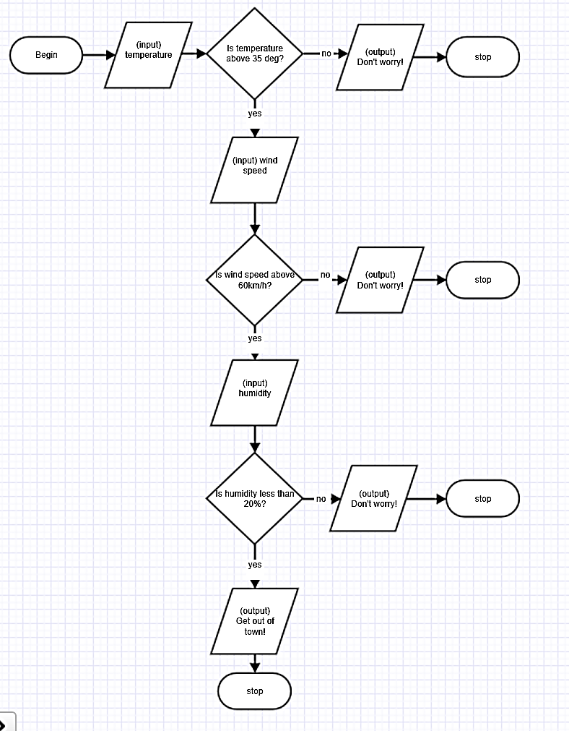

Appendix 13: Teacher resource sheet 2.3: Mathematical modelling
This resource sheet provides a number of possible fire prediction models. In all examples t = temperature in °C, h = % humidity,
w = wind speed in km/h). The following values have been used to test the individual models.
 | Yarloop fire | Summer day | Winter day
Mean maximum temperature (°C) | 40+ | 30.6 | 16.8
Mean relative humidity (%) | 20 | 54 | 82
Mean wind speed (km/h) | 60 | 13.4 | 10.4

Possible models | Example/testing using data above | Comments
Model 1  Risk = t + w + h | Yarloop fire:  Risk = 40 + 60 + 20 = 120  Summer day:  Risk = 30.6 + 13.4 + 54 = 98.0  Winter day:  Risk = 16.8 + 10.4 + 82 = 109.2 | - This is the simplest model. However, it is usually an error to add quantities that have different units.  - Students may or may not be aware of the need for added quantities to have the same units and examples using everyday items may help them to see that these totals do not have meaning eg. 5 oranges + 1 metre ruler = 6 ?  - Therefore, students should not be adding temperature, humidity and wind speed as the total does not have any real meaning.  - This model assumes all variables influence the risk in the same way (ie they all increase the risk). In reality, there is an inverse relationship between humidity and fire risk (as humidity increases the fire risk decreases). The higher risk ratings calculated in the testing, for a winter day compared with a summer day, emphasises the fault in this model.  - For this model to be appropriate 1 degree Celsius would have to have the equivalent effect on fire risk as 1% of humidity and 1 kmh-1 of wind speed.
Model 2  Risk = t + w - h | Yarloop fire:  Risk = 40 + 60 – 20 = 80  Summer day:  Risk = 30.6 + 13.4 – 54 = -10.0  Winter day:  Risk = 16.8 – 82 + 10.0 = – 54.8 | - This is another simple model. However, it is usually an error to add or subtract quantities that have different units.  - Students may or may not be aware of the need for added and subtracted quantities to have the same units and examples using everyday items may help them to see that these totals do not have meaning eg. 5 oranges + 1 metre ruler – 4 pillows = 2 ?  - Therefore, students should not be adding and/or subtracting temperature, humidity and wind speed as the total does not have any real meaning.  - This model is an improvement on Model 1 as it takes into consideration the inverse relationship between humidity and fire risk. The risk ratings calculated in the testing appears to rank the three days correctly.
Model 3  Risk = t x w x h | Yarloop fire:  Risk = 40 x 60 x 20 = 48 000  Summer day:  Risk = 30.6 x 13.4 x 54 = 22,142.16  Winter day:  Risk = 16.8 x 10.4 x 82 = 14,327.04 | - This is another simple model and it is possible to multiply and divide values with different units.  - The units for the total are non-standard as a combination of degrees Celsius, kilometres per hour and percentage of water vapour.  - This model assumes all variables influence the risk in the same way (ie they all increase the risk). In reality, there is an inverse relationship between humidity and fire risk (ie as humidity increases the fire risk decreases). The higher risk ratings calculated in the testing, for a winter day compared with a summer day, emphasises the fault in this model.  - For this model to be appropriate 1 degree Celsius would have to have the equivalent effect on fire risk as 1 kmh-1 of wind speed etc.
Model 4  Risk = t x w ÷ h | Yarloop fire:  Risk = 40 x 60 ÷ 20 = 120  Summer day:  Risk = 30.6 x 13.4 ÷ 54 = 7.59  Winter day:  Risk = 16.8 x 10.4 ÷ 82 = 2.13 | - It is possible to multiply and divide values with different units.  - The units for the total are non-standard as a combination of degrees Celsius, kilometres per hour and percentage of water vapour.  - This model is an improvement on Model 3 as it takes into consideration the inverse relationship between humidity and fire risk. The risk ratings calculated in the testing appears to rank the three days correctly.
Model 5  Risk = 2t – h + 1.5w | Yarloop fire:  Risk = (2 × 40) – 20 + (1.5 × 60) = 150  Summer day:  Risk = (2 × 30.6) – 54 + (1.5 × 13.4) = 27.3  Winter day:  Risk = (2 ×16.8) – 82 + (1.5 ×10) = – 32.8 | - Another consideration in building a numerical model is that the scales differ.  - The scales are:  - °C, which could have values from about 15 to 45  - %, which could be from 0 to 100  - km/h, which could have values from 0 to about 60  - As the scales differ and each variable has a different importance in affecting fire risk, a weighted model may be better.  - For example the variables could be weighted 2, -1 and 1.5 according to estimated importance
Model 6  Ordinal Scale  Risk = 2t + h + 1.5w | Using the table values would result in:  Yarloop fire:  Risk = (2 × 4) + 4 + (1.5 × 4) = 18  Summer day:  Risk = (2 × 3) + 2 + (1.5 × 1) = 9.5  Winter day:  Risk = (2 × 1) + 1 + (1.5 x 1) = 3.5 | - An ordinal scale could be used to emphasise the relative effect of extremes and can take into consideration the relative importance of, for example, extreme temperatures compared to high or moderate temperatures. For example,  Ordinal scale of fire risk 1 2 3 4  Mean maximum temperature (°C) < 30 30 – 35 36 - 38 > 38  Mean relative humidity (%) > 80 80 – 50 49 - 40 < 40  Mean wind speed (km/h) < 20 20 - 40 41 – 60 > 60  - An ordinal scale also removes the requirement for a combined unit of measurement. The unit of measurement could be ‘fire risk’.  - Possible overall risk rating scores for warning levels can then be applied.  Warning levels Overall risk rating  Extreme >10  High 8 - 10  Moderate 5 - 7  Low <5
.

Appendix 14: Teacher resource sheet 3.1: BoM data sets
The complexity of climate data is illustrated in these tables. However, it may be necessary to reduce data to a more simplified and concise format for students.

2016 Murray Road Bushfire (Western Australia)
Dates: 6 – 23 January 2016 Fatalities: 2 Houses burnt: 181 Area burnt: 69,915 ha

Climate data from BoM for Dwellingup (nearest weather station) for surrounding dates:
January
Date | Day | Temps |  | Rain | Evap | Sun | Max wind gust |  |  | 9 am |  |  |  |  |  | 3 pm
 |  | Min | Max |  |  |  | Dir | Spd | Time | Temp | RH | Cld | Dir | Spd | MSLP | Temp | RH | Cld | Dir | Spd | MSLP
 |  | °C | °C | mm | mm | hours | km/h |  | local | °C | % | 8th | km/h |  | hPa | °C | % | 8th | km/h |  | hPa
1 | Fr | 13.8 | 31.4 | 0 |  |  |  |  |  | 19.9 | 49 |  | ESE | 28 | 1017.2 | 30.0 | 24 |  |  |  | 1012.9
2 | Sa | 16.9 | 35.3 | 0 |  |  | ESE | 46 | 00:07 | 23.8 | 46 |  | E | 20 | 1012.7 | 34.6 | 24 |  | ESE | 13 | 1009.2
3 | Su | 17.7 | 35.1 | 0 |  |  | ESE | 48 | 06:12 | 24.5 | 52 |  | ESE | 26 | 1013.4 | 34.1 | 27 |  | ESE | 13 | 1010.9
4 | Mo | 19.0 | 34.3 | 0 |  |  | ESE | 39 | 00:05 | 22.9 | 56 |  | ESE | 17 | 1011.8 | 33.2 | 29 |  | WNW | 19 | 1009.6
5 | Tu | 17.1 | 32.6 | 0 |  |  | NW | 37 | 17:55 | 25.1 | 50 |  | ESE | 9 | 1011.9 | 30.8 | 39 |  | W | 15 | 1009.8
6 | We | 18.8 | 38.1 | 0 |  |  | ESE | 56 | 21:46 | 25.3 | 50 |  | E | 20 | 1015.2 | 35.0 | 18 |  | NE | 13 | 1012.6
7 | Th | 20.5 | 40.1 | 0 |  |  | ESE | 54 | 00:20 | 28.5 | 33 |  | E | 24 | 1017.0 | 38.5 | 13 |  | NNE | 13 | 1012.8
8 | Fr | 20.5 | 30.8 | 0 |  |  |  |  |  | 27.1 | 33 |  | ESE | 13 | 1013.9 | 26.3 | 56 |  | ENE | 28 | 1012.4
9 | Sa | 15.7 | 34.7 | 5.0 |  |  | NW | 43 | 16:42 | 26.9 | 41 |  | ENE | 6 | 1013.2 | 34.4 | 27 |  | NW | 17 | 1009.3
10 | Su | 17.6 | 25.9 | 0 |  |  | WNW | 35 | 13:08 | 20.5 | 69 |  | W | 13 | 1012.7 | 24.4 | 49 |  | WNW | 17 | 1011.7
11 | Mo | 15.1 | 26.6 | 0 |  |  | NW | 37 | 14:51 | 22.7 | 58 |  | NNW | 7 | 1012.1 | 25.1 | 50 |  | NW | 19 | 1011.0
12 | Tu | 17.0 | 24.1 | 1.4 |  |  | SSE | 44 | 22:18 | 19.6 | 80 |  | WSW | 13 | 1013.6 | 22.7 | 52 |  | WSW | 17 | 1014.1
13 | We | 11.6 | 28.5 | 0 |  |  | ESE | 59 | 08:49 | 17.7 | 48 |  | ESE | 28 | 1023.6 | 26.8 | 21 |  | ESE | 17 | 1021.2
14 | Th | 13.0 | 31.5 | 0 |  |  | ESE | 54 | 00:01 | 20.0 | 43 |  | E | 28 | 1024.8 | 30.6 | 17 |  | E | 22 | 1020.2
15 | Fr | 15.0 | 34.6 | 0 |  |  | SW | 39 | 18:12 | 25.3 | 32 |  | E | 17 | 1020.3 | 33.5 | 11 |  | ENE | 6 | 1016.2
16 | Sa | 18.6 | 36.4 | 0 |  |  | WNW | 46 | 14:27 | 29.3 | 29 |  | NE | 17 | 1014.6 | 34.0 | 21 |  | WNW | 22 | 1011.4
17 | Su | 16.9 | 32.0 | 0 |  |  | SSE | 52 | 19:26 | 26.1 | 46 |  | NW | 6 | 1010.7 | 30.5 | 30 |  | WSW | 15 | 1007.0
18 | Mo | 17.1 | 23.0 | 0 |  |  | N | 39 | 10:02 | 19.9 | 73 |  | N | 17 | 1004.7 | 21.0 | 60 |  | NW | 17 | 1003.2
19 | Tu | 14.2 | 24.7 | 0.6 |  |  | NE | 33 | 18:08 | 18.1 | 63 |  | NNW | 9 | 1005.2 | 17.7 | 73 |  | WNW | 4 | 1004.7
20 | We | 13.0 | 24.0 | 17.0 |  |  | S | 37 | 21:45 | 17.9 | 83 |  | SSE | 9 | 1008.0 | 22.3 | 57 |  | SSE | 11 | 1006.9
21 | Th | 13.9 | 23.3 | 0.2 |  |  | SSE | 35 | 09:05 | 18.0 | 78 |  | SSE | 17 | 1014.4 | 21.5 | 57 |  | SE | 13 | 1014.2
22 | Fr | 11.5 | 28.9 | 0 |  |  | E | 35 | 07:50 | 17.7 | 63 |  | ESE | 19 | 1018.6 | 27.3 | 28 |  | E | 9 | 1015.3
23 | Sa | 16.1 | 33.8 | 0 |  |  |  |  |  | 23.0 | 53 |  | ESE | 15 | 1016.3 | 27.0 | 40 |  | N | 30 | 1013.6
24 | Su | 17.4 | 34.6 | 2.0 |  |  | SE | 46 | 21:55 | 23.3 | 64 |  | ESE | 17 | 1016.2 | 33.0 | 26 |  | ENE | 9 | 1012.8
25 | Mo | 19.1 | 31.1 | 0 |  |  | ESE | 43 | 04:54 | 22.5 | 64 |  | E | 20 | 1012.0 | 29.5 | 47 |  | NE | 7 | 1009.0
26 | Tu | 18.5 | 32.7 | 0 |  |  | SE | 46 | 21:09 | 22.8 | 66 |  | E | 17 | 1013.6 | 30.1 | 35 |  | SSW | 13 | 1011.0
27 | We | 17.3 | 31.6 | 0 |  |  |  |  |  | 21.2 | 59 |  | ESE | 24 | 1017.1 | 29.8 | 27 |  | ESE | 19 | 1015.0
28 | Th | 14.2 | 31.7 | 0 |  |  | ESE | 57 | 07:40 | 19.9 | 53 |  | ESE | 28 | 1018.2 | 30.9 | 19 |  | E | 22 | 1014.9
29 | Fr | 15.6 | 34.7 | 0 |  |  | E | 57 | 06:44 | 22.0 | 52 |  | E | 28 | 1014.9 | 33.6 | 21 |  | NE | 13 | 1010.7
30 | Sa | 17.2 | 21.2 | 2.2 |  |  | E | 43 | 00:16 | 18.5 | 78 |  | S | 15 | 1009.1 | 18.6 | 86 |  | ENE | 17 | 1005.5
31 | Su | 17.4 | 21.0 | 14.2 |  |  | SW | 54 | 13:14 | 19.8 | 81 |  | WSW | 7 | 1001.5 | 16.8 | 68 |  | S | 24 | 1003.0
Statistics for January 2016
Mean |  | 16.4 | 30.6 |  |  |  |  |  |  | 22.3 | 56 |  |  | 17 | 1013.8 | 28.5 | 37 |  |  | 15 | 1011.4
Lowest |  | 11.5 | 21.0 | 0 |  |  |  |  |  | 17.7 | 29 |  | # | 6 | 1001.5 | 16.8 | 11 |  | WNW | 4 | 1003.0
Highest |  | 20.5 | 40.1 | 17.0 |  |  | ESE | 59 |  | 29.3 | 83 |  | # | 28 | 1024.8 | 38.5 | 86 |  | N | 30 | 1021.2
Total |  |  |  | 42.6

Climate data from BoM for Dwellingup in June
Date | Day | Temps |  | Rain | Evap | Sun | Max wind gust |  |  | 9 am |  |  |  |  |  | 3 pm
 |  | Min | Max |  |  |  | Dir | Spd | Time | Temp | RH | Cld | Dir | Spd | MSLP | Temp | RH | Cld | Dir | Spd | MSLP
 |  | °C | °C | mm | mm | hours | km/h |  | local | °C | % | 8th | km/h |  | hPa | °C | % | 8th | km/h |  | hPa
1 | We | 3.5 | 18.7 | 0 |  |  | E | 28 | 11:39 | 8.4 | 93 |  | SE | 13 | 1024.3 | 18.2 | 45 |  | ESE | 13 | 1021.3
2 | Th | 4.5 | 19.1 | 0 |  |  |  |  |  | 9.7 | 87 |  | ESE | 15 | 1022.0 | 18.4 | 39 |  | ENE | 13 | 1017.4
3 | Fr | 8.1 | 21.3 | 0 |  |  | W | 46 | 23:10 | 14.4 | 65 |  | NE | 13 | 1013.5 | 19.9 | 56 |  | NNW | 17 | 1010.6
4 | Sa | 10.7 | 15.3 | 9.6 |  |  | WSW | 46 | 03:47 | 11.0 | 83 |  | SSW | 15 | 1015.6 | 14.4 | 50 |  | SW | 13 | 1015.8
5 | Su | 2.4 | 15.1 | 0.2 |  |  | ENE | 22 | 10:48 | 5.4 | 93 |  | SE | 11 | 1017.6 | 14.6 | 55 |  | ENE | 9 | 1014.3
6 | Mo | 1.5 | 15.4 | 0 |  |  | SW | 54 | 20:22 | 9.3 | 94 |  | NE | 11 | 1011.0 | 12.8 | 85 |  | N | 15 | 1006.5
7 | Tu | 7.9 | 12.5 | 12.4 |  |  | SSW | 52 | 14:51 | 8.7 | 82 |  | SSW | 15 | 1010.4 | 10.5 | 65 |  | SSW | 28 | 1012.9
8 | We | 4.7 | 12.9 | 0 |  |  | S | 43 | 10:52 | 8.1 | 69 |  | SSW | 19 | 1024.8 | 12.1 | 54 |  | SSW | 15 | 1024.7
9 | Th | 7.6 | 13.2 | 0 |  |  | NNW | 30 | 09:40 | 10.1 | 72 |  | NNW | 13 | 1027.3 | 11.5 | 84 |  | N | 13 | 1025.5
10 | Fr | 9.5 | 17.0 | 6.0 |  |  | N | 30 | 04:23 | 13.1 | 94 |  | NW | 6 | 1026.3 | 15.8 | 65 |  | NW | 11 | 1025.7
11 | Sa | 7.5 | 17.2 | 0.4 |  |  | NNE | 39 | 12:14 | 10.8 | 81 |  | NE | 17 | 1026.5 | 16.1 | 52 |  | NNE | 17 | 1022.7
12 | Su | 9.8 | 20.1 | 0 |  |  | N | 50 | 14:20 | 13.5 | 56 |  | NNE | 17 | 1019.2 | 17.8 | 46 |  | N | 24 | 1013.5
13 | Mo | 6.6 | 16.3 | 26.8 |  |  | SSE | 37 | 21:20 | 10.6 | 95 |  | NW | 9 | 1015.7 | 15.9 | 68 |  | WSW | 9 | 1016.0
14 | Tu | 10.5 | 17.0 | 0.2 |  |  | SSE | 37 | 09:43 | 12.7 | 83 |  | SE | 19 | 1023.5 | 15.5 | 68 |  | SSE | 19 | 1021.6
15 | We | 9.9 | 16.1 | 0.2 |  |  | SSE | 26 | 01:35 | 12.1 | 86 |  | SE | 13 | 1022.4 | 15.5 | 66 |  | ESE | 6 | 1021.0
16 | Th | 7.1 | 17.5 | 0.2 |  |  | SSE | 24 | 18:18 | 10.4 | 93 |  | SSE | 9 | 1022.3 | 15.3 | 72 |  | SSE | 11 | 1020.0
17 | Fr | 7.6 | 15.5 | 0 |  |  | ESE | 37 | 09:46 | 8.8 | 89 |  | ESE | 13 | 1023.9 | 13.6 | 62 |  | E | 15 | 1021.7
18 | Sa | 4.5 | 16.8 | 0.2 |  |  | NNE | 35 | 14:20 | 9.1 | 88 |  | NE | 13 | 1022.0 | 16.6 | 52 |  | N | 17 | 1017.1
19 | Su | 6.9 | 17.8 | 0 |  |  |  |  |  | 11.6 | 73 |  | N | 15 | 1011.1 | 15.3 | 91 |  | NW | 19 | 1008.0
20 | Mo | 11.0 | 15.2 | 19.2 |  |  | SW | 39 | 22:04 | 12.9 | 95 |  | WNW | 6 | 1009.9 | 14.6 | 75 |  | WNW | 17 | 1008.3
21 | Tu | 4.3 | 14.3 | 0.4 |  |  | S | 33 | 01:23 | 8.3 | 93 |  | Calm |  | 1016.8 | 13.1 | 56 |  | SSW | 7 | 1016.0
22 | We | 6.5 | 15.9 | 0.4 |  |  | SW | 41 | 16:16 | 10.4 | 94 |  | W | 2 | 1017.3 | 15.3 | 56 |  | W | 19 | 1015.9
23 | Th | 6.5 | 14.7 | 3.0 |  |  | SSW | 28 | 02:33 | 8.9 | 91 |  | SSE | 11 | 1021.4 | 13.3 | 58 |  | SSE | 9 | 1020.4
24 | Fr | 4.5 | 14.3 | 0 |  |  | NNE | 30 | 10:28 | 8.8 | 79 |  | NNE | 9 | 1020.5 | 13.7 | 59 |  | NNW | 11 | 1017.3
25 | Sa | 8.7 | 15.1 | 6.2 |  |  | NNW | 35 | 02:09 | 10.1 | 94 |  | SSW | 15 | 1019.5 | 14.0 | 44 |  | SSW | 11 | 1020.5
26 | Su | 0.6 | 15.2 | 0.4 |  |  | N | 33 | 12:05 | 5.0 | 94 |  | N | 7 | 1025.4 | 14.0 | 58 |  | NNW | 13 | 1022.7
27 | Mo | 5.0 | 15.9 | 0 |  |  | NNE | 39 | 12:09 | 10.7 | 56 |  | N | 15 | 1020.4 | 15.1 | 43 |  | NNW | 20 | 1015.9
28 | Tu | 4.2 | 15.2 | 4.4 |  |  | W | 48 | 17:09 | 13.0 | 92 |  | NNW | 19 | 1012.4 | 14.7 | 91 |  | NNW | 13 | 1010.8
29 | We | 9.0 | 16.1 | 33.4 |  |  |  |  |  | 12.6 | 92 |  | W | 11 | 1017.7 | 15.0 | 62 |  | WSW | 15 | 1019.4
30 | Th | 1.7 | 16.3 | 0.4 |  |  | SSW | 19 | 12:12 | 5.2 | 94 |  | Calm |  | 1027.1 | 15.8 | 55 |  | W | 6 | 1024.8
Statistics for June 2016
Mean |  | 6.4 | 16.1 |  |  |  |  |  |  | 10.1 | 85 |  |  | 11 | 1019.6 | 14.9 | 61 |  |  | 14 | 1017.6
Lowest |  | 0.6 | 12.5 | 0 |  |  |  |  |  | 5.0 | 56 |  | Calm |  | 1009.9 | 10.5 | 39 |  | # | 6 | 1006.5
Highest |  | 11.0 | 21.3 | 33.4 |  |  | SW | 54 |  | 14.4 | 95 |  | # | 19 | 1027.3 | 19.9 | 91 |  | SSW | 28 | 1025.7
Total |  |  |  | 124.0

2015–16 Great Ocean Road Bushfire (Victoria)
Dates: 25 December – 5 January 2016 Fatalities: none Houses burnt: 116 Area burnt: 2,200 ha

Climate data from BoM for Aireys Inlet (nearest weather station) for surrounding dates: December 2015
Date | Day | Temps |  | Rain | Evap | Sun | Max wind gust |  |  | 9 am |  |  |  |  |  | 3 pm
 |  | Min | Max |  |  |  | Dir | Spd | Time | Temp | RH | Cld | Dir | Spd | MSLP | Temp | RH | Cld | Dir | Spd | MSLP
 |  | °C | °C | mm | mm | hours | km/h |  | local | °C | % | 8th | km/h |  | hPa | °C | % | 8th | km/h |  | hPa
1 | Tu | 11.0 | 21.2 | 0.8 |  |  | WSW | 65 | 14:16 | 14.6 | 64 |  | NW | 15 |  | 17.8 | 38 |  | WNW | 28
2 | We | 6.8 | 17.9 | 0 |  |  | SSW | 56 | 15:08 | 12.5 | 54 |  | WSW | 13 |  | 15.7 | 53 |  | SSW | 31
3 | Th | 10.7 | 20.6 | 0 |  |  | S | 24 | 14:36 | 13.7 | 70 |  | WNW | 7 |  | 17.8 | 63 |  | S | 15
4 | Fr | 11.9 | 20.8 | 0 |  |  | S | 26 | 15:43 | 15.6 | 77 |  | ENE | 9 |  | 19.5 | 68 |  | E | 9
5 | Sa | 13.2 | 21.5 | 0 |  |  | SSW | 30 | 12:42 | 15.7 | 85 |  | SW | 15 |  | 20.3 | 66 |  | SSW | 17
6 | Su | 14.3 | 19.7 | 0 |  |  | SW | 30 | 21:16 | 16.5 | 92 |  | S | 9 |  | 18.6 | 82 |  | SE | 7
7 | Mo | 16.1 | 24.7 | 0 |  |  | ESE | 30 | 06:22 | 16.8 | 91 |  | E | 7 |  | 18.9 | 78 |  | SE | 4
8 | Tu | 16.2 | 33.7 | 0 |  |  | NW | 91 | 06:32 | 20.1 | 80 |  | NNW | 31 |  | 24.0 | 48 |  | SSW | 28
9 | We | 15.5 | 24.5 | 0 |  |  |  |  |  | 18.5 | 60 |  | WNW | 28 |  | 23.8 | 41 |  | WSW | 20
10 | Th | 9.9 | 21.7 |  |  |  | SSW | 28 | 15:14 | 17.1 | 56 |  | ENE | 7 |  | 19.4 | 51 |  | SSE | 13
11 | Fr | 12.3 | 20.5 | 0 |  |  | WSW | 76 | 14:24 | 14.8 | 62 |  | W | 26 |  | 14.8 | 55 |  | SW | 39
12 | Sa | 8.4 | 18.2 | 0 |  |  | SW | 41 | 07:23 | 13.5 | 51 |  | SSW | 19 |  | 15.3 | 54 |  | SSW | 20
13 | Su | 8.6 | 19.9 | 0 |  |  | E | 28 | 10:27 | 15.9 | 61 |  | NE | 11 |  | 18.3 | 57 |  | S | 13
14 | Mo | 11.3 | 20.8 | 0 |  |  | S | 26 | 16:57 | 16.9 | 74 |  | SSW | 11 |  | 18.1 | 61 |  | SSE | 13
15 | Tu | 11.7 | 22.5 | 0 |  |  | S | 22 | 13:52 | 16.2 | 80 |  | ESE | 6 |  | 20.9 | 63 |  | S | 15
16 | We | 16.1 | 23.0 | 0 |  |  | SSW | 26 | 16:22 | 16.8 | 94 |  | SE | 7 |  | 20.9 | 73 |  | S | 11
17 | Th | 16.1 | 29.3 | 0 |  |  | SW | 33 | 12:39 | 20.8 | 76 |  | E | 9 |  | 25.0 | 64 |  | SW | 13
18 | Fr | 17.1 | 23.7 | 0 |  |  | SSW | 35 | 14:07 | 18.8 | 87 |  | SW | 15 |  | 18.7 | 83 |  | SSW | 20
19 | Sa | 14.9 | 43.0 | 0 |  |  | NW | 76 | 13:42 | 23.0 | 68 |  | E | 7 |  | 38.5 | 15 |  | WNW | 13
20 | Su | 22.5 | 33.6 | 0.2 |  |  | WNW | 72 | 11:22 | 30.4 | 33 |  | WSW | 20 |  | 17.7 | 86 |  | W | 26
21 | Mo | 13.3 | 20.2 | 1.8 |  |  | SW | 57 | 03:42 | 15.2 | 71 |  | SW | 22 |  | 19.0 | 47 |  | SSW | 26
22 | Tu | 12.6 | 21.7 | 0 |  |  | SW | 35 | 18:53 | 15.8 | 56 |  | SE | 9 |  | 20.5 | 51 |  | SSE | 15
23 | We | 14.3 | 22.6 | 0 |  |  | SSE | 30 | 14:37 | 18.9 | 71 |  | S | 11 |  | 21.0 | 69 |  | S | 19
24 | Th | 15.4 | 26.6 | 0 |  |  | E | 26 | 17:24 | 19.4 | 77 |  | SE | 6 |  | 23.5 | 60 |  | ESE | 9
25 | Fr | 19.4 | 37.2 | 0 |  |  | N | 63 | 07:28 | 26.5 | 35 |  | N | 33 |  | 36.1 | 17 |  | NNW | 22
26 | Sa | 11.3 | 18.9 | 16.4 |  |  | SW | 78 | 01:52 | 11.8 | 88 |  | WSW | 15 |  | 16.3 | 71 |  | SW | 37
27 | Su | 9.8 | 20.2 | 3.4 |  |  | SSW | 41 | 15:10 | 13.6 | 67 |  | SW | 17 |  | 19.1 | 50 |  | SSW | 22
28 | Mo | 12.7 | 20.3 | 0 |  |  | SSW | 26 | 18:48 | 16.7 | 55 |  | S | 11 |  | 19.6 | 53 |  | S | 15
29 | Tu | 11.7 | 21.7 | 0 |  |  | S | 24 | 14:55 | 17.2 | 69 |  | SSE | 6 |  | 20.1 | 57 |  | S | 13
30 | We | 11.6 | 29.3 | 0 |  |  | E | 19 | 11:25 | 17.9 | 74 |  | ENE | 4 |  | 22.7 | 61 |  | SE | 6
31 | Th | 17.8 | 39.9 | 0 |  |  | WNW | 48 | 13:14 | 29.0 | 22 |  | NW | 19 |  | 36.3 | 19 |  | SSE | 15
Statistics for December 2015
Mean |  | 13.4 | 24.5 |  |  |  |  |  |  | 17.7 | 67 |  |  | 13 |  | 21.2 | 56 |  |  | 17
Lowest |  | 6.8 | 17.9 | 0 |  |  |  |  |  | 11.8 | 22 |  | ENE | 4 |  | 14.8 | 15 |  | SE | 4
Highest |  | 22.5 | 43.0 | 16.4 |  |  | NW | 91 |  | 30.4 | 94 |  | N | 33 |  | 38.5 | 86 |  | SW | 39
Total |  |  |  | 22.6

January 2016
Date | Day | Temps |  | Rain | Evap | Sun | Max wind gust |  |  | 9 am |  |  |  |  |  | 3 pm
 |  | Min | Max |  |  |  | Dir | Spd | Time | Temp | RH | Cld | Dir | Spd | MSLP | Temp | RH | Cld | Dir | Spd | MSLP
 |  | °C | °C | mm | mm | hours | km/h |  | local | °C | % | 8th | km/h |  | hPa | °C | % | 8th | km/h |  | hPa
1 | Fr | 18.0 | 23.2 | 0 |  |  | SSW | 57 | 15:06 | 20.2 | 66 |  | SSW | 17 |  | 21.6 | 69 |  | SSW | 22
2 | Sa | 15.0 | 22.2 | 0 |  |  | SSW | 63 | 01:37 | 17.1 | 94 |  | S | 24 |  | 20.2 | 75 |  | SSE | 22
3 | Su | 16.8 | 21.1 | 0 |  |  | ESE | 52 | 17:19 | 17.4 | 73 |  | ESE | 17 |  | 19.9 | 66 |  | SE | 22
4 | Mo | 16.7 | 21.8 | 0 |  |  | ESE | 46 | 21:39 | 18.1 | 78 |  | E | 17 |  | 21.1 | 60 |  | ESE | 22
5 | Tu | 16.3 | 23.8 | 0 |  |  | E | 43 | 00:15 | 17.7 | 73 |  | ESE | 13 |  | 22.2 | 63 |  | SSE | 17
6 | We | 17.3 | 21.8 | 0 |  |  | S | 37 | 21:52 | 17.9 | 87 |  | SE | 15 |  | 19.9 | 73 |  | SSE | 15
7 | Th | 15.4 | 21.7 | 0 |  |  | SW | 52 | 20:08 | 17.2 | 69 |  | SSW | 20 |  | 19.8 | 53 |  | SSW | 28
8 | Fr | 14.4 | 21.9 |  |  |  | SSW | 39 | 01:43 | 16.3 | 63 |  | SW | 19 |  | 20.7 | 53 |  | S | 19
9 | Sa | 12.7 | 22.6 | 0 |  |  | SSW | 33 | 17:14 | 16.2 | 75 |  | WSW | 9 |  | 21.2 | 60 |  | SSW | 17
10 | Su | 12.9 | 27.5 | 0 |  |  | NNE | 24 | 21:47 | 16.4 | 74 |  | N | 7 |  | 19.9 | 64 |  | ESE | 9
11 | Mo | 16.4 | 34.7 | 0 |  |  | SSW | 44 | 16:43 | 27.5 | 32 |  | NNW | 11 |  | 22.6 | 66 |  | SW | 11
12 | Tu | 16.0 | 23.1 | 0.2 |  |  | ESE | 22 | 11:29 | 17.5 | 75 |  | SE | 7 |  | 21.1 | 59 |  | ESE | 9
13 | We | 15.4 | 36.3 | 0 |  |  | NW | 54 | 16:18 | 23.0 | 67 |  | NE | 11 |  | 31.1 | 39 |  | SE | 11
14 | Th | 15.5 | 19.2 | 0.4 |  |  | SSW | 72 | 15:57 | 15.8 | 63 |  | SW | 30 |  | 17.4 | 52 |  | SSW | 39
15 | Fr | 12.0 | 21.0 | 0.2 |  |  | SSW | 56 | 02:09 | 15.0 | 54 |  | S | 20 |  | 19.4 | 39 |  | S | 19
16 | Sa | 14.1 | 22.1 | 0 |  |  | S | 28 | 12:56 | 17.6 | 58 |  | SSE | 9 |  | 20.9 | 51 |  | S | 15
17 | Su | 14.9 | 27.1 | 0 |  |  | S | 22 | 23:04 | 19.0 | 69 |  | ESE | 6 |  | 25.3 | 54 |  | SE | 7
18 | Mo | 17.7 | 35.9 | 0 |  |  | NW | 57 | 10:32 | 27.0 | 25 |  | NW | 31 |  | 25.6 | 51 |  | SW | 19
19 | Tu | 13.4 | 24.1 | 0 |  |  | SSW | 24 | 16:07 | 19.0 | 65 |  | ENE | 4 |  | 21.2 | 66 |  | S | 11
20 | We | 15.2 | 22.6 | 1.8 |  |  | SSE | 19 | 15:32 | 17.4 | 84 |  | Calm |  |  | 21.7 | 75 |  | S | 9
21 | Th | 16.6 | 19.6 | 0 |  |  | S | 24 | 17:27 | 17.5 | 91 |  | Calm |  |  | 18.4 | 78 |  | SSE | 6
22 | Fr | 15.0 | 18.6 | 2.0 |  |  | WSW | 35 | 06:04 | 16.0 | 94 |  | NW | 6 |  | 17.7 | 94 |  | SE | 4
23 | Sa | 15.4 | 22.1 | 6.0 |  |  | SSW | 48 | 13:17 | 17.4 | 81 |  | WSW | 13 |  | 19.9 | 68 |  | SSW | 24
24 | Su | 14.8 | 23.6 | 0 |  |  | S | 35 | 19:21 | 17.1 | 80 |  | WSW | 13 |  | 20.6 | 67 |  | SSW | 19
25 | Mo | 16.1 | 21.8 | 0 |  |  | SSW | 43 | 16:52 | 17.3 | 64 |  | S | 19 |  | 19.7 | 57 |  | SW | 26
26 | Tu | 16.6 | 23.0 | 0 |  |  | ESE | 39 | 21:53 | 18.9 | 80 |  | SE | 13 |  | 22.5 | 66 |  | SE | 19
27 | We | 18.0 | 24.8 | 0 |  |  | ESE | 43 | 03:20 | 18.8 | 87 |  | E | 9 |  | 20.6 | 91 |  | ENE | 9
28 | Th | 17.9 | 23.1 | 3.0 |  |  | NW | 37 | 04:22 | 21.4 | 69 |  | WNW | 11 |  | 20.7 | 73 |  | E | 11
29 | Fr | 13.3 | 22.0 | 0 |  |  | SSW | 33 | 12:42 | 15.2 | 71 |  | W | 7 |  | 17.8 | 71 |  | SSE | 17
30 | Sa | 11.8 | 22.5 | 0 |  |  | ESE | 30 | 21:02 | 16.8 | 81 |  | SSE | 6 |  | 21.2 | 63 |  | SSE | 13
31 | Su | 16.1 | 23.6 | 12.2 |  |  | ENE | 33 | 15:18 | 16.9 | 93 |  | ENE | 13 |  | 21.9 | 62 |  | E | 17
Statistics for January 2016
Mean |  | 15.4 | 23.8 |  |  |  |  |  |  | 18.3 | 72 |  |  | 12 |  | 21.1 | 63 |  |  | 16
Lowest |  | 11.8 | 18.6 | 0 |  |  |  |  |  | 15.0 | 25 |  | Calm |  |  | 17.4 | 39 |  | SE | 4
Highest |  | 18.0 | 36.3 | 12.2 |  |  | SSW | 72 |  | 27.5 | 94 |  | NW | 31 |  | 31.1 | 94 |  | SSW | 39
Total |  |  |  | 25.8

Climate data from BoM for Aireys Inlet: June 2016
Date | Day | Temps |  | Rain | Evap | Sun | Max wind gust |  |  | 9 am |  |  |  |  |  | 3 pm
 |  | Min | Max |  |  |  | Dir | Spd | Time | Temp | RH | Cld | Dir | Spd | MSLP | Temp | RH | Cld | Dir | Spd | MSLP
 |  | °C | °C | mm | mm | hours | km/h |  | local | °C | % | 8th | km/h |  | hPa | °C | % | 8th | km/h |  | hPa
1 | We | 7.2 | 15.3 | 0.2 |  |  | NNW | 13 | 06:30 | 8.9 | 92 |  | NNW | 6 |  | 13.2 | 68 |  | E | 7
2 | Th | 8.8 | 14.4 | 0 |  |  | ESE | 22 | 23:49 | 11.2 | 89 |  | S | 2 |  | 12.9 | 79 |  | SSE | 6
3 | Fr | 11.0 | 14.5 | 0 |  |  | E | 35 | 08:02 | 13.4 | 74 |  | E | 20 |  | 13.9 | 82 |  | ESE | 9
4 | Sa | 11.4 | 14.5 | 5.0 |  |  | E | 26 | 01:41 | 13.1 | 92 |  | ENE | 13 |  | 13.9 | 90 |  | SSW | 7
5 | Su | 12.6 | 16.0 | 1.2 |  |  | NW | 22 | 13:16 | 12.8 | 95 |  | WNW | 9 |  | 14.1 | 79 |  | NW | 13
6 | Mo | 7.4 | 14.8 | 0 |  |  | NW | 30 | 23:50 | 9.9 | 84 |  | NW | 17 |  | 13.7 | 70 |  | N | 9
7 | Tu | 8.9 | 15.7 | 0 |  |  | NW | 52 | 07:18 | 10.7 | 90 |  | NW | 24 |  | 14.6 | 79 |  | W | 15
8 | We | 10.4 | 14.5 | 0.4 |  |  | NW | 48 | 13:43 | 10.7 | 86 |  | NW | 13 |  | 13.1 | 76 |  | NNW | 19
9 | Th | 10.4 | 15.6 | 6.6 |  |  | NW | 57 | 10:51 | 11.4 | 83 |  | NW | 26 |  | 13.5 | 82 |  | W | 17
10 | Fr | 7.6 | 15.1 | 0.4 |  |  | NW | 63 | 09:23 | 9.1 | 89 |  | NW | 24 |  | 14.4 | 66 |  | NW | 24
11 | Sa | 7.4 | 12.7 | 5.2 |  |  | WSW | 56 | 12:11 | 9.0 | 81 |  | WSW | 26 |  | 10.4 | 62 |  | SW | 33
12 | Su | 7.0 | 13.0 | 0.2 |  |  | NW | 35 | 22:47 | 8.0 | 79 |  | NW | 22 |  | 11.9 | 64 |  | NNW | 9
13 | Mo | 6.8 | 13.0 | 0 |  |  | NNW | 37 | 12:48 | 7.9 | 69 |  | NW | 19 |  | 12.5 | 60 |  | NNW | 19
14 | Tu | 5.5 | 13.8 | 0 |  |  | NNW | 59 | 07:59 | 8.5 | 72 |  | NW | 13 |  | 12.8 | 67 |  | WNW | 11
15 | We | 7.8 | 15.7 | 0 |  |  | NW | 41 | 06:30 | 9.7 | 80 |  | NW | 22 |  | 14.9 | 63 |  | NW | 13
16 | Th | 6.5 | 13.3 | 0 |  |  | NNW | 48 | 21:11 | 8.3 | 74 |  | NNE | 11 |  | 9.6 | 84 |  | N | 11
17 | Fr | 8.2 | 12.8 | 4.4 |  |  | SSW | 41 | 22:21 | 12.3 | 92 |  | WNW | 9 |  | 12.5 | 94 |  | WNW | 13
18 | Sa | 10.1 | 12.5 | 7.2 |  |  | SSW | 35 | 01:07 | 10.6 | 69 |  | S | 15 |  | 11.8 | 66 |  | SSW | 13
19 | Su | 9.4 | 13.9 | 0 |  |  | SE | 30 | 23:27 | 9.6 | 91 |  | NNE | 4 |  | 12.4 | 79 |  | SSE | 9
20 | Mo | 9.5 | 13.8 | 0.6 |  |  | SSW | 43 | 14:09 | 12.8 | 86 |  | S | 22 |  | 13.3 | 74 |  | SSW | 28
21 | Tu | 9.3 | 13.7 | 0 |  |  | NNW | 57 | 11:42 | 9.9 | 83 |  | NNW | 13 |  | 11.0 | 90 |  | NNW | 20
22 | We | 8.8 | 13.8 | 2.0 |  |  | W | 61 | 12:43 | 9.1 | 85 |  | WNW | 24 |  | 13.2 | 69 |  | W | 24
23 | Th | 9.1 | 13.4 | 1.4 |  |  | NNW | 96 | 11:50 | 10.4 | 84 |  | NNW | 44 |  | 10.6 | 88 |  | NNW | 48
24 | Fr | 3.5 | 7.9 | 2.8 |  |  | SW | 72 | 13:54 | 4.7 | 89 |  | WNW | 26 |  | 7.3 | 70 |  | W | 26
25 | Sa | 3.0 | 13.5 | 4.4 |  |  | SW | 41 | 02:18 | 7.7 | 73 |  | W | 13 |  | 11.6 | 71 |  | WNW | 7
26 | Su | 4.6 | 11.2 | 0 |  |  | NNW | 59 | 12:40 | 6.0 | 79 |  | N | 6 |  | 10.4 | 63 |  | NNW | 17
27 | Mo | 5.8 | 12.1 | 0 |  |  | NW | 61 | 03:56 | 7.2 | 86 |  | NW | 33 |  | 11.1 | 71 |  | WNW | 17
28 | Tu | 7.2 | 15.1 | 0 |  |  | NW | 57 | 03:46 | 9.2 | 81 |  | NW | 26 |  | 13.5 | 76 |  | NW | 17
29 | We | 8.9 | 15.3 | 0 |  |  | N | 50 | 15:05 | 9.6 | 82 |  | NW | 24 |  | 13.4 | 56 |  | N | 26
30 | Th | 7.7 | 10.7 | 4.0 |  |  | WNW | 67 | 15:07 | 7.8 | 95 |  | N | 35 |  | 9.2 | 91 |  | NNW | 33
Statistics for June 2016
Mean |  | 8.1 | 13.7 |  |  |  |  |  |  | 9.7 | 83 |  |  | 18 |  | 12.4 | 74 |  |  | 17
Lowest |  | 3.0 | 7.9 | 0 |  |  |  |  |  | 4.7 | 69 |  | S | 2 |  | 7.3 | 56 |  | SSE | 6
Highest |  | 12.6 | 16.0 | 7.2 |  |  | NNW | 96 |  | 13.4 | 95 |  | NNW | 44 |  | 14.9 | 94 |  | NNW | 48
Total |  |  |  | 46.0

2015 Pinery Bushfire (South Australia)
Dates: 25 November – 2 December 2015 Fatalities: 2 Area burnt: 85,000 ha

Climate data from BoM for Rosedale (nearest weather station) for surrounding dates: November 2015
Date | Day | Temps |  | Rain | Evap | Sun | Max wind gust |  |  | 9 am |  |  |  |  |  | 3 pm
 |  | Min | Max |  |  |  | Dir | Spd | Time | Temp | RH | Cld | Dir | Spd | MSLP | Temp | RH | Cld | Dir | Spd | MSLP
 |  | °C | °C | mm | mm | hours | km/h |  | local | °C | % | 8th | km/h |  | hPa | °C | % | 8th | km/h |  | hPa
1 | Su | 12.5 | 25.4 | 0 | 8.8 |  |  |  |  | 16.5 | 94 | 8 | N | 2
2 | Mo | 12.4 | 23.2 | 0.2 | 6.2 |  |  |  |  | 17.1 | 87 | 8 | Calm
3 | Tu | 12.8 | 28.7 | 0 | 4.8 |  |  |  |  | 19.0 | 59 | 8 | E | 11
4 | We | 17.4 | 25.0 | 5.6 | 6.6 |  |  |  |  | 21.5 | 86 | 2 | E | 2
5 | Th | 14.5 | 19.8 | 20.0 | 3.8 |  |  |  |  | 16.6 | 94 | 8 | W | 4
6 | Fr | 13.9 | 21.5 | 0.4 | 2.2 |  |  |  |  | 15.5 | 94 | 8 | WSW | 2
7 | Sa | 8.5 | 31.2 | 0 | 3.2 |  |  |  |  | 15.5 | 84 | 4 | NE | 2
8 | Su | 14.5 | 36.0 | 0 | 6.8 |  |  |  |  | 24.5 | 57 | 4 | NE | 6
9 | Mo | 21.0 | 37.0 | 0 | 7.6 |  |  |  |  | 31.1 | 49 | 7 | NNW | 2
10 | Tu | 19.0 | 27.0 | 0 | 9.6 |  |  |  |  | 21.0 | 73 | 8 | E | 2
11 | We | 14.2 | 26.5 | 0 | 5.0 |  |  |  |  | 16.7 | 79 | 7 | E | 7
12 | Th | 14.0 | 25.8 | 3.2 | 4.0 |  |  |  |  | 20.0 | 77 | 1 | Calm
13 | Fr | 6.6 | 22.5 | 0 | 9.6 |  |  |  |  | 15.0 | 75 | 6 | SSW | 4
14 | Sa | 6.0 | 23.5 | 0 | 7.0 |  |  |  |  | 14.5 | 78 | 2 | SSE | 2
15 | Su | 6.5 | 25.4 | 0 | 4.0 |  |  |  |  | 14.0 | 78 | 2 | W | 2
16 | Mo | 7.5 | 31.0 | 0 | 7.2 |  |  |  |  | 24.0 | 39 | 0 | ENE | 11
17 | Tu | 11.8 | 36.2 | 0 | 7.8 |  |  |  |  | 28.0 | 22 | 2 | NW | 2
18 | We | 16.2 | 40.4 | 0 | 11.2 |  |  |  |  | 34.0 | 14 | 6 | N | 11
19 | Th | 19.2 | 40.0 | 0 | 12.2 |  |  |  |  | 31.2 | 37 | 2 | SE | 2
20 | Fr | 16.0 | 22.8 | 0 | 11.4 |  |  |  |  | 20.5 | 65 | 8 | SW | 6
21 | Sa | 7.4 | 23.3 | 0 | 6.2 |  |  |  |  | 16.8 | 55 | 5 | SE | 4
22 | Su | 4.5 | 21.9 | 0 | 7.4 |  |  |  |  | 14.5 | 68 | 1 | WNW | 2
23 | Mo | 9.8 | 23.2 | 0 | 5.6 |  |  |  |  | 16.6 | 65 | 8 | SW | 4
24 | Tu | 6.4 | 31.0 | 0 | 6.8 |  |  |  |  | 18.0 | 67 | 0 | E | 7
25 | We | 13.2 | 36.5 | 0 | 10.0 |  |  |  |  | 31.0 | 31 | 6 | NNW | 11
26 | Th | 11.4 | 18.9 | 0 | 7.6 |  |  |  |  | 14.6 | 57 | 7 | SW | 4
27 | Fr | 3.2 | 21.7 | 0 | 8.2 |  |  |  |  | 15.0 | 54 | 2 | S | 4
28 | Sa | 5.0 | 24.2 | 0 | 6.0 |  |  |  |  | 16.5 | 60 | 1 | E | 2
29 | Su | 10.5 | 29.6 | 0 | 6.2 |  |  |  |  | 18.0 | 66 | 3 | ENE | 2
30 | Mo | 17.5 | 35.8 | 0 | 8.0 |  |  |  |  | 29.5 | 45 | 2 | N | 15
Statistics for November 2015
Mean |  | 11.8 | 27.8 |  | 7.0 |  |  |  |  | 20.2 | 63 | 4 |  | 4
Lowest |  | 3.2 | 18.9 | 0 | 2.2 |  |  |  |  | 14.0 | 14 | 0 | Calm
Highest |  | 21.0 | 40.4 | 20.0 | 12.2 |  |  |  |  | 34.0 | 94 | 8 | N | 15
Total |  |  |  | 29.4 | 211.0

December 2015:
Date | Day | Temps |  | Rain | Evap | Sun | Max wind gust |  |  | 9 am |  |  |  |  |  | 3 pm
 |  | Min | Max |  |  |  | Dir | Spd | Time | Temp | RH | Cld | Dir | Spd | MSLP | Temp | RH | Cld | Dir | Spd | MSLP
 |  | °C | °C | mm | mm | hours | km/h |  | local | °C | % | 8th | km/h |  | hPa | °C | % | 8th | km/h |  | hPa
1 | Tu | 12.4 | 20.5 | 0 | 10.2 |  |  |  |  | 19.2 | 61 | 2 | W | 19
2 | We | 2.2 | 21.2 | 0 | 4.0 |  |  |  |  | 14.6 | 56 | 4 | Calm
3 | Th | 9.4 | 29.2 | 0 | 8.4 |  |  |  |  | 18.0 |  | 0 | E | 11
4 | Fr | 12.1 | 35.5 | 0 | 7.8 |  |  |  |  | 27.5 |  | 6 | NNE | 4
5 | Sa | 21.5 | 40.3 | 0 | 10.4 |  |  |  |  | 30.7 |  | 1 | NE | 6
6 | Su | 23.5 | 43.0 | 0 | 13.2 |  |  |  |  | 35.3 |  | 7 | NNW | 6
7 | Mo | 30.0 | 38.2 | 0 | 15.6 |  |  |  |  | 34.3 |  | 8 | NE | 13
8 | Tu | 15.4 | 27.0 | 2.6 | 9.8 |  |  |  |  | 23.5 | 65 | 0 | NW | 4
9 | We | 15.2 | 25.7 | 0 | 9.4 |  |  |  |  | 20.4 | 63 | 6 | WSW | 7
10 | Th | 10.9 | 27.0 | 0 | 7.2 |  |  |  |  | 18.5 | 63 | 4 | E | 2
11 | Fr | 13.4 | 22.8 | 0 | 9.0 |  |  |  |  | 17.8 | 58 | 6 | W | 11
12 | Sa | 4.0 | 25.7 | 0 | 6.2 |  |  |  |  | 15.2 | 49 | 1 | ESE | 6
13 | Su | 9.8 | 34.1 | 0 | 7.0 |  |  |  |  | 22.2 | 35 | 8 | NE | 4
14 | Mo | 15.8 | 37.2 | 0 | 9.2 |  |  |  |  | 29.5 | 25 | 2 | E | 7
15 | Tu | 19.0 | 35.5 | 1.6 | 10.0 |  |  |  |  | 23.5 | 60 | 8 | E | 4
16 | We | 20.8 | 40.8 | 0 | 7.6 |  |  |  |  | 32.5 | 37 | 3 | NE | 11
17 | Th | 24.2 | 42.3 | 0 | 13.0 |  |  |  |  | 35.8 | 18 | 0 | NNE | 7
18 | Fr | 18.2 | 42.7 | 0 | 12.2 |  |  |  |  | 33.5 | 28 | 0 | SE | 4
19 | Sa | 26.0 | 42.8 | 0 | 14.4 |  |  |  |  | 38.2 | 29 | 8 | N | 6
20 | Su | 20.5 | 24.4 | 1.2 | 9.0 |  |  |  |  | 20.5 | 100 | 8 | W | 6
21 | Mo | 11.0 | 25.2 | 1.2 | 5.0 |  |  |  |  | 16.8 | 75 | 8 | E | 7
22 | Tu | 10.4 | 31.7 | 0 | 6.0 |  |  |  |  | 20.2 | 62 | 0 | E | 11
23 | We | 10.8 | 34.3 | 0 | 8.4 |  |  |  |  | 24.9 | 49 | 1 | E | 7
24 | Th | 18.0 | 38.6 | 0 | 11.2 |  |  |  |  | 29.2 | 53 | 0 | ENE | 11
25 | Fr | 23.5 | 38.4 | 0 | 12.0 |  |  |  |  | 32.5 | 52 | 6 | N | 6
26 | Sa | 14.0 | 23.8 | 0 | 10.0 |  |  |  |  | 17.5 | 66 | 3 | SSW | 6
27 | Su | 5.5 | 26.5 | 0 | 8.0 |  |  |  |  | 15.0 | 68 | 0 | ENE | 9
28 | Mo | 14.5 | 30.9 | 0 | 11.2 |  |  |  |  | 19.2 | 63 | 0 | E | 9
29 | Tu | 14.0 | 35.2 | 0 | 8.0 |  |  |  |  | 26.1 | 60 | 0 | E | 4
30 | We | 21.3 | 38.1 | 0 | 12.0 |  |  |  |  | 29.0 | 55 | 8 | NE | 4
31 | Th | 21.0 | 39.5 | 0 | 8.2 |  |  |  |  | 32.5 | 47 | 3 | Calm
Statistics for December 2015
Mean |  | 15.8 | 32.8 |  | 9.5 |  |  |  |  | 25.0 | 53 | 3 |  | 6
Lowest |  | 2.2 | 20.5 | 0 | 4.0 |  |  |  |  | 14.6 | 18 | 0 | Calm
Highest |  | 30.0 | 43.0 | 2.6 | 15.6 |  |  |  |  | 38.2 | 100 | 8 | W | 19
Total |  |  |  | 6.6 | 293.6

Climate data from BoM for Rosedale (nearest weather station) for June 2016
Date | Day | Temps |  | Rain | Evap | Sun | Max wind gust |  |  | 9 am |  |  |  |  |  | 3 pm
 |  | Min | Max |  |  |  | Dir | Spd | Time | Temp | RH | Cld | Dir | Spd | MSLP | Temp | RH | Cld | Dir | Spd | MSLP
 |  | °C | °C | mm | mm | hours | km/h |  | local | °C | % | 8th | km/h |  | hPa | °C | % | 8th | km/h |  | hPa
1 | We | 9.4 | 19.5 | 1.4 | 0.4 |  |  |  |  | 12.2 | 92 | 7 | E | 2
2 | Th | 10.4 | 18.0 | 0 | 1.8 |  |  |  |  | 13.0 | 77 | 7 | Calm
3 | Fr | 3.9 | 17.5 | 0 | 1.2 |  |  |  |  | 9.0 | 92 | 6 | Calm
4 | Sa | 3.0 | 16.0 | 0 | 1.7 |  |  |  |  | 8.3 | 96 | 4 | Calm
5 | Su | 7.5 | 15.2 | 0 | 0.9 |  |  |  |  | 11.5 | 82 | 8 | NW | 2
6 | Mo | 9.6 | 16.1 | 5.0 | 1.8 |  |  |  |  | 12.6 | 91 | 7 | W | 22
7 | Tu | 8.4 | 15.7 | 1.6 | 1.2 |  |  |  |  | 12.1 | 94 | 8 | W | 4
8 | We | 9.5 | 17.5 | 3.0 | 0.6 |  |  |  |  | 12.0 | 88 | 8 | ENE | 4
9 | Th | 10.9 | 15.0 | 5.6 | 2.6 |  |  |  |  | 13.2 | 97 | 8 | W | 7
10 | Fr | 10.0 | 15.2 | 5.0 | 1.6 |  |  |  |  | 12.1 | 89 | 8 | NW | 2
11 | Sa | 4.5 | 15.2 | 5.6 | 1.2 |  |  |  |  | 6.7 | 97 | 8 | S | 2
12 | Su | 5.2 | 13.8 | 0.2 | 0.6 |  |  |  |  | 7.5 | 86 | 7 | NE | 2
13 | Mo | 1.0 | 14.5 | 0 | 1.4 |  |  |  |  | 5.5 | 84 | 4 | E | 2
14 | Tu | 5.5 | 20.5 | 0 | 1.6 |  |  |  |  | 11.5 | 82 | 1 | Calm
15 | We | 7.5 | 18.7 | 0 | 0.8 |  |  |  |  | 11.7 | 80 | 2 | E | 2
16 | Th | 11.7 | 15.2 | 1.4 | 2.2 |  |  |  |  | 14.4 | 87 | 8 | N | 4
17 | Fr | 12.2 | 15.8 | 7.0 | 1.8 |  |  |  |  | 13.2 | 100 | 8 | W | 2
18 | Sa | 9.5 | 14.7 | 4.2 | 0.8 |  |  |  |  | 11.0 | 78 | 8 | SE | 2
19 | Su | 8.5 | 13.5 | 0.2 | 2.0 |  |  |  |  | 10.5 | 87 | 2 | Calm
20 | Mo | 3.7 | 14.0 | 0.2 | 1.2 |  |  |  |  | 8.0 | 100 | 8 | Calm
21 | Tu | 6.6 | 13.8 | 7.6 | 1.4 |  |  |  |  | 10.5 | 94 | 8 | NW | 4
22 | We | 8.5 | 15.4 | 4.2 | 1.0 |  |  |  |  | 11.0 | 90 | 8 | NW | 4
23 | Th | 10.0 | 13.2 | 0.4 | 1.0 |  |  |  |  | 11.5 | 82 | 5 | NW | 7
24 | Fr | 6.0 | 12.7 | 23.0 | 4.0 |  |  |  |  | 8.0 | 87 | 3 | W | 4
25 | Sa | 3.0 | 13.8 | 0.2 | 1.0 |  |  |  |  | 6.5 | 93 | 8 | SE | 2
26 | Su | 6.0 | 13.5 | 0 | 1.0 |  |  |  |  | 9.2 | 84 | 8 | NE | 2
27 | Mo | 5.5 | 14.5 | 0.8 | 0.8 |  |  |  |  | 10.0 | 96 | 8 | Calm
28 | Tu | 4.5 | 15.5 | 0.2 | 1.4 |  |  |  |  | 8.3 | 86 | 2 | NNW | 2
29 | We | 2.0 | 12.7 | 0 | 1.6 |  |  |  |  | 6.0 | 93 | 8 | Calm
30 | Th | 5.5 | 13.7 | 0.8 | 1.0 |  |  |  |  | 10.9 | 89 | 2 | WNW | 15
Statistics for June 2016
Mean |  | 7.0 | 15.3 |  | 1.4 |  |  |  |  | 10.3 | 89 | 6 |  | 3
Lowest |  | 1.0 | 12.7 | 0 | 0.4 |  |  |  |  | 5.5 | 77 | 1 | Calm
Highest |  | 12.2 | 20.5 | 23.0 | 4.0 |  |  |  |  | 14.4 | 100 | 8 | W | 22
Total |  |  |  | 77.6 | 41.6

Acknowledgement: Bureau of Meteorology

Appendix 15: Student activity sheet 4.1: Peer evaluation
 | Always | Usually | Sometimes | Rarely
Remains focused on tasks presented
Completes set tasks to best of their ability
Works independently without disrupting others
Uses time well
Cooperates effectively within the group
Contributes to group discussions
Shows respect and consideration for others
Uses appropriate conflict resolution skills
Actively seeks and uses feedback

Comments: __________________________________________________________________________________________________________________________________________________________________________________________________________________________________________________________________________________________________________________________________________________________

Appendix 16: Student activity sheet 4.2: Self-evaluation
Algorithm Reflection
Photograph or drawing
What did you make? | How did you feel about your algorithm?
What did you like about your algorithm? | What could you have done better?
What would you do differently?

Notes
________________________________________________________________________________________________________________________________________________________________________________________________________________________________________________________________________________________________________________________________________________________________________________________________________________________________________________________________________________________________________________________________________________________________________________________________________________________________________________________________________________________________________________________________________________________________________________________________________________________________________________________________________________________________________________________________________________________________________________________________________________________________________________________________________________________________________________________________________________________________________________________________________________________________________________________________________________________________________________________________________________________________________________________________________________________________________________________________________________________________________________________________________________________________________

