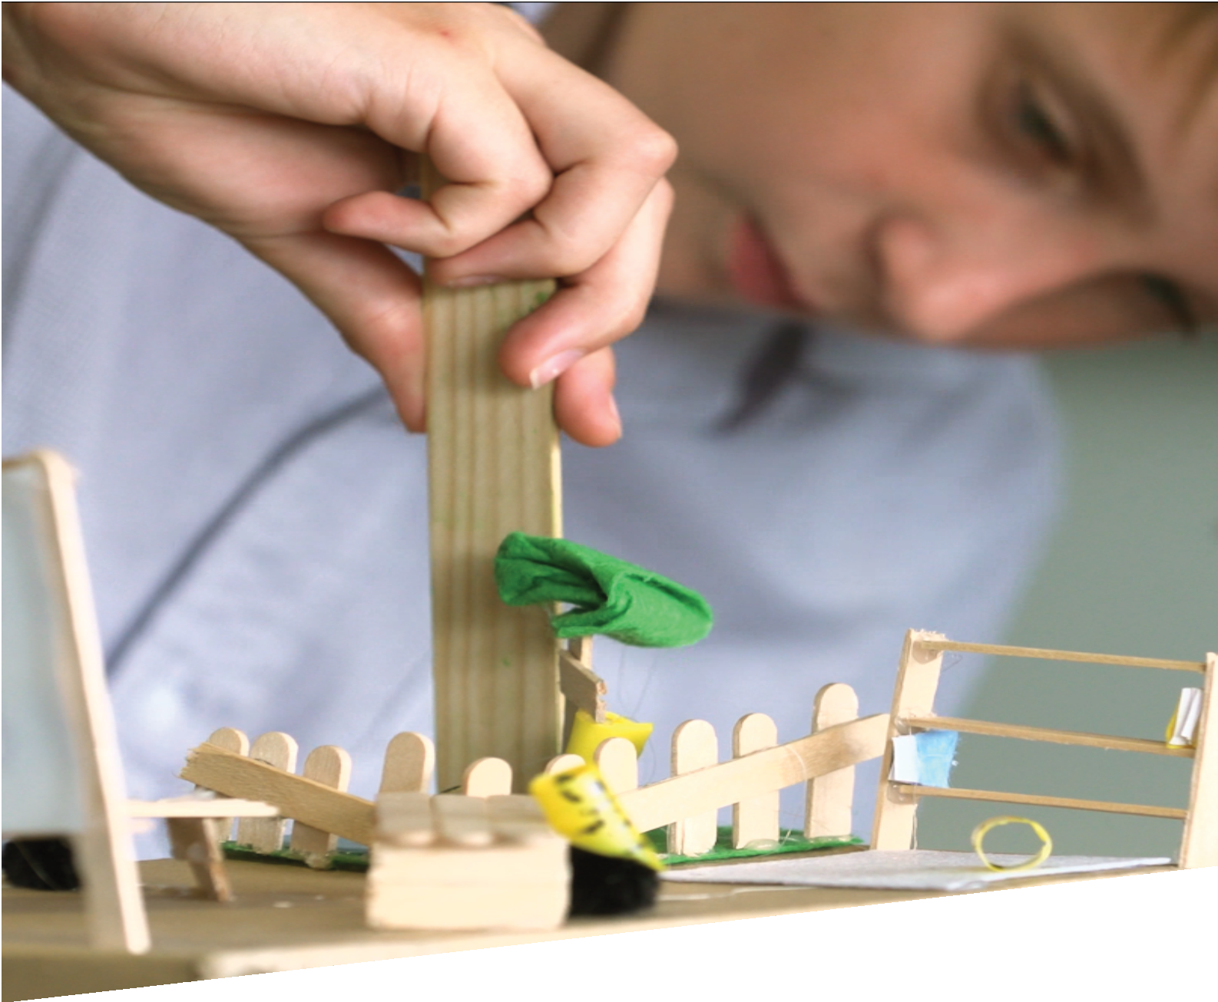

CURRICULUM RESOURCE MODULE
Sustainable classrooms
YEAR 7

Acknowledgements
The STEM Learning Project respectfully acknowledges the Traditional Custodians of the lands upon which our students and teachers live, learn and educate.

The STEM Learning Project is funded by the Western Australian Department of Education (the Department) and implemented by a consortium in STEM education comprising the Educational Computing Association of WA, the Mathematical Association of WA, the Science Teachers Association of WA and Scitech. We acknowledge and thank the teachers and schools who are the co-creators of these resources.
Copyright and intellectual property
The copyright and intellectual property of this module remain the property of the Department.

Any Western Australian Curriculum content in this resource is used with the permission of the School Curriculum and Standards Authority (the Authority); this permission does not constitute Authority endorsement of the resource. The Authority accepts no liability for any errors or damages arising from reliance on its content.

The Western Australian Curriculum content may be freely copied, or communicated on an intranet, for non-commercial purposes in educational institutions, provided that the Authority is acknowledged as the copyright owner. Copying or communication for any other purpose can be done only within the terms of the Copyright Act 1968 or with prior written permission of the Authority. Any Australian Curriculum content in the Western Australian Curriculum is used by the Authority under the terms of the Creative Commons Attribution-NonCommercial 3.0 Australia licence.

Any content on the www.scsa.wa.edu.au domain that has been derived from the Australian Curriculum may be used under the terms of Creative Commons Attribution-NonCommercial 3.0 Australia licence.

Appendix 2: General capabilities continuums is adapted from ACARA, © Australian Curriculum, Assessment and Reporting Authority (ACARA) 2009 to present, unless otherwise indicated. This material was downloaded from the ACARA website (www.acara.edu.au) (accessed December 2015) and was not modified. The material is licensed under CC BY 4.0 (https://creativecommons.org/licenses/by/4.0/). ACARA does not endorse any product that uses ACARA material or make any representations as to the quality of such products. Any product that uses material published on this website should not be taken to be affiliated with ACARA or have the sponsorship or approval of ACARA. It is up to each person to make their own assessment of the product.

This resource includes references and examples of iOS, Android and other apps. The Department does not endorse or recommend any commercial products and simply provides these as examples for teachers.

The Department is committed to providing quality information to its customers. Whilst every effort has been made to ensure accuracy, currency and reliability of the information within these documents, the Department accepts no responsibility for errors, omissions or amendments made since the time of publishing. Confirmation of information may be sought from the Department or the originating bodies providing the information. The Department has no control over the content of material published on websites to which users are referred in this resource. It is the responsibility of the internet user to make their own decision as to the relevancy, accuracy, currency and reliability of information found on those sites.

This resource contains various images from iStock used under license.

Attributions: Microsoft Excel and PowerPoint, Keynote, Kidblog, Weebly, Evernote, Autodesk,
Tinkercad, SketchUp, Sway, Prezi.
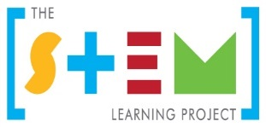
Table of contents
The STEM Learning Project 2
Overview 3
Activity sequence and purpose 8
Background 9
Activity 1: Why sustainability? 12
Activity 2: Our school’s sustainability 25
Activity 3: Designing sustainable classrooms 42
Activity 4: Sharing sustainable classrooms 50
Appendix 1: Links to the Western Australian Curriculum 55
Appendix 1B: Mathematics proficiency strands 59
Appendix 2: General capabilities continuums 60
Appendix 3: Materials list 64
Appendix 4: Design process guide 65
Appendix 5: Drawing in the design process 66
Appendix 6: Student journal 67
Appendix 7: Student activity sheet 1.0: Journal checklist 68
Appendix 8: Teacher resource sheet 1.1: Cooperative learning – Roles 69
Appendix 9: Teacher resource sheet 1.2: Cooperative learning – Placemat 70
Appendix 10: Teacher resource sheet 1.3: Cooperative learning – Think, Pair, Share 71
Appendix 11: Teacher resource sheet 1.4: Cooperative learning – Silent card sort 72
Appendix 12: Student activity sheet 1.5: Resource cards 73
Appendix 13: Teacher resource sheet 1.6: Water cycle 75
Appendix 14: Student activity sheet 1.7: Water cycle 76
Appendix 15: Student activity sheet 2.1: Investigation checklist 78
Appendix 16: Teacher resource sheet 3.1: Flowcharting symbols 79
Appendix 17: Teacher resource sheet 3.2: Flowchart example 80
Appendix 18: Teacher resource sheet 4.1: Design evaluation 81
Appendix 19: Teacher resource sheet 4.2: Evaluation 82
Appendix 20: Student activity sheet 4.3: Peer evaluation 83
Appendix 21: Student activity sheet 4.4: Self-evaluation 84

The STEM Learning Project
The aim of the STEM Learning Project is to generate students’ interest, enjoyment and engagement with STEM (Science, Technology, Engineering and Mathematics) and to encourage their ongoing participation in STEM both at school and in subsequent careers. The curriculum resources will support teachers to implement and extend the Western Australian Curriculum across Kindergarten to Year 12 and develop the general capabilities.
Why STEM?
A quality STEM education will develop the knowledge and intellectual skills to drive the innovation required to address global economic, social and environmental challenges.
STEM capability is the key to navigating the employment landscape changed by globalisation and digital disruption. Routine manual and cognitive jobs are in decline whilst non-routine cognitive jobs are growing strongly in Australia. Seventy-five per cent of the jobs in the emerging economy will require critical and creative thinking and problem-solving, supported by skills of collaboration, teamwork and literacy in mathematics, science and technology. This is what we call STEM capability. The vision is to respond to the challenges of today and tomorrow by preparing students for a world that requires multidisciplinary STEM thinking and capability.
The approach
STEM capabilities are developed when students are challenged to solve open-ended, real-world problems that engage students in the processes of the STEM disciplines.
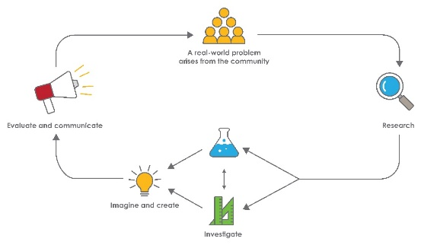
Year 7 – Sustainable classrooms
STEM Consortium

Overview
In the 21st century, research organisations are reporting that unchecked human population growth, accompanied by increasing consumption of natural resources, is having a dramatic destructive impact on the environment. According to the Executive Director of the United Nations Environmental Program ‘It is essential that we understand the pace of environmental change that is upon us and that we start to work with nature instead of against it to tackle the array of environmental threats that face us.’ (United Nations Sustainable Development Goals 2016)
In this module, students develop an awareness of several ways the environmental impact of human development can be reduced in the context of their classroom and school’s use of energy and material resources.
Students have the opportunity to make positive, practical and actionable changes at a school level. They engage in planning for greater sustainability in classrooms of the future using real and anticipated technological advances.
What is the context?
Clean energy, sustainable cities and communities, responsible consumption and production and climate action are all United Nations Sustainable Development Goals for 2030. As global citizens, it is everybody’s responsibility to contribute towards achieving these goals. A focus on increasing water and energy efficiency and the use of environmentally friendly resources and building products in a school context can help students understand how these considerations can be generalised and contribute to global sustainability.
What is the problem?
How can we improve the sustainability of our classrooms now and in the future?

How does this module support integration of the STEM disciplines?
Science
Students consider the relative sustainability of various resources (ACSSU116: Some of Earth’s resources are renewable but others are non-renewable) and investigate the consumption of electricity and water at their school. They consolidate their understanding of electricity sources from Year 6 and are introduced to Year 7 Science content regarding the water cycle (ACSSU222: Water is an important resource that cycles through the environment).
When investigating the effects of the Sun on room temperature, students learn how the relative positions of the Sun and Earth create the seasons (ACSSU115: Predictable phenomena on Earth, including seasons and eclipses, are caused by the relative positions of the sun, Earth and the moon). They plan and conduct an investigation (ACSIS125: Collaboratively and individually plan and conduct a range of investigation types, including fieldwork and experiments, ensuring safety and ethical guidelines are followed), measure and control variables (ACSIS126: Measure and control variables, select equipment appropriate to the task and collect data with accuracy), and have the opportunity to construct representations of their data (ACSIS129: Construct and use a range of representations, including graphs, keys and models to represent and analyse patterns or relationships in data using digital technologies as appropriate).
When researching the history of school buildings in Activity 1, and during their planning of future classrooms in Activity 3, students engage with the idea that scientific knowledge changes over time as new evidence becomes available (ACSHE119: Scientific knowledge has changed peoples’ understanding of the world and is refined as new evidence becomes available). In Activity 4 they communicate sustainability ideas to a wider audience (ACSIS133: Communicate ideas, findings and evidence-based solutions to problems using scientific language, and representations, using digital technologies as appropriate).
Technologies
When researching changes in school buildings over time and when considering their plan for a future classroom, students have opportunities to understand some of the competing considerations that are important in the development of technologies (ACTDEK029: Competing factors, including social, ethical and sustainability considerations, in the development of technologies) and ways in which products, services and environments evolve locally, regionally and globally (ACTDEK030: Ways in which products, services and environments evolve locally, regionally and globally). They also carefully consider the selection and combination of appropriate materials, systems, components, tools and equipment (ACTDEK034: Material and technology decisions and processes influence the selection and combination of materials, systems, components, tools and equipment).
Students’ design automated digital control systems in their plans for a future classroom (ACTDIK023: Different types of networks, including wired, wireless and mobile networks) and have the opportunity to design the user experience of a digital system (ACTDIP028: Design the user experience of a digital system) and create a user interface (ACTDIP030: create digital solutions that include a user interface where choices can be made).
The Design process guide is included as a resource to help teachers understand the complete design process as developed in the Technologies curriculum under Processes and Production Skills (WATPPS39: Define and break down a given task, identifying the purpose; WATPPS40: Consider components/resources to develop solutions, identifying constraints; WATPPS41: Design, develop, review and communicate design ideas, plans and processes within a given context, using a range of techniques, appropriate technical terms and technology and WATPPS44: Independently apply given contextual criteria to evaluate design processes and solutions).
Mathematics
Students practise measurement and number calculation skills in their investigations and use geometry in their designs and models. The opportunity for explicit teaching of Number and Algebra is provided when students use percentages to compare data (ACMNA158: Find percentages of quantities and express one quantity as a percentage of another, with and without digital technologies).
Students calculate mean, median, mode and range for sets of data and interpret these statistics to determine aspects of energy usage (ACMSP171: Calculate mean, median, mode and range for sets of data. Interpret these statistics in the context of data). They describe and interpret data displays (ACMSP172: Describe and interpret data displays using median, mean and range) when compiling the results of their investigations in Activity 2 and when reporting to the school community in Activity 4.
Students also identify and investigate issues they have encountered during the collection of their data (ACMSP169: Identify and investigate issues involving numerical data collected from primary and secondary sources) as they investigate the use of water and electricity at their school and conduct an investigation into room temperatures during Activity 2. Their investigations should engage students in all four mathematics proficiencies, with a focus on understanding and problem-solving.

General capabilities
There are opportunities for the development of the general capabilities and cross-curriculum priorities as students engage with Sustainable classrooms. In this module, students:
- Develop critical and creative thinking skills as they research the problem and its context (Activity 1); investigate parameters impacting on the problem (Activity 2); imagine and develop solutions (Activity 3); and evaluate and communicate their solutions to an audience (Activity 4).
- Utilise creative thinking as they generate possible design solutions; and critical thinking, numeracy skills, and ethical understanding as they investigate the issues and choose between alternative approaches to solving the problem of how to reduce the use of energy and other resources in the classroom.
- Utilise personal and social capability as they develop socially cohesive and effective working teams; collaborate in generating solutions; adopt group roles; and reflect on their group work capabilities through sharing their ideas, responding to the suggestions of others and engaging in self and peer evaluation.
- Utilise a range of literacies and information and communication technology capabilities as they collate records of work completed throughout the module in a journal, represent their data appropriately, and represent and communicate their solutions to an audience using digital technologies.
- Communicate and, using evidence, justify their groups’ designs to the school community through face-to-face presentations and by distributing information in hard copy or by electronic means.

What are the pedagogical principles of the STEM learning modules?
The STEM Learning Project modules develop STEM capabilities by challenging students to solve real-world problems set in authentic contexts. The problems engage students in the STEM disciplines and provide opportunities for developing higher order thinking and reasoning, and the general capabilities of creativity, critical thinking, communication and collaboration.
The design of the modules is based on four pedagogical principles:
- Problem-based learning
All modules are designed around students solving an open-ended, real-world problem. Learning is supported through a four-phase instructional model: research the problem and its context; investigate the parameters impacting on the problem; design and develop solutions to the problem; and evaluate and communicate solutions to an authentic audience.
- Developing higher order thinking
Opportunities are created for higher order thinking and reasoning through questioning and discourse that elicits students' thinking, prompts and scaffolds explanations, and requires students to justify their claims. Opportunities for making reasoning visible through discourse are highlighted in the modules with the icon shown here.
- Collaborative learning
This provides opportunities for students to develop teamwork and leadership skills, challenge each other’s ideas, and co-construct explanations and solutions. Information that can support teachers with aspects of collaborative learning is included in the resource sheets.
- Reflective practice
Recording observations, ideas and one’s reflections on the learning experiences in some form of journal fosters deeper engagement and metacognitive awareness of what is being learnt. Information that can support teachers with journaling is included in the resource sheets.
These pedagogical principles can be explored further in the STEM Learning Project online professional learning modules located in Connect Resources.

Activity sequence and purpose
Why sustainability?
Students are introduced to the concept of global sustainability. They research renewable and non-renewable resources and consider how sustainability can be enhanced by school design.
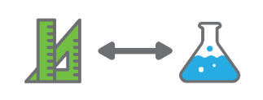 | Our school’s sustainability  Students investigate their school’s current use of resources, with a focus on the consumption of water and electricity. They learn how seasons occur and investigate passive solar design.
Designing sustainable classrooms
Students are introduced to ‘smart buildings’ that use technology to minimise energy consumption. They design a sustainable classroom of the future incorporating a digital solution that monitors, manages and minimises the use of resources.
Sharing sustainable classrooms
Students evaluate the sustainability of each future classroom design using the success criteria. They produce a range of communications that can be presented to the school community to convey ways of improving sustainability in schools.

Background
Expected learning | Students will be able to:  - Explain the meaning of ‘sustainability’ as it applies to the consumption of renewable and non-renewable energy and materials resources.  - Recognise how scientific knowledge has changed our understanding of the world and is refined as new evidence becomes available.  - Recognise some of the competing factors that should be considered in the development of technologies including social, ethical and sustainability matters.  - Understand and describe the water cycle and the reason for the seasons and the changing position of the Sun.  - Calculate percentages and means from data collected on the school’s consumption of water and electricity.  - Plan and conduct a fair investigation into the effect of the Sun’s position on the internal temperature in classrooms.  - Describe ways in which products, services and environments evolve locally, regionally and globally.  - Identify that decisions around materials and technologies influence the selection of materials, tools and equipment in a school context.  - Include digital systems in their design solutions that involve a user interface where choices can be made.  - Work collaboratively to design, develop and communicate ideas and digital solutions to the given problem.  - Use technologies to organise and present information about their design solutions and communicate their ideas and findings using scientific language and representations.
Vocabulary | This module uses subject-specific terminology. The following vocabulary list contains terms that need to be understood, either before the module commences, or developed as they are used:  Algorithm, atmosphere, automation, axis, condensation, consumption, energy, evaporation, geothermal, hemisphere, hydro, kilolitre, kilowatt, mean, orbit, percentage, potable, power, precipitation, rate, renewable/non-renewable, resource, revolution, rotation, solar, sustainability, tilt, vapour, water cycle.
Timing | There is no prescribed duration for this module. The module is designed to be flexible enough for teachers to adapt. Activities do not equate to lessons; one activity may require more than one lesson to implement.
Consumable materials | A Materials list is provided for this module. The list outlines the materials outside of normal classroom equipment that will be needed to complete the activities.
Safety notes | There are potential hazards inherent in these activities and with the equipment being used, and a plan to mitigate any risks will be required.  Potential hazards specific to this module include but are not limited to:  - Possible exposure to cyber bullying, privacy violations and uninvited solicitations when using the internet.  - Water spills when collecting water from different sources.
Assessment | The STEM modules have been developed to provide students with learning experiences to solve authentic real-world problems using science, technology, engineering and mathematics capabilities. While working through the module, the following assessment opportunities will arise:  - Formative assessment of students’ mathematics calculation and problem-solving skills during Activity 2 when they determine rates of water and electricity usage and calculate percentages (Number) and means, medians, modes and ranges (Statistics) from their data  - Formative assessment of students’ understanding of Digital Technologies in Activity 3; specifically, their ability to design an algorithm and user interface for automated digital control of resource use in their planned future classroom  - Summative assessment of the Science Inquiry Skills during the temperature investigation in Activity 2  - Summative assessment of students’ mathematical skills in representing and communicating statistical information during Activity 4.  Appendix 1 indicates how the activities are linked to the Western Australian Curriculum  Evidence of learning from journaling, presentations and anecdotal notes from this module can contribute towards the larger body of evidence gathered throughout a teaching period and can be used to make on-balance judgements about the quality of learning demonstrated by the students in the science, technologies and mathematics learning areas.  Students can further develop the general capabilities of Information and communication technology capability, Critical and creative thinking, Personal and social capability and Numeracy. Continuums for these are included in the General capabilities continuums but are not intended to be for assessment purposes.

Activity 1: Why sustainability?
Activity focus | Students are introduced to the concept of global sustainability. They research renewable and non-renewable resources and consider how sustainability can be enhanced by school design.
Background information | Responsible consumption and production is only one of 17 challenges included in the United Nations 2030 Sustainable Development Goals. It is, however, the one most accessible to students wishing to take some practical actions. For more information, refer to the UN Sustainable Development Goals website at sustainabledevelopment.un.org/sdgs.  Refer to the United Nations Environment Assembly website at web.unep.org/unea for links to current research and international reports on topics relevant to this module, in particular, Activity 1.  The EnvironmentalScience.org webpage at www.environmentalscience.org/sustainability provides teachers with a useful overview of sustainability.
Instructional procedures | This activity involves separating the students into small groups. Students continue to work in these groups throughout the module so group dynamics should be considered when dividing the class.  To facilitate cooperative learning, it is advised that group members are assigned a role. These roles can be changed throughout the module to give students a range of experiences. For further information see Teacher resource sheet 1.1: Cooperative learning - Roles.  Student thinking from all activities should be recorded in a student journal. The journal can be either digital or physical. See Student journal for more support.
Expected learning | Students will be able to:  - Distinguish between renewable and non-renewable resources (Science).  - Define some of the competing factors that include social, ethical and sustainability considerations in the development of technologies (Technology).  - Describe the cycling of water resources in the environment and its importance (Science).  - Identify some of the ways material and technology decisions influence the selection of materials, tools and equipment (Technologies).  - Describe some ways in which products, services and environments evolve locally, regionally and globally (Technologies).
Equipment required | For the class:  Projector or interactive whiteboard  Teacher resource sheet 1.6: Water cycle  See Materials list
For the students:
Student activity sheet 1.5: Resource cards – one set per group
Optional: Student activity sheet 1.7: Water cycle
Preparation | View the suggested videos in the Digital resources section and download where possible, exclude advertising and decide where to pause for class discussion.  Prepare placemats (see Teacher resource sheet 1.2: Cooperative learning - Placemat) with ‘Sustainability’ at the centre.  Photocopy and laminate sets of Student activity sheet 1.5: Resource cards. Alternatively, the pages can be photocopied and cut up by students.  Set up the equipment for the teacher demonstration of the water cycle as detailed in Teacher resource sheet 1.6: Water cycle.  Alternatively, source the equipment needed for the students’ simulation as detailed in Student activity sheet 1.7: Water cycle.  Contact a home builder or an architect involved in school design to arrange a school visit. Ask the visiting speaker to focus on the design features of school classrooms and how this may have changed over time and why.  If a visit is not possible, this information could be sourced by students interviewing their parents or grandparents, or by searching on the internet for articles such as:  The Future of School Design (Alexandra Lange, 2018)  www.architectmagazine.com/design/the-future-of-school-design_o  Vertical School Design - Strategising the spatial configuration of a multi-storey typology (NSW Architects Registration Board, 2015)  https://www.architects.nsw.gov.au/download/Vertical%20School%20Design_AdamSwinburn.pdf  Provide students with guiding information to research building changes in education and schooling. Additional website suggestions are provided in Digital resources.  Provide students with the appropriate technology to document the processes they work through in the activities, and for their presentation and reflection in Activity 4.
Activity parts | Part 1: Sustainability  Students work in small groups to list the different things they think ‘sustainability’ might mean using a placemat strategy (see Teacher resource sheet 1.2: Cooperative learning - Placemat).  Students watch the What is sustainability? video at youtu.be/FbAjxkGvDNs and revisit their placemat to expand on their original ideas.  In their groups, students compare their responses. Stimulate further discussion using prompt questions such as:  - Why do you think sustainability has become an important issue for humans? …because…  - Which of the three pillars of global sustainability do you think individuals can influence most? Why?...because…  Explain that the sustainable use of resources will be the overall focus of this module.
Part 2: Renewable and non-renewable resources
Students learn about which of Earth’s natural resources are renewable (can be regenerated within a lifetime), and which are non-renewable (cannot be regenerated within a lifetime). Introduce the meaning of ‘renewable’ and ‘non-renewable’ resources by showing the short video Renewable and Nonrenewable Resources at youtu.be/xzzybh8_Ago.
Working in their small groups, students cut out and use the resource cards (see Student activity sheet 1.5: Resource cards) to do a silent card sort (see Teacher resource sheet 1.4: Cooperative learning - Silent card sort), sorting the cards into the two categories – Renewable resources and Non-renewable resources. Manufactured materials have been included in the card sort activity, as well as natural resources. Students will need to consider the source of raw materials used in their manufacture. Students watch the longer video Renewable vs Non-renewable - Steve Trash Science at youtu.be/osBVRfvkmAU. This provides an engaging and more detailed coverage of a wider range of resources. Pause the video at intervals to focus on any resource cards students were unsure about.
Explain to students that they will be looking closely at some natural resources and their role in a more sustainable future. Establish a wall display using input from students:
      - Allocate one resource card to pairs or small groups of students
      - Students use the internet to research more information about their resource or material (see Digital resources for useful links)
      - Each group produces a mini poster that defines and illustrates the resource and explains why it is either renewable or non-renewable and its place in global sustainability
      - Display the posters in the classroom, library or other areas of the school.
Students watch the short video Sustainability: told as a Children's Fairy Tale with Beautiful Montage at youtu.be/fKWQuU0sHPw to consolidate their understanding of sustainability, as it relates to renewable and non-renewable resources.
Part 3: The water cycle
Focus student thinking on water as a renewable resource that is essential to all life on Earth. To initiate class discussion, ask students, Where does water come from?
Students watch the Sydney Water Cycle Animation video at youtu.be/OrNzBF1BfZA. This is a Sydney-based video that is well suited to Western Australian students. There are, however, many online videos demonstrating this cycle to choose from, see Digital resources section.
To consolidate students’ understanding of the water cycle, arrange a teacher demonstration (see Teacher resource sheet 1.6: Water cycle) or student simulation (see Student activity sheet 1.7: Water cycle).
Following the teacher demonstration, ask questions to stimulate students’ use of the appropriate terminology. Prompt further discussion by asking:
      - What do you think is happening to the boiling water immediately after it was poured into the container?
      - Why do you think the glass and the plastic are becoming opaque? (ie difficult to see through)
      - What effect does the ice have on the water vapour?
      - Where have you seen that effect before? (eg condensation that forms on the outside of an ice-cold glass or can of drink on a warm day)
After the teacher demonstration or student simulation ask:
      - What makes the water droplets fall rather than stay on the plastic wrap?
      - What do you think has caused the sand to get wet? Why?
      - How did the water get onto the sand?
      - How was the water removed from the container?
      - What did the plastic do? How did the weight on the plastic help?
      - How is this model of the water cycle the same as, and different to, the real water cycle?
Take photos of the demonstration or simulation and set up a class display if desired.

Ask students to research the question:
      - If water cycles so easily and continuously in nature, why do we need to worry about how much we use?
Encourage student groups to conduct different lines of research. For example, they may focus on the effects of:
      - Different weather patterns on Earth’s water distribution
      - The concentration of human populations in different areas
      - Pollution of water sources
      - Deforestation
      - Human use of rivers, lakes, artesian basins
      - Overuse of groundwater
      - The relationship between salinity and the water table
      - Desalination processes
      - Damming rivers
      - Recycling of wastewater.
Assist students to recognise that these complexities mean that while the total quantity of water on, in and above the Earth is constant, its distribution and potability is always changing. Therefore, conserving the quality and availability of water is essential.
Part 4: Resources used in our school
Encourage students to think about the resources used in their school.
Student groups walk around the school and into available classrooms to take photographs of:
      - Materials used in the buildings and classrooms
      - Evidence of resources consumed
      - Evidence of energy consumption.
Each student group should investigate a different area to ensure a variety of photographs are obtained.
Consolidate students’ photos and, as a class, discuss the materials, resources and energy being used.
Students use their journals to record their observations. See Student journal for more information.
Student groups use their photos to create slide presentations (using digital programs such as Microsoft PowerPoint, Keynote or similar). Students label and annotate the photos, focusing on which are renewable and which are non-renewable resources (eg electricity source).
Encourage students to consider the sustainability of their current school classrooms and use their journals to document some initial thoughts, giving reasons for their thinking.
Part 5: Changes in school buildings over time
Students research how school buildings have changed over time in Western Australia.
If possible, invite a home builder or an architect involved in school design to discuss with students the considerations applied when designing schools today and the changes that have occurred over time.
Students research the history of school buildings and how changes in education might have influenced changes in design.
To stimulate students’ interest in how Australian teaching has changed, and therefore the buildings in which it takes place, show them the video on the Behind the News webpage at www.abc.net.au/btn/classroom/teaching-changes/10522258.
Students may need support to refine their online searches. See Digital resources for starting points or try these general searches:
      - ‘Changes in education over time’
      - ‘School building changes over time’
Note: Refining searches to ‘Australia’ provides more relevant links to Australian information, but refining searches to ‘Western Australia’ provides very limited information about historic changes. Prompt students to consider:
      - How has education changed over the last 100 years? How has that affected school buildings?
      - What differences are there in the size of classrooms, windows, lighting, furniture and equipment, and play areas? Why?
      - What might have influenced changes in the materials used in schools over time in general, and more specifically in different parts of Western Australia?
      - How has technology changed school classrooms and buildings in the last 100 years?
Students use their journals to respond to the above questions and to make notes about the visiting speaker, videos and their research.
Part 6: Sustainable classrooms in the future
Facilitate a class discussion about the next activities. Introduce the problem the students will be addressing: How can we improve the sustainability of our classrooms now and in the future?
Advise students they will:
      - Work in their groups to plan a sustainable classroom of the future
      - Consider ways that resource consumption in their school can be reduced
      - Investigate the current resource consumption of their school, with a focus on the use of water and electricity
      - Investigate how the seasons and the position of the Sun can influence resource consumption in classrooms, and how this can be considered during design and construction
      - Learn about ‘smart buildings’ and how technology can be applied to reduce a building’s energy consumption
      - Design a solution to the problem: How can we improve the sustainability of our classrooms now and in the future?
      - Communicate their designs and findings to the rest of the school.
Resource sheets | Student journal  Teacher resource sheet 1.1: Cooperative learning - Roles  Teacher resource sheet 1.2: Cooperative learning - Placemat  Teacher resource sheet 1.4: Cooperative learning - Silent card sort  Student activity sheet 1.5: Resource cards  Teacher resource sheet 1.6: Water cycle  Student activity sheet 1.7: Water cycle
Digital resources | United Nations Environment Assembly homepage  web.unep.org/unea  Teachers can access the latest information and reports from around the world that focus on environmental degradation and progress towards the 2030 Sustainable Development Goals. The fourth session of the UN Environment Assembly gathered in Nairobi, Kenya from 11–15 March 2019. It focused on the role of innovation in changing the choices we make and how we consume and produce.  In particular, Australia’s National Statement presented at the Assembly may be of interest: web.unep.org/environmentassembly/node/42637
UN Sustainable Development Goals: Rate of Environmental Damage Increasing Across Planet but Still Time to Reverse Worst Impacts (United Nations, 2016)
www.un.org/sustainabledevelopment/blog/2016/05/rate-of-environmental-damage-increasing-across-planet-but-still-time-to-reverse-worst-impacts/
The Sustainable Development Goals are a call to action by all countries to promote prosperity while protecting the planet.
What Is Sustainability and Why Is It Important? (EnvironmentalScience.org, n.d)
www.environmentalscience.org/sustainability
Text resource that provides a detailed discussion of sustainability from a global perspective which teachers may find helpful as personal background reading.
The Future of School Design (Alexandra Lange, 2018)
www.architectmagazine.com/design/the-future-of-school-design_o
Vertical School Design - Strategising the spatial configuration of a multi-storey typology (NSW Architects Registration Board, 2015)
https://www.architects.nsw.gov.au/download/Vertical%20School%20Design_AdamSwinburn.pdf

Digital resources for Part 1
What is sustainability?|ACCIONA (ACCIONA, 2016)
youtu.be/FbAjxkGvDNs
Video of drawings with voice over explaining the idea of sustainable living. Describes and illustrates the ‘three pillars’ of sustainability. Simple, clear description.
What Is Sustainability? (Christian Weisser, 2014)
youtu.be/rmQby7adocM
Comprehensive description of sustainability with visual and text support – could be above some Year 7 students if shown in entirety. Teachers could choose suitable sections to show, rather than the whole video. Describes some historic development of the idea of sustainability from an American perspective.
Sustainability Illustrated videos

sustainabilityillustrated.com/en/sustainability-videos/
Several very short videos using animated drawings with voice overs covering many aspects of sustainability suitable for Year 7 students to explore. Some are quite sophisticated while others are easier to understand. All are presented in a similar way and so can be understood by students if the concepts are within their grasp.
Digital resources for Part 2
Renewable and Nonrenewable Resources (Studies Weekly, 2015)
youtu.be/xzzybh8_Ago
A short two-minute video with a simple description of renewable/non-renewable resources which could be used as an introduction.
The Water Cycle - Steve Trash Science (Steve Trash, 2017)
youtu.be/l_9tvm9P1u0
A comprehensive description of the water cycle from an American who produces environmentally based videos (and presents school shows in the USA). Entertaining and engaging for Year 7 age group.

Renewable vs Non-renewable - Steve Trash Science (Steve Trash, 2017)
youtu.be/osBVRfvkmAU
Steve Trash describes the difference between renewable and nonrenewable resources in an entertaining and engaging way. He covers all aspects of natural resources and energy sources. Would be suitable to pause at intervals for discussion students and could be shortened if desired.
Sustainability: told as a Children's Fairy Tale with Beautiful Montage (HD) (worldfromaboveHD, 2013)
youtu.be/fKWQuU0sHPw
The sustainability message is presented in a fairy tale format with attractive visuals. It focuses on the environmental effects of unchecked human ‘progress’ with the message that changing future energy needs to renewal sources may save the environment.
Digital resources for Part 3
Sydney Water Cycle Animation (SydneyWaterTV, 2017)
youtu.be/OrNzBF1BfZA
Australian video based on Sydney water, but appropriate to Western Australia. There are many videos showing the water cycle online, but this seems more suitable for Australian students. It includes all the water cycle-related vocabulary students should become familiar with.
The Water Cycle (National Science Foundation, 2013)
youtu.be/al-do-HGuIk
A more formal video explaining the water cycle. Very detailed though not so engaging for Year 7s. The visuals are excellent and lend themselves to pausing at intervals for discussion or oral or written responses from students.
Water and You: The Water Cycle (New Jersey American Water, 2011)
youtu.be/R8NQUQDZ3N0
A video showing the water cycle and where water comes from.
All About the Water Cycle for Kids: Introduction to the Water Cycle for Children – FreeSchool (Free School, 2015)
youtu.be/IO9tT186mZw
A more formal description of the water cycle – not Australian. It includes vocabulary and has good visuals. Does not mention underground water.
"Water Cycle" by The Bazillions (The Bazillions, 2015)
youtu.be/DJBXflNyFs4
Song with animated visuals about the water cycle and including much of the required vocabulary. May suit some student groups.
Digital resources for Part 5
Teaching Changes (Behind the News, ABC, 2017)
www.abc.net.au/btn/classroom/teaching-changes/10522258
Includes a video showing how teaching has changed over time in Australia, with some stimulus questions to consider.
The next generation of Australian schools (University of Melbourne, 2018)
pursuit.unimelb.edu.au/articles/the-next-generation-of-australian-schools
Article and further links from Melbourne University explaining changes in school building plans. A teacher/student resource.
Then and Now – 10 ways schools have changed (Families Magazine, 2019)
www.familiesmagazine.com.au/10-ways-schools-have-changed/
Article with photos detailing some changes over time in Australian schools.
How Schools have Changed in the Past 100 Years (WH Magazine, n.d)
wh-magazine.com/educational-philosophy/how-schools-have-changed-in-the-past-100-years
Short article outlining the main changes in education. Written as a general article and suitable for students to read.

How schools have changed over the last 80 years (Insider, 2019)
www.insider.com/old-school-vintage-classroom-photos-evolution-2018-5
Many photos of American schools over 80 years. The changes are similar to changes in Australian classrooms.
Education and school records (State Records Office of Western Australia, n.d)
www.sro.wa.gov.au/archive-collection/collection/education-and-school-records
Source of archive information on the history of schools and schooling in Western Australia.

Activity 2: Our school’s sustainability
Activity focus  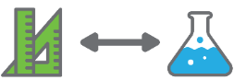 | Students investigate their school’s current use of resources, with a focus on the consumption of water and electricity. They learn how seasons occur and investigate passive solar design.
Background information | The investigations in this activity directly involve calculating consumption rates in various contexts.  During the investigation of electricity, the starting point could be a given rate of kilowatts per hour for lights or appliances, which can then be multiplied to calculate the consumption of electricity over a longer period.  When working with rates of water consumption, students will be expected to measure capacity and time and calculate rates percentages and means. This will require students to decide between operations, which demands a deep understanding of the inverse relationship between multiplication and division, a concept that will challenge many Year 7 students.  Students may need explicit teaching to make these connections. It is suggested that the teachers of science and mathematics liaise to ensure students have sufficient understanding of rates to fully engage in the activity.  Photovoltaic (PV) cells (solar panels) transform light energy into electrical energy. Materials such as silicon in a photovoltaic cell absorb photons of light and release electrons. These free electrons can be made to flow in an electric circuit. Solar panels generate direct current (DC) electricity like a battery. An inverter can be used to convert direct current to alternating current (AC) like the electricity supplied from a power station. The electrical output from a set of 10 solar panels can be as high as 3,000 watts (3 kW). This is enough to boil a kettle and run a toaster at the same time.
Instructional procedures | This activity provides students with the opportunity to explore and interpret the mathematical ideas of mean, mode, median, rates and percentages in a meaningful/authentic context.  Students are more likely to make sense of these mathematics concepts when they are supported to explore the ideas informally within a real context, compared to when students are first taught a mathematical rule out of context, and then asked to apply it.  This type of introduction to mathematical ideas supports students to become numerate, efficiently choosing to use and apply mathematics in scientific contexts, exemplifying STEM behaviours.
Expected learning | Students will be able to:  - Calculate percentages to compare data and use mean, median, mode and range to describe and interpret their data displays (Mathematics).  - Describe some issues involving numerical data collected from their primary sources (Mathematics).  - Recognise the predictable effect that the relative position of the Sun and Earth have on seasons (Science).  - Collaboratively and individually plan and conduct investigations safely and ethically (Science).  - Select appropriate equipment to collect accurate data (Science).  - Construct representations of their data to analyse patterns and relationships using digital technologies (Science).  - Identify some ways that new scientific knowledge has changed peoples’ understanding of the world (Science).
Equipment required | For the class:  Projector or interactive whiteboard  Shadow stick and stones
For the students:
Access to computers, calculators and devices
Stopwatches
Capacity measuring equipment
Thermometers
Student activity sheet 2.1: Investigation checklist
Preparation | View the Direction Finding – Shadow Stick Method video at youtu.be/YApn651P1K4 on how to use sticks and stones to determine compass directions.  View the suggested videos in Digital resources, download where possible, exclude advertising, and plan where to pause for discussion.  Source, from the school’s electricity supplier, information about how their electricity is generated. Obtain information about the school’s consumption and cost of water and electricity over the previous 12 months, monthly if possible as consumption may vary with the seasons.
Activity parts | Part 1: Consumable resources  Introduce Activity 2 by referring students to their photos of the school buildings and resources from Activity 1. Ask them to identify and list which resources are continually consumed by the school over time.  Their list may include a wide range of material resources such as paper, plastics, food, gas, as well as water and electricity.  Focus students’ attention on water and electricity as resources that are used for a variety of different purposes and will be further investigated.  Show students the cost of the school’s electricity and water for the previous year. Explain that they are likely to be the most expensive consumable resources used by the school.  Tell students that they will be investigating how electricity and water are being used across the school.  Advise students that they will use what they have learnt later in Activity 3 when they consider alternatives and ways to better conserve those resources in their designs for future classrooms.
Part 2: How much electricity do we use?
It is assumed students will have had some learning experiences regarding the generation of electricity in
Year 6, but they may not know how the local electricity supply is generated.

Students use a think-pair-share process (see Teacher resource sheet 1.3: Cooperative learning - Think, Pair, Share) to review their knowledge of electricity. Questions could include:
      - How do you think the school’s electricity is generated?
      - How is electricity used in the school?
Share the information from the electricity provider about the school’s source of electricity and ask students to consider whether the school’s electricity source is renewable.
Schools that have moved to generate electricity through photovoltaic (PV) cells could compare electricity consumption pre and post the instillation.
Students share their answers to the second question to construct a class list of the different purposes electricity is used for at the school. The list is likely to cover at least the following:
      - Lighting
      - Heating/cooling classrooms
      - Power for computers and devices
      - Cooking and heating food/drinks (canteen)
      - Refrigeration
      - Heating water to wash hands/dishes/other
      - Cleaning/polishing machinery
      - Technology learning area (machinery, laser cutters etc)
      - Gardening – reticulation system.
Prompt student thinking by asking:
      - Which purpose do you think uses the most electricity? Why?
Companies such as Ergon Energy provide information about the hourly running cost of appliances as well as tools to calculate the estimated cost of energy for select periods. See www.ergon.com.au/retail/residential/home-energy-tips/calculators/appliance-running-cost-calculator.
Use this activity to provide explicit teaching about rates. Explain that a ‘rate’ is about the relationship between two measures.
Provide simple examples of the kinds of everyday rates students will have encountered and ask them to identify which are the two measures involved. For example, which two measures are involved in:
      - The price of apples at the greengrocer? (amount of money and mass of apples)
      - The speed of a vehicle? (distance travelled and length of time)
      - The price of tickets to the movies? (amount of money and number of people)
Students watch What’s a watt? at youtu.be/1__KjuGNzxc to learn about the ‘watt’ as the unit of power used to measure electricity use. This non-technical explanation is enough to enable students to work with watts to determine and compare electricity consumption.
Highlight the following:
      - Measuring the watts can tell us the amount of electricity generated or used. A ‘kilowatt’ is 1,000 watts.
      - The amount of electricity (quantity of watts) required by different appliances can be compared if we know how many watts each appliance requires to run over a given period.
To gain more information, students may question school staff, seek information on the internet and check the labels on various appliances.
Explain that the accuracy of the rates will be dependent upon how specific the students can be about the type of appliances, machinery, lighting and heating used at the school.
Once a range of electricity rates are obtained, students calculate the amounts of electricity used for various purposes over a comparable period such as a school week.
For example, one group might compare the amount of electricity used to light their classroom with the amount of electricity used to vacuum their classroom’s floor.
For this comparison, students would need to:
      - Consider the number of kilowatts per hour used by each light multiplied by the number of lights
      - Consider the number of kilowatts per hour used by a cleaner’s vacuum cleaner
      - Consider the amount of time the item is used (eg the lights are on all day, while the vacuum cleaner is used for say half an hour per day)
      - Find the number of hours the lights are on over a week and the number of hours the vacuum cleaner is used over a week
      - Use multiplication to calculate the rate of energy used per week by each item
      - Compare total kilowatts used to identify which uses more electricity in the classroom each school week, the lights or the vacuum cleaner.
Students record the results of their findings.
Students share their results with the class and discuss the implications. Ask questions to prompt student thinking:
      - Which appliances consume the most electricity per hour?
      - What is the same about these kinds of appliances?
      - Which appliances consume the most electricity per week? Why?
      - Which appliances consume the least electricity? Why?
Remind students they will need to consider their findings when designing their sustainable future classroom in Activity 3.
Part 3: How much water do we use?
Students investigate the school’s consumption of water and explore ways of communicating their findings using various measures of central tendency.
Show students the information provided by their school about the previous year’s consumption of scheme water in litres. If possible, show each month’s consumption, which will likely vary with the seasons.
Prompt students to suggest how to calculate the daily or weekly average consumption:
      - Given the total litres used last March, how will we calculate the average daily consumption in March?
      - Why would calculating the average consumption per school day be more useful data?
      - How would we calculate the average school day consumption if we only know the total litres used in a year?
      - Would we need to account for any water consumed during school holiday breaks (consider water used for the gardens and by the cleaners)?
Once an amount of water consumption is established for a more manageable timeframe such as a day or a week, challenge students to investigate how much of that is consumed for different purposes.
Begin by brainstorming the different uses of water at the school. Some examples could include:
      - Drinking
      - Flushing the toilet
      - Washing hands
      - Washing dishes (staff room, food preparation classes)
      - Canteen
      - Garden
      - Cleaners.
Working in their groups, students consider how they could find out how much water is used for each purpose in a given period of time.
A different investigation method is likely to be needed for different water uses and teacher guidance may be required. For example, they could:
      - Design a questionnaire for the canteen manager, asking for an estimate of how much water they use in a day for different activities such as cooking, washing hands, washing utensils, the dishwasher, cleaning benches, mopping the floor
      - Use a stopwatch to measure the length of time each student takes to have a drink at the drinking fountain or to wash their hands. From that information, they can calculate the mean time taken for a drink or a hand wash, and therefore calculate the amount of water used for each purpose by the school population
      - Use capacity measuring jugs to catch and measure the water flow from various outlets (drink fountains and water taps) over a given period of time
      - Determine the total number of students who will have a drink or wash their hands
      - Observe or question students to determine how often students drink or wash hands
      - Use multiplication and/or division and their knowledge of rates to calculate the amount of water used for drinking and handwashing over a period of time.
Each group should investigate one purpose of water use. Establish a timeframe, such as a day or a week, for which students will estimate the school's consumption so that their findings can be compared. Two different groups or pairs should investigate the same purpose independently so they can compare their results when complete, try to explain any differences and come to a consensus regarding the most accurate estimate.
For students to summarise and compare their findings effectively they need to calculate measures of central tendency and percentages.
Use the data collected from the groups who are timing students drinking and washing hands to explicitly teach the calculation and comparison of mean, median, mode/s and range. This is also an opportunity to use a spreadsheet (eg Microsoft Excel) to list the raw data and use the ‘sort’ and ‘formula’ features to make the calculations.
Explain to students:
      - For the mean, the total time taken for all the measured students to have a drink is re-distributed or ‘shared out’ among those students.
      - For the median, they can use ‘sort’ and then ‘count’ to establish the middle value.
      - For the mode/s and the range, the sorted list can be examined to establish both values.
Help students compare the different measures of central tendency to decide which is preferable for further calculations. Questions can include:
      - How is the mean different from the median?
      - What do you think has caused the mean to be higher/lower than the median?
      - While one student’s drink time is always exactly equal to the median, why doesn’t the mean drink time need to equal to any particular student’s time?
      - What’s the difference between a data set with a single-mode and bi-modal and multi-modal data sets?
      - Why might knowing the range assist in interpreting the data?
      - Which average measure do you think is best for calculating the total water used for drinking by all students in a day or a week? Why?
Use students’ calculations of the total volume of water used at the school to explicitly teach them how to calculate one amount as a percentage of another.
Using percentage is another way of summarising data. In Year 7 it is best if students explore these ideas informally within a real context before learning to use a formula.
Calculating percentages should be taught initially as a meaningful informal strategy – not by introducing a standard formula to memorise.
Use questioning to develop students’ starting point and guide their thinking, for example:
      - What does percentage mean? (out of 100)
      - If you wanted to work out how much one per cent of any quantity was, what would you do? (divide by 100)
      - If the total water used was 1,000 kilolitres, how much would 100% be and how much would 1% be? (1,000 kL and 10 kL)
      - So, what would 2% of 1,000 kilolitres be and how did you work it out? (20 kL, 1,000 divided by 100 to find 1%, which is 10 kL multiplied by 2)
      - If I wanted to know what percentage of 1,000 kL that 50 kL would be – how could I work that out? (5%, 1,000 divided by 100 to get 10 kL which is 1% and then how many 10 kL are in 50 kL will tell me how many 1%s in 50 kL)
Provide more examples for students to help them understand that by calculating the value of 1% as a starting point, they will always be able to calculate the result regardless of which part is unknown. For example:
      - Finding a given percentage of a total amount (find the value of 1% and multiply that by the given percentage; eg 25% of a total usage of 1,000 kL is 1,000 divided by 100 to find 1%, which is 10 kL multiplied by 25 is 250kL).
      - Expressing one amount as a percentage of a total amount (find the value of 1%, then divide that value into the first amount; eg 500 kL of a total usage of 1,000 kL is 1,000 divided by 100 to find 1%, which is 10 kL. 500 kL divided by 10 kL = 50%).
      - Finding the total amount given a percentage amount (find the value of 1% by dividing the given amount by its percentage value then multiply by 100; eg 500 kL divided by 50% = 10 multiplied by 100 = 1,000 kL).
The ability to flexibly use this informal approach to percentage calculations requires a deep understanding of both the meaning and use of percentages.
Note: When students do have this level of operational understanding of percentages, they will be able to use a calculator with meaning to solve percentage problems involving much larger and more complex numbers and situations. It will also enable them to understand why the standard formula for calculating percentages works.
Working in their groups, students use their collected data to arrive at and justify their estimations of the amount and percentage of water each kind of use consumes in a day/week.
When the different estimates are complete, students construct a class table to show each use and the estimated number of litres of water consumed in a day/week in each category. Students sum the amounts and compare to the mean daily/weekly number of litres consumed in the same month/year previously.
Problem-solve any discrepancies and adjust if necessary. Emphasise that the amounts are all estimates based on assumptions (eg that current use of water is close to previous use, that the mean drink time by a sample of students is close to what would be the mean drink time of all students). They may need to add a category of ‘other’ to account for water use they may have missed, and so cover 100% of the total consumption based on school records.
After calculating the percentages of each category of use, introduce students to a pie graph as an appropriate way to display the data. This may be constructed using a spreadsheet (eg Microsoft Excel), or manually using students’ knowledge of angles.
When complete, use the data to discuss the results:
      - What surprised you about the amounts of water used for different purposes? Why?
      - What sort of variation did you detect in the length of time students took to have a drink?
      - What sort of variation did you detect in the time students took to wash their hands?
      - What discrepancies or errors could have occurred in your measurements or calculations?
      - Where might there be scope for reducing water use?
      - What kinds of automation can be used to save water? (Student may be familiar with sensor or timer taps that switch on and off in response to movement or after a period of time).
Students record the results of this discussion in their journal for reference during Activity 3 when they will have the opportunity to consider ways to conserve water in their school.
Students may also like to investigate the source of their school water. This might be a dam, rainwater tanks, underground bores, desalination or a combination. Students may consider other sources of water in their design for the future to improve sustainability, for example, using rainwater or recycling wastewater.
Part 4: Seasons and the Sun
Refer to the construction of school buildings and ask students:
      - How might the design of a school affect its energy use?
It may be necessary to be very specific and ask how lighting and heating in a classroom might be affected by the way a school is constructed. Elicit responses that suggest the positioning of a classroom can affect whether or not it can take advantage of seasonal positions of the Sun.
Explicitly teach how the seasons are produced, noting the relative positions of the Sun and Earth at different times of the year.
Students watch the Why do we have Summer and Winter, Day and Night? video at youtu.be/Ps85AsmXjxU. The video demonstrates the effect of the tilt of the Earth as it orbits the Sun.
A globe of the world or basketball and a torch could be used to consolidate students’ understanding of the day/night rotation and the annual orbit of the Earth in relation to the Sun. This lunar phases interactive animation may also be helpful when consolidating knowledge:
highered.mheducation.com/olcweb/cgi/pluginpop.cgi?it=swf::800::600::/sites/dl/free/0072482621/78778/Lunar_Nav.swf::Lunar Phases Interactive
Students search the internet for ‘shadow stick southern hemisphere’ videos and view the demonstrations to inform their shadow stick set up. See digital resources for examples.
Model using a shadow stick and how to use a compass to confirm directions.
It is important for students to note the directions as they will need them when participating in the school walk later in this Activity.
Students predict the length and position of the shadows at the beginning of the school day, the middle of the day and the end of the day. Students justify their predictions based on their understanding of the seasons and the relative position of the Sun.
Students mark the shadow endpoints at regular times during the day and take measurements and photos of the shadows for later review in class.
Using scaled drawings on grid paper, such as that shown below, students compare this information to their predictions and calculate the angle of the Sun’s rays at different times of the day.
Shadow Stick
50 cm
30 cm
70 cm
Length of shadow at 8 am
Length of shadow at 12 noon
As a class, display the photos and measurements and their conclusions to illustrate what they predicted and what they found.
Ask students to reflect on the following focus questions in their journals:
      - How would the angle of the Sun’s rays at different times of the day and in different seasons affect the heat and light in a room?
      - How would the size and position of windows affect the amount of light or heat that can enter a room?
      - How would verandahs and eaves affect how much sunlight/solar energy enters a room?
      - How might choosing the orientation of a building or rooms in relation to the Sun and the seasons affect how much electricity is needed to heat or light a room?
Show students relevant sections of the Energy Efficient - The secret for saving energy and building an energy-efficient home video at youtu.be/SXKgTOwyRGM. Stop the video at appropriate intervals to review the key messages about the angle of the Sun on windows in different seasons and at different times of the day, as well as the role of eaves, verandahs, blinds, shutters and vegetation.
Students use their journals to add to their initial responses to the focus questions while viewing the video.
Students do an observational walk around the school and record the direction the windows are facing in different classrooms. Prompt student thinking by asking:
      - When will sunlight be able to enter this classroom?
      - Which classrooms will get maximum light and heat in winter and minimum light and heat in summer?
Students plan and conduct investigations to determine how the Sun’s position affects the temperature in classrooms.
If students have had sufficient previous learning experiences, this investigation could provide an opportunity to assess individual student achievement of the Year 7 Standard for Science Inquiry Skills.
To do so, students would need to plan and conduct the investigation independently, with little guidance. To assist students to demonstrate their full range of knowledge, they may be provided with a Science Inquiry Skills checklist (see Student activity sheet 2.1: Investigation checklist).
While students are measuring temperature in classrooms, they should choose their question to investigate that might involve, for example, the:
      - Position of different classrooms
      - Orientation of classroom windows
      - Size of classroom windows
      - Presence of eaves or blinds
      - Time of the day.
Students should consider all aspects of a scientific investigation including:
      - The variables to be changed and measured
      - The equipment they need
      - How they will ensure the accuracy of their measurements
      - A suitable summary of their data
      - Appropriate representations and use of language
      - How they will draw on evidence to support their conclusions
      - Their reflections and suggestions for improvements or further questions that could be investigated.
If students are not experienced in the full range of Science Inquiry Skills, this investigation provides opportunities for students to develop these skills.
Conclude with a class discussion on the sustainability implications of what they have learnt, with a focus on how the Sun and the seasons can be used to reduce dependence on other energy sources.
Questions to stimulate discussion could include:
      - How could sunlight be used more effectively in classrooms?
      - What heating sources could be replaced by heat energy from the Sun?
      - How can we take advantage of the seasons to cool keep our classrooms warm or cool?
Part 5: Reflection and journaling
In preparation for the next activity, engage students in a brainstorm or placemat activity focused on two questions:
      - What have we learnt about our school’s current level of sustainability?
      - How could that be improved now and in the future?
Remind students that in the next activity they will design a classroom of the future that could be situated in a school of the future. Let them know they are welcome to think outside the box and use technology that is available today, as well as anticipate future innovation.
Show selected videos from those listed in the Digital resources section to stimulate their thinking.
Students use their journals to reflect on their learning and list any initial ideas they may have for their classroom designs.
Resource sheets | Teacher resource sheet 1.3: Cooperative learning - Think, Pair, Share  Student activity sheet 2.1: Investigation checklist
Digital resources | Sustainable Schools WA (Department of Education WA)  det.wa.edu.au/curriculumsupport/sustainableschools/detcms/portal/  This has been designed to support teachers focusing on sustainability and includes many valuable ideas and resources that will assist teachers in developing the learning activities in Activity 2.
Energy, Sustainable Schools WA (Department of Education WA)
det.wa.edu.au/curriculumsupport/sustainableschools/detcms/navigation/action-learning-areas/energy/
Provides links to various energy conservation programs in several Western Australian schools.
Digital resources for Part 2
What's a Watt? (Robert Bryce, 2011)
youtu.be/1__KjuGNzxc
A short, non-technical video that explains the nature of a watt as a measure of power.
Appliance running cost calculator (Ergon Energy)
www.ergon.com.au/retail/residential/home-energy-tips/calculators/appliance-running-cost-calculator
A calculator to help consumers determine how much their appliances cost to run.
5 buildings of the future (Tech Insider, 2016)
youtu.be/Spk3W6Zs53U
Short visual clip of five different extreme buildings of the future. A useful resource to stimulate ‘outside the box’ thinking about classrooms.
Earth 2050 - Searching for Utopia (Shell, 2011)
youtu.be/rpu3nqenPiA
A short video on Masda, a futuristic city being built in the middle east, that shows the potential of solar energy.

School Design Project (hamza abdo, 2016)
youtu.be/xXETWZSR1o0
Short animated school design from Palestine. Muting the sound will enable a class discussion
Sustainable school of the future (Dimitar Angelov, 2014)
youtu.be/xnUHbIjpPkw
Sun Rays School - Design of a sustainable school (sa syr, 2016)
youtu.be/ImIca595TqA
Architecture design - termintra school animated presentation 2016 (Abdelrahman EL-Safory, 2017)
youtu.be/MJzRNpL5Lbk
Three videos showing views of a three-dimensional design for a sustainable school. There is no voice-over. Students are encouraged to discuss thoughts about how the design is sustainable as they view the clip.
Digital resources for Part 4
Why do we have Summer and Winter, Day and Night? (Meneer Wiersma, 2017)
youtu.be/Ps85AsmXjxU
A clear explanation of the seasons and visuals of the Earth’s relationship to the Sun. Includes some further information regarding the solar system and moon orbits that may not be needed at this time.
Lunar Phases Interactive (McGraw Hill, n.d.)
highered.mheducation.com/olcweb/cgi/pluginpop.cgi?it=swf::800::600::/sites/dl/free/0072482621/78778/Lunar_Nav.swf::Lunar Phases Interactive
This lunar phases interactive animation may also be helpful when consolidating students’ understanding of the day/night rotation and the annual orbit of the Earth in relation to the Sun.
Direction Finding - Shadow stick Method (HikingVegas, 2011)
youtu.be/YApn651P1K4
A short Australian video showing how a shadow stick and two stones can be used to approximate basic compass directions with reasonable accuracy within 30 minutes.

Energy Efficient - The secret for saving energy and building an energy-efficient home (Science&Energy, 2014)
youtu.be/SXKgTOwyRGM
Details design ideas that minimise the use of non-renewable energy to heat and cool a home in Australia. Some parts will not be required, and teachers will need to identify the sections to show. Stop at intervals to discuss with students and focus on main aspects.

Activity 3: Designing sustainable classrooms
Activity focus | Students are introduced to ‘smart buildings’ that use technology to minimise energy consumption. They design a sustainable classroom of the future incorporating a digital solution that monitors, manages and minimises the use of resources.
Background information | There is a strong Digital Technologies component in this activity. Some students may already know the basics of creating an algorithm in the form of a flowchart using branching and iteration, as well as using visual coding programs to implement their algorithms with robots.  This activity asks students to design an algorithm, including iteration (repetition of sequences) and branching (points where decisions are made), to control energy resources in a ‘smart classroom’, that could provide an automated means for controlling, and therefore minimizing, resource use in their classroom.  Students are also asked to include a user interface, a concept that is introduced in the Year 7 Digital Technologies curriculum.  Teacher resource sheet 3.1: Flowcharting symbols and Teacher resource sheet 3.2: Flowchart example are provided to assist teachers.
Expected learning | Students will be able to:  - Identify changes in people’s understanding of resource use (renewable and non-renewable) due to new scientific evidence and the evolution of products, services and environments (Science, Technologies).  - Consider material and technology decisions in the selection of materials, systems and equipment in their planning (Technologies).  - Incorporate their understanding of the seasons and the relative positions of the Sun and Earth in their plans (Science).  - Design a digital solution, breaking down a given task, considering constraints and showing some understanding of digital networks in their plans (Technologies).  - Create an algorithm as a flowchart as well as a user interface for an automated digital control system for energy optimisation in their design (Technologies).
Equipment required | For the class:  Projector or interactive whiteboard  Teacher resource sheet 3.1: Flowcharting symbols  Teacher resource sheet 3.2: Flowchart example
For the students:
Drawing equipment
A list of flowcharting symbols
Optional: Access to computers and computer-aided design (CAD) software
Preparation | View the suggested videos in the Digital resources section, download and exclude advertising where possible. Plan where to pause for discussion.  If it is to be used, ensure suitable, familiar CAD software that is available. See Drawing in the design process for more information.  Prepare a handout of flowcharting symbols from Teacher resource sheet 3.1: Flowcharting symbols. Also provided is an example of an algorithm represented as a flowchart illustrating branching (see Teacher resource sheet 3.2: Flowchart example). This is provided as a guide to the kind of skills students may bring to the task if they have been exposed to Years 5 and 6 Digital Technologies curriculum content. Explicit teaching may be needed to prepare students for Part 3.
Activity parts | Part 1: Designing their future classroom  Students watch the short Schools of the Future video at youtu.be/x28uXrwHNZE to learn how future classrooms might be very different from traditional classrooms to accommodate changes in education as well as technology and sustainability considerations.  Discuss with students the expectations about what they are expected to include in their solution to the problem: How can we improve the sustainability of our classrooms now and in the future?  Students will need to:  - Design the building in which the classroom is situated and consider the seasons in deciding its orientation  - Identify the materials used to build it and the sources of energy used for lighting, heating and cooling as well as other uses they wish to include  - Identify the uses of electricity and, using what they have learnt about electricity in their current school, propose how this can be reduced or replaced in their future classroom  - Use science ideas and mathematics to make and justify their decisions based on the need for maximum sustainability.  In presenting their overall design, students use drawings and produce ‘specifications’ describing the sustainable approaches and identifying the materials and resources used. They may also choose to create a physical model.  Note: If students are experienced with CAD programs, teachers may include the option to create plans and drawings using this platform (See Drawing in the design process).  Before progressing with the design process, introduce students to the idea of smart buildings. Show the IoT Stories - Smart Building video at youtu.be/RmuEurPH9M4 to introduce this concept and stimulate students’ ideas about how digital technology can assist in optimising resource consumption.  Students watch one or more videos listed in the Digital resources to see the kinds of ‘smart building’ technologies currently available. Note that the videos are produced by various technology companies to advertise their systems.  Prompt class discussion by asking questions such as:  - How are digital systems currently used to assist in conserving energy and resources in buildings?  - What could future technology do to improve sustainability that is beyond current technologies?  - What would need to be in human control and what could be automated?  Encourage students to consider how their classroom of the future might incorporate digital technologies to improve sustainability.
Part 2: Incorporating digital technology
In their groups, students begin their planning for a future classroom and, during the process, decide what could be controlled automatically using digital technology (eg lighting, heating, cooling, opening and closing windows).
Students need to be provided with adequate time to produce their plans, specifications and digital solutions. It is important that students are given the opportunity to plan, reflect and re-plan, sharing their ideas to collaboratively arrive at solutions in their group.
Parts of the We let kids design our city - here's what happened video at youtu.be/9cudn_vSdCY could be shown to students to highlight an example of valuing children’s ideas.
Incorporating an automated system should involve an open-ended process where students are free to anticipate new inventions and technological advances, but they should be able to justify their predictions and explain how they envisage them to operate.
Part 3: Automated systems
As part of their design solution, students create a simple algorithm. The algorithm should be represented as a flowchart, using appropriate structure and symbols (see Teacher resource sheet 3.1: Flowcharting symbols).
Show the Desigo Total Room Automation - Energy efficiency and reduced life cycle costs video at youtu.be/3W-hfbRdMmc to demonstrate an automated system for controlling energy use in an office and the relationship between automation and the user interface. Note that this is an advertising video ‘selling’ what is currently available.
Encourage students to consider how automation might translate to a school context by asking:
      - Which ideas from the video could be used in classrooms?
      - How could energy use be reduced by such a system?
      - What sort of input is needed in a room automation system?
      - How could the automated system receive that input?
      - What sorts of decisions would need to be programmed into the system?
      - What would the user interface consist of?
      - What choices would the user be able to make?
Provide further examples of the user interface in digital systems that students may be familiar with, such as:
      - The input needed for a robot to execute a pre-coded sequence (What can you tell it to do and what can’t you make it do?)
      - Choosing the settings on a modern air conditioner (Which changes are in response to a sensor and what can a person input?)
      - Playing a video game (What is under user control and what has been programmed to happen?).
Encourage students to consider the dangers of fully automated systems and how the user interface can be planned to minimise problems that might occur. They also consider what needs to be monitored by humans and how the system could monitor itself.
Students separate into small groups and begin to design an algorithm. Providing students with enough time and the opportunity to struggle is important in the problem-solving process. Scaffolding should be minimal at first to encourage student thinking. Encouragement rather than information is advised for this stage of problem-solving.
When groups have progressed as far as they can, it may be helpful to facilitate a class discussion that supports their current thinking and leads them further.
Focus questions at this point could include:
      - What input variables are you using?
      - Does your algorithm allow for the input of all these variables?
      - What outputs are you using?
      - Does your algorithm lead to one of these outputs?
Students test each other’s algorithms for logical structure and sensible branching, as well as a user interface that safeguards their system.

Part 4: Completing their designs
Encourage groups to share tasks once they have collaboratively decided on the features of their classroom of the future so that while, for example, two students are drawing the physical plans, another two students are working on the algorithm or the specifications.
Encourage students to accommodate each other’s interests and talents. If one student is particularly skilled in drawing or model building, then the group should utilise that person’s skill in their finished product. Another student may be more accomplished in describing the features of their building, while another is more confident planning the algorithm for their automated digital system.
Part 5: Sharing solutions and finalising designs
Students view all groups’ designs during their creation and hear about their ideas and solutions. They adjust their designs, making use of others’ ideas to inspire improvements (see Design process guide).
Avoid presenting the activity as a ‘competition’ so that students value the learning that occurs when they hear and see solutions that may be an improvement on their ideas.
Students discuss the criteria that could be applied to evaluating the overall success of their final products. Use students’ ideas to create a set of success criteria to provide to students in Activity 4.
Resource sheets | Design process guide  Drawing in the design process  Teacher resource sheet 3.1: Flowcharting symbols  Teacher resource sheet 3.2: Flowchart example
Digital resources | Digital resources for Part 1  Schools of the future (SHW Group, 2011)  youtu.be/x28uXrwHNZE  Short American video talking about features of classrooms of the future. Show at the beginning of this activity to stimulate students’ thinking about contemporary classroom design.
IoT Stories - Smart Building (VEM sistemi, 2016)
youtu.be/RmuEurPH9M4
This is a cartoon contrasting basic ‘smart building’ with older technology. It shows negative experience followed by a positive experience. A good introduction and conversation starter. Suitable to pause and discuss after each section.
What is a smart building? (AMX talk, 2013)
youtu.be/NKBwJtq-TQo
A short video about smart automated buildings - advertising by a company that supplies software.
Siemens Smart Building (SiemensIndustryUS, 2010)
youtu.be/jnPD_gvErNk
Brief description of ways a smart building of the future can manage consumption in ‘green’ ways. Demonstration of automation of energy and water.
Siemens Smart Buildings (THINKCKdotCOM, 2018)
youtu.be/PWPLO6Wdl20
Video showing the technological monitoring of a building currently available – the idea of a ‘smart building’ learning from the data produced. Advertising by Siemens.
Digital resources for Part 2
We let kids design our city -- here's what happened | Mara Mintzer | TEDxMileHigh (TEDx Talks, 2018)
youtu.be/9cudn_vSdCY
An interesting video about children designing cities – should be appreciated by Year 7 children. Begins by assuming children would have silly ideas but uses the point that children will be living in the future. It may not be of interest to show the whole video, but enough to encourage students to take seriously the task of designing for the future.
Digital resources for Part 3
Desigo Total Room Automation - Energy efficiency and reduced life cycle costs (Siemens, 2012)
youtu.be/3W-hfbRdMmc
Optimising room energy use by Siemens. Provides ideas for students to consider in planning their classrooms and ideas for their user interface.
Samsung Smart Building Solution (VinylC, 2018)
https://youtu.be/ZHWnRn1C6B8
Samsung advertising their current smart building solutions. Provides students with some current possibilities for creating smart buildings.

Activity 4: Sharing sustainable classrooms
Activity focus | Students evaluate the sustainability of each group's future classroom using the success criteria. They produce a range of communications that can be presented to the school community to convey ways of improving sustainability in schools.
Background information | This activity is intended to actively involve all students in disseminating their learning about ways to increase the sustainability of a classroom.  Students learn best when they are working in an area that is of interest to them and that utilises their talents. Therefore, teachers are encouraged to provide choices and structure their approach to maximise each student’s opportunity to demonstrate their strengths and interests through their choice of the communication platform.
Instructional procedures | Some student groups will develop a presentation on their future classroom solution and others will work on solutions the school can implement now. New groupings may be beneficial.
Expected learning | Students will be able to:  - Explain their design and justify design choices drawing on scientific and mathematical principles (Science, Mathematics).  - Use some appropriate technical terms and, given criteria, to evaluate others’ design solutions (Technologies).  - Use a range of techniques, appropriate technical terms, digital technologies and scientific language in their communications (Technologies, Science).  - Describe how scientific evidence has changed and refined people’s understanding of the world and the relative sustainability of renewable and non-renewable resources (Science).  - Use graphs and models to represent their data using digital technologies (Mathematics, Science).  - Use percentages and median, mean and range to present and justify data collected from primary and secondary sources (Mathematics).
Equipment required | For the class:  Multimedia specific to students’ presentation requirements
For the students:
Digital devices loaded with appropriate apps for multimedia presentations
Teacher-prepared design evaluation sheets
Student activity sheet 4.3: Peer evaluation
Student activity sheet 4.4: Self- evaluation
Preparation | View the suggested videos in the Digital resources section, download and exclude advertising where possible. Plan where to pause for discussion.  Based on students’ contributions in Activity 3, Part 5, work with students to co-design an evaluation sheet to include pre-established success criteria from Activity 3. Teacher resource sheet 4.1: Design evaluation provides a blank proforma that could be adapted for this purpose.  Assist students to negotiate suitable dates and places for their face-to-face presentations to representatives of the school community, such as the School Council or Parents and Citizens Association, ensuring suitable technology and equipment is available depending on the students’ chosen communications.
Activity parts | Part 1: Evaluating designs for future classrooms  Students share their final designs, specifications and digital solutions with the class and use provided success criteria to evaluate each other’s work.  Students complete individual design evaluation sheets (constructed by the teacher from Teacher resource sheet 4.1: Design evaluation) with a 1 (low) to 3 (high) rating assigned for each given criteria for the design solutions. The ratings can be summed, and mean ratings calculated to decide on which designs will be presented to a wider audience.  At this point, make clear to the students that two separate tasks need to be completed:  - Some students will produce a presentation about the highest-rated ‘classroom of the future’ designs (this can be made by any students, ideally not the design winners). They could create video clips interviewing the ‘designers’ and asking them to explain their thought processes or produce a presentation (eg Microsoft PowerPoint, Sway, Prezi) with photos of their plans and/or models. Use the analogy of the producers being like a film crew and the designs and designers are the topics to be presented.  - The remaining students produce a presentation(s) detailing how sustainability can be improved in ‘classrooms of today’. See Part 2 for more detail.  Seek and accept students’ ideas and wishes about the audience they would like.  Support all students to choose a task. Forming new groupings may be beneficial at this point.
Part 2: Reducing current resource consumption
To stimulate students’ ideas about how they might present their findings of resource consumption and their suggestions for reducing current consumption, show selected videos from the Digital resources section. These depict different schools’ approaches to improving sustainability.
Also, refer to the Department’s Sustainable Schools WA webpage and resources for ideas, and in particular, see det.wa.edu.au/curriculumsupport/sustainableschools/detcms/navigation/action-learning-areas/energy for further ideas from WA school programs.
Students brainstorm ideas for reducing consumption of energy and water and how they might educate their school community. Encourage students to extend their ideas to the conservation of the other material resources that they had suggested in Activity 2, Part 1.
Part 3: Preparing to share with a wider audience
Support students to prepare their presentations and communications.
Remind students to use photos taken earlier in the module as well as the results of their investigations in Activity 2 in their presentations, and to justify their recommendations.
According to their interest, assist all students to be directly involved in developing at least one of the following:
      - A pamphlet or set of pamphlets addressed to other students, suggesting how they can minimise their use of energy or material resources – justifying the reasons for doing so
      - A newsletter for teachers and students that outlines their findings and reasons for reducing resource consumption (this could be ongoing, and could be circulated by email)
      - Video clips with students demonstrating how to reduce energy and/or material resource consumption
      - A library display including posters and/or models and photographs to communicate the need for a sustainable future
      - One or more face-to-face presentations to be delivered at a meeting of the School Council and/or the Parents and Citizens Association describing their designs for future more sustainable classrooms, their investigations, findings and current recommendations for improving sustainability at their school.
Part 4: Delivering presentations
Students deliver their presentations, including the first task in Part 1 of this activity, and communications to the audiences they have chosen.
Following each presentation or communication, students reflect on their experience in their journals.
Students could be asked to share their experiences with the rest of the class through an oral presentation.
Students could also be asked to complete the reflection sheets provided to assess their own (see Student activity sheet 4.4: Self-evaluation) and their peers (see Student activity sheet 4.3: Peer evaluation) contributions during the module.
A teacher checklist is also provided for teachers to evaluate students contributions (see Teacher resource sheet 4.2: Evaluation). Students submit their journals and Student activity sheet 1.0: Journal checklist if required.
Resource sheets | Student activity sheet 1.0: Journal checklist  Teacher resource sheet 4.1: Design evaluation  Teacher resource sheet 4.2: Evaluation  Student activity sheet 4.3: Peer evaluation  Student activity sheet 4.4: Self- evaluation
Digital resources | Energy, Sustainable Schools WA (Department of Education WA)  det.wa.edu.au/curriculumsupport/sustainableschools/detcms/navigation/action-learning-areas/energy/  Links to various energy conservation programs in several WA schools.
Eco Schools HundrED Sustainability Spotlight (Eco-Schools FEE, 2018)
youtu.be/Y_q2Clr9o2o
Eco Schools project explained – could be used as a way to stimulate students to make an action plan for their school.
How To Make Your School More Sustainable (FYA videos, 2014)
youtu.be/atAGQ7kqL-g
Secondary students talking about actions they have taken towards making their school more sustainable.
Actsmart Schools, Saving Energy at your school (Environment, Planning and Sustainable Development, 2017)
youtu.be/eHZJ6ZPRe4g
A discussion of an Australian primary school's project for saving energy in their school. Could assist with ideas.
Actsmart Schools - Sustainable School Grounds (Environment, Planning and Sustainable Development, 2017)
youtu.be/G0bgA8GWdks
An Australian primary school’s efforts to improve sustainability in their school grounds. Can be used as an example for students to produce a similar video to encourage students to conserve electricity.
How to use one paper towel | Joe Smith | TEDxConcordiaUPortland (TEDx Talks, 2012)
youtu.be/2FMBSblpcrc
The way to reduce the use of paper towels is demonstrated in an engaging way.

Appendix 1: Links to the Western Australian Curriculum
The Sustainable classrooms module provides opportunities for developing students’ knowledge and understandings in science, technologies and mathematics. The table below shows how this module aligns to the content of the Western Australian Curriculum and can be used by teachers for planning and monitoring.
SUSTAINABLE CLASSROOMS | ACTIVITY
 | 1 | 2 | 3 | 4
SCIENCE
SCIENCE UNDERSTANDING
Earth and space sciences: Predictable phenomena on Earth, including seasons and eclipses, are caused by the relative positions of the sun, Earth and the moon (ACSSU115) |  | ● | ●
Earth and space sciences: Some of Earth’s resources are renewable but others are non-renewable (ACSSU116) | ● | ● | ● | ●
Earth and space sciences: Water is an important resource that cycles through the environment (ACSSU222) | ● | ●
SCIENCE INQUIRY SKILLS
Planning and conducting: Collaboratively and individually plan and conduct a range of investigation types, including fieldwork and experiments, ensuring safety and ethical guidelines are followed (ACSIS125) |  | ●
Planning and conducting: Measure and control variables, select equipment appropriate to the task and collect data with accuracy (ACSIS126) |  | ●
Processing and analysing data and information: Construct and use a range of representations, including graphs, keys and models to represent and analyse patterns or relationships in data using digital technologies as appropriate (ACSIS129) |  | ● |  | ●
Communicating: Communicate ideas, findings and evidence-based solutions to problems using scientific language, and representations, using digital technologies as appropriate (ACSIS133) |  |  |  | ●
SCIENCE AS A HUMAN ENDEAVOUR
Nature and development of science: Scientific knowledge has changed peoples’ understanding of the world and is refined as new evidence becomes available (ACSHE119) | ● |  | ● | ●
SUSTAINABLE CLASSROOMS | ACTIVITY
 | 1 | 2 | 3 | 4
TECHNOLOGIES - DESIGN TECHNOLOGIES
KNOWLEDGE AND UNDERSTANDING
Technologies and society: Competing factors, including social, ethical and sustainability considerations, in the development of technologies (ACTDEK029) | ● | ● | ● | ●
Technologies and society: Ways in which products, services and environments evolve locally, regionally and globally (ACTDEK030) | ● |  | ●
Technologies contexts: Materials and technologies  Material and technology decisions and processes influence the selection and combination of materials, systems, components, tools and equipment (ACTDEK034) | ● |  | ● | ●
PROCESSES AND PRODUCTION SKILLS
Creating solutions by: Investigating and defining  Consider components/resources to develop solutions, identifying constraints (WATPPS40) |  |  | ● | ●
Creating solutions by: Designing  Design, develop, review and communicate design ideas, plans and processes within a given context, using a range of techniques, appropriate technical terms and technology (WATPPS41) |  |  | ● | ●

SUSTAINABLE CLASSROOMS | ACTIVITY
 | 1 | 2 | 3 | 4
TECHNOLOGIES - DIGITAL TECHNOLOGIES
KNOWLEDGE AND UNDERSTANDING
Digital systems: Different types of networks, including wired, wireless and mobile networks (ACTDIK023) |  |  | ●
Digital implementation: Design the user experience of a digital system (ACTDIP028) |  |  | ●
Digital implementation: Create digital solutions that include a user interface where choices can be made (ACTDIP030) |  |  | ●
PROCESSES AND PRODUCTION SKILLS
Creating solutions by: Investigating and defining  Define and break down a given task, identifying the purpose (WATPPS39) |  |  | ● | ●
Creating solutions by: Designing  Design, develop, review and communicate design ideas, plans and processes within a given context, using a range of techniques, appropriate technical terms and technology (WATPPS41) |  |  | ● | ●
Creating solutions by: Evaluating  Independently apply given contextual criteria to evaluate design processes and solutions (WATPPS44) |  |  |  | ●

SUSTAINABLE CLASSROOMS | ACTIVITY
 | 1 | 2 | 3 | 4
MATHEMATICS
NUMBER AND ALGEBRA
Real numbers: Find percentages of quantities and express one quantity as a percentage of another, with and without digital technologies (ACMNA158) |  | ● |  | ●
STATISTICS AND PROBABILITY
Data representation and interpretation: Identify and investigate issues involving numerical data collected from primary and secondary sources (ACMSP169) | ● | ● |  | ●
Data representation and interpretation: Calculate mean, median, mode and range for sets of data. Interpret these statistics in the context of data (ACMSP171) |  | ● |  | ●
Data representation and interpretation: Describe and interpret data displays using median, mean and range (ACMSP172) |  | ● |  | ●
Further information about assessment and reporting in the Western Australian Curriculum can be found at: k10outline.scsa.wa.edu.au/home.

Appendix 1B: Mathematics proficiency strands
Key ideas
In Mathematics, the key ideas are the proficiency strands of understanding, fluency, problem-solving and reasoning. The proficiency strands describe the actions in which students can engage when learning and using the content. While not all proficiency strands apply to every content description, they indicate the breadth of mathematical actions that teachers can emphasise.
Understanding
Students build a robust knowledge of adaptable and transferable mathematical concepts. They make connections between related concepts and progressively apply the familiar to develop new ideas. They develop an understanding of the relationship between the ‘why’ and the ‘how’ of mathematics. Students build understanding when they connect related ideas, when they represent concepts in different ways, when they identify commonalities and differences between aspects of content, when they describe their thinking mathematically and when they interpret mathematical information.
Fluency
Students develop skills in choosing appropriate procedures; carrying out procedures flexibly, accurately, efficiently and appropriately; and recalling factual knowledge and concepts readily. Students are fluent when they calculate answers efficiently, when they recognise robust ways of answering questions, when they choose appropriate methods and approximations, when they recall definitions and regularly use facts, and when they can manipulate expressions and equations to find solutions.
Problem-solving
Students develop the ability to make choices, interpret, formulate, model and investigate problem situations, and communicate solutions effectively. Students formulate and solve problems when they use mathematics to represent unfamiliar or meaningful situations, when they design investigations and plan their approaches, when they apply their existing strategies to seek solutions, and when they verify that their answers are reasonable.
Reasoning
Students develop an increasingly sophisticated capacity for logical thought and actions, such as analysing, proving, evaluating, explaining, inferring, justifying and generalising. Students are reasoning mathematically when they explain their thinking, when they deduce and justify strategies used and conclusions reached, when they adapt the known to the unknown, when they transfer learning from one context to another, when they prove that something is true or false, and when they compare and contrast related ideas and explain their choices.

Source: ACARA - www.australiancurriculum.edu.au/f-10-curriculum/mathematics/key-ideas/?searchTerm=key+ideas#dimension-content

Appendix 2: General capabilities continuums
The general capabilities continuums shown here are designed to enable teachers to understand the progression students should make with reference to each of the elements. There is no intention for them to be used for assessment.
Information and communication technology (ICT) capability learning continuum
Sub-element | Typically by the end of Year 6 | Typically by the end of Year 8 | Typically by the end of Year 10
Create with ICT  Generate ideas, plans and processes | use ICT effectively to record ideas, represent thinking and plan solutions | use appropriate ICT to collaboratively generate ideas and develop plans | select and use ICT to articulate ideas and concepts, and plan the development of complex solutions
Create with ICT  Generate solutions to challenges and learning area tasks | independently or collaboratively create and modify digital solutions, creative outputs or data representation/transformation for particular audiences and purposes | design and modify simple digital solutions, or multimodal creative outputs or data transformations for particular audiences and purposes following recognised conventions | design, modify and manage complex digital solutions, or multimodal creative outputs or data transformations for a range of audiences and purposes
Communicating with ICT  Collaborate, share and exchange | select and use appropriate ICT tools safely to share and exchange information and to safely collaborate with others | select and use appropriate ICT tools safely to lead groups in sharing and exchanging information, and taking part in online projects or active collaborations with appropriate global audiences | select and use a range of ICT tools efficiently and safely to share and exchange information, and to collaboratively and purposefully construct knowledge

Critical and creative thinking learning continuum
Sub-element | Typically by the end of Year 6 | Typically by the end of Year 8 | Typically by the end of Year 10
Inquiring – identifying, exploring and organising information and ideas  Organise and process information | analyse, condense and combine relevant information from multiple sources | critically analyse information and evidence according to criteria such as validity and relevance | critically analyse independently sourced information to determine bias and reliability
Generating ideas, possibilities and actions  Imagine possibilities and connect ideas | combine ideas in a variety of ways and from a range of sources to create new possibilities | draw parallels between known and new ideas to create new ways of achieving goals | create and connect complex ideas using imagery, analogies and symbolism
Generating ideas, possibilities and actions  Seek solutions and put ideas into action | assess and test options to identify the most effective solution and to put ideas into action | predict possibilities, and identify and test consequences when seeking solutions and putting ideas into action | assess risks and explain contingencies, taking account of a range of perspectives, when seeking solutions and putting complex ideas into action
Reflecting on thinking and processes  Transfer knowledge into new contexts | apply knowledge gained from one context to another unrelated context and identify new meaning | justify reasons for decisions when transferring information to similar and different contexts | identify, plan and justify the transfer of knowledge to new contexts

Personal and social capability learning continuum
Sub-element | Typically by the end of Year 6 | Typically by the end of Year 8 | Typically by the end of Year 10
Social management  Work collaboratively | contribute to groups and teams, suggesting improvements in methods used for group investigations and projects | assess the extent to which individual roles and responsibilities enhance group cohesion and the achievement of personal and group objectives | critique their ability to devise and enact strategies for working in diverse teams, drawing on the skills and contributions of team members to complete complex tasks
Social management  Negotiate and resolve conflict | identify causes and effects of conflict, and practise different strategies to diffuse or resolve conflict situations | assess the appropriateness of various conflict resolution strategies in a range of social and work-related situations | generate, apply and evaluate strategies such as active listening, mediation and negotiation to prevent and resolve interpersonal problems and conflicts
Social management  Develop leadership skills | initiate or help to organise group activities that address a common need | plan school and community projects, applying effective problem-solving and team-building strategies, and making the most of available resources to achieve goals | propose, implement and monitor strategies to address needs prioritised at local, national, regional and global levels, and communicate these widely  discuss the concept of leadership and identify situations where it is appropriate to adopt this role

Numeracy learning continuum
Sub-element | Typically by the end of Year 6 | Typically by the end of Year 8 | Typically by the end of Year 10
Understand and use numbers in context;  Estimate and calculate | solve problems and check calculations using efficient mental and written strategies | solve complex problems by estimating and calculating using efficient mental, written and digital strategies | solve and model problems involving complex data by estimating and calculating using a variety of efficient mental, written and digital strategies
Apply proportional reasoning | solve problems using equivalent fractions, decimals and simple percentages | solve problems using simple percentages, ratios and rates | solve problems involving fractions, decimals, percentages, ratios and rates
Interpret data displays | collect, compare, describe and interpret data as 2-way tables, double column graphs and sector graphs, including from digital media | compare, interpret and assess the effectiveness of different data displays of the same information | evaluate media statistics and trends by linking claims to data displays, statistics and representative data
Estimate and measure with metric units | choose and use appropriate metric units for length, area, volume, capacity and mass to solve everyday problems | convert between common metric units for volume and capacity and use perimeter, area and volume formulas to solve authentic problems | solve complex problems involving surface area and volume of prisms and cylinders and composite solids
Further information about general capabilities is available at:
k10outline.scsa.wa.edu.au/home/p-10-curriculum/general-capabilities-over/general-capabilities-overview/general-capabilities-in-the-australian-curriculum

Appendix 3: Materials list

The following materials are required to complete this module.

Activity 1 – Teacher demonstration – Water cycle
- Small aquarium
- Square cake tin or casserole dish
- Two cups of dry sand
- Plastic wrap and tape or a length of elastic to seal the edges
- Boiling water
- Small weight and a tray of ice blocks

Activity 1 – Students’ simulation – Water cycle
- Small aquarium
- Square cake tin or casserole dish
- Two cups of dry sand
- Plastic wrap and tape or a length of elastic to seal the edges
- Water
- Small weight and a tray of ice blocks

Activity 2
- Stopwatches
- Capacity measuring jugs
- Thermometers
- Shadow stick
- Calculators
- Measuring tape

Activity 3
Materials suitable for creating three-dimensional odels (eg cardboard, plastic)

Appendix 4: Design process guide
Safe production of the final design or multiple copies of the final design.
Fine tuning the production process, such as division of labour for batch or mass production.
Use of intended materials and appropriate tools to safely make the solution to the design problem.
Reflection on the process taken and the success of the design.
Evaluation can lead to further development or improvement of the design and can be a final stage of the design process before a conclusion is reached.
Could be formal or informal and verbal or written.
Ideation
Development
Development of the design ideas. Improvements, refinements, adding detail, making it better.
Activities such as detailed drawings, modelling, prototyping, market research, gaining feedback from intended user, further research – if needed – to solve an issue with the design, testing different tools or equipment, trialling production processes, measuring or working out dimensions, testing of prototypes and further refinement.
Idea generation – turning ideas into tangible forms so they can be organised, ordered and communicated to others.
Activities such as brainstorming, mind mapping, sketching, drawing diagrams and plans, collecting colour samples and/or material samples and talking through these ideas can help to generate creative ideas.
Using the SCAMPER model can assist with this: www.mindtools.com/pages/article/newCT_02.htm
www.designorate.com/a-guide-to-the-scamper-technique-for- creative-thinking
Analysis
Finding useful and helpful information about the design problem.
Gathering information, conducting surveys, finding examples of existing solutions, testing properties of materials, practical testing.
Understanding the meaning of the research findings.
Analysing what the information means, summarising the surveys, judging the value of existing solutions, understanding test results.
Research
Production
Evaluation

Appendix 5: Drawing in the design process
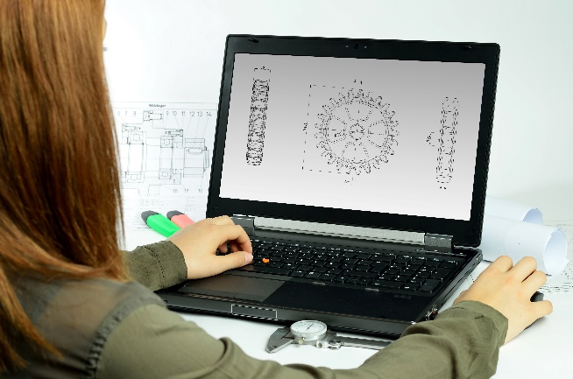
Incorporating the design process into the STEM modules will often result in the need for students to draw plans of their designs. This can be done at a simple level using hand-drawn sketches or at a more technical level using computer-aided design (CAD).
By developing skills using industry-standard software, students may be well-placed to explore future career pathways.
istockphoto.com
There are several CAD software options, two free examples are detailed below. Autodesk is a third package that is also free for educational use.
Tinkercad
- Format: Web-based app requiring internet access via a browser
- Purpose: A simple, online 3D design and 3D printing app
- Home: www.tinkercad.com
- Blog: blog.tinkercad.com
- Tutorials: www.tinkercad.com/learn
- Feature: Connects to 3D printing and laser cutting.
SketchUp
- Format: Can be downloaded and installed on devices, or used in a browser
- Purpose: Enables students to draw in 3D
- Home: www.sketchup.com 'Products' 'SketchUp for Schools'
- Help centre: help.sketchup.com/en
- Blog: blog.sketchup.com
- Tutorials: www.youtube.com/user/SketchUpVideo. From beginner tool tips to intermediate and advanced modelling techniques, the video tutorials help to build SketchUp skills.

Appendix 6: Student journal
When students reflect on learning and analyse their ideas and feelings, they self-evaluate, thereby improving their metacognitive skills.
These modules encourage students to self-reflect and record the stages of their learning in a journal. This journal may take the form of a written journal, a portfolio or a digital portfolio.
istockphoto.com
Using digital portfolios can help develop students’ information and communication technology (ICT) capability.
Reflective practice and recording can be supported in classrooms by creating opportunities for students to think about and record their learning through notes, drawings or pictures. Teachers should encourage students to revisit earlier journal entries to help them observe the progress of their thoughts and understanding.
Journals are a useful tool that gives teachers additional insight into how students value their own learning and progress, as well as demonstrating their individual achievements.
The following links provide background information and useful apps for journalling.
Reflective journal (University of Technology Sydney)
www.uts.edu.au/sites/default/files/reflective_journal.pdf
Reflective writing (University of New South Wales Sydney))
student.unsw.edu.au/reflective-writing
Balancing the two faces of ePortfolios (Helen Barrett, 2009)
electronicportfolios.org/balance/Balancing.jpg
Digital portfolios for students (Cool tools for school)
cooltoolsforschool.wordpress.com/digital-student-portfolios
Kidblog – digital portfolios and blogging
kidblog.org/home
Evernote (a digital portfolio app)
evernote.com
Weebly for education (a drag and drop website builder)
education.weebly.com
Connect – the Department of Education’s integrated, online environment connect.det.wa.edu.au

Appendix 7: Student activity sheet 1.0: Journal checklist
As an ongoing part of this module, you have been keeping a journal of your work.
Before submitting your journal to your teacher please ensure you have included the following information.
- Tick each box once complete and included.
- Write N/A for items that were not required in this module.
istockphoto.com

Your name and group member's names or photographs
An explanation of the problem you are solving
Your notes from Activity 1
Your notes from Activity 2
Your notes from Activity 3
Your notes from Activity 4
Student activity sheet 1.7: Water cycle
Student activity sheet 2.1: Investigation checklist
Student activity sheet 4.3: Peer evaluation
Student activity sheet 4.4: Self-evaluation
Student activity sheet 1.0: Journal checklist

Appendix 8: Teacher resource sheet 1.1: Cooperative learning – Roles
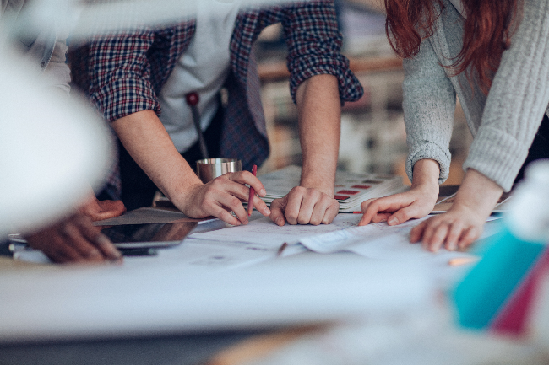
Cooperative learning frameworks create opportunities for groups of students to work together, generally to a single purpose.
As well as having the potential to increase learning for all students involved, using these frameworks can help students develop personal and social capability.
When students are working in groups, positive interdependence can be fostered by assigning roles to group members.
istockphoto.com
These roles could include:
- Working roles such as Reader, Writer, Summariser, Time-keeper
- Social roles such as Encourager, Observer, Noise monitor, Energiser.
Further to this, specific roles can be delineated for specific activities that the group is completing. It can help students if some background to the purpose of group roles is made clear to them before they start, but at no time should the roles get in the way of the learning. Teachers should decide when or where roles are appropriate to given tasks.
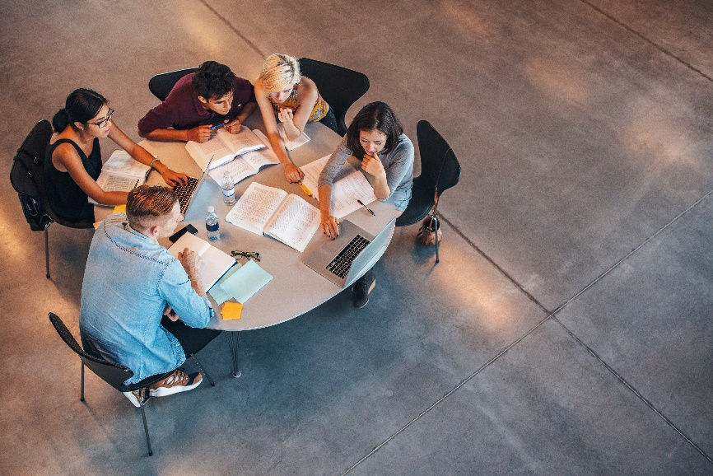

istockphoto.com

Appendix 9: Teacher resource sheet 1.2: Cooperative learning – Placemat
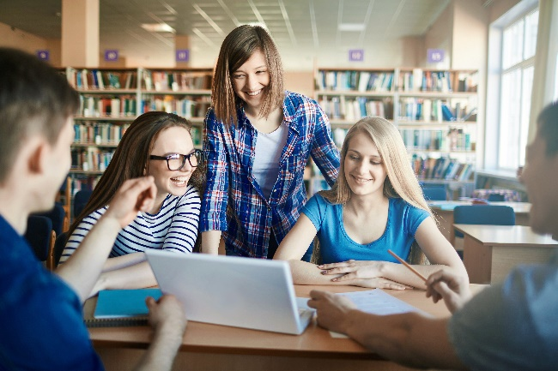
Cooperative learning frameworks create opportunities for groups of students to work together, generally for a single purpose.
As well as having the potential to increase learning for all students involved, using these frameworks can help students develop personal and social capability.
The placemat strategy involves students working collaboratively to record prior knowledge about a common topic and brainstorm ideas. It also allows teachers to readily see the contribution of each student. The diagram below shows a typical placemat template.
istockphoto.com

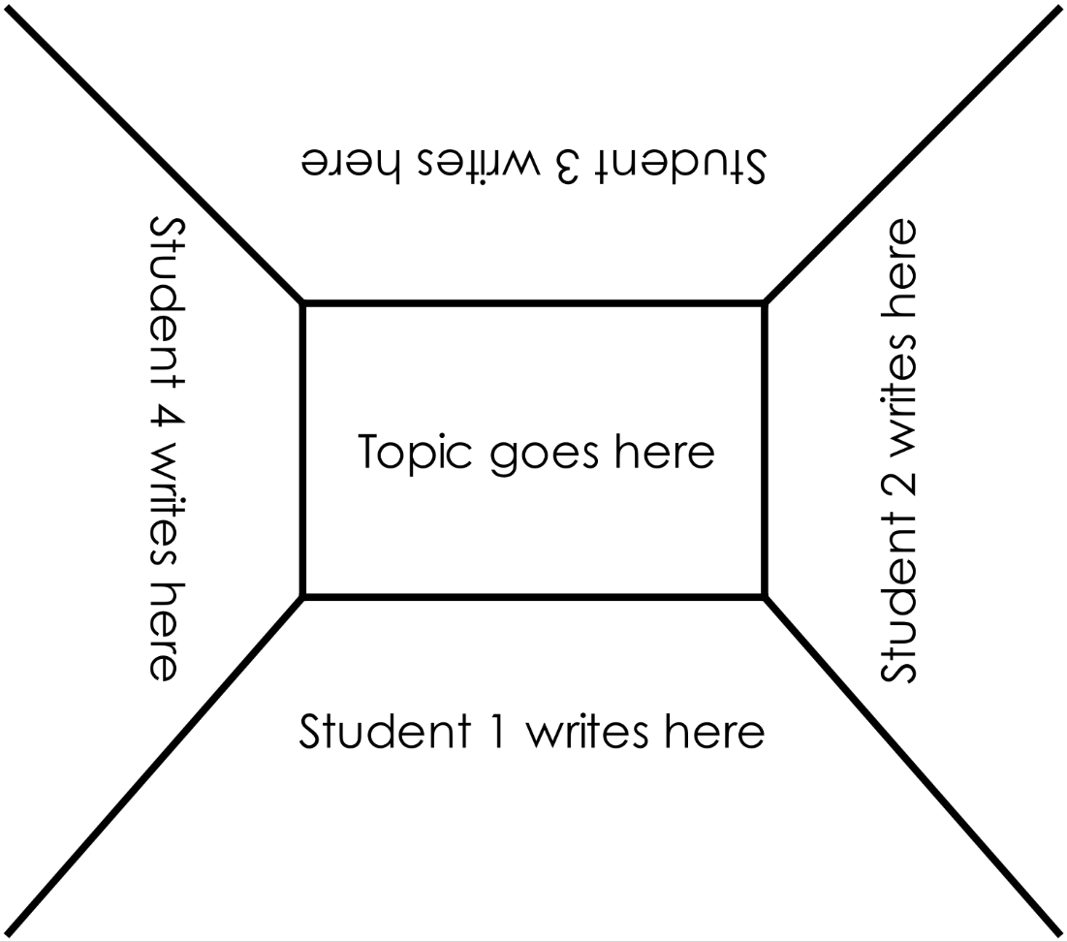
STEM Consortium

Appendix 10: Teacher resource sheet 1.3: Cooperative learning – Think, Pair, Share
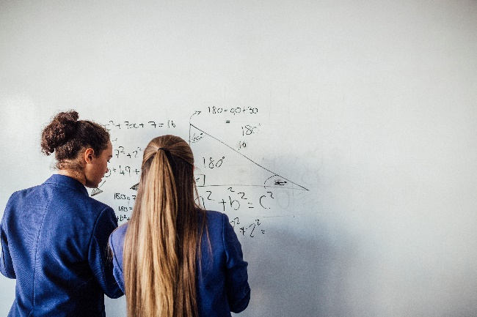
Cooperative learning frameworks create opportunities for groups of students to work together, generally to a single purpose.
As well as having the potential to increase learning for all students involved, using these frameworks can help students develop personal and social capability.
In the 'think' stage, each student thinks silently about a question asked by the teacher.
istockphoto.com
In the 'pair' stage, students discuss their thoughts and answers to the question in pairs.
In the 'share' stage, the students share their answer, their partner’s answer or what they decided together. This sharing may be with other pairs or with the whole class. It is important also to let students 'pass'. This is a key element of making the strategy safe for students.
Think-pair-share increases student participation and provides an environment for higher levels of thinking and questioning.
istockphoto.com

Appendix 11: Teacher resource sheet 1.4: Cooperative learning – Silent card sort
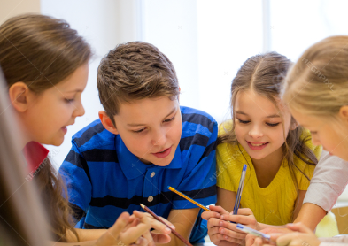
Cooperative learning frameworks create opportunities for groups of students to work together, generally for a single purpose.
As well as having the potential to increase learning for all students involved, using these frameworks can help students develop personal and social capability.
To engage in a silent card sort, students should be in groups of three or four students.
They are provided with a set of cards that need to be sorted into two or more given categories. In the initial phase, students must not speak at all. They silently use their fingers to move the cards around, all at the same time, cooperating and coordinating their actions without using any words or sounds.
istockphoto.com
When most have completed the sort, the teacher gives the signal to begin talking and students then explain to each other their actions and negotiate any changes group members think necessary.
This activity provides for equal engagement from all in the group during the silent card sort, without any one person using language to take control of the activity. It requires cooperation and initial consensus through the movement of the cards alone. Students often use body language to convey meaning requiring attention to visual rather than aural cues.
When given the opportunity to talk, the participant then can justify and present arguments for any changes and gain final consensus through discussion.

Appendix 12: Student activity sheet 1.5: Resource cards
Solar energy | Timber | Gold
Plastic | Animal power | Crude  oil
Petrol | Biogas | Marble
Hydro electricity | Coal | Natural gas
Paper | Mineral sands | Water

Iron ore | Wind energy | Tidal energy
Geothermal energy | Glass | Aluminium
Ethanol | Kerosene | Alcohol
Electricity | Steel | Nuclear energy
Stone | Clay bricks | Concrete

Appendix 13: Teacher resource sheet 1.6: Water cycle
The water cycle
Materials:
Small aquarium
Square dish
Two cups of dry sand
Plastic wrap and tape or a length of elastic to seal the edges
Boiling water
Small weight and a tray of ice blocks
Small aquarium
water
Slope the sand upwards
Cover aquarium with plastic wrap and secure with tape.
Place a small weight on the plastic wrap then after 5 minutes, replace it with the ice.

Square cake tin with boiling water
Dry sand

STEM Consortium
Prepare the aquarium as shown in the diagram above:
Half-fill the cake tin container with boiling water (simulating evaporation by the heat of the sun), being careful not to splash any water on the dry sand.
Immediately cover the top of the aquarium loosely with several sheets of plastic wrap (simulating the atmosphere layer where clouds are forming), seal the perimeter and weigh down the end over the sand with a small weight.
After five minutes, replace the weight with blocks of ice (simulating the colder upper atmosphere).
Students observe and take photos of the aquarium at intervals over the next 20 minutes.
Condensation will initially cover the glass and plastic wrap (simulating cloud formation). During that time the condensation should increase and begin to make water droplets fall on the sand and run down the side of the aquarium (simulating precipitation).
Carefully remove the ice and the plastic wrap after about 20 minutes. There should be clear evidence of water in the dry sand, and some runoff may also be visible from the droplets running down the side of the aquarium.

Appendix 14: Student activity sheet 1.7: Water cycle
Students’ simulation – Water cycle
You will need:
Small aquarium
Square dish
Two cups of dry sand
Plastic wrap and tape or a length of elastic to seal the edges
Water
Small weight and a tray of ice blocks

Prepare the aquarium as shown below.
water
Slope the sand up
Cover with plastic wrap and secure with tape

Small weight
Square cake tin with boiling water

Dry sand

STEM Consortium
Place the aquarium in full sunlight, avoiding areas of shade during the day. Leave overnight.
In the morning, examine the aquarium.
What do you notice?
__________________________________________________________________________________
After carefully removing the plastic, what do you see?
__________________________________________________________________________________

__________________________________________________________________________________
Explain what has made the sand wet? How did the water get there?
__________________________________________________________________________________

__________________________________________________________________________________

What do these words mean?
Evaporation
__________________________________________________________________________________
Condensation
__________________________________________________________________________________
Precipitation
__________________________________________________________________________________

Appendix 15: Student activity sheet 2.1: Investigation checklist
Use the following checklist to ensure you cover all aspects of your investigation. There is space for notes.
I have chosen a research question that can be answered using a scientific investigation?
I have considered all variables and decided which will be changed.
I have decided what I will be measuring.
I have chosen the equipment I will need.
I have conducted the investigation carefully.
I have recorded my data accurately and consistently.
I have chosen a suitable way to summarise my data and used scientific language.
I have chosen suitable graphs and/or tables to represent my data.
I have justified my conclusions using evidence from my investigation.
I have reflected on my investigation and suggested improvements.
I have suggested further questions that could be investigated.

Appendix 16: Teacher resource sheet 3.1: Flowcharting symbols
A flowchart is a diagrammatic representation of an algorithm. It can take the form of a branching set of shapes with decision-making steps. The shapes used in a flowchart are shown here with explanations of their purpose.

Terminator
This symbol is used to represent the start and end of a flowchart.
Process
This symbol is used to represent one or more instructions or things to do.
Data
This symbol is used to represent the input or output of any information.
Decision
This symbol is used to represent a point in the flowchart where a decision is made and from which two or more paths could be followed.
Flow line
This symbol is used to show the direction of the process or data flow.

Appendix 17: Teacher resource sheet 3.2: Flowchart example
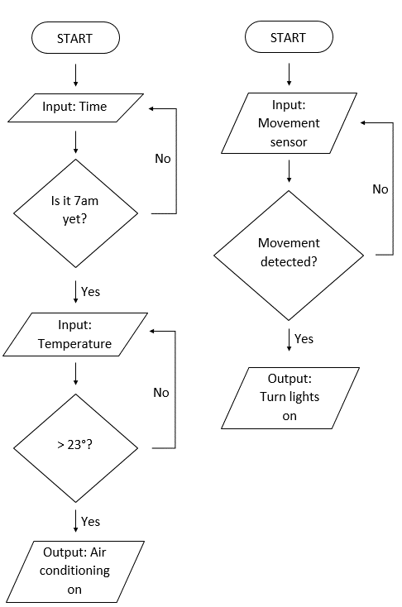
STEM Consortium

Appendix 18: Teacher resource sheet 4.1: Design evaluation
Criteria  Rating code:  3 – Outstanding  2 – Well done  1 – Could be improved | Design solutions
 | Group  1 | Group  2 | Group  3 | Group  4 | Group  5 | Group  6 | Group  7 | Group  8
Total ratings
Mean

Appendix 19: Teacher resource sheet 4.2: Evaluation

Key:  - Sometimes  - Consistently  - Independently and consistently | Student name
Remains focused on tasks presented
Completes set tasks to best of their ability
Works independently without disrupting others
Manages time effectively
Cooperates effectively within the group
Contributes to group discussions
Shows respect and consideration for others
Uses appropriate conflict resolution skills
Actively seeks and uses feedback

Appendix 20: Student activity sheet 4.3: Peer evaluation
 | Always | Usually | Sometimes | Rarely
Remains focused on tasks presented
Completes set tasks to best of their ability
Works independently without disrupting others
Uses time well
Cooperates effectively within the group
Contributes to group discussions
Shows respect and consideration for others
Uses appropriate conflict resolution skills
Comes to class prepared for activities
Actively seeks and uses feedback

Comments: __________________________________________________________________________________________________________________________________________________________________________________________________________________________________________________________________________________________________________________________________________________________

Appendix 21: Student activity sheet 4.4: Self-evaluation
 | Always | Usually | Sometimes | Rarely
Remains focused on tasks presented
Completes set tasks to best of their ability
Works independently without disrupting others
Uses time well
Cooperates effectively within the group
Contributes to group discussions
Shows respect and consideration for others
Uses appropriate conflict resolution skills
Comes to class prepared for activities
Actively seeks and uses feedback

Comments: __________________________________________________________________________________________________________________________________________________________________________________________________________________________________________________________________________________________________________________________________________________________

Notes
________________________________________________________________________________________________________________________________________________________________________________________________________________________________________________________________________________________________________________________________________________________________________________________________________________________________________________________________________________________________________________________________________________________________________________________________________________________________________________________________________________________________________________________________________________________________________________________________________________________________________________________________________________________________________________________________________________________________________________________________________________________________________________________________________________________________________________________________________________________________________________________________________________________________________________________________________________________________________________________________________________________________________________________________________________________________________________________________________________________________________________________________________________________________________________________________________________________________

