 | WATER  Conserving water and protecting the health of our waterways and oceans | ENERGY  Conserving energy and deriving our energy supplies through renewable sources (‘natural power’) | TRANSPORT AND AIR  Reducing pollution/greenhouse gas emissions though the use of alternative modes of transport to motor vehicles; switching to smaller, more fuel-efficient motor vehicles | BIODIVERSITY  Valuing, protecting and replenishing native flora and fauna | PURCHASING AND WASTE  Reducing consumption, choosing environmentally-and/or socially-friendly products, and effectively managing waste streams in the most environmentally-friendly way possible
SECTION A:
TEACHING AND LEARNING
Programs and activities at year levels or phases of learning
SECTION B:
PROFESSIONAL LEARNING
Courses, workshops, conferences attended by staff
SECTION C
INFRASTRUCTURE/OPERATIONS
Water and/or energy efficiency appliances/features/structures/processes; infrastructure/processes supporting ‘travel smart’ activity, biodiversity protection/enhancement, reduced consumption, effective waste management.
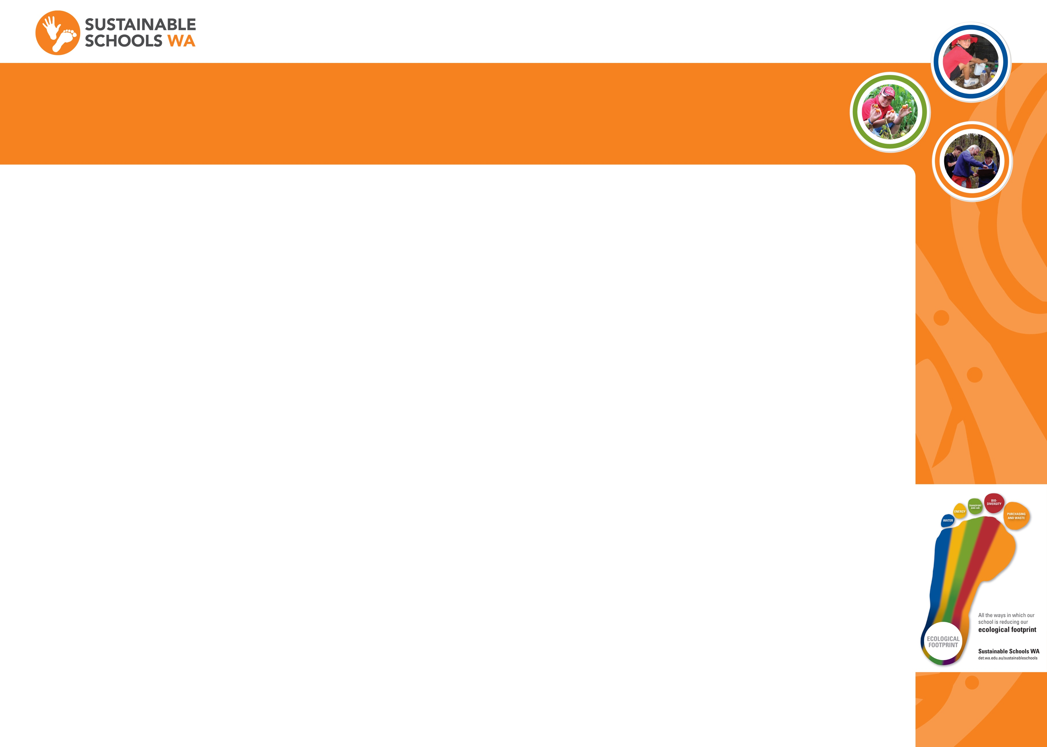
ECOLOGICAL FOOTPRINT

