ACTIVITY AND OUTCOMES | ABORIGINAL AND TSI HISTORIES AND CULTURES  Enhancing communication with, and understanding the histories and cultures of, the ‘first Australians’ | CULTURAL AND  SOCIAL DIVERSITY  Understanding, learning from and valuing other cultures and social diversity | COMMUNITY PARTNERSHIPS  Working with others within the broader school community to achieve shared goals and outcomes | STUDENT AND STAFF WELLBEING  Supporting the physical and emotional wellbeing of students and educators now and into the future | ECONOMICS, BUILT ENVIRONMENT  Saving money through effective utilities management; raising money for environmental and social justice projects; creating a harmonious, vibrant, ecologically-sound teaching and learning environment
SECTION A:
TEACHING AND LEARNING
Programs and activities at year levels or phases of learning
SECTION B:
PROFESSIONAL LEARNING
Courses, workshops, conferences attended by staff
SECTION C
INFRASTRUCTURE/OPERATIONS
Features/structures/processes supporting a harmonious, vibrant, ecologically-sound environment
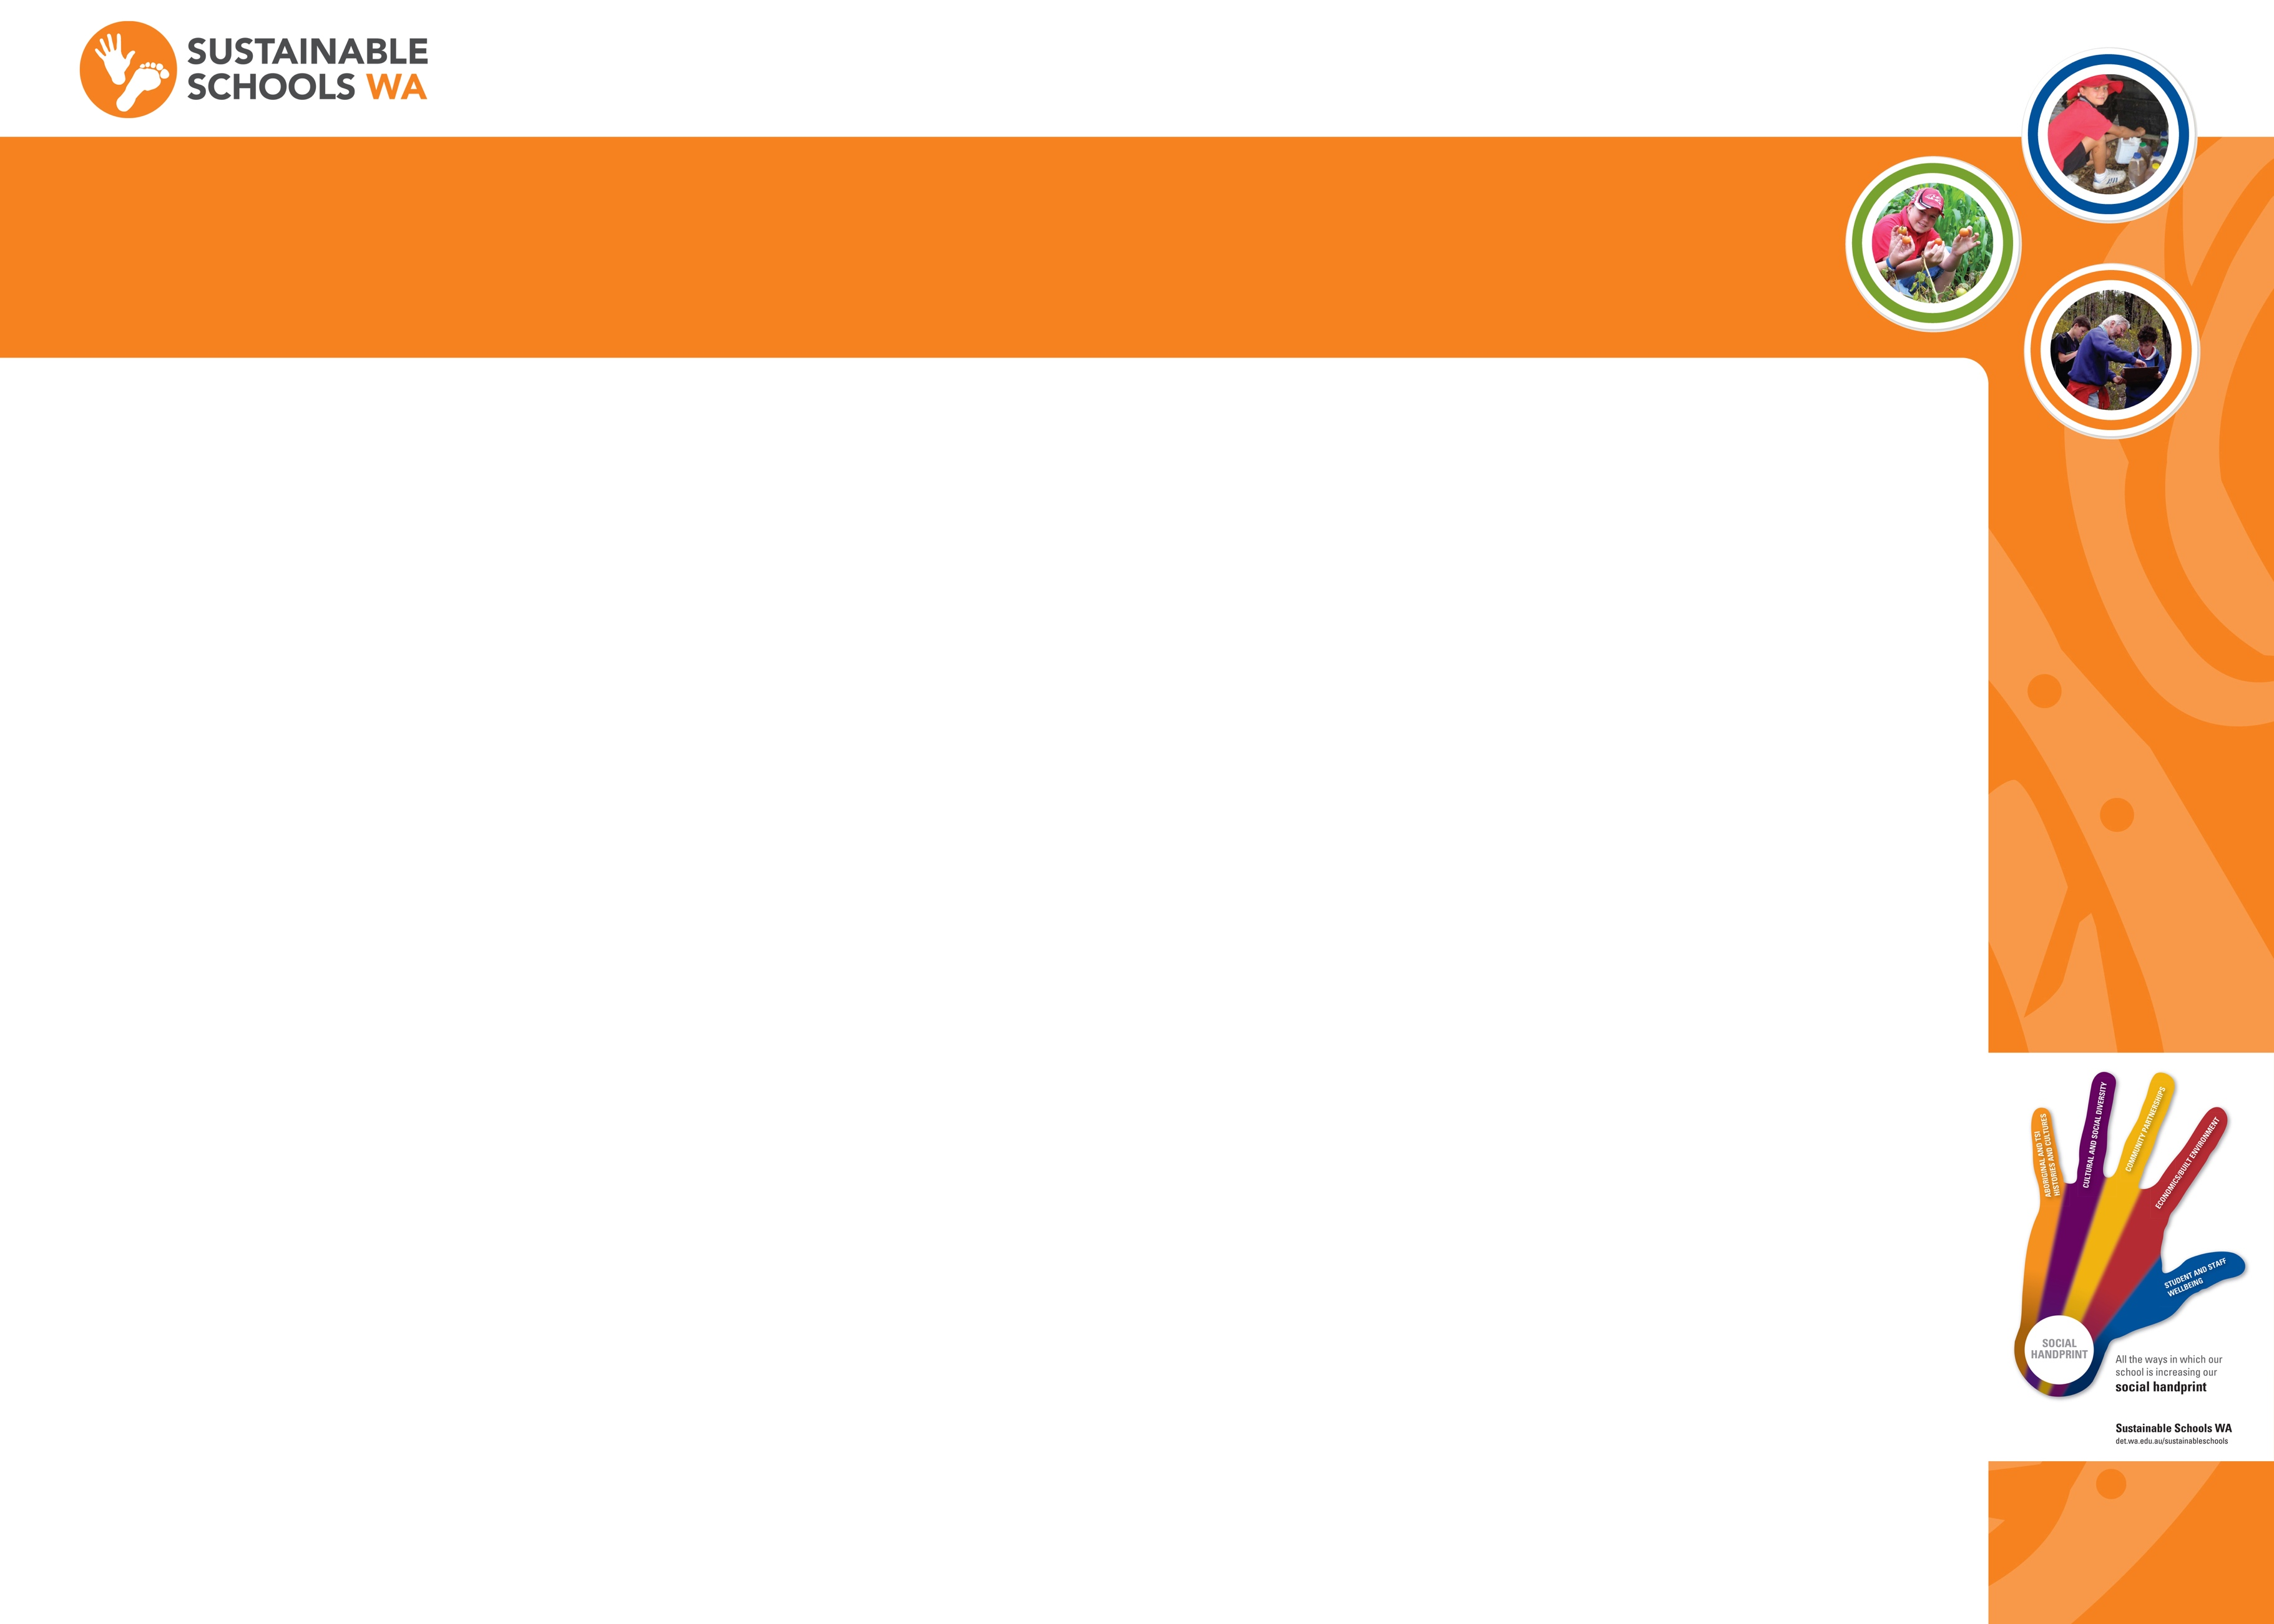
SOCIAL HANDPRINT

