**INFORMATION SHEET**

**SUSTAINABLE SCHOOLS WA aims to SUPPORT:**

* schools with a whole-school planning framework that focuses on increasing   
  the knowledge, skills and understandings of education for sustainability within   
  school communities;
* the use of sustainability as a key context for teaching and learning linked,   
  where appropriate, to school infrastructure and day-to-day management; and
* the application of sustainability concepts and principles across the   
  whole-school community through student-centred, action-based learning experiences;   
  critical and creative thinking; reflection; and systems thinking.

**What it means for Schools:**

* support to implement the *Western Australian Curriculum*;
* support for STEM education and its focus on critical and creative thinking and ‘real world’ problem solving;
* professional learning and resources; and
* support from Sustainable Schools WA Alliance education for sustainability partners.

**WHAT IT MEANS FOR OTHER KEY STAKEHOLDERs:**

* ***education for sustainability providers*** – opportunities to expand partnership and   
  network activities between providers that enhances the quality and reach of   
  their programs;
* ***local and regional government*** – opportunities for improved take-up and   
  integration of resources and programs with schools’ sustainability action planning   
  processes. An opportunity to expand partnership and network activities with other   
  education for sustainability providers that enhance the quality and reach of   
  their programs;
* ***natural resource management groups*** – opportunities for schools to be engaged   
  with local community conservation projects; and
* ***business and industry*** - opportunities to support local schools to achieve their   
  education for sustainability goals, and promote respective sustainability activities.

**Further Information**

For more information about Sustainable Schools WA and the Sustainable Schools WA Alliance, please contact:

Howard Flinders, Teaching and Learning Services, Statewide Services Centre

Telephone: 9402 6259

Email: [howard.flinders@education.wa.edu.au](mailto:howard.flinders@education.wa.edu.au)

Website: [www.det.wa.edu.au/sustainableschools](http://www.det.wa.edu.au/sustainableschools)

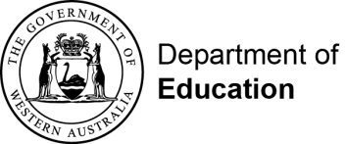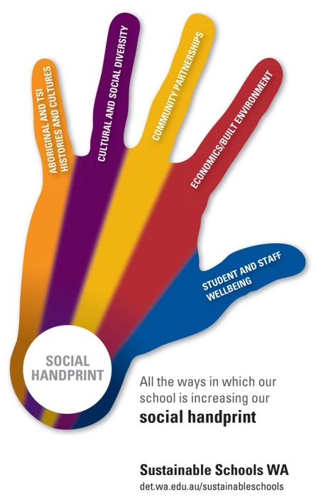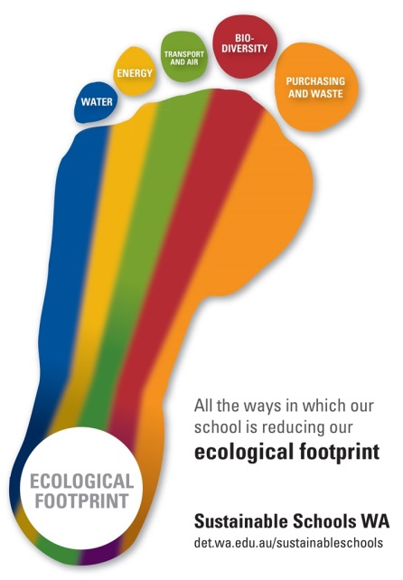

**SUSTAINABLE SCHOOLS WA   
ALLIANCE MEMBERS**



* Department of Education
* Department of Biodiversity, Conservation and Attractions (Nearer to Nature)
* Australian Association for Environmental Education (WA)
* Department of Water and Environmental Regulation (Waste Wise Schools)
* Water Corporation (Waterwise Schools)
* City of Canning (Canning River Eco Education Centre)
* Keep Australia Beautiful WA (Clean Schools)
* Botanic Gardens and Parks Authority (Kings Park Education)
* South East Regional Centre for Urban Landcare (SERCUL)
* The Stephanie Alexander Kitchen Garden Foundation
* United Nations Association of Australia (WA)
* Eastern Metropolitan Regional Council
* Switch Your Thinking (local government)
* Department of Fire and Emergency Services
* Perth Natural Resource Management (Adopt A Beach)
* City of Wanneroo
* Millennium Kids (Green Lab)
* Environment House
* Roots and Shoots
* Captain Cleanup Pty Ltd
* One World Centre
* Angela Rossen Artist/Educator
* Department of Transport (Your Move)
* Perth Zoo
* RRaFT Educators
* Maia Maia
* WA Museum
* City of Stirling
* ClimateClever
* Kanyana Wildlife
* Piney Lakes Environmental Education Centre
* REmida Creative Reuse Centre
* Cockburn Wetlands Education Centre
* South Metropolitan Regional Council
* Insight Ornithology (Simon Cherriman)
* Roaming Reptile Education
* Whiteman Park
* WA Wildlfe