**INFORMATION SHEET**

**SUSTAINABLE SCHOOLS WA aims to SUPPORT:**

* school communities with a whole-school planning framework that focuses on increasing knowledge, skills and understandings of education for sustainability;
* the use of sustainability as a key *context* for teaching and learning linked,   
  where appropriate, to school infrastructure and day-to-day management; and
* the application of sustainability concepts and principles across the   
  whole-school community through student-centred, action-based learning experiences;   
  critical and creative thinking; reflection; and systems thinking.

**What it means for Schools:**

* support to implement the *Western Australian Curriculum*;
* a way to engage with/enact *Caring for Country together,* the Department’s Sustainability Framework;
* support for STEM education and its focus on critical and creative thinking and ‘real world’ problem solving;
* professional learning and resources; and
* support from Sustainable Schools WA Alliance education for sustainability partners (see over).

**WHAT IT MEANS FOR OTHER KEY STAKEHOLDERs:**

* ***education for sustainability providers*** – opportunities to expand partnership and   
  network activities between providers that enhances the quality and reach of   
  their programs;
* ***local and regional government*** – opportunities for improved take-up and   
  integration of resources and programs with schools’ sustainability action planning   
  processes;
* ***natural resource management groups*** – opportunities for schools to be engaged   
  with local community conservation projects; and
* ***business and industry*** - opportunities to support local schools to achieve their   
  education for sustainability goals, and promote respective sustainability activities.

**Further Information**

For more information about Sustainable Schools WA and the Sustainable Schools WA Alliance, please contact:

Howard Flinders, Quality Teaching and Innovation, Statewide Services Centre

Telephone: 9402 6259

Email: [howard.flinders@education.wa.edu.au](mailto:howard.flinders@education.wa.edu.au)

Website: [www.det.wa.edu.au/sustainableschools](http://www.det.wa.edu.au/sustainableschools)

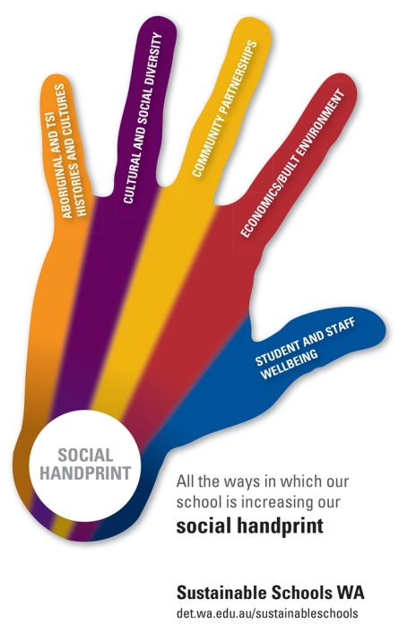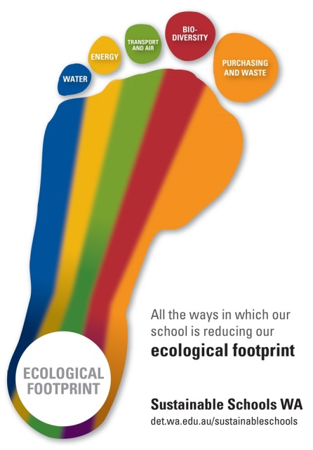

**SUSTAINABLE SCHOOLS WA   
ALLIANCE MEMBERS**



* Department of Education
* Department of Biodiversity, Conservation and Attractions (Nearer to Nature)
* Australian Association for Environmental Education WA (Little Green Steps)
* Department of Water and Environmental Regulation (WasteSorted Schools)
* One World Centre
* Water Corporation (Waterwise Schools)
* City of Canning (Canning River Eco Education Centre)
* Angela Rossen Artist/Biodiversity Educator
* Keep Australia Beautiful WA (Clean Schools)
* Millennium Kids (Green Lab)
* Botanic Gardens and Parks Authority (Kings Park Education)
* South East Regional Centre for Urban Landcare (SERCUL)
* Perth Zoo
* Herdsman Lake Discovery Centre
* WA Wildlfe
* OzHarvest
* City of Wanneroo
* Perth Natural Resource Management (Adopt A Beach)
* Environment House
* Roots and Shoots
* Captain Cleanup Pty Ltd
* Department of Transport (Your Move)
* RRaFT Educators
* City of Stirling
* ClimateClever
* Kanyana Wildlife
* Piney Lakes Environmental Education Centre
* REmida Creative Reuse Centre
* Cockburn Wetlands Education Centre
* South Metropolitan Regional Council
* Re-Cyc-Ology Project (Simon Cherriman & Associates)
* Perth City Farm
* City of Kalamunda
* Foothills Sustainability Centre
* Bottle Top Hill
* Eco Action (Laura Folan & Associates)
* WA Return Recycle Renew Ltd (Containers for Change WA)