Student worksheet 1.1

SPC #MyFamilyCan Case Study
Watch the video SPC #MyFamilyCan < https://youtu.be/_0P9NvnI3Yk> and answer the questions below.
You can also view more information about the SPC #MyFamilyCan campaign here: https://causemarketing.com/case-study/spc-myfamilycan/

1. What was the main concern from the Australian farmers about food produced overseas?
2. What happened in Australia to make the government want to change the food labelling regulations?
3. What did SPC do to their labels?
4. Why did SPC family farmers want a change?
5. What did consumers think about the changes SPC made to their canned foods?

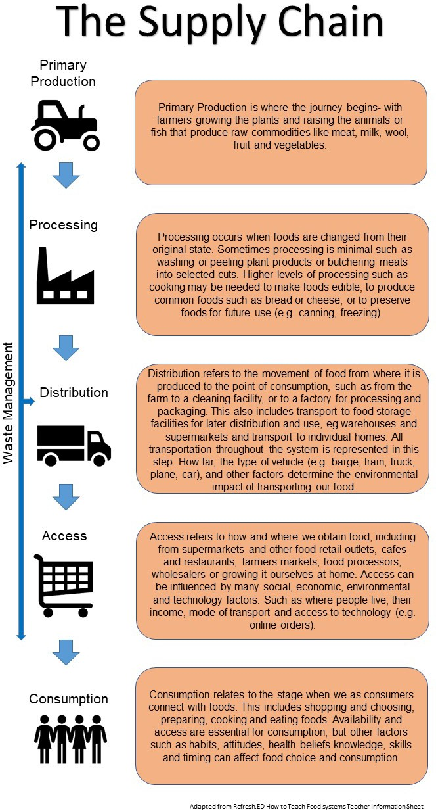
Classroom resource 2.0

Locally produced food and fibre
Primary industries in Western Australia produce many of the food and fibre products we use every day.
- Define the following terms and provide an example for each

Primary industry:
Commodity:

- Use the Agriculture in Western Australia Map from https://foodyoucantrust.org.au/agacademy/students to list some of the commodities which come from each of the primary industries practiced in WA.
Grain | Horticulture | Aquaculture and seafood
Meat and livestock | Dairy | Fibre
Forestry/Timber | Eggs and poultry | Grapes and wine

Western Australian supply chains
- Watch the PRIMED Dairy Supply Chain video.

During the video, write notes to describe the steps that the dairy products/milk travelled from production to consumption.
Milk/yoghurt
Primary production
Processing
Distribution

Access
Consumption

Waste management

Consumer decisions
?

- Draw a flow chart to represent the supply chain journey of milk/yoghurt.
NB: The order may differ from the order in the infographic.

- Draw a flow chart to represent the supply chain journey of milk.

Student worksheet 2.3

Who made my dinner?
Many people are involved in the supply chain process and we can track the journey of our dinner back to the farmer/grower who produces the food we eat.
Use the spaghetti bolognaise image below as an example to map out who actually makes your favourite meal.
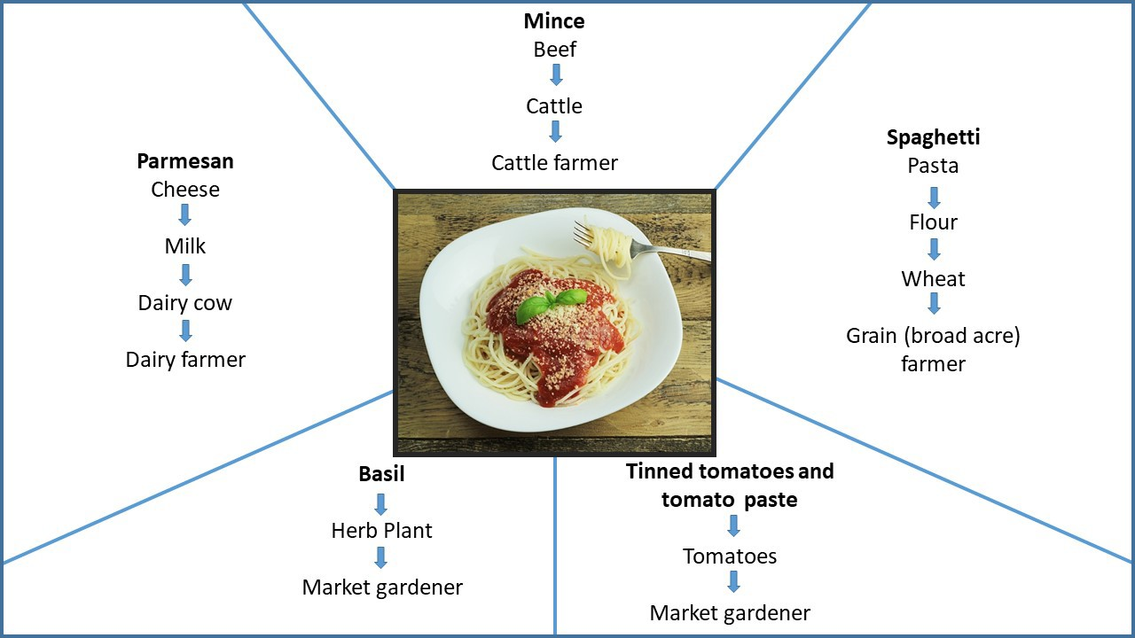
“Pasta” by Free-Photos, available at < https://pixabay.com/photos/spaghetti-pasta-food-restaurant-863304/ >

  - What is one of your favourite meals?

  - List the ingredients used in this meal.

  - Draw a chart/map to explain who really made your dinner.

Student worksheet

3.1 Western Australian food production
- Select 2 commodities you know are produced in Western Australia.
Complete a mind map to represent as many value-added products you can think of that are made from these commodities.
‘Dairy products’ by Free-Photos, available at <https://pixabay.com/illustrations/dairy-products-food-diet-cheese-5621769/>

- Research a company that processes food in Western Australia and complete the table below.

a. Company name and background information:
b. Where is this business located?
c. What do they produce?
d. What raw commodities/ingredients do they use to produce their food?
e. Where do they source their ingredients from?

Student worksheet 4.1

What did you buy?
What was the last 2 things you purchased and where did you buy it?

 | Is this item a |  | Is this item a
NEED | or a | WANT | NEED | or a | WANT

Why did you buy this item? | Why did you buy this item?

Student Worksheet 4.2 Consumer decisions
We often make decisions when buying products, for example, which brand or what size/quantity to buy. Every consumer makes different decisions for different reasons. Sometimes these decisions are financial, while other times they are decisions based on our beliefs and values or personal taste.
- Review the egg carton analysis you completed in class and write down the reasons you and your classmates chose a particular egg brand.
- Watch the videos What about barn-laid eggs and Free range eggs or cage eggs? from https://eggfarmersaustralia.org/ and write down any other reasons customers considered when buying eggs.

Buying Eggs

We can categorise these decisions into social, environmental and economic reasons. On the brainstorm above, use different coloured pens to indicate which of the decisions fit into social, environmental and economic reasons.
How do you think consumers’ buying decisions and opinions of free range, barn laid, and caged eggs have made egg farmers adapt the way they produce and sell eggs? Provide examples.

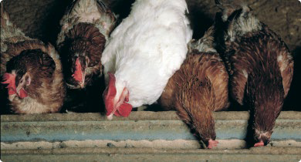

Chickens [1]’ used courtesy of Department of Primary Industries and Regional Development, available
at: <https://www.agric.wa.gov.au/sites/gateway/files/styles/page_featured_image/public/0139023_Chickens%5B1%5D.J PG?itok=XKyYb63Z&c=53af6343a786ef158ac0f76f72e74ae3>
Buying eggs is just one example of how consumers’ buying decisions can influence the supply chain and demand for products. Provide another example of how consumers buying decisions can influence the supply of products.

Design challenge 5.1

The food and fibre journey
The food we eat and the clothes we wear all travel an interesting journey before they get to us. Starting at the point of production (eg a farm), food and fibre are eventually served as a tasty meal or used to produce clothing or furnishings and other textile items. Each stage of this journey forms part of a supply chain. Primary producers/farmers, factories, transporters and consumers all have a role to play in the journey. Understanding the journey that food and fibre takes makes us educated consumers.
For this challenge, your team is responsible for investigating the journey of a food or fibre commodity which is grown in Western Australia. You will produce an information package aimed to inform consumers about the journey this commodity has been on from the farm to us and produce an example value-added product using this commodity. You will use the knowledge you have gained about supply chains and include all the steps the commodity has taken, including the type of processing that occurs to make this commodity a useable product. This information package must encourage consumers to consider buying locally grown produce.
The way you choose to present your information is up to you, examples could be a wall display, poster, brochure, PowerPoint, video. You need to make it informative, and visually engaging. Be creative.
Your research must be collected along the way and all notes, planning and drafts are to be submitted with your final product.
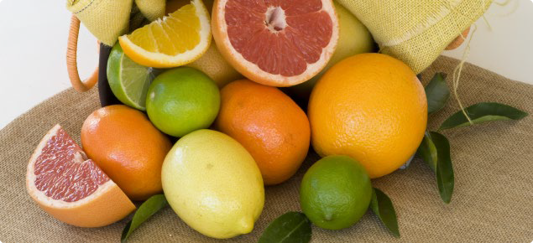
Image 5.1.1
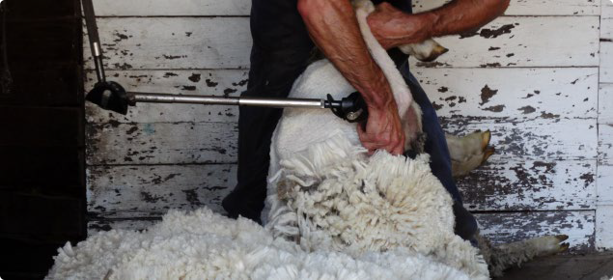
Image 5.1.2

Task Summary

Step 1 | Defining  What are the requirements of this task; explain the purpose of the task. | You will complete this step individually.  In your own words, define the requirements of this task and write down what you need to research.
Step 2 | Investigating  Consider components/resources to develop solutions and identify any constraints | You will complete this step as a member of a small group of students.  Investigate how the commodity you have chosen is processed into a useable product. You are going to track the journey of the commodity from the farm to its end use by us as consumers.
Step 3 | Designing  Design, develop, review and communicate design ideas, plans and processes within a given context, using a range of techniques, appropriate technical terms and technology | You will complete this step as a member of a small group of students.  Prepare a plan for how you will present your information package. Ensure it is engaging, informative and highlights how consumers can find locally produced items made from this commodity.  Design an example of a product that you can produce that uses the commodity you have researched. This could be either a food or a fibre item.
Step 4 | Producing and implementing  Safely make solutions using a range of components, equipment and techniques. | You will complete this step as a member of a small group of students.  Implement your plan to make an information package that explains the journey of your commodity and produce an example of a product that is made from this commodity.
Step 5 | Evaluating  Independently apply given contextual criteria to evaluate design processes and solutions. | You will complete this step individually. Complete the evaluation criteria provided.

Before you start
Select a way to organise your research – for example, handwritten notes in a workbook or portfolio or create a digital document to type your research notes. You must keep all research notes and draft copies of your information package.

Step 1. Defining
  - Write the requirements of this task in your own words. List the essential criteria you must consider.
  - Select a Western Australian grown commodity to use for your investigation.

Step 2 Investigating
Record your research on Student worksheet 5.2 – Commodity research

- What does this food/fibre commodity come from? Eg what plant or what animal.
- How is this food/fibre commodity produced?
- What primary industry produces this food/fibre commodity?
- Where is this food/fibre commodity produced in Western Australia?
- Why is this food/fibre commodity produced in these locations? Consider rainfall/water availability, climate, soil conditions, landscapes, and transportation.
- Who produces this food/fibre commodity? Name a company that produces/grows this food/fibre commodity?
- What time of the year is this food/fibre commodity produced in Western Australia?
- Where can we buy this food/fibre commodity? How much does it cost?
- What products can be made from this food/fibre commodity? How much do they cost? List as many different items as you can.
- What processing does this food/fibre commodity have to go through before we can buy it? Consider both primary and secondary processing.
- Prepare a flow chart diagram that represents the supply chain process this commodity has been through from production to consumption.

Step 3 Designing
It is time to get creative!

Reflect on the information you have collected and think about some creative ways you could produce this into an information package. Remember your aim is to inform consumers about the journey this food or fibre commodity has been on from the farm to us. This information package must encourage consumers to consider buying locally grown produce.
Part A – Information package
- Brainstorm presentation ideas.
- Consider the advantages and disadvantages of presenting the information in this format.
- Select one presentation idea and explain why you think this is the best way to present your information package.
- Sketch a plan of your presentation. Label what images and information will be provided, including all headings and sections. Then label which team member will be responsible for each section.

Part B – Value-added product
- Brainstorm ideas of what your group could make from this food/fibre commodity.
- Consider your skills and the materials/equipment available to you and select one product to make.
- Prepare a list of materials/equipment you would need to make this item.
- Plan the steps you would take to produce the item, allocating roles to each of your group members.

Step 4 Producing and implementing
Part A – Information package
As a group, produce your information package. Use your plan as a guide and note changes to your original plan as you go.
Remember to work together as a group to make an engaging and informative package that explains where your meal came from.
Part B – Value-added product
As a group safely prepare your example value-added product.

Step 5 Evaluating
Complete Step 5 individually.

Self-evaluation
- Did you complete each stage of the project on time?
- Did you finish all stages as planned?
- How successful was your information package and value-added product design plans? Did you need to revise your designs after production started?
- Evaluation is important during the design process. This involves getting other people to provide feedback on your ideas.
  - What feedback did you get from other people in your group during design and production?
  - What feedback did you get from your teacher?
  - How did you act on the feedback you were given?

Effectiveness of solution
- How does your information package explain the supply chain process of your commodity?
- How does the package successfully promote the use of local produce?

Acknowledgements
Image 5.1.1 ‘Citrus’ used courtesy of Department of Primary Industries and Regional Development, available at:
<https://www.agric.wa.gov.au/autumn/internal-maturity-standards-citrus-fruit>, accessed on 14 June 2021

Image 5.1.2 ‘shearing closeup2’ used courtesy of Department of Primary Industries and Regional Development, available at:<https://www.agric.wa.gov.au/sheep/livestock-and-carbon>, accessed on 14 June 2021

Design challenge response document 5.2

The food and fibre journey Step 1. Defining
- Write a statement in your own words that explains what you need to do for this challenge.

List the essential criteria you must consider when completing this task.

1.
2.
3.
4.
5.

- Brainstorm some commodities produced in Western Australia that you could use for your investigation.

- Select a commodity to investigate and use to produce a product.

Step 2 Investigating
- Define – Raw commodity

Value-added product

- Identify the value-added products your commodity can be made into.

Raw commodity | Value-added products
 | Primary | Secondary
eg wheat | four | pasta, bread, pastry, cakes, biscuits, etc.

- Investigate your commodity.

- What does this food/fibre commodity come from? For example, what plant or what animal.
- How is this food/fibre commodity produced?
- What primary industry produces this food/fibre commodity?
- Where is this food/fibre commodity produced in Western Australia?
- Why is this food/fibre commodity produced in these locations? Consider rainfall/water availability, climate, soil conditions, landscapes, transportation.
- Who produces this food/fibre commodity? Name a company that produces/grows this food/fibre commodity?
- What time of the year is this food/fibre commodity produced in Western Australia?
- Where can we buy this food/fibre commodity? How much does it cost?
- What products can be made from this food/fibre commodity? How much do they cost? List as many different items you can.
- What processing does this food/fibre commodity have to go through before we can buy it? Consider both primary and secondary processing.
Note: Record your research in the table provided – Student worksheet 5.3 – Commodity investigation

Step 3 Designing
It is time to get creative!

Part A – Information package

Reflect on the information you have collected and think about some creative ways you could produce this into an information package. Remember your aim is to inform consumers about the journey this commodity has been on from the farm to us. This information package must encourage consumers to consider buying locally grown produce.
- Brainstorm presentation ideas.
- Consider the advantages and disadvantages of presenting the information in these formats.

Presentation idea 1:
Presentation idea 2:

Presentation idea 3:
Presentation idea 4:

- Select 1 presentation idea and explain why you think this is the best way to present your information package.

- Sketch a plan of your presentation. Label what images and information will be provided, including all headings and sections. Then label which team member will be responsible for each section.

Part B – Value-added product

Reflect on the information you have collected and think about some creative products you could produce from your commodity. Remember to consider your skills and the materials and equipment available to you. Your product must showcase your commodity.
- Brainstorm some product ideas. Consider the advantages and disadvantages of each idea.

Idea 1:
Idea 2:

Idea 3:
Idea 4:

- Select one product idea and explain why you think this is the best product to showcase your commodity.

- Write a list off all the materials and equipment need to produce your product.

Materials | Equipment

- Write done the steps you will take to produce your product and allocate each step to a team member.
Production Steps

Step | Action | Team Member

Step 4 Producing and implementing
Part A – Information package
As a group, produce your information package. Use your plan as a guide and note changes to your original plan as you go.
Remember to work together as a group to make an engaging and informative package that explains where your meal came from.
- Keep all your notes and draft copies.
- Your final information package will be presented or displayed to the class.

Part B – Value-added product
As a group, produce your value-added product. Use your plan as a guide and note changes to your original design as you go.
Image: 5.2.1 Freepik.com
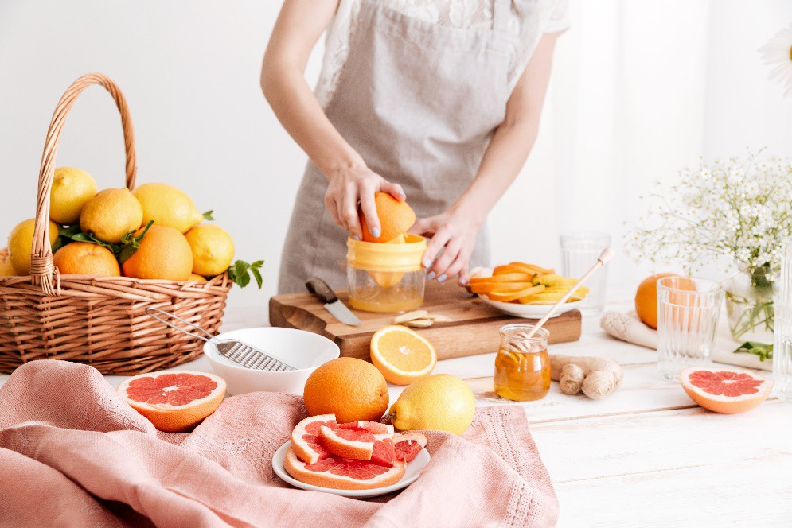
Image 5.2.2: Freepik.com

Step 5 Evaluating
Complete Step 5 individually.

Self-evaluation
- Did you complete each stage of the project on time?

- Did you finish all stages as planned?

- How successful was your information package and value-added product design plans? Did you need to revise your designs after production started?

- Evaluation is important during the design process. This involves getting other people to provide feedback on your ideas.
  - What feedback did you get from other people in your group during design and production?

  - What feedback did you get from your teacher?

  - How did you act on the feedback you were given?

Effectiveness of solution

- How does your information package explain the supply chain process of your commodity?

- How does the package successfully promote the use of local produce?

Acknowledgements
Image 5.2.1 ‘Beautiful knitted clothes, neatly folded, close-up, handmade sweaters’ by Freepik.com, available at < https://www.freepik.com/free-photo/beautiful-knitted-clothes-neatly-folded-close-up-handmade-sweaters_9046206.htm >, accessed on 15 June 2021

Image 5.2.1 by Freepik.com, available at <https://www.freepik.com/free-photo/cropped-image-woman-squeezes-out- juice-citruses_7807879.htm#page=1&query=citrus%20food%20products&position=28>

Student worksheet 5.3 (Recommended to Print A3)

Commodity investigation
What does this food/fibre commodity come from? For example, what plant or what animal.
How is this food/fibre commodity produced?
What primary industry produces this food/fibre commodity?
Where is this food/fibre commodity produced in Western Australia?

Why is this food/fibre commodity produced in these locations? Consider rainfall/water availability, climate, soil conditions, landscapes, and transportation.
Who produces this food/fibre commodity? Name a company that produces/grows this food/fibre commodity?
What time of the year is this food/fibre commodity produced in Western Australia? Why?

Where can we buy this food/fibre commodity? How much does it cost?
What products can be made from this food/fibre commodity? How much do they cost? List as many different items you can.
What processing does this food/fibre commodity have to go through before we can buy it? Consider both primary and secondary processing.

Prepare a flow chart diagram that represents the supply chain process this commodity has been through from production to consumption.

Sources of information:
Record all the resources you have used to gather your information.

