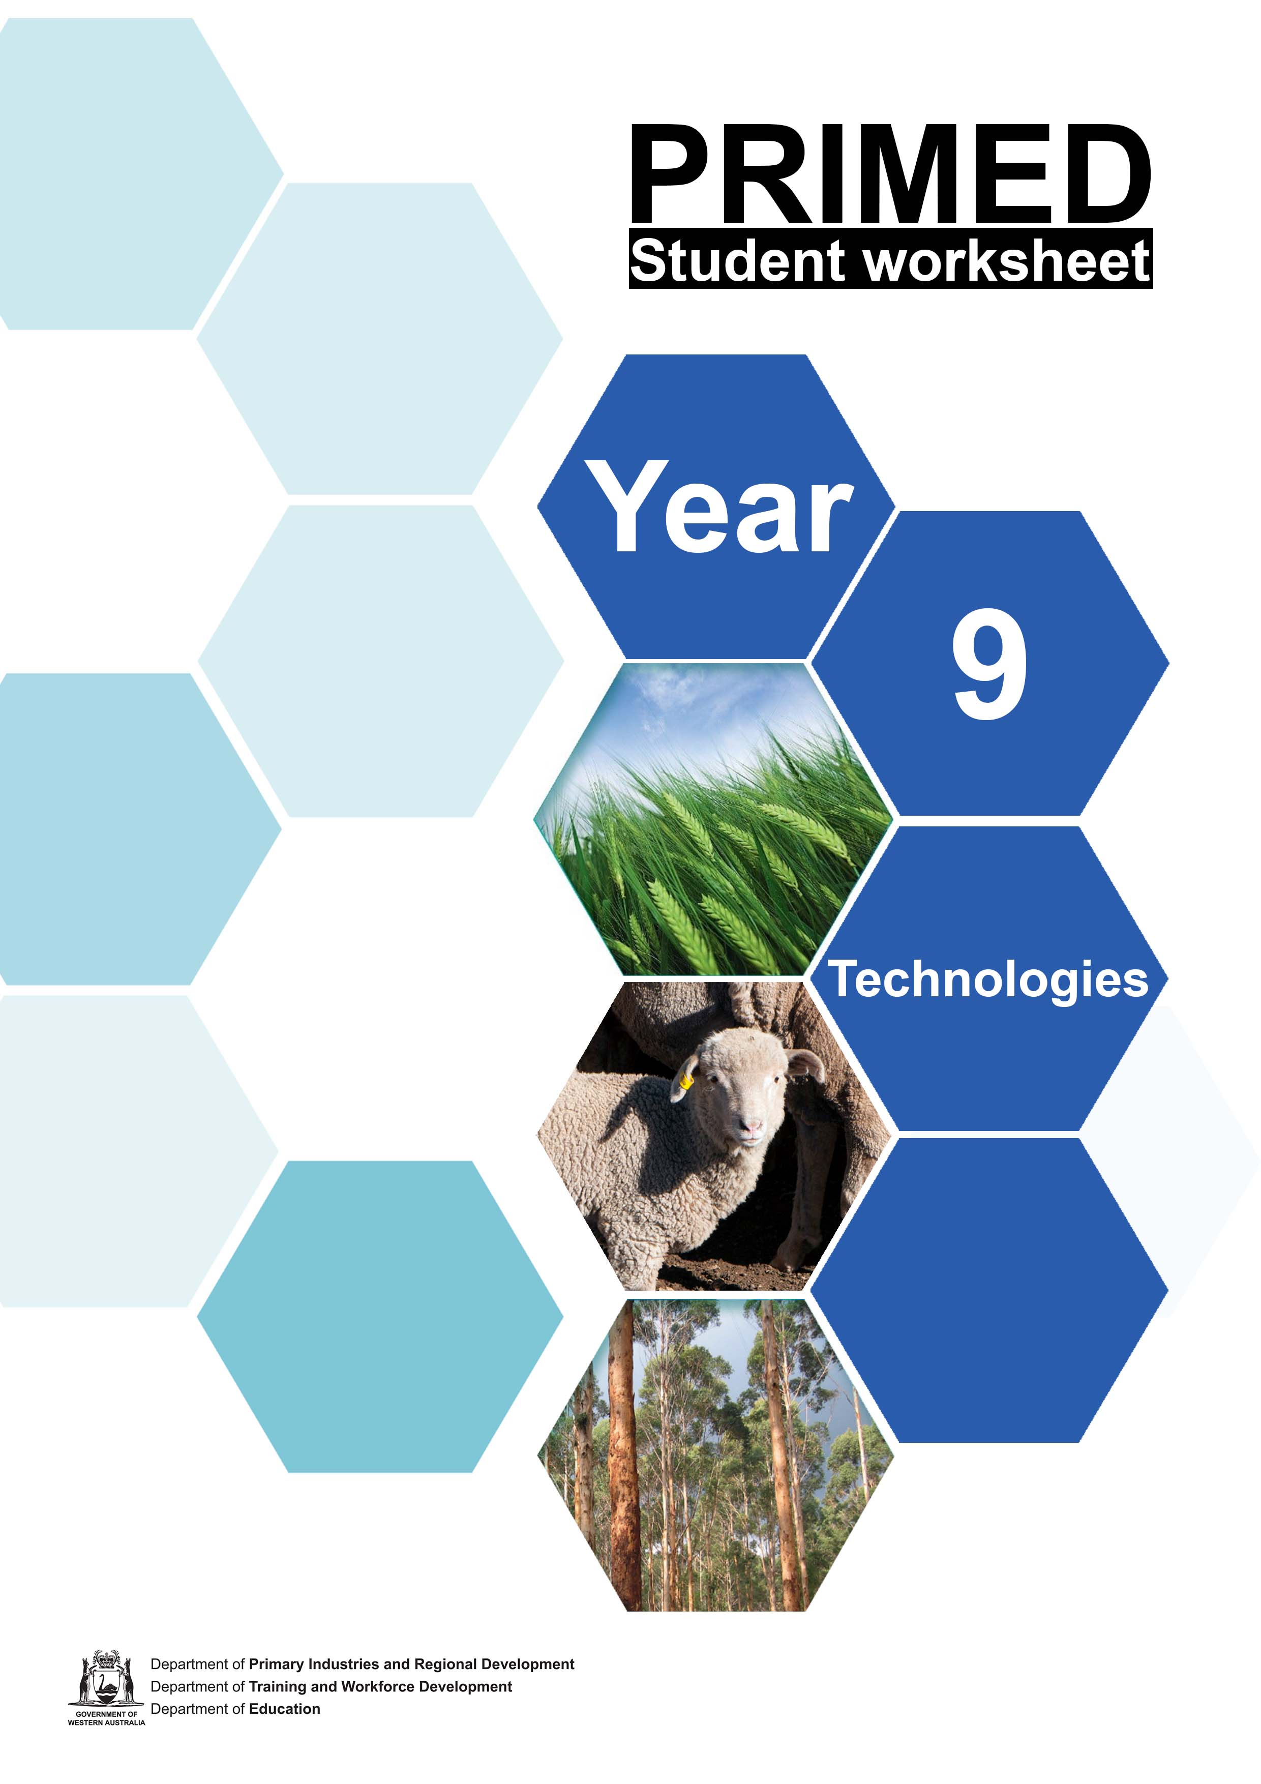

Student worksheet 1.1
The process of making

- We have all been involved in making something. For example, this could be making a cake, a toy model or a vegetable garden.
  - Name three things that you have made or have been involved in making.

1. | 2. | 3.

  - Consider the definition of production. Would you say that when you were making these, you were involved in production?

Explain your answer.

- Match the following aspects of production to identify either input, process or output.

Input |  | The final result of production.
 |  | The steps to implement technology to create the product.
 |  | The impact of the production process, for example, on the environment.
Process |  | The series of operations to produce the product.
 |  | Finished products, by-products and waste.
 |  | The knowledge and skills. This is the knowledge and skills needed to apply technology
Output |  | The materials – these are the ingredients that are changed during the production process into the final product.
 |  | The actual making of the product.
 |  | The energy, the sunlight, electricity, fuel to power all the stages of production.

- Use the following headings to explain the production process you would use to make a toasted ham, cheese and tomato sandwich.

Input | List the materials you would need to produce this item.
 | Identify the equipment you would need to produce this item.
 | Describe the prior knowledge you would need to produce this item.
 | Explain the source of energy that would be used in the production of this item.
Process | Explain the steps you would take to produce this item.
 | What technology is available to produce this item?
Output | Identify the finished product from this process.
 | Describe any by-products that come from this production process and explain what could be done with them.
 | List any waste that is produced in the process and explain how you could sustainably manage this waste.
 | Discuss the environmental impact of this production process.

- Use this website to follow the instructions for Method 3 – Sewing a pencil case: How to make a pencil case
Check the processes used. Use the IPO table below to identify what is happening during the production of the pencil case.

Input | List the materials you would need to produce this item.
 | Identify the equipment you would need to produce this item.
 | Describe the prior knowledge you would need to produce this item.
 | Explain the source of energy that would be used in the production of this item.
Process | Explain the steps you would take to produce this item.
 | What technology is available to produce this item?
Output | Identify the finished product from this process.
Describe any by- products that come from this production process and explain what could be done
with them.
List any waste that is produced in the process and explain how you could
sustainably manage this waste.
Discuss the environmental impact of this production
process.

Acknowledgements
Wikihow (24 February 2021) ‘How to make a pencil case’ <https://www.wikihow.com/Make-a- Pencil-Case> accessed on 15 July 2021

Student worksheet 2.1

Know your food and fibre
- Use a web search engine to search for information on how many different products are sold by the companies listed in the table below. You could use the search text: “how many products does sell”. Do not forget to also indicate where your data came from.

Company | Number products | Who is telling us this?
Amazon
Bunnings
Coles
Woolworths

This gives you some idea of the scale of world production. A production process (input, process and output) is used to make each one of these thousands of products.
- Join a group of three people.
  - Each person in the group can choose one of the following terms:
    - food and fibre production
    - primary industry
    - raw materials

  - Each member explains the meaning of their term to the other members of the group.
  - The group then discusses what is:
    - common between these three terms.
    - different between these three terms.

  - Record what you discovered during the group discussion in the table below.

What is common?
What is different?

- We have seen that many different products are made worldwide and are available to consumers. Food and fibre production accounts for a sub-set of these products. Identify which of the following products in the table below are the result of food and fibre production. Explain your choice.

Product | Food and fibre product? | Explain why/why not
Apples
Black truffles
Bottled wine
Bamboo fabric
Timber
Fast food
Mobile phone
Wool
Particle board

- Name five different food or fibre raw materials that you have used in your home. Rate yourself on how much knowledge you have of the how each of these products is made. That is, your knowledge of the production process for these products – input, process and output.

Raw materials I have used are: | Did I use it directly (in raw form) or did I use it to make something else? | My knowledge of the production of these raw material is: (choose extensive, some, little or none)

- You are visiting a supermarket and have a choice of five different brands of the same food or fibre product. Explain each of the following criteria you might use to decide which one to buy.

Criteria | How would I decide?
Price
Packaging: type of material, amount of packaging and appearance.
Knowledge of the production process: local product, sustainable, proven quality and environmental impact.

- Explain why, as consumers, it is important that we have some knowledge of the production process (input, process and output) of the products we choose.

Student worksheet 2.2

Kimberly Wild Gubinge
Visit the website Kimberley Wild Gubinge.

Use the information on the website and the information about the Kakadu plum provided by your teacher to answer the following questions. Include images from the web site in your answers.
- The Kimberly Wild Gubinge is a primary industry engaging in food and fibre production to produce a raw material - the Kakadu plum.
  - Explain why the business Kimberly Wild Gubinge is an example of a primary industry.

  - Explain why the business Kimberly Wild Gubinge is an example of food and fibre production.

  - Explain why the product the Kakadu plum is an example of a raw material.

- Complete the following Input-Process-Output (IPO) model for the production process used by the business Kimberly Wild Gubinge.

Input | List the materials you would need to produce this item.
 | Identify the equipment you would need to produce this item.
 | Describe the prior knowledge you would need to produce this item.
 | Explain the source of energy that would be used in the production of this item.
 | Explain the steps you would take to produce this item.
Process | What technology is available to produce this item?
 | Identify the finished product from this process.
Output | Describe any by- products that come from this production process and explain what could be done with them.
 | List any waste that is produced in the process and explain how you could sustainably manage this waste.
 | Discuss the environmental impact of this production process.

- As a consumer, rate this product based on the following criteria. Also briefly explain your rating.

Criteria | Rating (1 high  to 5 low) | Why
Is a Western Australian business
Supports a local community
Has a low environmental impact
Is a sustainable product
Dependable information available to confirm the quality of the product and the production process

Acknowledgement
Kimberley Wild Gubinge (2020) ‘Welcome’ accessed at
<https://www.kimberleywildgubinge.com.au> accessed on 22 June 2021

Student worksheet 3.1

The primary attraction
- List the features you think would make a good holiday.
Classify these into accommodation, experience, food, adventure and other.

- Explain the features of an agritourism experience.
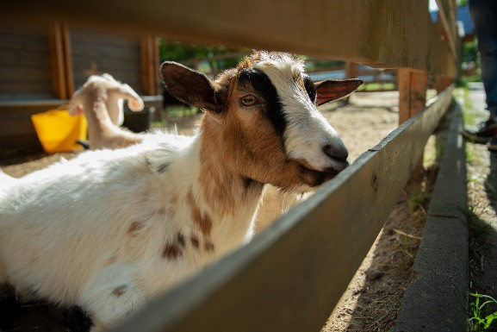
Image 3.1.1

- Identify examples of agritourism experiences in Western Australia.

- If you had the chance to be an agritourist, what food or fibre products (primary industry product) would you like to see made? This would include visiting the places where the product is made and seeing the people involved. For example, chocolate, cheese, eggs, milk or wool.

The food and fibre products I would like to see being produced: | Why I would like to visit the production of these products.

- Rank the following agritourist visitor experiences from 1, what you would be most interested in, to 5, what you would be least interested in:

My Ranking
Share/Hear stories
Appreciation of regional life
Appreciation of the challenges for producers
Experience fresh and new produce and products
Exposure to alternative livelihoods
Source: Holliday, R., Martinus, K.* and Boruff, B. (2020) Agritourism in Southwest Western Australia. Cooperative Research Centre for Honey Bee Products, Perth, Western Australia.

- Some of the reasons why people may be interested in agritourism include.

1 | To meet the people who are involved and learn about regional lifestyles.
2 | To hear about the role of people, their skills and the interesting range of occupations associated with production.
3 | To find out about innovation and the use of state-of-the-art technology.
4 | A chance to visit rural locations, get away and experience something different.
5 | To experience the range of materials used for production.
6 | To experience the operations that take place to transform materials during the production process.
7 | To learn about the challenges faced during the stages of production.
8 | To participate in some of the steps during the production process.
9 | To have an authentic experience interacting with the process (not a documentary or news item but hands-on).
10 | To realise where food and fibre products come from.
11 | To connect between the production process and the final consumer product.
12 | To experience operations for packaging and distribution.
13 | To engage with environmental management and consider the side effects of production.
14 | To make comparisons and explore ideas such as pure products, natural products, and sustainable production.
15 | Other

Using information from the above table, write the matching number for each reason tourists might want to visit primary industry production next to the matching aspect of input, process or output of production below. You can write numbers next to more than one aspect if necessary. One reason has been completed for you.

 | Aspect of production | Reason for visit
Input | The materials that are used. | 5
 | The people that carry out tasks.
 | The facilities, a place to work and carry out production.
 | The equipment and technology that is needed.
 | The energy that is needed.
Process | The steps used to make the product.
 | Technology being applied.
Output | The finished product.
 | The by-products.
 | The waste and impact on the environment.

- Use the diagram below to consider the benefits of agritourism for providers and visitors. Summarise the benefits in the table below.

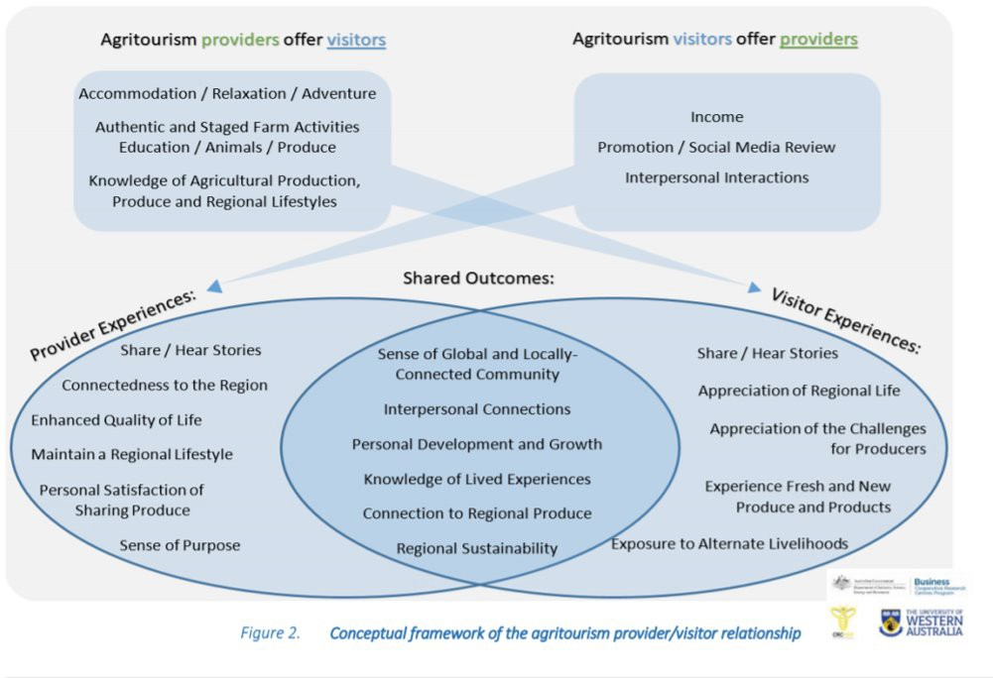

Image 3.1.2

Benefits of Agritourism
Provider | Visitor

Acknowledgement
Images
Image 3.1.1 Irina kukuts ‘Goat’ available at <https://pixabay.com/sv/photos/vdnh-get-semester- resa-moskva-6508126/>
Image 3.1.2 Holliday, R., Martinus, K.* and Boruff, B. (2020) Agritourism in Southwest Western Australia. Cooperative Research Centre for Honey Bee Products, Perth, Western Australia.
<http://www.crchoneybeeproducts.com/wp-content/uploads/2020/06/Agritourism-Report_FINAL- with-CRCHBP-cover.pdf>

Student worksheet 3.2

Exploring the primary attraction.
Watch the video Destination WA: Willie Creek Pearls and answer the following questions.

- Explain the experience showcased in the video.

- Where is this destination located?

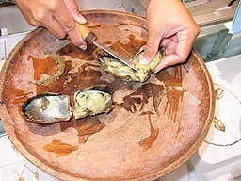

Image 3.2.1

- List the knowledge visitors will learn from this experience.

- Explain the involvement visitors will have during this experience? For example, full immersion (a day in the life), practical tasks, observation tasks or self-guided involvement.

- Use the Input, Process and Output (IPO) stages and explain what visitors get to experience at this agritourism destination for each stage of the IPO model?

Input
Process
Output

Acknowledgements
Destination WA (22 March 2020) ‘Destination WA – Willie Creek Pearl’ YouTube available at
<https://www.youtube.com/watch?app=desktop&v=JrPc2BeiUhI> accessed 18 August 2021

Images
Image 3.2.1 “Pearl Oysters” by Keith Pomakis. Licenced CC BY-SA 2.5 available at < https://commons.wikimedia.org/wiki/File:Pearl_Oysters.jpg > accessed on 18 August 2021

Student worksheet 3.3

Western Australian Agribusiness Case Study
In a small group

- choose a Western Australian (WA) food or fibre business from Great Southern Food and Beverage Capability Guide or from Midwest Food and Beverage Capability Guide
- identify the production process used in the business.

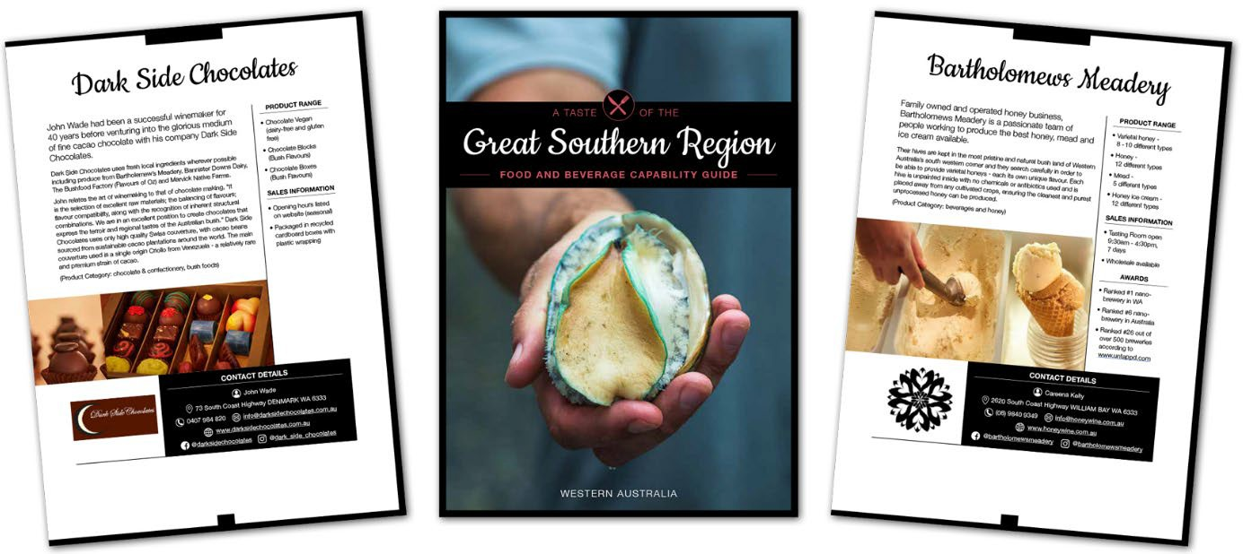
Image 3.2.1

- Meet with your group and choose the WA food or fibre business you will research.

Name of our chosen business:
Location:
Primary industry:
Raw material produced:

- Work together to locate and read information on your chosen Western Australian business. Collaborate to identify what is happening in the production process of the business and to identify what might be of interest to tourists.

 | Describe what happens | Explain how this could be attractive to tourists
Input
Process
Output

Acknowledgements
Department of Primary Industries and Regional Development (19 August 2021) ‘Food and Beverage Capability Guides’ available at https://www.agric.wa.gov.au/capability-guides accessed on 23 August 2021

Images
Image 3.3.1 Department of Primary Industries and Regional Development (19 August 2021) ‘Food and Beverage Capability Guides’ available at https://www.agric.wa.gov.au/capability-guides accessed on 23 August 2021

Design Challenge 4.1 Pitch and promote

Design situation
Agritourism within Western Australia (WA) is a growing industry. A tour company is keen to bring more visitors to regional WA to learn about food and fibre production through agritourism experiences. The tour company is looking for destinations to include on their travel itinerary and have asked each Western Australian region to host an exhibition stand at a tourism showcase. The local councils are interested in this opportunity, as it could attract tourists to visit the regions.

Design brief

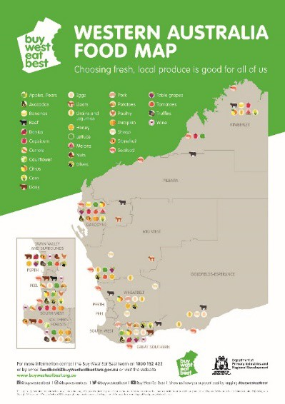
Image 4.1.1

The local council is asking for a small team of people to come together and help prepare a showcase of locally produced food and fibre that will promote local agritourism businesses in the region.
As a working team you will use your knowledge of primary industries in WA and your design skills to promote an agritourism experience from one of the Western Australian regional development zones.
The tour company will only choose one region to host their tour experiences, so you are competing with all the other regions of WA.

Constraints
You will need to design and produce an exhibition stand that showcases the food and fibre produced in your Western Australian region.
You will need to:
- research everything your region has to offer
- select one example of a food or fibre commodity produced in your region to become your ‘star’ commodity
- create an experience, structured around the input, process and output of the production process that is enjoyable and educational, based around your ‘star’ commodity, which will help you promote your region
- create an exhibition stand to promote your region which includes your ‘star’ commodity hands-on experience
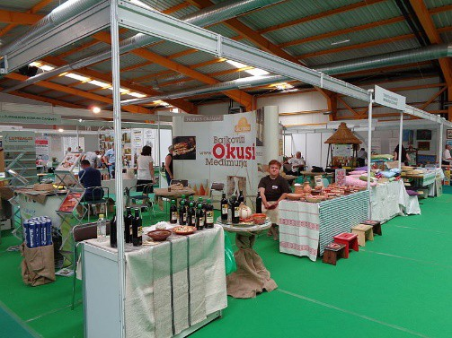
The goal is to engage people with the production process of local food or fibre and highlight the potential the region has as an agritourism destination.

Design folio
Your design folio is an important communication tool for design projects. You need to keep a record of the journey of your project’s development and record which jobs each team member has contributed to. Your folio will start from your first rough ideas, to the final evaluation of your design solution.

Image 4.1.2 Sample exhibition stand

Ongoing collaboration and management
The design and production process
- What are the requirements of this task; explain the purpose of the task.
- You will complete this step individually by completing Step 1 to define the requirements of the Production Task.
Define
- Consider components/resources to develop solutions, identifying constraints.
- You will complete this step as a member of a group by completing Step 2 to consolidate your knowledge, research the business and confirm
Investigate that you are ready to begin making your design.
Design
- Design, develop, review and communicate design ideas, plans and processes within a given context, using a range of techniques, appropriate technical terms and technology.
- You will complete this step as a member of a group by completing Step 3 to guide you through the Designing stage of your product.
- Safely make solutions using a range of components, equipment and techniques.
- You will complete this step as a member of a group by completing
Produce and Step 4 to guide you through the Producing and implementing stage of your product.
implement
Evaluate
- Independently apply given contextual criteria to evaluate design processes and solutions.
- You will complete this step individually by completing Step 5 to assist you in completing the Evaluating stage for your product.

Step 1 – Define
Complete Step 1 individually.

Unpacking the task

- In your own words, explain what you are required to do to complete this task.

Criteria for success

- In order to complete this project, what will you need to do? Make a list of the things you believe will make your project a success.

Stop and reflect:
- Step 1 is to define. Why is it essential that you clearly define the purpose and requirements of a task before getting started on developing a solution?

- Explain the following:

tour company
food or fibre production
agritourism
Western Australian regions
local council
exhibition stand
engage people with the production process

A stakeholder is a party (person or organisation) that has an interest in a business or project.

- Review the design situation and brief and list the stakeholders who have an interest in this project. Describe the benefits for each and list any disadvantages they might identify in being involved in this project.

Stakeholder | Benefits | Disadvantages

- Clarify the difference between:
  - explaining and

promoting.

- Explore a range of promotional products that could be used in an exhibition stand, for example posters/banners, videos, visual displays, photography, digital slide presentations. List your ideas and provide an explanation of each.

1.
2.
3.
4.

Circle one or two you think you would like to use as part of your exhibition stand.

- Reflect on the agritourism experiences we have explored in class. Describe what an agritourism promotional experience could be.

- Think of hands-on activities you could use to promote a food or fibre commodity and list your ideas below.

Step 2 – Investigate

Complete Step 2 in a small group. In this step you will:
- revise and confirm your knowledge about production and the Input-Process-Output (IPO) framework.
- choose a Western Australian region to explore.
- investigate the food and fibre commodities produced in this region.
- revise your knowledge of agritourism.
- identify the production process used to produce your chosen commodity.

Step 2 is important as you will be applying the background knowledge from this investigation in Step 3 and Step 4 to design and create a solution.

- Get your group together and organise the first meeting.

Group members: | 1.  2.  3.  4.

- Locate all the work you completed in the previous lessons, read through the information and revise by writing notes in point form for each of the following questions. Tick each of the questions to indicate you have confirmed your knowledge. Were you uncertain of anything? Ask other members of the group or your teacher for support.

Question | Notes | ✓
1. Explain the term production and provide an example.
- Explain each of the following aspects of the production process
  - Input
  - Process
  - Output.

3. Describe food and fibre production. Explain how it is different from other forms of production.
4. Define raw commodities and provide two examples produced in WA.
5. Explain what primary industry means and provide two examples of primary industry businesses that operate in WA.
6. Why is it important to have knowledge of the production process of products we purchase?
- Explain why tourists enjoy participating in experiences related to the food and fibre production process
  - Input
  - Process
  - Output.

- Meet with your group and research the Western Australian region you will represent. Your teacher will provide you with alternatives.
Suggested sources of information:
Discover Regional Western Australia Buy West Eat Best WA Regions
Department of Primary Industries and Regional Development

Region:
Location:
Include major towns and other features of this region
Major tourist attractions in this region
Climate and recommendation of the best time of the year to visit the region
Primary industries in the area

Identify the raw commodities produced in the area.
Examples of existing agritourism businesses in this region

- Select one food or fibre commodity that best showcases what this region has to offer.

- Meet with your group. Work together to locate and read information on your chosen local commodity. Collaborate to identify what is happening in the production process of the commodity and to identify what might be of interest to tourists.

 | Describe what happens | Explain how this is attractive to tourists
Input
Process
Output

- Stop and reflect:
Why is it important to carry out a thorough investigation before getting started on developing a solution?

Step 3 – Designing

Complete Step 3 in your group.

The purpose of Step 3 is to assist you in developing the design for your Western Australian region exhibition stand and hands-on experience. There are two requirements for the design:
- Explain to the tour company where your region is and what food and fibre production occurs in your region. It is important to use language suitable for the audience here as well as creative visual ways to present your information.
- Promote your region and the production process of your ‘star’ commodity via a hands-on activity and exhibition stand. Aim to showcase your region as an agritourist destination to the tour company. Choices of language, pictures, colours and fonts are important here.

Specifications for your exhibition stand:

- Discuss with your teacher the specifications you need to consider when planning your exhibition stand, for example, where it will be presented, the size of the display, the facilities available.
List the specification here:

- In the previous section, Step 2, you investigated and documented the production process of your commodity and potential areas of interest for tourists. Now meet with your group and discuss what type of promotional products you will develop for your exhibition stand. This needs to include a hands-on experience for the tour company representatives as well as a showcase of what your region has to offer. Consider the expertise of each group member in your discussion. For some ideas on how to set up an exhibition stand visit: 15 Exhibition Stand Design Ideas To Draw More People.
Types of promotional products we will develop:

- Your group will work together to develop the design of your exhibition stand, which includes your hands-on experience. Each person in the group will design at least one promotional item for display in your exhibition stand and you will all work together to produce the hands-on experience.
It is very important that you work together and communicate to ensure uniformity in the design of your stand. Even though you are working on individual sections, your language, layout, colours and font need to be consistent.

Meet with your group and decide what information about your region you will include in your exhibition and allocate who is responsible for each section.

Section to be designed | Student Name
Hands-on experience | Everyone

- You are now ready to start work on creating the design:
  - Create the information for each section. This will explain the region and what it has to offer (For example, a map, food grown in the area and why, fibre produced in the area and why, types of farming, landscape, major towns or any other points of interest) and highlight ways tourists could be involved in food and fibre production in the region.
  - Find suitable images to support the information.
  - As a group, identify suitable colours, font and layout.

Use the following table to assist in this process. Remember, each team member will be working on the design of one of the display sections.

Promotion item | Write the information that will be used in the promotion item. | What pictures will be used to support the promotion item. | What font will be used? What colours and layout will you  use?
Hands-on experience

- Meet again with your group to share each section of the design. Ensure that all members of the group agree on the final design. Remember, at this stage it is a design and not the final product.

- Discuss and decide on the title for the exhibition stand and the key message it will present. For example, a statement that promotes your region as the best place to experience agritourism.

Title
Key message

- Sketch how your exhibition stand and hands-on experience will be presented.

- Check your group design plan with your teacher. The next stage is creation of your solution!

Step 4 – Producing and implementing
Complete this step in a group.

The purpose of this step is to assist you to produce your promotional product/showcase.

At this stage, you should have a clear design created for your group solution. Ensure that your teacher has signed off on your design from Step 3 before commencing this step.
You all need to communicate as a group during the production of the solution. Ensure that you follow your plan developed during the design stage. If you need to make any changes, discuss them with the group and take a note of the changes.

- Confirm that all members of the group are familiar with the design plan. Check that each member has access to resources they need to create their section of the solution, for example access to the necessary software application.
Confirm that you are all familiar with the format that you will use including font, layout and colours.
- Each group member will be creating a different part of the solution.

Decide on which section of the product each member will work on. It will probably be the same as the section you worked on during the design phase (Step 3), but this is not compulsory. Also, you need to think about which member/s will create the title and key message.
Who is responsible for producing each section?

Promotion item | Student name
Hands-on experience | Everyone

- Develop the solution.

Each group member can work on developing their section of the exhibition stand. Ensure you continue to communicate with each other while working on individual sections.
- Meet with your group to compile the final product. Share the sections created by individual members and finalise the set up your trade exhibition in an inviting and creative way. Complete any other sections such as the title and the key message.

- Submission of solution.

Each group will compile a final solution and individually submit a solution for assessment using the following checklist.

Checklist for submission: | ✓
Step 1
Step 2
Step 3
Exhibition stand and promotional product Step 4

Step 5 – Evaluating
Complete Step 5 individually.

The evaluation stage of the design process provides the opportunity to reflect on the production process, to identify successes and to determine the areas that could be improved. This process is useful to provide knowledge that will help improve future projects you undertake.

Self-evaluation
- Describe your ability to meet the project deadlines.

- Did you finish all stages as planned? Explain what changes you made to your plan along the way.

- How successful was your design plan? Did you need to revise your design after production started?

- Evaluation is important during the design process. This involves getting other people to provide feedback on your ideas.
  - Describe the feedback you got from other people in your group during design and production.

  - Describe the feedback you got from your teacher along the way.

  - Explain how you acted on the feedback you were given.

Effectiveness of solution

- Explain how your hands-on activity explores the production process used to produce your ‘star’ commodity. Outline what benefits this has for tourists and consider how you could further develop this idea to encourage tourist to return and experience this activity more than once.

- Summarise how your exhibition stand successfully promotes your region as a tourist destination.

- Throughout this investigation, you have learnt about WA regions, food and fibre production and agritourism.
On a separate page create a detailed mind map of the types of jobs you can identify that would be involved in agritourism, both directly (on farm) and in-directly (within the community).

Acknowledgements

References
Department of Primary Industries and Regional Development (n.d) ‘Agribusiness and Food Investment’ <http://www.waopenforbusiness.wa.gov.au/> accessed on 27 August 2021
Department of Primary Industries and Regional Development (2021) ‘WA Regions’ Buy West Eat Best <https://www.buywesteatbest.org.au/eat-local/wa-regions/> accessed on 27 August 2021
Department of Primary Industries and Regional Development (2017) ‘Kimberley’ Government of Western Australia <http://www.drd.wa.gov.au/regions/Pages/Kimberley.aspx> accessed on 27 August 2021
EventbriteBlog (2020) ’15 Exhibition Stand Design Ideas To Draw More People’ available at
<https://www.eventbrite.com.au/blog/design-show-stopping-exhibition-stand-ds00/> accessed on 18 August 2021

Images
Image 4.1.1 Department or Primary Industries and Regional Development ‘Buy West Eat Best’
<https://www.buywesteatbest.org.au/> accessed on 18 August 2021

Image 4.1.2 Silverije ‘turistički štand’ Licenced CC BY-SA 4.0 available on
<https://commons.wikimedia.org/wiki/File:MESAP_2015._-_turisti%C4%8Dki_%C5%A1tand.jpg> accessed on 18 August 2021

