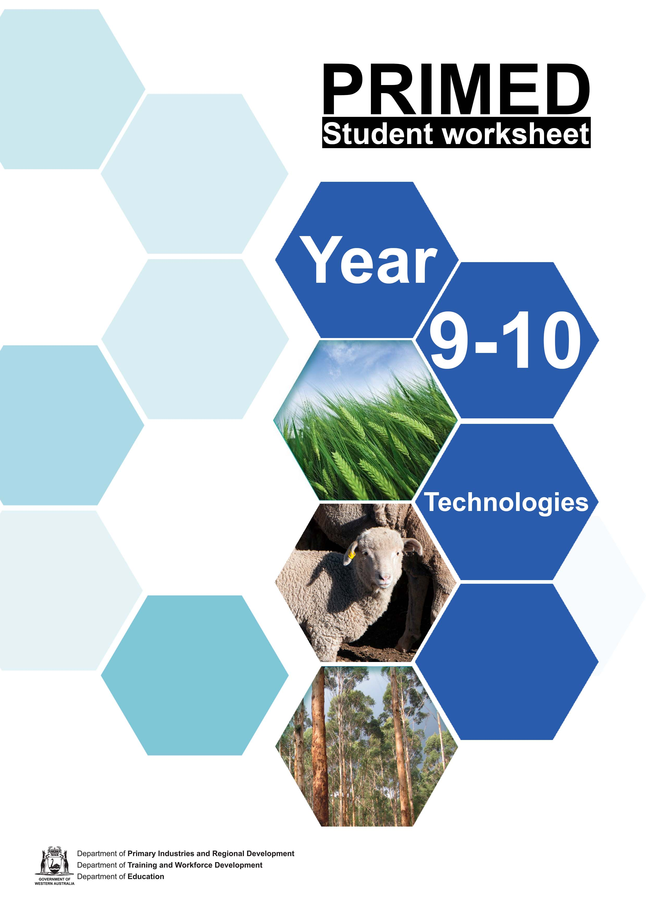

Student worksheet 1.1 – The IPO model
To help understand what happens when different materials are produced, we can organise production processes into:
Input: what's going in - everything that’s needed.

Process: all the activities that happen, the steps taken to make a product.

Output: what's coming out (everything resulting from production) For example:

Honey production

Input | - Equipment – hive, smoker, protective clothing, extractor, strainer, glass jars packaging, advertising materials.  - Materials - bee colony, flowing plants.  - People - bee keeper, business manager, people involved in production and marketing.  - Knowledge and skills – knowledge of the process, knowledge of the requirements of bees, skills working with bees, scientific knowledge of bee health, predators and pest control. Knowledge of customers and marketing.  - Facilities – land to situate hives and carry out processing, location suitable for bee colony.  - Energy – electricity.
Process | - Prepare hives and bee colony.  - Check and maintain hives, protect hives.  - Collection of nectar and storage of honey by bees.  - Harvest honey – remove frames from hives.  - Extract honey – separate wax from honey and filter.  - Bottle honey and package. Promotion of product.
Output | - Extracted pure honey in packaged form ready for consumption.  - By-products – beeswax (can be sold to commercial manufacturers, to be used for example in furniture polish and candles. Pollen (can be used as a dietary supplement). Royal jelly used to feed the queen bee (can be used as a skin product). Propolis used by bees to maintain the hive (can be used as a disinfectant and for medical purposes).  - Pollinated plants.  - Waste – obsolete production equipment, used jars and packaging, possibly pollution from electricity generation.

Many production processes can require several repetitions of the Input-Process-Output (IPO) model. This means that the output from one process becomes part of the input for the next process.

Match the following aspects of production to identify either input, process or output.

Input |  | The final result of production.
 |  | The steps to implement technology to create the product.
 |  | The impact of the production process, for example, on the environment.
Process |  | The series of operations to produce the product.
 |  | Finished products, by-products and waste.
 |  | The knowledge and skills. This is the knowledge and skills needed to apply technology
Output |  | The materials – these are the ingredients that are changed during the production process into the  final product.
 |  | The actual making of the product involving
 |  | The energy, electricity, fuel to power all the stages of production.

IPO Model Focus Questions

Input
What materials are needed? What equipment is needed?
What prior knowledge is required?

Process
What are the steps used? What technology is used?

Output
Were there any by-products? Was there any waste?
Would there be any impact on the environment?

The IPO model can also be represented as a flow chart. For the example given earlier, this could look like this:

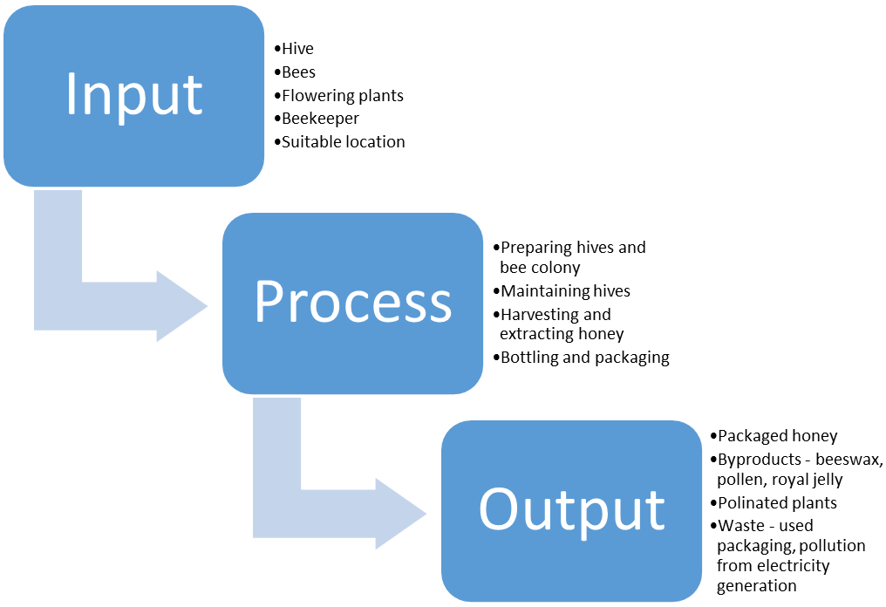

If we were to make toast with honey using the honey from the output stage of the process, it would become part of the input stage of the new IPO model.

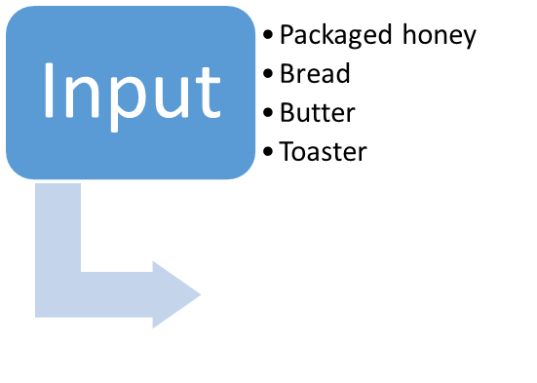

Student worksheet 1.2 – The timber production process

View the video “The timber production process”

- While watching the video, record as many key steps as you can in the spaces below.

- Use the template “The timber production process – IPO model” on the next page to describe the process of timber production, including all steps from saw logs to dimensional timber.

Remember!
Input
Anything that is added or goes into the process

Process
What happens during the operation

Output
Anything that is produced

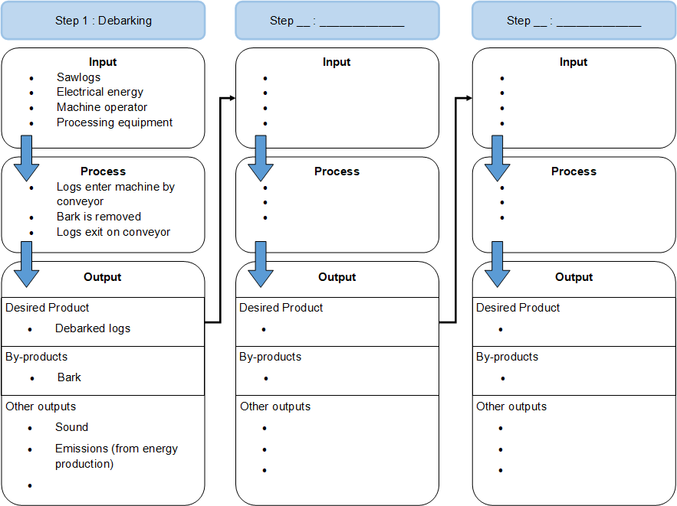

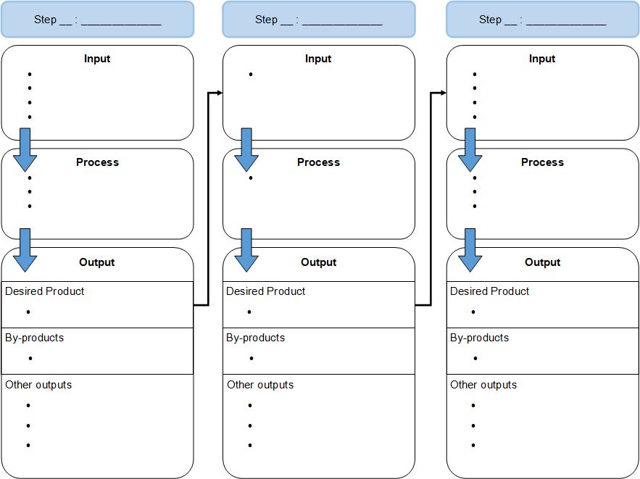

- Which processes produced timber by-products? Complete the table below.

Process | By-product

Extension Activity

How could these by-products be repurposed to minimise waste of natural resources?

  - Use the internet to research ways that producers make use of timber by-products. Consider the focus questions at the bottom of the page when searching for information. You may also use the links provided as a source of information.

  - Suggest some of your own ideas

Focus questions
How are timber by-products used?
How can businesses reduce wood waste?

Useful links
Recycling and wood waste Bioenergy from wood waste

Acknowledgements
References
Wood solutions (2021) ‘Recycling and wood waste’ available at:
<https://www.woodsolutions.com.au/recycling-and-wood-waste> accessed 26 July 2021

Department of Agriculture, Water and the Environment (4 November 2019) ‘Bioenergy from wood waste’ Australian Government available at: <https://www.awe.gov.au/agriculture- land/forestry/industries/bioenergy-from-wood-waste> accessed 26 July 2021

Student worksheet 1.3 – Defining a problem
Your task has two parts:
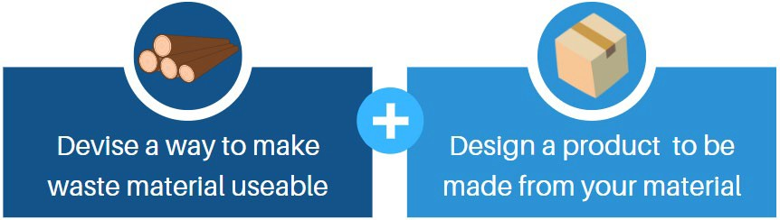

First, we need to look at the problem of workshop timber waste in a bit more detail.

- Who is experiencing the problem?
- What is the main issue?
- Where is it happening?
- Why do we need to address the issue?
- What do we stand to gain?

Clearly understanding the answers to these questions will help to guide our design process.
Use the organiser below to record ideas from your
What do we stand to gain?
Why do we need to address the issue?
What
is the main issue?
the issues.
group/class discussion about
Where is it happening?
Who is experiencing the problem?

The problem
From your discussions, write a brief statement describing the issue – be sure to address all of the questions from the previous page.

Defining success
How will we know if our solution is a good one?

Before we begin to address our problem, we need to work out how we can tell if we have been successful in our aims. In the space below, list as many characteristics of a successful solution as you can think of.

Think about the following aspects:
Efficiency | Processed involved | Aesthetics
Properties | Time | Function
Cost | Usefulness of material | Client needs

Uses waste material effectively

Is cost-effective

Our success criteria
From your list on the previous page, choose the five most important criteria that you will use to determine the success of your solution.

Success criteria:
1)
2)
3)
4)
5)

Student worksheet 2.1 – Analysing the problem
Before we begin to conduct any research, we first need to identify what we know, and what we need to find out. This helps us to select the topics that require further investigation.
One way to do this is by using a mind map. Mind maps allow us to rapidly document ideas and make connections between different aspects of a task.
The mind map below is from a task which required students to design a water bottle.
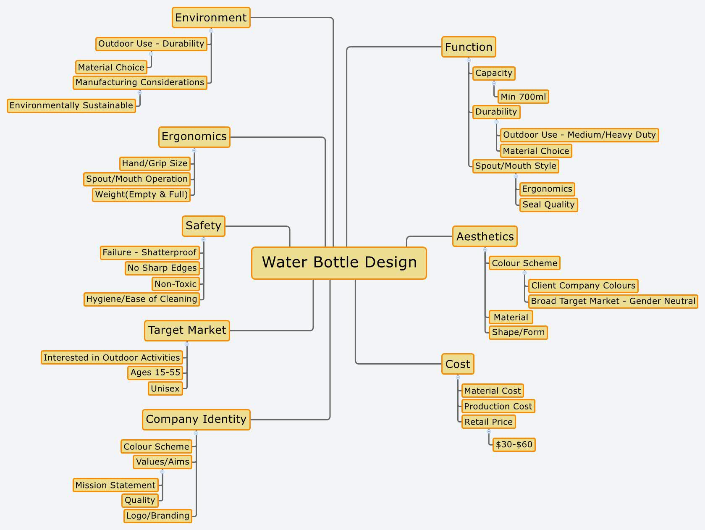

You can see that the central topic and all of the ideas that branch from it are very brief. The main factors affecting the design make up the headings, and then branching from each heading is all the provided information from the design brief, and anything else that the designer can think of which may be relevant to the project.

Task
On the mind map above, identify the topics that require research in your task (circle/highlight/underline)

Key factors influencing design
Below are some factors that you may wish to consider when analysing your problem.
Cost
- Of production – how much can you afford to spend to make the product?
- Of the finished product – what would someone pay for it?

Ergonomics
- What size/configuration does the product need to be in order to be comfortable to use?

Materials
- What materials do you have available?
- Which materials will be most appropriate for your project?

Production methods
- How will the product be manufactured?

Customer requirements
- What does the customer need/want? Are there any specific requirements?

Aesthetics
- How should the product look?

Function
- What does the product need to do?

Environment
- Where will the product be used?

Company identity (When designing for a company)
- Brand colours
- Logos
- Values

Not all of these will be relevant to your project!

Choose the ones that apply to your task and use these as headings for your mind map on the next page.
Depending on your project, there may be other factors that are not listed here.

Mind map
Use the space below to create a mind map for your design problem. Include as many relevant factors as you can, especially things you need to find out!

Writing enquiry questions
From your mind map, choose the three most important factors that require further investigation. These will be used to create our enquiry questions – questions that help to guide our research

Factor 1:

Factor 2:

Factor 3:
process.

The factors above are the topics that we need to research, but we first need to create a set of
enquiry questions that will keep our research heading in the right direction.

A good enquiry question should be:
- Clear and focused. The question should clearly state what the designer needs to do.
- Not too broad and not too narrow.
- Not too easy to answer.
- Not too difficult to answer.
- Researchable.
- Usually start with 'what' or 'how'

In the boxes below, write your enquiry questions for this task.

Enquiry question 1:

Enquiry question 2:

Enquiry question 3:

Student worksheet 2.2 – Investigating existing materials

Enquiry question

What manufacturing techniques are used to produce functional, high quality materials from scraps and recycled timbers?

View the video “Manufactured Wood Products - FWPAFWPA” (YouTube).

In the boxes below, name the six types of engineered timber products described in the video.

Abbreviation / Common Name |  | Abbreviation / Common Name
“Ply” |  | L V L
Full material name |  | Full material name
Plywood
Abbreviation / Common Name  Full material name |  | Abbreviation / Common Name  Full material name
Abbreviation / Common Name Full material name |  | Abbreviation / Common Name Full material name

From the materials above, select three that you feel are the most relevant to your project.

Materials research

Existing engineered timber product:

Enquiry question:

Raw materials used in this product:

Manufacturing process:

•

•

•

•

•

•

•

Equipment required: (industrial production) → Equipment available at school: (show links)

Gang saws |  |  | Band saw

Materials research continued
Summarise your materials research – discuss each material that you researched and make connections to this project. Think about equipment required, use of materials, properties, processes, costs involved and anything else that may be relevant to our task.

Student worksheet 2.3 – Investigating existing products
When we are thinking about the product that we need to design, we must look at similar items that

Consider factors such as:
Aesthetics | Function | Production methods
Ergonomics | Time | Environment
Cost | Use of materials | Client needs

already exist.

In the table below, record your thoughts about the existing products.

Product | Positive aspects | Opportunities for improvement | Interesting points

Investigating existing products continued
When designing any product, certain features are essential, while some may just be nice to have. From your research into existing products, identify essential and desirable features to help you to design the best product possible.
Essential features (MUST haves)

•

•

•

•

•

•

•

Desirable features (nice to haves)

•

•

•

•

•

•

Materials testing
Before we decide on the best way to repurpose our timber waste, we need to gather some real- world information about some different options. In this step, you will produce a number of different materials using the resources available to you in your workshop in order to make an informed decision about the best solution to our problem.

Things we need to find out about each method:
- What processes are required to produce the material?
- What raw materials are required?
- How long does the process take?
- How expensive is the process?
- What are the properties of the finished material?
- What kinds of applications would the material be suited to?

Materials to be tested
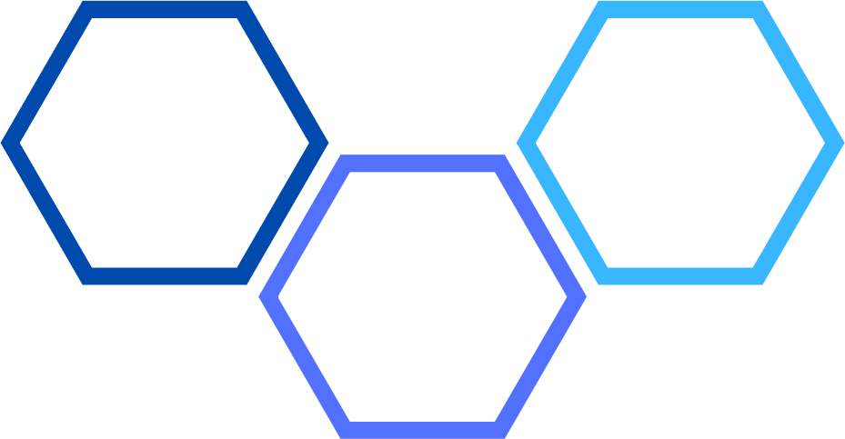

Materials testing

Material:

INPUT
Raw materials required:
Equipment required:
PROCESS
Production steps:
OUTPUT
Describe the material:
Observations about the material:
Observations about the production process:

Materials testing continued
Summarise your findings about the tested materials/production methods.

In each box below, draw a possible idea (concept) for your product. Write clear notes about features, materials and anything else on your drawing that may not be clear to another person.
Concept 1
Concept
Notes
Concept 2
Concept
Notes

Concept

Concept
Notes
Concept
Concept
Notes

In this activity, you gather feedback about your ideas in order to ensure that you design the best possible product.
In the box below, redraw the concept idea that you think best addresses your design problem.
Annotate your drawing to explain as much about your idea as possible.

Move into a group of four. Each group member passes their drawing to the person on your right. Write a comment about the design that you now have in front of you. Remember – don’t just write “looks good!”. Think about how the idea addresses your design problem. How might the product be made? Are there any changes that you can think of that would improve the product?
Concept
Feedback

Person 1
Person 2
Person 3

From your concept drawings, choose the one that you would like to develop further. This could be the most unique, the most interesting, or the most cost effective.
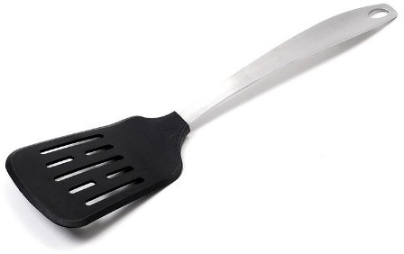Our next step is to identify the key components of your product. If we were designing a kitchen spatula (like the one on the right), our main components would be the blade and the handle. Each of these parts can be changed without affecting the other, which allows us to choose the most effective combination for the best possible product. The type of item that you are designing will determine how many key components you will have.
Image 3.3.1 Spatula

My product’s key components are:

•

•

•

Once you have identified the key components that make up your project, we can begin developing our product.
The process:

- Choose an appropriate view in which to draw each component. This will be most likely be different for each part. For the spatula blade, we would draw a top view while the handle could be drawn in either top or side view.
- Draw each component into the “Concept” box, as it appears on your concepts page. Don’t change anything yet, this is just our original idea.
- In the “Possible alternative” boxes, draw three different ways that the component could look. These could be drawn from your other concepts, in response to an issue that you have noticed, or from an existing product. If you have gathered feedback about any of your concepts, use it now!
- Comment on each alternative, paying attention to the same factors that we used to analyse existing products.
- Select your best option and make note of your choice in the location provided.
- Redraw your entire product in the “Designed solution” box, including your selected modifications.

Comments
Possible alternative 1
Concept
Comments
Possible alternative 1
Concept
Component: Option selected:

Possible alternative 2
Possible alternative 3
Comments
Comments
Component: Option selected:

Possible alternative 2
Possible alternative 3
Comments
Comments

Designed solution

Acknowledgements
Images
Image 3.3.1: ‘Spatula’ by PxHere. Licenced CC0 1.0 Public Domain Dedication available at:
<https://pxhere.com/en/photo/1386745> accessed 20 October 2021

From your concept drawings, choose the one that you would like to develop further. This could be the most unique, the most interesting, or the most cost effective.
- Redraw this in the “Original concept” box exactly as it appears on your concept drawings page.
The aim of this process is to make small changes to the product in order to improve it. Consider the same factors that we used to analyse existing products, and any issues you have noticed with your design.
- Redraw your product in the next box, making ONE change only. Make a note of what you changed, and why. If you have gathered feedback about any of your concepts, you can use it now!
- Repeat this process in the next box, continuing until you have addressed all issues with the product.
- Redraw your last version of your product in the “Designed solution” box.

Change made:
Change made:
Change made:
Original concept

Change made:

Designed solution

Once you have devised and developed your solution, you need to make sure that your product meets the requirements of the task. In the table below, write down as many design requirements as possible.
You may need to check back to your previous work to find all of these!

Task requirement | Included in solution  Yes No
Product must be made using waste timber products | □ | □
 | □ | □
 | □ | □
 | □ | □
 | □ | □
 | □ | □
 | □ | □
 | □ | □

Does your product meet all requirements for the task? (circle one)

Yes! Not yet…

If you circled “not yet”, what do you need to change to make your project suitable?

Once you have devised and developed your solution, you need to explain the reasons behind your design choices. In the space below, write a statement to justify your design. This statement should refer to your design brief and any relevant information that you discovered in your research.

Student worksheet 5.1 – Evaluating a solution

Success criteria
Now that your product has been manufactured, we need to conduct an evaluation to determine how well it addresses the original design problem. To do this, we need to look back at the success criteria that we created at the beginning of the project.

The success criteria I identified for my product are:

1)
2)
3)
4)
5)

For each of the criteria above, give your product a score out of 5, and explain how well it meets the requirements of the project.

Success criteria: Score: /5

Success criteria: Score: /5

Success criteria: Score: /5

Success criteria: Score: /5

Success criteria: Score: /5

How well did your product do? Have you met your criteria for success?

My product’s overall score is:
/25

22-25 | Excellent!
18-21 | Good
14-17 | Satisfactory
10-13 | Room for Improvement
<10 | Below Expectations

General project evaluation
We also need to look at the process that we followed while completing our project and the project as a whole. Address the questions below to evaluate how well you worked during the task.
Describe some safety considerations that were addressed during your project.

Comment on your time management.

(Written component)

(Practical component)

Describe one problem you encountered during your project, and how you overcame it.

List three things that you did well (these could be processes or features of your product).

1

2

3

What would you do differently if you were to repeat this task?

Describe how well you worked with others during this project.

Summarise your thoughts about your project in a general sense. Was it a success? Did you enjoy a particular aspect of the task? Would you have liked to approach the problem differently?

Student worksheet 6.1 – Blank drawing template

Student worksheet 6.2 – Blank lined template

