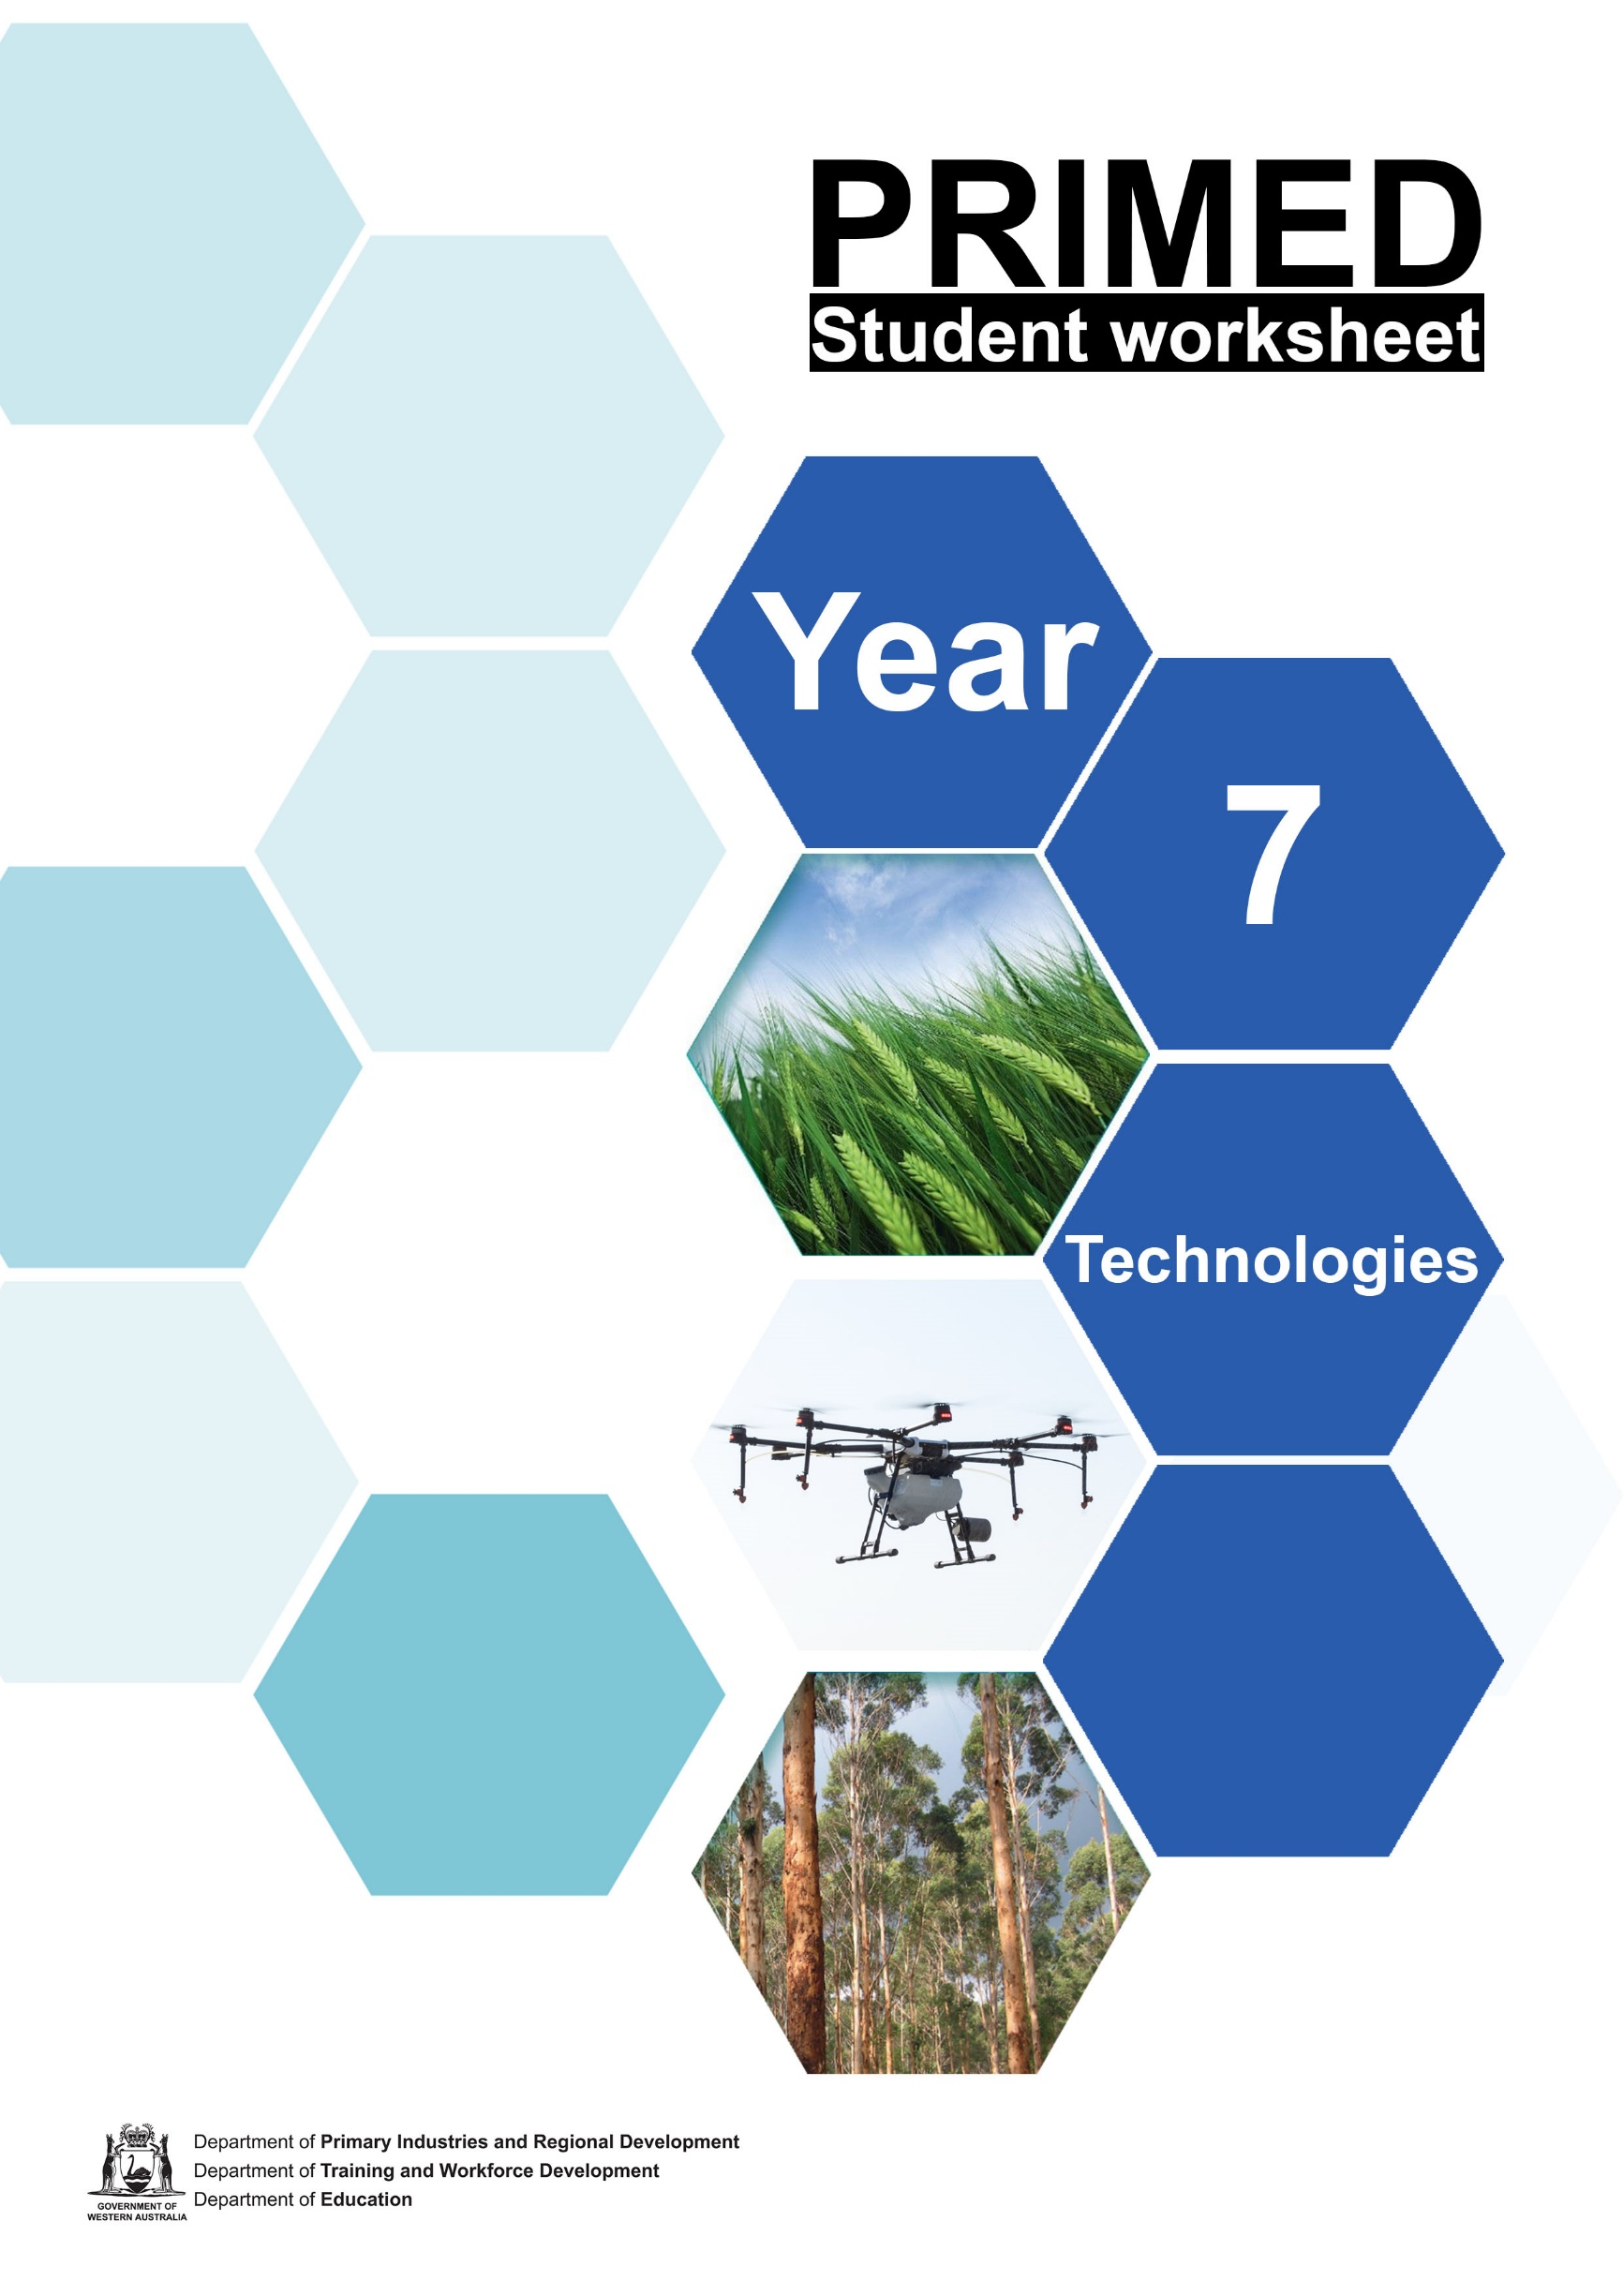

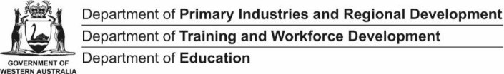
PRIMED

Student worksheet 1.1

KWHL chart
A KWHL chart is used to assess what you know about a topic before, during and after you have engaged with it.
Topic: Food and fibre production in Western Australia

What do I Know? | What do I Want to know? | How do I find out? | What have I Learnt?

Student worksheet 1.2

Primary industries in Western Australia
Primary industries in Western Australia produce many of the food and fibre products we use daily.

- Define the following terms and provide an example for each.

Primary industry:
Raw commodity:
Value-added product:

- Using some of the product images you have cut out, paste a product example into each of the boxes to show which Western Australian primary industry produces it.

Grain | Horticulture | Aquaculture and seafood
–Meat and livestock | Dairy | Fibre
Forestry/Timber | Eggs and poultry | Grapes and wine

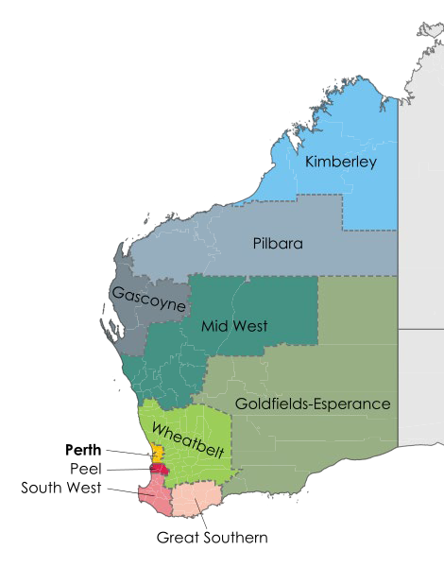
Student worksheet 2.1

Western Australian regional development zones
Western Australia is divided into nine regional development zones:

Kimberly Pilbara Gascoyne Mid West Wheatbelt
Goldfields–Esperance Perth
Peel
South West Great Southern

Author – Philtro. Creative Commons, 4.0 International, 3.0 Unported, 2.5 Generic, 2.0 Generic and 1.0 Generic license available at https://commons.wikimedia.org/wiki/File:Regions_of_Western_Australia.svg

In your small group, research one region of Western Australia and provide a summary of the following information:
  - Location of the region
  - Region population and major cities/towns
  - Region ports/airports and other major transport features
  - Description of the region’s landscape
  - Overview of the region’s rainfall and climate
  - Description of the soil types in the region
  - Summary of the region’s agricultural practices, including the types of food and fibre produced there

Useful resources include:
WA Open for Business website
http://www.waopenforbusiness.wa.gov.au/Why-Western-Australia/Discover-Western-Australia
Buy West Eat Best website https://www.buywesteatbest.org.au/
Buy West Eat Best – Western Australian Food Map
Department of Primary Industries and Regional Development Website http://www.drd.wa.gov.au/regions/Pages/default.aspx
Regional Climate Zones Map http://www.bom.gov.au/climate/climate-guides/

When you have gathered your information, you are going to report your findings to the rest of your class by providing a summary of your research on the page attached.

PRIMED
Western Australian zone:
Location:
Population:
Transport:
Soils:
Climate and rainfall:
Landscape:
Agricultural practices:

Student worksheet 3.1

Understand the production process
To help understand what happens when different products are grown/produced, we can organise production into:
- Input: what's going into the process – everything that’s needed to produce the item
- Process: all the activities that happen – the steps taken to make a product
- Output: what's coming out – everything resulting from the production process For example:

Honey production

Input | - Equipment: hive, smoker, protective clothing, extractor, strainer, glass jars, packaging, advertising materials  - Materials: bee colony, flowing plants  - People: beekeeper, business manager, workers involved in production and marketing  - Knowledge and skills: knowledge of the process and the needs of bees; skills to work with bees; scientific knowledge of bee health, predators and pest control; and knowledge of customers and marketing  - Facilities: suitable land to situate hives on and carry out processing  - Energy: electricity
Process | - Prepare the hives and bee colony.  - Check, maintain and protect the hives (throughout the process).  - (The bees) collect nectar, make the honey with it and then store the honey.  - Harvest the honey (by removing the frames from the hives).  - Extract the honey (by separating it from the beeswax and filtering it).  - Bottle and package the honey.  - Promote the product.
Output | - Extracted pure honey in packaged form ready for consumption.  - By-products – beeswax (can be sold to commercial manufacturers, to be used for example in furniture polish and candles. Pollen (can be used as a dietary supplement). Royal jelly used to feed the queen bee (can be used as a skin product). Propolis used by bees to maintain the hive (can be used as a disinfectant and for medical purposes).  - Pollinated plants.  - Waste – obsolete production equipment, used jars and packaging, possibly pollution from electricity generation.
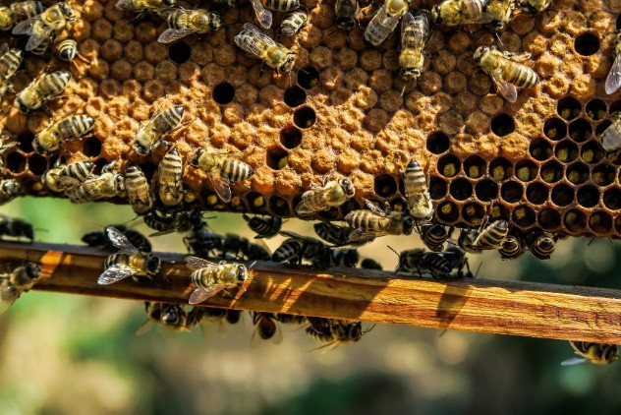
Image: by Pexels, available at https://pixabay.com/photos/apiary-bee-beehive-beekeeping-1867537/

    - Match the following aspects of production to identify input, process or output.

Input |  | The final result of production.
 |  | The steps to implement technology to create the product.
 |  | The impact of the production process – for example, on the environment.
Process |  | The series of operations to produce the product.
 |  | Finished products, by-products and waste.
 |  | The knowledge and skills needed to apply technology.
Output |  | Materials – the ingredients that are changed during the process into the final product.
 |  | The actual making of the product.
 |  | The energy, such as sunlight, electricity and fuel, to power all the stages of production.

    - Watch the PowerPoint presentation How to Grow a pair of jeans on the Cotton Australia website <cottonaustralia.com.au/grow-a-pair-of-jeans>.
    - Use the question prompts to explain the production process used to ‘grow’ a pair of jeans.

Input | What materials are needed?
 | What equipment is needed?
 | What prior knowledge is required?
 | What energy is required?
Process | What are the steps used to grow the cotton?
 | What technology is used?
Output | What is the finished product?
 | Are there any by-products?
 | Is there any waste?
 | Is there any impact on the environment?

Student worksheet 4.1

The triple bottom line
- Define ‘sustainability’ in your own words:

- Explain the triple bottom line:

- For a primary industry to be sustainable it must consider economic, environmental and social factors. Watch the PowerPoint presentation and add notes below explaining the three elements of the triple bottom line.

Social
Economic
Environmental

Case study
Read the passage below and use three different colour highlighters to identify which factors in the case study the fit under economic, environmental and social.

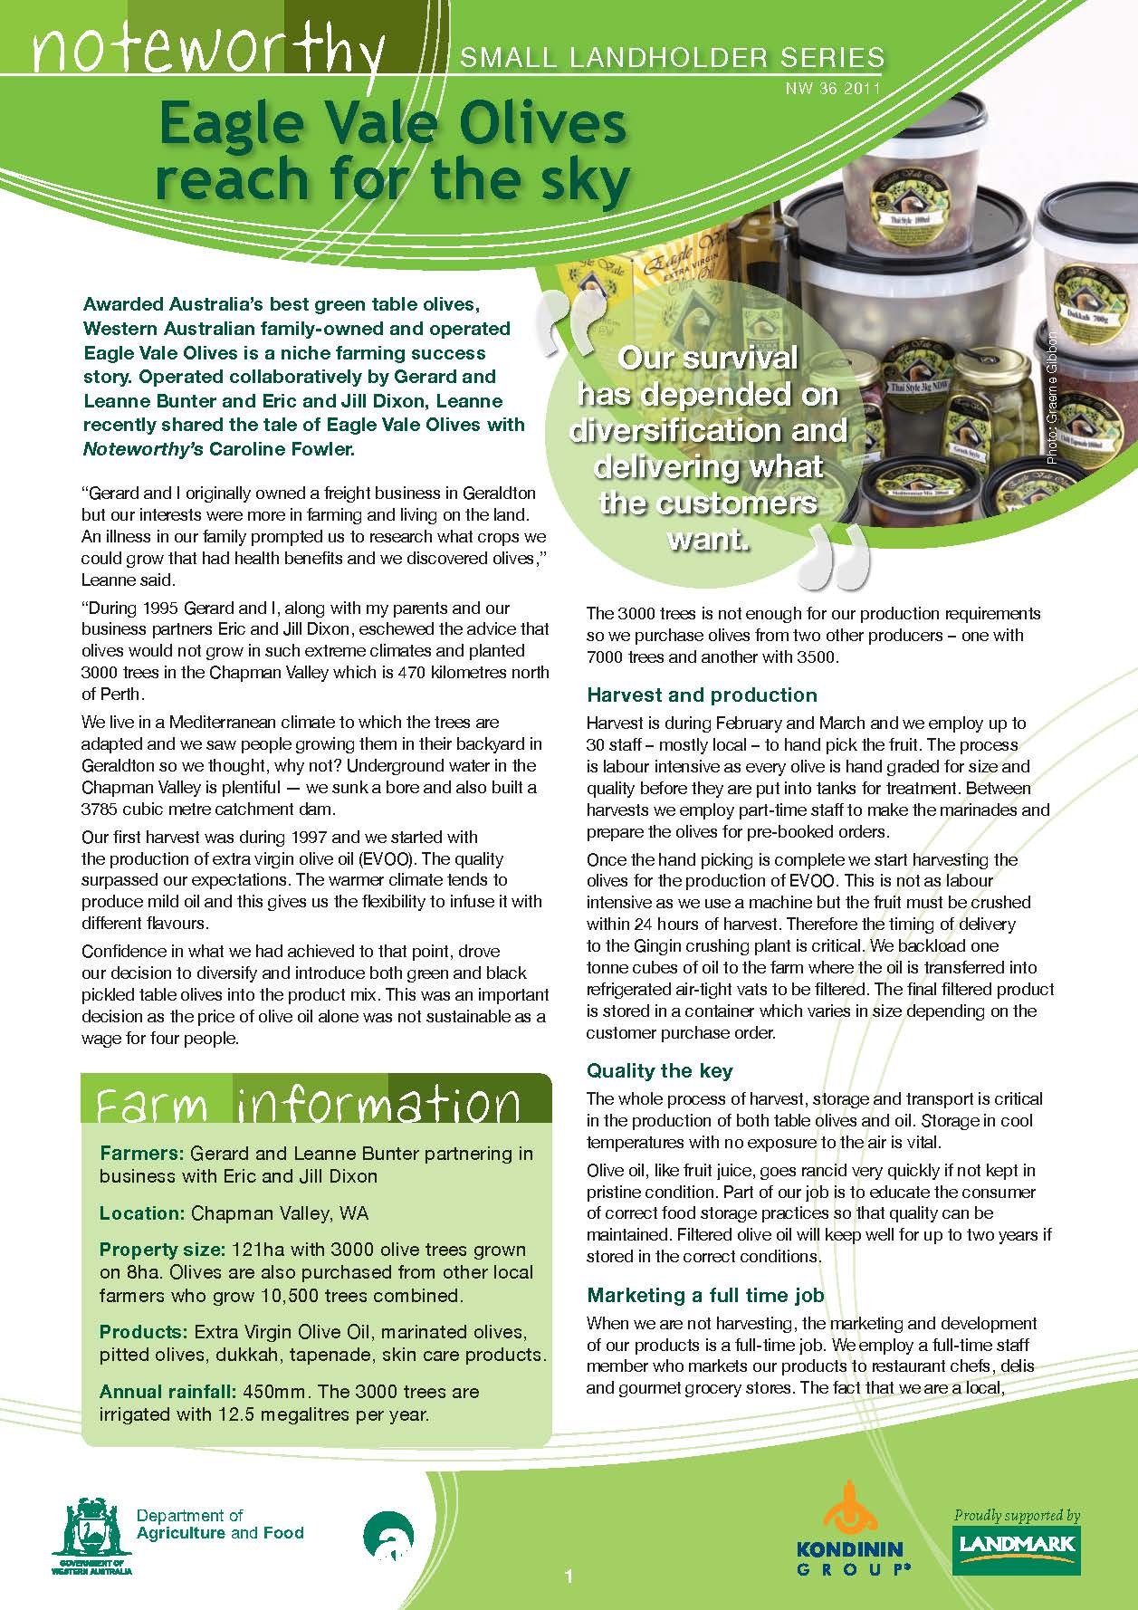

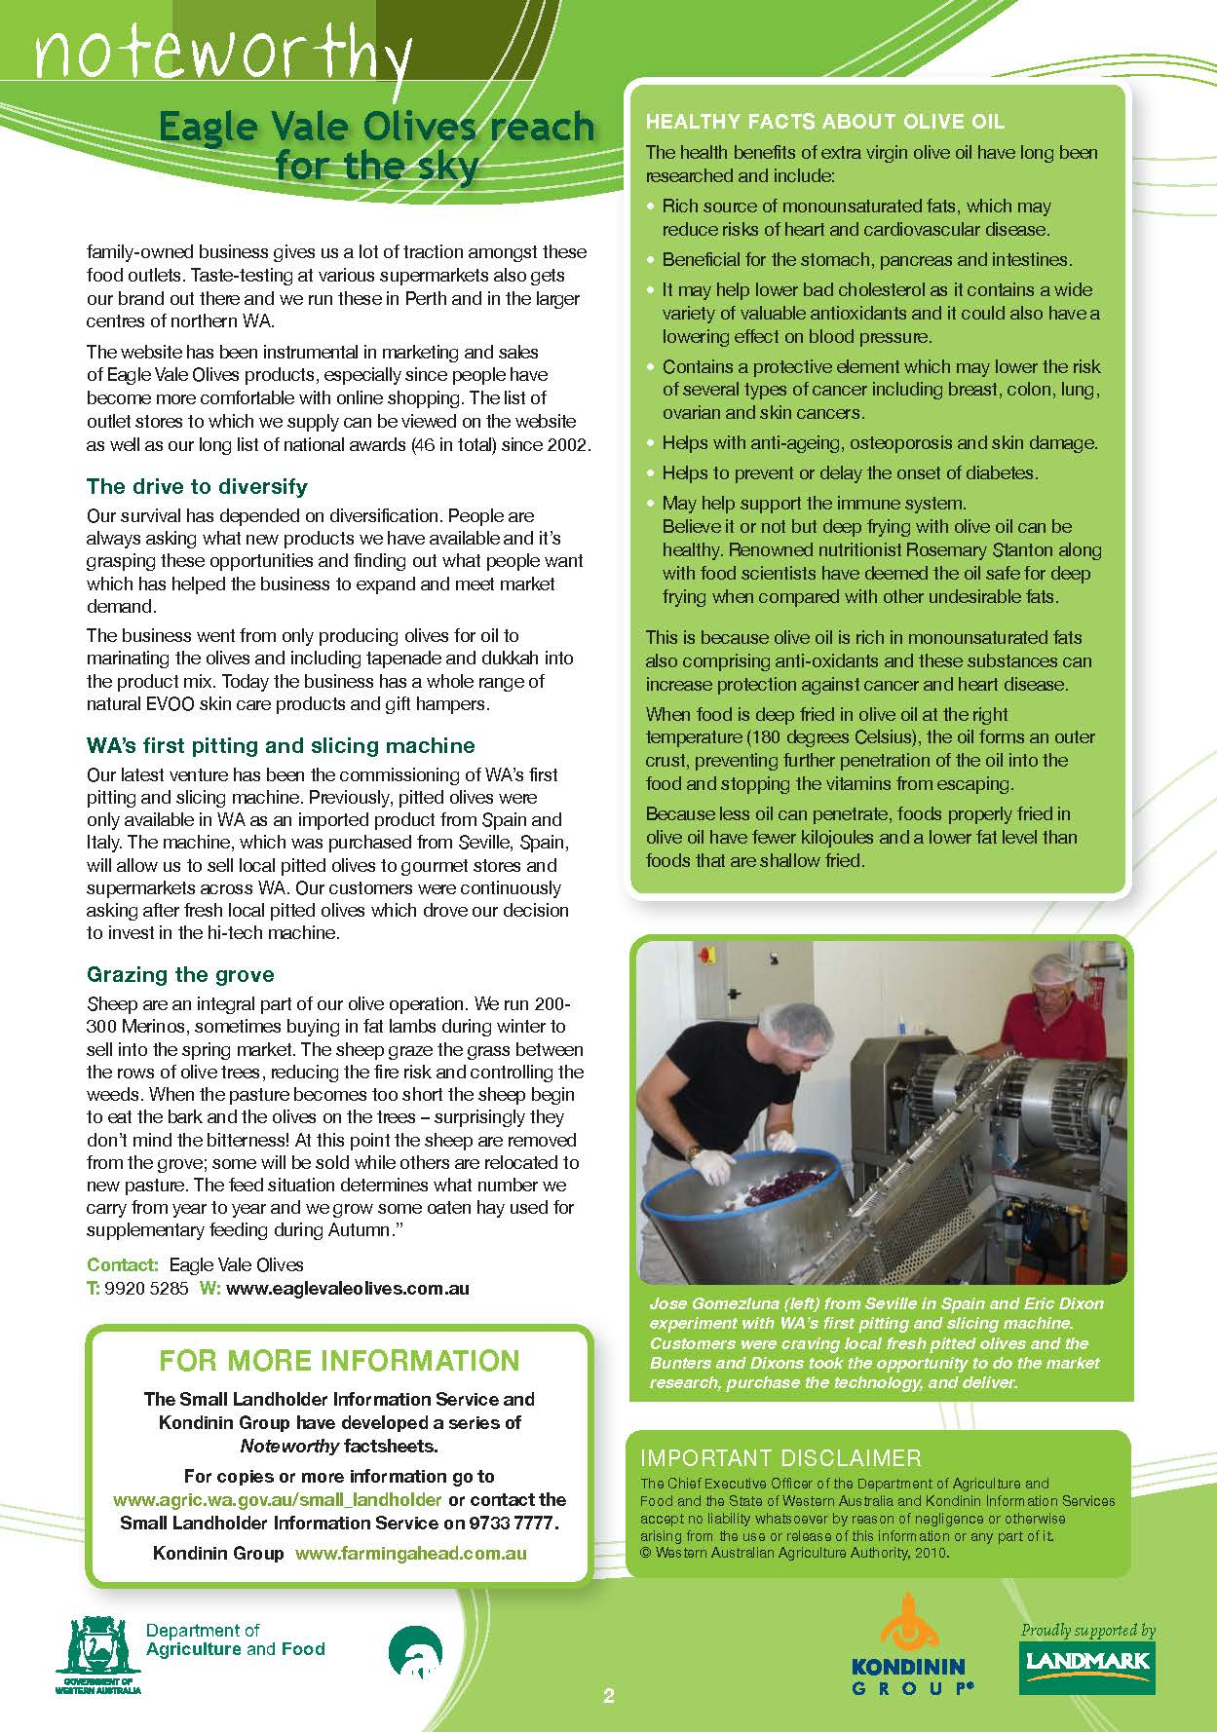

Student worksheet 5.1

Design challenge: Futureproof food and fibre production
Agricultural practices have come a long way over the years, with changes in farm machinery, livestock handling, farm facilities, feeding capabilities, crop science, breading programs, processing techniques, waste management, water efficiencies and more. Many farms are now using artificial intelligence and robotics to produce food and fibre commodities.
Looking towards the future, we need to be making continual improvements in our food and fibre production systems to ensure they are sustainable. This means ensuring, we can produce enough affordable food and fibre commodities for our growing population that doesn’t have a detrimental impact on our environment.
In this task you will:
- Reflect on what you already know about food and fibre production in Western Australia.
- Select one food or fibre commodity grown in Western Australia and:
  - investigate where and how it is grown/produced
  - analyse the on-farm production system of this commodity and complete a review of the inputs, processes and outputs of its production
- Apply this knowledge to design a diorama (3D miniature model – like a mini museum display) or digital model of a futureproof production system for a Western Australian food or fibre commodity, which meets the criteria of a sustainable enterprise.
Sample diorama
This diorama represents a cooling tower construction.
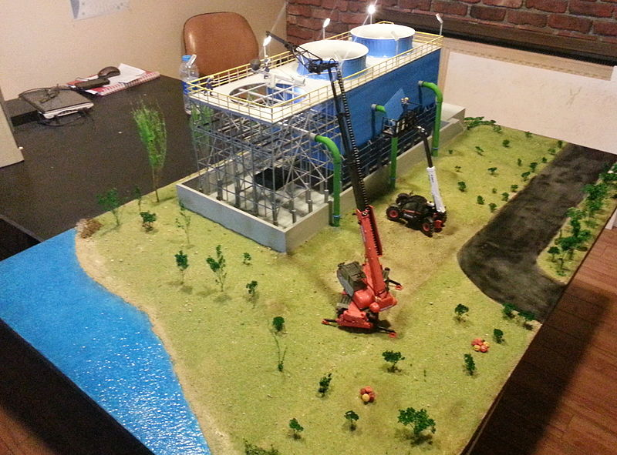
Image: ‘Cooling tower construction diorama’ by Birhanb. Licensed CC BY-SA 3.0. Available at <https://commons.wikimedia.org/wiki/File:Cooling_tower_construction_diorama.jpg>

Task summary
You can do steps 2, 3 and 4 as part of a small group. But you must complete steps 1 and 5 (the defining and evaluating parts) on your own.
Step 1 | Define  What are the requirements of this task? Explain the purpose. | Complete this step individually.  In your own words, define the requirements of this task.
Step 2 | Investigate  Consider components/resources to develop solutions and identify constraints. | Complete this step as a member of a small group of students.  In detail, investigate a food or fibre production process that occurs in WA.  Find out the inputs, processes and outputs needed to make this production process sustainable. Consider environmental, economic and social factors.
Step 3 | Design  Design, develop, review and communicate design ideas, plans and processes within a given context, using a range of techniques, appropriate technical terms and technology | Complete this step as a member of a small group of students.  Prepare a plan to produce a diorama or digital model of a sustainable food or fibre production process.
Step 4 | Produce  Safely make solutions using a range of components, equipment and techniques. | Complete this step as a member of a small group of students.  Follow your plan and create a diorama or digital model representing a sustainable food or fibre production process
Step 5 | Evaluate  Apply given contextual criteria to evaluate design processes and solutions. | Complete this step individually.  Use the evaluation criteria you create in Step 1 to reflect on your design.

Before you start
Select a way to organise your research – for example, writing your research notes in a workbook or portfolio, or typing them into a digital document.

Step 1: Define
- Review the design challenge set for you.
- In your own words write down a list of criteria that explains what you need to do to complete the challenge.

Step 2: Investigate
- Research the types of farming that take place in Western Australia and provide some examples of different types of farms.
- Select a food or fibre commodity grown in Western Australia to research.
- Research where this commodity is produced and why it is produced in that region. Consider climate conditions, soil types and other facilities in the area.
- Research when this commodity is produced. What processes take place throughout the year to produce this commodity?
- Research how this commodity is produced. Consider the steps taken in the production process on the farm, including:
- technology used
- people involved / job roles required
- environmental considerations
- Complete a summary of the input-process-output (IPO) model specifically for this commodity.

Step 3: Design
- Use the information you have gathered of the production of your commodity to design a futureproof food or fibre production model which represents a farm / production process of your commodity.
- Brainstorm your ideas first. Consider how:
- to produce enough of this commodity for the future population
- the production process won’t damage the environment
- the production process will be profitable
- technology can be used to improve production
- people will be involved in the process.
- Draw your design ideas using labels to describe your plans.
- Select your chosen design and write the steps you will take to produce your model (a production plan), remember to plan this as a group and allocate tasks to each person).
- Prepare a list of all the materials/resources you will need to complete your model

Step 4: Produce
- Implement your design and produce your model:

Remember
You can produce either:
- a diorama (3D miniature model) – for example, using a shoebox model to represent your production system
or
- a digital model using a digital application.
The important thing is to be able to demonstrate, through your model:
- your understanding of the production process
- how you have designed your future farm / production process to be sustainable.
You must include labels or an index explaining how the parts of your farm/process are sustainable.

Step 5: Evaluate
- Independently reflect on your design process and complete an evaluation using the following criteria.

- Review the criteria you prepared in step 1. How does your design meet the criteria you listed?
- How does your model represent a sustainable production system?
- Are you happy with the final product of your model? Why/why not?
- How could you improve your model if you were to produce it again?
- Did you and your partner work well to produce your model?

- Finally, review your KWHL chart (Student worksheet 1.1) from the first lesson and complete the ‘What have I Learnt?’ column.

Input-process-output model
Inputs | What materials are needed?
 | What equipment is needed?
 | What prior knowledge is required?
 | What energy is required?
Processes | What are the steps used to grow the commodity?
 | What technology is used?
Outputs | What is the finished product?
 | Are there any by-products?
 | Is there any waste?
 | Is there any impact on the environment?

