Whole-school approach to road safety education

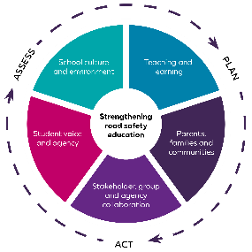

At <Insert school name> we have identified the following practices and strategies to support a whole school approach in road safety education. This approach embeds student knowledge, skills, and understanding at a whole-school level and strengthens relationships and partnerships with parents and communities.

Contact Road Safety and Drug Education for resources and support on 9402 6415 or via [rsde.rfa@education.wa.edu.au](mailto:rsde.rfa@education.wa.edu.au)

|  |  |  |  |  |  |
| --- | --- | --- | --- | --- | --- |
| Teaching and learning | School culture and environment | | Parents, families, and communities | Student voice and agency | Stakeholder, group, and agency collaboration |
| *Example:*   * *Use resources available from* *myresources.education.wa.edu.au**:* * *Early Years Road Safety 0-5* * *Road Safety Education P-6* * *Road Safety Education 7-9* * *Keys4Life pre-driver education.*   *Develop scope and sequences to current curriculum and review on an annual basis.* | *Example:*   * *Access professional learning opportunities for staff relating to road safety education.*   *Create an environment that encourages road safe behaviours at school.* | | *Example:*   * *Use RSDE resources to communicate with parents/carers about key road safety messages.*   *Involve the school board/P&C in whole school planning.* | *Example:*   * *Involve students in planning activities such as:* * *Road Safety Week*   *Ride or walk to school days.* | *Example:*   * *Consider guest speaker guidelines prior to engaging with external agencies.* |
| Current practice: | Current practice: | | Current practice: | Current practice: | Current practice: |
| Actions: | Actions: | | Actions: | Actions: | Actions: |
| Who: | Who: | | Who: | Who: | Who: |
| When: | When: | | When: | When: | When: |
| Prepared by: | | **Endorsed by:** | | **Date:** | **Review date:** |