7. Using the STAR (Situation, Task, Action, Result) evidence framework

**Australian blueprint for career development**

|  |  |  |  |  |  |  |  |  |  |  |  |
| --- | --- | --- | --- | --- | --- | --- | --- | --- | --- | --- | --- |
| Career Management Competency | | | | | | | | | | | |
| 1 | 2 | 3 | 4 | 5 | 6 | 7 | 8 | 9 | 10 | 11 | 12 |

**Learning intention**

Students will understand what the STAR (Situation, Task, Action, Result) evidence framework is and how to effectively apply it in written applications and job interviews.

**Success criteria**

Students can:

* explain the 4 components of the STAR framework
* apply the star evidence framework to interview questions using the STAR framework.

**Resources**

* Tasmanian University Student Association ‘[STAR technique for job applications and interviews’](https://www.youtube.com/watch?v=f_sEPp3rB5w) (3:03)
* STAR information sheet: Understanding the STAR framework(attached)
* Handout: Suggested interview questions(attached)
* [STAR Selection Criteria](https://www.selection-criteria.com.au/starselectioncriteria.shtml)
* Using the STAR model to respond to selection criteria

**Classroom organisation**

* Small groups
* Individual

**Preparation**

* Familiarise yourself with the STAR framework and lesson content.
* Ensure each student has access to the 2 supporting documents Understanding the STAR framework and Suggested interview questions either in printed or digital form.

**Activity 1**

* Explain that the STAR evidence framework allows students to provide examples, either verbally or in writing, that highlight skills and experience related to selection criteria.
  + Situation – give a brief outline of the situation you were in.
  + Task – describe the task or problem you needed to complete or solve.
  + Action – describe what you did and how you did it.
  + Result – describe the outcomes (what you achieved). Be specific about your role in the project/situation and how it contributed to the outcome.
* Ask students why having a framework like STAR might be useful in writing a job application or in a job interview.

**Activity 2**

* Show the ‘STAR technique for job application and interviews’ [video](https://www.youtube.com/watch?v=f_sEPp3rB5w)
* Model the use of the STAR framework. An example may be “explain a situation which demonstrates your leadership”. A suggested response could be:

Recently, we were tasked with undertaking a group assignment for Humanities which involved groups of 4 students working together to investigate protest movements. We had to provide a research paper and a presentation to the class on our findings. After noticing that no member was really taking the lead in terms of organising the tasks to be done and the timeline required, I stepped in and focused the groups’ attention on creating a do-to-list, delegating roles, and monitoring tasks to ensure we all finished our components on time. The group achieved a great mark, and the teacher provided positive feedback.

* Identify where each of the elements of the STAR framework appear in the example provided.
* In groups of 3-4, provide students with access to the Understanding the STAR framework and Suggested interview questions handouts.
* Explain that one student will be interviewed, and the other students will make up the interview panel.
* Each panel member asks the student an interview question (see the handout with suggested questions) and the student needs to respond using the STAR framework. The interviewee should be given time to consider their answer (1-2 minutes). During the response, the interview panel need to pay attention to whether the 4 components of STAR method have been covered. The panel should provide feedback on this.
* Rotate the roles so every student has a turn at being interviewed.
* Ask students to brainstorm examples they could use which demonstrate their skills. Examples could include teamwork, leadership, communication, time management. Students can draw on examples from school, sporting commitments, community involvement or paid employment.
* Ask students to share examples from the brainstorm activity with the class.

**Reflection**

Ask students to discuss in their groups how useful they found the STAR framework in answering the mock interview questions. Some prompts could be:

* What challenges did you face with using the STAR method?
* Is the STAR method reasonably straightforward? Do you feel confident that you could use it in the future?
* How did listening to your peers’ answers help your own understanding of the STAR method.

**Understanding the STAR framework**

The STAR method stands for situation, task, action and result.

* **Situation**: describe your role and responsibility.
* **Task**: describe the task, project or outcome you were required to achieve.
* **Action**: describe what you did and how you did it.
* **Result**: describe the outcomes.

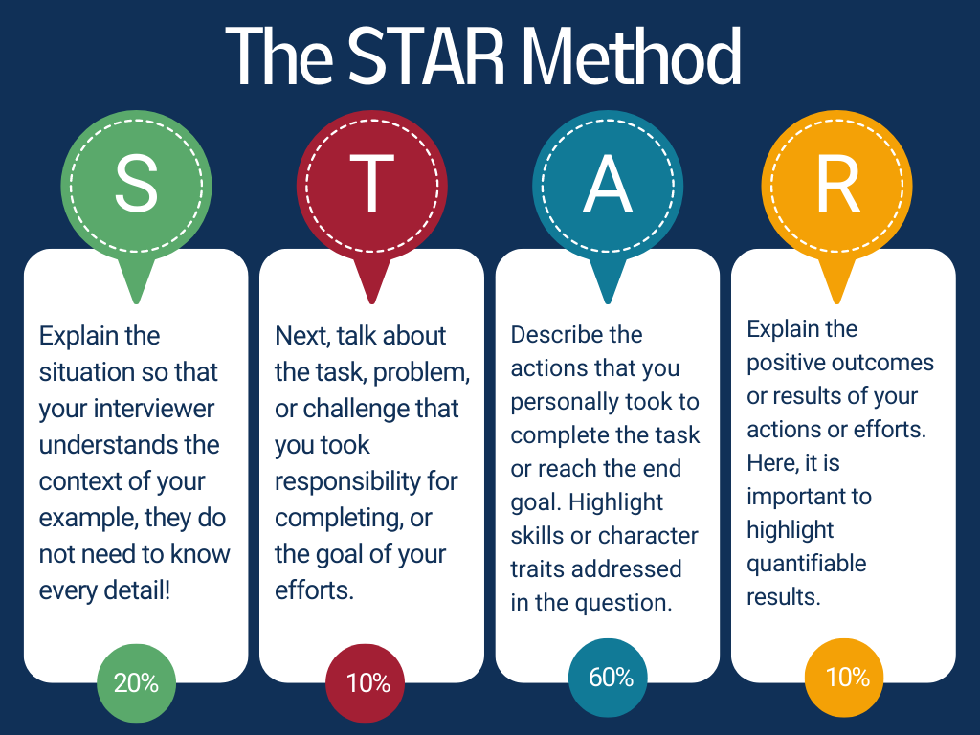

Source: <https://capd.mit.edu/resources/the-star-method-for-behavioral-interviews/>

**Tips on using STAR method**

* Try to keep your responses short and concise – avoid irrelevant detail as your point can be lost.
* In an interview, you want the tone to be conversational in nature. If your answers sound too rehearsed, you can risk coming across robotic as opposed to natural.
* You should expect the interviewer to ask follow up questions about your example.
* Try to give specific examples rather than make general statements. Being too general or unclear about success can make the answer seem less convincing.

**Suggested interview questions**

* Have you ever had to develop a new skill? Tell me about your approach to the learning process.
* Describe a time when you had a tight deadline to meet. How did you get things done?
* How do you go about setting goals?
* Give me an example of a time when you failed to achieve your goals. How did you respond and what did you do?
* Explain a situation that demonstrates your leadership.
* Describe a time when you were faced with a stressful situation that demonstrated your coping skills.
* Tell me about a time where you went above and beyond the call of duty in order to get a job done.
* What is your typical way of dealing with conflict?
* Provide an example of a time when you showed initiative and took the lead.
* Tell me about a time where you were forced to make an unpopular decision.
* Describe a time you motivated your team to achieve results. What was your approach?
* Explain a situation where you overcame a challenge at work.
* Tell me about a time when you had to make a tough decision.
* Describe a time where you helped a peer achieve their goals.
* Describe a time when you set your sights too high or too low.