1. Making difficult decisions

# Australian blueprint for career development

|  |  |  |  |  |  |  |  |  |  |  |  |
| --- | --- | --- | --- | --- | --- | --- | --- | --- | --- | --- | --- |
| Career Management Competency | | | | | | | | | | | |
| 1 | 2 | 3 | 4 | 5 | 6 | 7 | 8 | 9 | 10 | 11 | 12 |

# Learning intention

Students will understand that that their career is not linear.

# Success criteria

Students can:

* list the three steps for decision making identified in the video
* sketch what they think their career path might look like.

# Resources

* [How to make a difficult career decision](https://www.youtube.com/watch?v=sR_jPWbIF5Y) – YouTube video access
* Worksheet – Making career decisions

# Classroom organisation

* Whole class
* Small groups

# Preparation

Print Making career decisions worksheet for each student.

# Activity 1

The video presents students with the idea that they can look at decisions with their brain or with their heart. Do we make decisions with our heart, or do we make decisions with our head? Decisions can expand us, our future and raise possibilities. Conversely, decisions can shrink or inhibit us and keep things closed.

* Students watch the video [How to make a difficult career decision](https://youtu.be/sR_jPWbIF5Y) and record the 3 steps presented to help with making difficult decisions on the Making career decisions worksheet.
* Students discuss the results.

# Activity 2

* Students consider the quote about careers on the worksheet.
* Students discuss what they think the statement means before answering the questions.

# Reflection

On the back of the worksheet, students sketch a flowchart for a career pathway of current interest.

# Worksheet: Making career decisions

How to make career decisions - What are the 3 steps delivered in the video?

|  |  |  |
| --- | --- | --- |
| 1.  ________________________ ________________________ ________________________ ________________________ ________________________ ________________________ ________________________ ________________________ ________________________ ________________________ | 2.  ________________________ ________________________ ________________________ ________________________ ________________________ ________________________ ________________________ ________________________ ________________________ ________________________ | 3  ________________________ ________________________ ________________________ ________________________ ________________________ ________________________ ________________________ ________________________ ________________________ ________________________ |

In small groups, consider this statement about careers.

[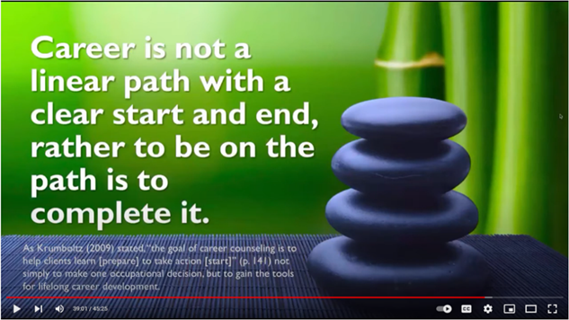](https://www.youtube.com/watch?v=iGorz_vSmUk)

What do you understand this statement to be saying?

_________________________________________________________________________________________________________________________________________________________________________________________________________________________________________________________________________________________________________________________________________________________________________________________________

How many smaller messages can you find in this statement? What are they?

_________________________________________________________________________________________________________________________________________________________________________________________________________________________________________________________________________________________________________________________________________________________________________________________________