2. Patterns and order

# Australian blueprint for career development

|  |  |  |  |  |  |  |  |  |  |  |  |
| --- | --- | --- | --- | --- | --- | --- | --- | --- | --- | --- | --- |
| Career Management Competency | | | | | | | | | | | |
| 1 | 2 | 3 | 4 | 5 | 6 | 7 | 8 | 9 | 10 | 11 | 12 |

# Learning intention

Students will understand that careers are not linear and because of their complexity, we should look for systems and patterns.

# Success criteria

Students can:

* complete a visual mapping activity
* make connections and identify categories
* identify common themes or threads from categories.

# Resources

* Blank A3 paper per student.
* 3-4 coloured markers per student.

# Classroom organisation

* Individual

# Preparation

Source paper and coloured markers.

# Activity 1

* Using an A3 piece of paper, students are to create a visual map. Encourage students to fill their map with as many thoughts that come to mind in response to the questions below. Thoughts can be drawn from the start of school across all aspects of the student’s life.
* Follow these instructions.
  + Using a black pen write key words, short phrases, or draw pictures.
  + Draw a circle around each thought you write.
  + Do not worry about spelling or appearance.
  + Do not censor your thoughts.
* Provide scaffolding prompts
  + Have you taken interesting courses?
  + Do you have a memorable holiday experience?
  + What are some achievements you’re most proud of?
  + Which of your proudest achievements, skills or abilities are you most proud of?
  + Where do you like to visit?
  + Have you faced any tough challenges?
  + What is your most memorable experience?
  + Do you have interesting hobbies?
  + What do you like to do in your free time?
  + What have been your favourite school subjects?
  + What are some of your favourite school experiences?
  + Have you had any jobs that you’ve loved?
  + Do you have any hobbies that you have pursued for a long time?
  + Have you just learnt something very interesting, and you want to know more?
  + What are your favourite things?

# Activity 2

* Once completed, students use a variety of colours and look for connections between their thoughts, noticing which thoughts have things in common (sport, holidays, creativity, classes, jobs).
* Students make connections between the circled words/phrases and the category they fit into using different coloured lines to link them.
* Teacher provides scaffolding questions to prompt student reflection.
  + Are you surprised by the categories?
  + How did you feel as you were making the connections into categories?
  + Are there any categories there that you didn’t expect?
  + A white board with writing on it

    Description automatically generated with medium confidenceAre the categories equally weighted or are any larger than others?

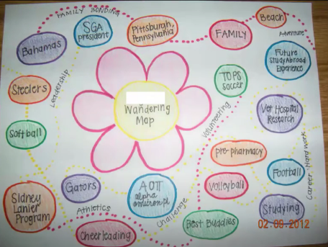

# Activity 3

* Once categories have been made, students will take some time and look more closely at each category. Provide prompts for reflection.
  + Can you see a thread that has followed you from pre-primary?
  + Is there a pattern to the types of courses you have liked and chosen?
  + Do some of your different experiences have anything in common?
  + Do your likes and hobbies have a common thread?
* Students consider possible themes for each category they have created. Using a third colour, students should label the theme they have identified for each category.
* Some possible themes are:
  + Adventure – taking risks, trying new things
  + Creativity – self-expression, ideas as in art and music
  + Family – nurturing, children, family gatherings
  + Health – exercise, diet, eating well
  + Independence – freedom and autonomy
  + Physical Work – using your hands, building
  + Security – safety, stability
  + Leadership – organising, inspiring
  + Learning – curiosity, desire to learn
  + Spirituality – practising religion, meditating
  + Teamwork – communication, accountability, common goals.

# Reflection

Students reflect on the following questions.

* What were your primary themes?
* Were there any surprises?
* How can you further develop these themes in your career and life?