2. TISC Presentation

# Australian blueprint for career development

|  |  |  |  |  |  |  |  |  |  |  |  |
| --- | --- | --- | --- | --- | --- | --- | --- | --- | --- | --- | --- |
| Career Management Competency | | | | | | | | | | | |
| 1 | 2 | 3 | 4 | 5 | 6 | 7 | 8 | 9 | 10 | 11 | 12 |

# Learning intention

Students view the Year 12 Tertiary Institutions Service Centre (TISC) presentation to develop an understanding of the processes for application to university and the support and information that is available.

# Success criteria

Students can access the TISC website resources to seek answers to questions related to university applications.

# Resources

* [TISC](https://www.tisc.edu.au/static/home.tisc) - home
* [TISC Presentation pdf](https://www.tisc.edu.au/static-fixed/download/tisc-presentation-for-year12.pdf)
* [TISC Presentation PowerPoint](https://www.tisc.edu.au/static/guide/video.tisc) – available for download – editable
* [TISC Help Videos](https://www.tisc.edu.au/static/guide/video.tisc)

# Classroom organisation

* Whole cohort

# Preparation

* Secure appropriate space.
* Computer access for presentation.
* Download [Year 12 TISC Presentation](https://www.tisc.edu.au/static/guide/career-advisors.tisc).
* Preview the TISC PowerPoint presentation to ensure understanding of content.
* Edit the TISC PowerPoint as contextually appropriate.

# Activity 1

Students view the TISC presentation and teacher addresses questions as they arise.

# Activity 2

Students explore the TISC website and familiarise themselves with the resources and information available, including the Help Video section, and access those that are of particular interest.

# Reflection

Students discuss aspirations and intentions for applications with a partner.

[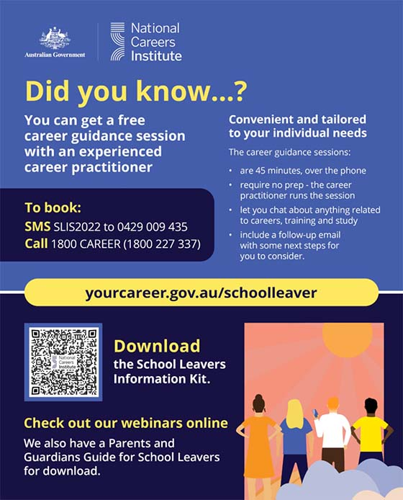](https://aus01.safelinks.protection.outlook.com/?url=http%3A%2F%2Furl3939.cdaa.org.au%2Fls%2Fclick%3Fupn%3DEoSWXIdKWLPManDaRAJg2u8OhkQxGtmdLploktOXYf-2BHbX-2BAEdK9V1JzGqVyuvCqrXoXUuyIJDHgQ9KbYBp1uA-3D-3DYCLA_bPJQ-2BOCb3aW1T83x2gM7vjsz2-2Bj68WZVmmnpwF8wxVHCAc1Vffk1AwcIcmAZeXyB7z-2FvBu42RkINoCg6tleFmdu46fbhSqcTzTjPykvX-2BIKh4CbpTsGKC-2BGyigUBM9sKxcQ3J1QhXKxLh-2BZ3jXEKnBVsopW-2Bk-2BFhNxqiF1uPzDjzeHW2nMwFbARMrYAabQAayXFyqcGEa4QMRwSQqUPwfExupEhEAupcA1scBHvdg4-2Bj102w03CFaSG6kXUgqlIstrTB04mXsEWFyiU356yUyXBJTZavll3bELAh1Wxs06IneLNpHl44iwxa9-2FAC13jIAM62gLvhTRrzzU-2BrqprzM7eWG-2BnZP49hBau1al0K2KQ8f9bFuGTLPXU8uQQAuraLdjsQkPHW2K4iIDa8aAkwET3n7qMc0kTKvXUq0lFUsnd9sQ2jmQAiy6-2BZMF4JPPMG0ZIyrN45iBICyNEPY-2FkxMd5Ks0zG-2F8WomKeeYvwid-2FC39yxOzH-2F1yMLNufLLleTK&data=05%7C01%7Clinda.whiteside%40education.wa.edu.au%7C27e2c0ba42124a65d5f708dade3574f5%7Ce08016f9d1fd4cbb83b0b76eb4361627%7C0%7C0%7C638066618451803948%7CUnknown%7CTWFpbGZsb3d8eyJWIjoiMC4wLjAwMDAiLCJQIjoiV2luMzIiLCJBTiI6Ik1haWwiLCJXVCI6Mn0%3D%7C3000%7C%7C%7C&sdata=a0ojrbdyXi6bQXaTQs8zhSkz2fSiUZe%2FflOkWno%2Bsgk%3D&reserved=0)