Year 5

Australian Identity
_________________________________________________________________________________________________
Focus: Australian identity and challenging perceptions

Lesson overview
In this lesson, students will challenge perceptions of Australia to further understand Australian identity. The lessons link English, Humanities and Social Sciences, and Health and Physical Education from the Western Australian curriculum.

Cultural safety considerations
The cultural safety of Aboriginal and Torres Strait Islander students, and culturally and linguistically diverse (CaLD) students must be a priority when planning and delivering these lessons.
Teachers are expected to establish a learning environment that is culturally, psychologically, spiritually, physically, and emotionally safe for all students, particularly for Aboriginal and CaLD students. Culturally responsive teaching practices should aim to create the conditions for students, staff, and families to experience cultural safety in schools and remove and minimise harmful experiences, such as racism in all its forms. Teachers should remain mindful of assumptions, stereotypes and unconscious biases and apply strategies to mitigate them.
Engaging in meaningful teaching and learning about multiculturalism and anti-racism requires teachers to create the conditions for cultural safety in the planning, delivery and assessment of lessons. This includes:
- knowing students’ cultural backgrounds and understanding how this may be relevant to (or impact) the learning environment
- letting students and families know about the planned content and resources in advance so that they can prepare for the learning, and contribute where safe to do so
- knowing any cultural protocols in advance that may impact the lesson (for example, using a disclaimer at the start of a film about people who may have passed away)
- knowing the sensitive language that may cause harm (for example, removing racial slurs or hate speech in films)
- not assuming that students or staff will want to share their cultural backgrounds and lived experiences with their peers during the lesson
- not calling on students during lessons without warning about content that has the potential to make them feel uncomfortable or singled out
- allowing for students, staff and families to provide input and feedback when they feel cultural safety in the planning, delivery and evaluation of lessons
- where possible, checking in with students and seeking their feedback on the activities and learning, if they feel culturally safe to do so.

Curriculum content
English
Language: Language for interacting with others
Understand how to move beyond making bare assertions by taking account of differing ideas or opinions and authoritative sources WA5ELAI2
Language: Language for expressing and developing ideas
Understand that the structure of a complex sentence includes an independent clause and at least one dependent clause, and understand how writers can use this structure for effect WA5ELALA1
Understand how vocabulary is used to express greater precision of meaning, including through the use of specialist and technical terms, and explore the history of words WA5ELALA4
Literacy: Creating texts
Plan, create, edit and publish written and multimodal texts whose purposes may be imaginative, informative and persuasive, developing ideas using visual features, text structure appropriate to the topic and purpose, text connectives, expanded noun groups, specialist and technical vocabulary, and punctuation, including dialogue punction WA5ELYC1
Humanities and Social Sciences skills
Questioning and researching
Identify current understandings, consider possible misconceptions and identify personal views on a topic
Analysing
Identify different perspectives in information and/or data
Evaluating
Draw and justify conclusions, and give explanations, based on the information and/or data in texts, tables, graphs and maps WAHASS59
Communicating and reflecting
Reflect on learning, identify new understandings and act on findings in different ways WAHASS63
Health and Physical Education
Personal, social and community change: Personal identity and change
Ways individuals and groups adapt to different contexts and situations WA5HEHPP1

Learning intention
We are learning about how stereotypes affect perceptions and the identity of Australians.

Success criteria
I will be successful in this lesson when I can:
- identify stereotypes and how they affect perceptions
- describe the limitations of stereotypes
- define Australia’s multicultural identity.

Key terminology
- Culture – is the characteristics and knowledge of a particular group of people, encompassing shared values, beliefs, expectations, attitudes, assumptions and norms formed through similar experiences. Culture is not just about ethnicity. It is the shared system of learned and shared values, beliefs and rules of conduct that make people behave in a certain way. It is a process for perceiving, believing, evaluating and acting. It is a lens through which we view the world.
- Perception – the way someone thinks about or interprets something.
- Stereotype – a widely held but fixed and oversimplified image or idea of a particular type of person or thing.
Activity 1 - Challenging Australian stereotypes
Explore perceptions of Australian identity and develop critical thinking about common stereotypes.
Resources required:
- Resource #1 Challenging perceptions.
- Ask students ‘What does it mean to be Australian?’ Record answers on the board.

- Show images of iconic Australian scenes e.g. Uluru, Sydney Opera House, bushland, AFL match, NAIDOC celebrations. Discuss how these represent different aspects of Australian identity. Add any new ideas to brainstorm if appropriate.

- Explain that perceptions are the way someone thinks about or interprets something. There are many perceptions of Australia and Australians that rely on stereotypes.
  - Ask students to recall what they understand the term stereotype means.

- Explain the Greek roots of the word stereotype: stereo meaning solid or firm and type meaning impression or model.
  - Define the term stereotype as a firm impression or model.
  - In modern times, it is described as a widely held but fixed and oversimplified image or idea of a particular type of person or thing.

- Distribute Resource #1 and model how to answer the first example. Direct students to work in pairs or small groups to complete the questions.
  - Collect student answers with part or whole class.

Activity 2 - Syntax practise: Challenging perceptions in sentences
Students create sentences that reflect nuanced understandings of Australian identity and move beyond generalisations.
Resources required:
- Appendix Resource #2 Syntax practise: Challenging perceptions in sentences.

- Distribute Resource #2 to students and model the process to turn simple sentences into complex sentences with dependent clauses. For example:
  - All Australians love vegemite is a misleading perception because our country is made up of different cultures with different tastes.

- Allocate Resource #2 Syntax practise: Challenging perceptions in sentences and ask students to use their ideas from Resource #1 to write complex sentences that reflect their thinking (you do).

Activity 3 - Defining Australian identity
Students explore traditions, foods, languages, and cultures to broaden perspectives on what it means to be Australian.
Resources required:
- Appendix Resource# 3 Brainstorm.

- Organise students into small groups and distribute Resource #3. Direct groups to record their ideas under the following headings: traditions, foods, languages and cultures, to the question ‘What is Australian?’
  - Note: The collation of this information may be used to scaffold research inquiries into each of the topic headings using source information.)

- Direct students to create a short response to this question once they have added notes to Resource #3. Collect ideas from the class.

Activity 4 - Contemporary Australian identity
This activity asks students to add a verse to a well know song about Australian identity.

- Inform students that they will be listening to a well-known song that conveys an historical perspective of Australian identity: I am Australian, (Bruce Woodley, 1987).

- After listening, facilitate a class discussion about the changing Australian identity throughout the song. Where necessary, explain the historical figures and context/time period of the song to build understanding.

- Replay the chorus and provide students with the lyrics and direct students to write a reflective paragraph of how the chorus is relevant to today’s Australian identity, drawing on the information from the previous activities.

- Direct students to share their paragraph with a partner and provide feedback on paragraph structure.

Optional activity
Facilitate a class role-play the following scenario:
  - You meet a very friendly and likeable alien who has never met an Australian – how would you describe an Australian to them?

Resource #1 Challenging perceptions
Stereotype | Do you agree, partially agree, or completely disagree? Explain your answer using examples.
All Australians love Vegemite
All Australians look the same
All Australians are obsessed with sport
All Australians speak English
All Australians have the same religion
All Australians celebrate Christmas
All Australians love barbeques
All Australians love the outdoors

Resource #2 Syntax Practise: Challenging perceptions in sentences
Stereotype or perception? | Use the following sentence stems to create a complex sentence.
All Australians love Vegemite
Example: Many Australians love Vegemite; however, this stereotype overlooks the fact that many people in Australia have different tastes and cultural backgrounds.
All Australians look the same
All Australians look the same is a false perception because of the ...............of our nation which is made up of...................

All Australians are obsessed with sport
Although many Australians love their sport, many of us ................also love ....................or prefer........

All Australians speak English
English is a dominant language in Australia and in our schools, however many Australians speak or learn an additional language such as.............

All Australians have the same religion
Australia is made up of many cultures and therefore.........

All Australians celebrate Christmas
Christmas is largely celebrated in Australia and is allocated as a public holiday, but the celebration of this day may differ due to...................

All Australians love barbeques
Many Australians may enjoy a BBQ for cooking and celebrations but…

All Australians love the outdoors
Whilst we have a lot of outdoor space in Australia, many Australians may … because...

Resource #3 Brainstorm

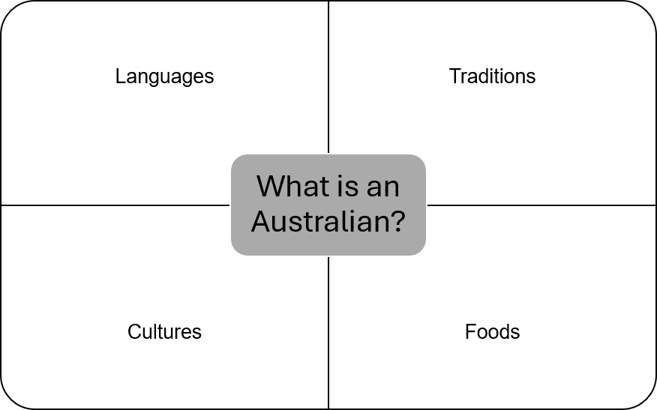
© Department of Education Western Australia 2025.This product has been generated or modified using artificial intelligence and to the extent that copyright subsists in it, the copyright is retained by the Department of Education Western Australia.

