Year 5

Attitudes and perspectives
____________________________________________________________________________________________________
Focus: Mutual respect, civic values, fairness, equality and participation
Lesson overview
This lesson supports students to explore the concepts of fairness, equality, equity, and democracy through a ‘race’ and visual prompts.

Cultural safety considerations
The cultural safety of Aboriginal and Torres Strait Islander students, and culturally and linguistically diverse (CaLD) students must be a priority when planning and delivering these lessons.
Teachers are expected to establish a learning environment that is culturally, psychologically, spiritually, physically, and emotionally safe for all students, particularly for Aboriginal and CaLD students. Culturally responsive teaching practices should aim to create the conditions for students, staff, and families to experience cultural safety in schools and remove and minimise harmful experiences, such as racism in all its forms. Teachers should remain mindful of assumptions, stereotypes and unconscious biases and apply strategies to mitigate them.
Engaging in meaningful teaching and learning about multiculturalism and anti-racism requires teachers to create the conditions for cultural safety in the planning, delivery and assessment of lessons. This includes:
- knowing students’ cultural backgrounds and understanding how this may be relevant to (or impact) the learning environment
- letting students and families know about the planned content and resources in advance so that they can prepare for the learning, and contribute where safe to do so
- knowing any cultural protocols in advance that may impact the lesson (for example, using a disclaimer at the start of a film about people who may have passed away)
- knowing the sensitive language that may cause harm (for example, removing racial slurs or hate speech in films)
- not assuming that students or staff will want to share their cultural backgrounds and lived experiences with their peers during the lesson
- not calling on students during lessons without warning about content that has the potential to make them feel uncomfortable or singled out
- allowing for students, staff and families to provide input and feedback when they feel culturally safe in the planning, delivery and evaluation of lessons.

Curriculum content
English
Literacy: Interacting with others
Use appropriate interaction skills, including paraphrasing and critical literacy questioning to clarify meaning, make connections to own experience, and present and justify an opinion or idea WA5ELYI1
Literacy: Creating texts
Plan, create, edit and publish written and multimodal texts whose purposes may be imaginative, informative and persuasive, developing ideas using visual features, text structure appropriate to the topic and purpose, text connectives, expanded noun groups, specialist and technical vocabulary, and punctuation, including dialogue punction WA5ELYC1
Health and Physical Education
Personal, social and community health: Interacting with others
Skills and strategies to establish and maintain respectful relationships WA5HEHPI1
Humanities and Social Sciences
Civics and Citizenship
The key values and features of Australia’s democracy and the electoral process
Skills: Communicating and reflecting
Reflect on learning, identify new understandings and act on findings in different ways

Learning intention
We are learning about the key concepts of fairness, equality, equity, respect, participation, and democracy.

Success criteria
I will be successful in this lesson when I can:
- explain the meaning of fairness, equality, and equity
- contribute ideas to help design a fair decision-making process for our class
- describe how democracy is related to fairness, equality and equity
- create a poster that promotes civic values like respect, fairness, equality, and participation.

Key terminology
- Civic values - important ideas about how we should behave and work together in our community, like fairness, respect, responsibility, and helping everyone have a voice
- Democracy - Democracy means that people have the power to make decisions about how their country or community is run. They do this by voting for leaders and laws, and everyone has a say, no matter who they are.
- Equality - recognises that, as human beings, we all have the same value. This means that we all have the same rights, should all receive the same level of respect, and should have the same access to opportunities.
- Equity - is about everyone achieving equal outcomes. It recognises that each person has different circumstances and allocates the exact resources and opportunities needed to reach an equal outcome. We all have the same value and deserve a good life, but we all start from a different place. It is because of these differences that we sometimes need to be treated differently for us live safely, healthily, happily and equally.
- Fairness- making sure everyone is treated justly by following rules and giving people what they need, not always the same thing, so all have a fair chance.
- Participation - taking an active part in activities and decisions that affect you and your community by sharing your ideas, listening to others, and contributing respectfully.
- Privilege - is a special right or advantage that a particular person or group of people has. This is often attributed to dominant social groups that control the value systems and rewards in a particular society. It can refer to groups who hold political power in society, as well as groups who are of the ethnic or religious majority in a society.
- Respect - treating yourself and others fairly and kindly, valuing differences and listening to others’ opinions and feelings.

Activity 1 - The fairness race
This activity is based on the video from The school that tried to end racism. There is an British version (4.08 min) and Australian version (3.14 min). It is suggested the running race is conducted with students to experience unfairness. Teachers can choose to play the video for students after completing the activity.
- Explain that students will run a race, however the starting position will be determined by their answers to questions. If the question applies to them, they can take a big step forward, if it doesn’t apply to them they stay where they are.
  - If both your parents were born in Australia, take a step forward
  - If you have ever travelled overseas, take a step forward
  - If both parent’s first language is English, take 2 steps forward
  - If you have ever been asked, where did you come from, take a step backwards
  - If you have noticed that most people on TV look like you, take 3 steps forward
  - If the Prime Minister of Australia looks like you, take 3 steps forward.

- Ask students the following questions:
  - Is this a race that you are positioned to win? Why or why not?
  - How did you feel about your starting position?
  - How did you feel about the people that were starting in front/behind you?

- Explain that what they have experienced is unfair and unjust. The term associated with this is sometimes referred to as white privilege. Privilege means having an advantage that sometimes is not noticed. It is about being aware of the bias in society and being fair regardless of the way people look or their backgrounds.

- Allow time for students to reflect on their experience and share a key message they have learnt with a partner.
  - Record key messages onto a class chart, e.g. one thing I learnt today is that people experiences can be different even though if we are in the same class.

Activity 2 - Equality vs equity
This activity builds students’ knowledge and understanding of the differences between equality and equity.
Resources required:
- Appendix Resource #1 Boxes at the Fence
- Appendix Resource #2 Boxes at the Fence: Equity.

- Ask students to consider if the following statement is true or false: If we treated everyone equally, it would be a fairer world.

- Display Resource #1 and invite students to discuss the question prompts, in small groups.
  - Facilitate the sharing of responses.
- Display Resource #2 and ask students to:
  - describe what they see in the picture
  - discuss the difference between equity and equality.

- Using their experience from the race and the image from Resource #2, facilitate a discussion to develop a class definition of equality and equity. Ensure these are visible throughout the remainder of the lesson.

- Ask students to consider examples of some obstacles or barriers, such as language and cultural differences, that may affect fairness and equity of some groups of people.

Activity 3 - Australian values campaign

Resources needed:
  - Poster paper, coloured markers, pencils, or digital tools (if available).

- Introduce some of Australia's core values:
  - Equality and fairness
- Australians believe in equal opportunity regardless of gender, race, or background.
- The concept of a “fair go” is central; everyone deserves a fair chance.
  - Respect for diversity
- Australia is a multicultural society that values inclusion and respect for different cultures and beliefs.
  - Mutual respect and compassion
- Emphasis on helping others, community spirit, and respect for human dignity.

- Direct students to create posters which promote these values and encourage the school community to practise every day.
  - Explain to students that they will create short campaign posters or digital artworks promoting one of the civic values learned during the lesson – equality and fairness, respect for diversity, mutual respect and compassion.
  - Students work individually, or in small groups, to decide which value to promote and how best to represent it visually and/or with a slogan.
  - Encourage simple, positive messages like “Fairness means everyone gets a chance” or “Respect listens to all voices.”
  - Once completed, display all posters around the room. Students walk through the gallery, viewing and reflecting on each poster’s message. Students may choose to briefly explain their posters or democratically vote on the most inspiring messages.

Reflection
  - How can we use what we’ve learned about fairness, respect, compassion, equality and equity every day at school?

Resource #1 Boxes at the Fence

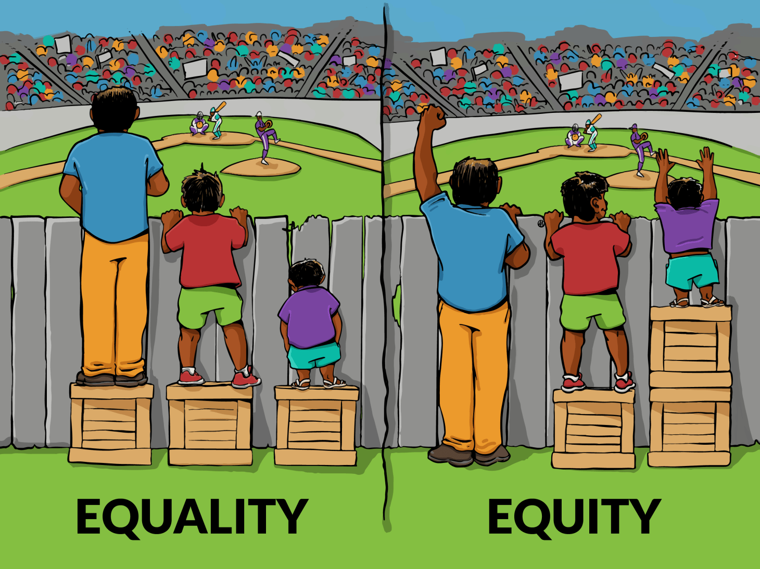
Everyone in this image has been treated equally.

    - What do you notice about who is equipped to succeed?

    - Does everyone have the same opportunity to succeed?

    - Who is more likely to notice that the activity was unfair?

    - What does that person need to succeed?

Resource #2 Boxes at the Fence: Equity Sourced from Illustrating Equality VS Equity - Interaction Institute for Social Change : Interaction Institute for Social Change

