Year 5

Australian Identity
_________________________________________________________________________________________________

Focus: Stereotypes and complexity of identity

Lesson overview
In this lesson, students will examine Australia’s diversity and how to challenge stereotypical perceptions of Australians.

Teaching note
Teachers may select, adapt, or combine activities to suit the needs of their students. The sequence can be taught as a single extended lesson or spread across multiple sessions, depending on available time and the depth of exploration desired. Activities may also be condensed or expanded to align with student readiness and classroom context.

Cultural safety considerations
The cultural safety of Aboriginal and Torres Strait Islander students, and culturally and linguistically diverse (CaLD) students must be a priority when planning and delivering these lessons.
Teachers are expected to establish a learning environment that is culturally, psychologically, spiritually, physically, and emotionally safe for all students, particularly for Aboriginal and CaLD students. Culturally responsive teaching practices should aim to create the conditions for students, staff, and families to experience cultural safety in schools and remove and minimise harmful experiences, such as racism in all its forms. Teachers should remain mindful of assumptions, stereotypes and unconscious biases and apply strategies to mitigate them.
Engaging in meaningful teaching and learning about multiculturalism and anti-racism requires teachers to create the conditions for cultural safety in the planning, delivery and assessment of lessons. This includes:
- knowing students’ cultural backgrounds and understanding how this may be relevant to (or impact) the learning environment
- letting students and families know about the planned content and resources in advance so that they can prepare for the learning, and contribute where safe to do so
- knowing any cultural protocols in advance that may impact the lesson (for example, using a disclaimer at the start of a film about people who may have passed away)
- knowing the sensitive language that may cause harm (for example, removing racial slurs or hate speech in films)
- not assuming that students or staff will want to share their cultural backgrounds and lived experiences with their peers during the lesson
- not calling on students during lessons without warning about content that has the potential to make them feel uncomfortable or singled out
- allowing for students, staff and families to provide input and feedback when they feel cultural safety in the planning, delivery and evaluation of lessons
- where possible, checking in with students and seeking their feedback on the activities and learning, if they feel culturally safe to do so

Curriculum content
Humanities and Social Sciences skills
Questioning and researching
Identify current understandings, consider possible misconceptions and identify personal views on a topic WAHASS50
Evaluating
Use decision-making processes, including the use of criteria to assess possible effects
Communicating and reflecting
Reflect on learning, identify new understandings and act on findings in different ways WAHASS63
English
Language: Language for interacting with others
Understand how to move beyond making bare assertions by taking account of differing ideas or opinions and authoritative sources WA5ELAI2
Language: Language for expressing and developing ideas
Understand how vocabulary is used to express greater precision of meaning, including through the use of specialist and technical terms, and explore the history of words WA5ELALA4
Health and Physical Education
Personal, social and community health: Interacting with others
Skills and strategies to establish and maintain respectful relationships WA5HEHPI1
Personal, social and community health: Personal identity and change
Ways that individuals and groups adapt to different contexts and situations WA5HEHPP1

Learning intentions
We are learning how diversity shapes Australian identity and how stereotypes can affect the way we see others.
Success criteria
I will be successful in this lesson when I can explain:
- how cultural diversity makes Australia unique and builds our national identity
- how stereotypes and assumptions about people can be misleading
- respectful actions I may take when interacting with different people.
Key terminology
- Community – a group of people who share common interests, values, goals or geographic location and interact with one another in a meaningful way.
- Diversity – encompasses the range of visible and invisible attributes, experiences and identities that shape each individual. Diversity includes all human differences including but not limited to ethnicity, sex, gender, gender identity, sexual orientation, age, social class, physical ability or attributes, religious or ethical values system and national origin.
- Identity – a person’s conception and expression of individuality or group affiliation, self-concept and self-representation. Identity is closely connected to both culture and language. Thinking and talking about the self is influenced by the cultural frames, which are offered by different languages and cultural systems. Identity is not fixed. Second language learners’ experience with different linguistic and cultural systems introduces them to alternative ways of considering the nature and the possibilities associated with identity.
- Stereotype – a widely held but fixed and oversimplified image or idea of a particular type of person or thing.

Activity 1 - What makes an Australian?
This activity explores the diverse population of Western Australia.

- Ask students to form a picture in their mind when they hear the phrase, “I am an Australian”. Students work in pairs to discuss the picture in their mind and discuss student answers to the following questions:
  - What language are they speaking?
  - What interests might they have?
  - What foods are they eating?
  - What events might they celebrate?
  - What traditions might they have?

- Display Western Australian Museum’s WA Faces series. Explain that this resource shows the diverse population of Australia.
  - Share the back story of this website. The Western Australian Museum asked people to upload a photo and share why they were proud to be a West Australian.

- Discuss the pictures from the WA museum and ask students to match the picture they created in their mind with any images on the website.

- Introduce the word diversity and explain its etymology.
  - Latin: diversitas – meaning difference, variety
  - Old French: diversite (12th century) meaning difference, variety and multiplicity
  - Middle English: diversite (14th century) - referring to the condition or quality of being different or varied Ask students to use the word diversity in a sentence to describe the collection of images on the website

- Ask students to reflect on what have they have learnt about the diversity of Australia. Teacher reinforces that Australia’s identity is diverse.

Activity 2 - Stories behind the faces
This activity highlights the stereotypes and assumptions people might make.

Resources required:
- A3 paper for group work
- Headshots from WA Faces for distribution to groups (hard copies or digital)
- Appendix Resource #1 Stereotype sentence starters.

- In groups of 2-3, distribute A3 paper and allocate one picture from WA Faces to each group. Ask students to brainstorm answers and record on a A3 sheet of paper to the following questions:
  - What do you think this person likes or dislikes?
  - What celebrations and traditions do you think they may have?
  - Who lives in their home?
  - How do they contribute to Australian communities?

- Once completed, instruct students to review other groups’ work and add additional ideas to their brainstorms.
- Introduce the word ‘stereotype,’ using Australia specific examples to explain the meaning. For example:
  - all Australians eat Vegemite
  - all Australians play Aussie Rules Football.

- In the same groups, ask students to identify stereotypes they may have recorded on their sheet. Ask:
  - What makes this a stereotype?
  - Why might this be misleading?
  - How might stereotyping make people feel?

- Distribute Resource #1 to each group. Model the completion of the first sentence (I do) and support the class to co-construct the second sentence (we do) before directing students to compete the rest (you do).

- Conclude by reminding students that they can avoid stereotyping by asking questions, listening to stories and seeing everyone as an individual.

Activity 3 - Moving beyond stereotypes to build our identity
In this activity, students create an identity web to explore the different parts of who they are and share how their personal identities connect to Australia’s diversity and national values.
Resources required:
- Appendix Resource #2 Nyah’s identity web
- Appendix Resource #3 Identity web.

- Provide students with Resource #2. As a class, predict and record responses under the headings on the resource. Model this if needed, narrating the thought process and how the web demonstrates assumptions that are made based on face value.

- Play the BTN clip, Nyah’s Two Cultures and ask students discuss and add in a different colour new information about Nyah to Resource #2. Discuss what surprised them and make a link to the previous stereotyping activity.

- Distribute Resource #3 and ask students to complete the web about themselves. Explain this web helps them to understand who they are, their identity. If needed, use the prompts below to guide students through each section.
  - Family: Do you live with parents, grandparents, or extended family? Is there a special family tradition that matters to you?
  - Culture and traditions: Does your family celebrate any cultural or religious traditions? Do you take part in events like NAIDOC Week, Harmony Week, or Anzac Day?
  - Language: What language do you speak at home? Do you know any words from another language?
  - Interests and hobbies: What do you enjoy doing outside of school? What sports or arts are important to you?
  - Values and beliefs: What values are important to you? What values do your family share?
  - Community: What groups or communities do you belong to? This could be school, a sports team, a church, or your suburb.
- Direct students to share their identity web with each other. Discuss similarities and differences as a class.

- Where appropriate, ask if any students walk in 2 cultures like Nyah.
  - Reinforce that diversity makes Australia unique and builds our national identity.
  - Remind students that stereotypes oversimplify people, and our identity webs show the real, complex picture of who we are.

Activity 4 - Standing up for diversity
Encouraging students to identify ways they can contribute to an inclusive and respectful community.

Resources required:
- Appendix Resource #4 Leaf template
- Appendix Resource #5 Respectful ways to talk about people TEACHER COPY.

- Rewatch the end of the BTN video (timestamp 1:16), Nyah’s Two Cultures story and ask students to recall the action that Nyah talked about to make her feel more valued and included. She called it her stand up moment.
  - Ask students to complete a think-pair-share on what actions or stand-up moment they could take to promote diversity and challenge stereotypes. Invite a few verbal responses to activate recall and set the tone for reflection.

Choose either option:
- Using Resource #4, ask students to write actions they could take to stand up. Statements could include:
  - One small action I could take to make people feel welcome is…
  - My school could celebrate diversity by…
  - I wish Australians would…

- Co-construct an anchor chart titled, Respectful ways to talk about people.
  - Resource #5 is a teacher copy for guidance.

Resource #1 Stereotype sentence starters

It is unfair when we don’t see people as individuals because…

We shouldn’t judge others before getting to know them because…

Some stereotypes come from old-fashioned beliefs or traditions that…

When we believe stereotypes, we might miss out on learning or making friends because…

Sometimes stereotypes lead to unfair decisions, for example when…

Resource #2 Nyah’s Identity Web
Nyah
Family
Culture
Language
Traditions
Interests
Values
Community

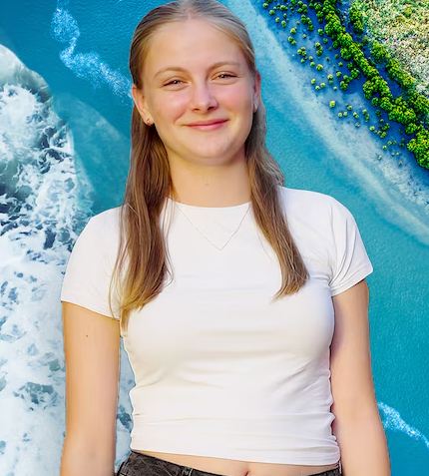

Resource #3 Identity Web
ME
Family
Culture
Language
Traditions
Interests
Values
Community

Resource #4 Leaf template
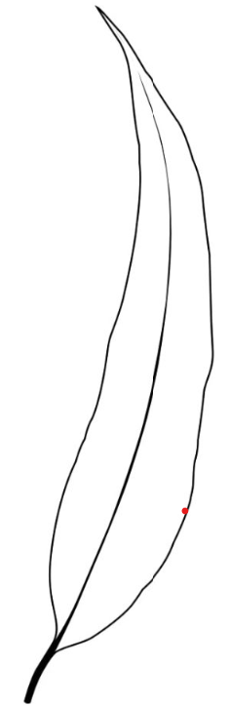

Resource #5 Respectful ways to talk about people TEACHER COPY

Use kind language
- Say people’s names correctly — if you’re unsure, politely ask how to pronounce it
- Use the words people choose for themselves e.g., Aboriginal or Torres Strait Islander rather than outdated terms
- Say people who…instead of those kinds of people
- Avoid labels e.g. instead of the disabled student, a student who uses a wheelchair
- Speak about groups with respect: people from different cultures, not foreigners.

Listen to people’s stories
- Ask Can you tell me more about that? when someone shares a tradition or belief
- Listen without judging or interrupting
- Show interest - That sounds interesting!

Ask questions in a respectful way
- Ask because you want to learn, not to compare or criticise
- Say “I’d love to learn more about your culture”
- It’s okay to be curious, but it’s not okay to make assumptions.

Show appreciation, not appropriation
- Appreciate cultural practices by learning or asking permission before joining in
- Give credit — This food comes from Vietnamese culture
- Celebrate diversity respectfully e.g., Harmony Day, NAIDOC Week without turning it into costume or stereotypes

Speak up for fairness
- If you hear someone being teased for their culture, name, or accent, say:
  - That’s not kind
  - We don’t talk like that here
  - Everyone deserves respect
  - Tell a teacher or trusted adult if it keeps happening.

Use people-first thinking
- Talk about people as individuals first — not as a group stereotype
- Remember: one person doesn’t represent a whole culture or religion

Value differences
- Say things like:
  - That’s a great way to do it.
  - I’ve never tried that before — can you show me?
- Recognise that different doesn’t mean wrong — it means interesting, unique, and worth celebrating.

Reflections
- Ask:
  - Would I feel proud if someone said that about me?
  - Could my words make someone feel small or left out?
  - Am I speaking with kindness?

© Department of Education Western Australia 2025.This product has been generated or modified using artificial intelligence and to the extent that copyright subsists in it, the copyright is retained by the Department of Education Western Australia.

