Year 6

Australian Identity
_________________________________________________________________________________________________
Focus: Mutual respect, international diversity and civic action

Lesson overview
This is the first lesson set within a sequence. In this lesson, students explore a government initiative (Harmony Week) to celebrate the diversity of Australia. The lessons link English, Humanities and Social Sciences, and Health and Physical Education from the Western Australian curriculum.

Cultural safety considerations
The cultural safety of Aboriginal and Torres Strait Islander students, and culturally and linguistically diverse (CaLD) students must be a priority when planning and delivering these lessons.
Teachers are expected to establish a learning environment that is culturally, psychologically, spiritually, physically, and emotionally safe for all students, particularly for Aboriginal and CaLD students. Culturally responsive teaching practices should aim to create the conditions for students, staff, and families to experience cultural safety in schools and remove and minimise harmful experiences, such as racism in all its forms. Teachers should remain mindful of assumptions, stereotypes and unconscious biases and apply strategies to mitigate them.
Engaging in meaningful teaching and learning about multiculturalism and anti-racism requires teachers to create the conditions for cultural safety in the planning, delivery and assessment of lessons. This includes:
- knowing students’ cultural backgrounds and understanding how this may be relevant to (or impact) the learning environment
- letting students and families know about the planned content and resources in advance so that they can prepare for the learning, and contribute where safe to do so
- knowing any cultural protocols in advance that may impact the lesson (for example, using a disclaimer at the start of a film about people who may have passed away)
- knowing the sensitive language that may cause harm (for example, removing racial slurs or hate speech in films)
- not assuming that students or staff will want to share their cultural backgrounds and lived experiences with their peers during the lesson
- not calling on students during lessons without warning about content that has the potential to make them feel uncomfortable or singled out
- allowing for students, staff and families to provide input and feedback when they feel cultural safety in the planning, delivery and evaluation of lessons
- where possible, checking in with students and seeking their feedback on the activities and learning, if they feel culturally safe to do so

Curriculum content
Humanities and Social Sciences
ACHASSK141 Australia’s connections with countries and how these connections change people and places
ACHASSK136/ACHASSK137 Stories of groups of people who migrated to Australia, including from one Asian country, the reasons they migrated and their contributions to society
WAHASS50 Identify current understandings, consider possible misconceptions and identify personal views on a topic
WAHASS56 Interpret information and/or data collected
Health
WA6HEHPS2 Staying safe: Strategies that promote safety
WA6HEHPH3 Healthy and active communities: Actions that promote and maintain community health, safety and wellbeing
WA6HEHPI1 Interacting with others: skills to establish and manage positive relationships
English
WA6ELYC4 Creating texts: Use features of digital tools to create or add to texts for a purpose and audience
WA6ELYT1 Texts in context: Examine texts, including media texts, that represent ideas and events, and identify how they reflect the context in which they were created

Learning intentions
We are learning about the purpose and significance of Harmony Week in promoting inclusivity, respect and belonging and celebrating Australia’s diverse multicultural society.
Success criteria
I will be successful in this lesson when I can:
- explain what Harmony Week is and why it is celebrated in Australia
- read population data and explain Australia’s diversity
- plan Harmony Week activities that reflect inclusivity, respect and belonging
- create a poster that clearly communicates the purpose of Harmony Week (eliminating discrimination) and Harmony Week principles (inclusivity, respect and belonging).

Teaching note
This is the first lesson within this sequence. Each lesson is intentionally structured with scaffolded activities that must be taught in sequence to ensure students build conceptual understanding. Teachers may differentiate the activities according to students’ needs and time constraints.

Key terminology
- Democracy - a system of government in which the people have a say about how they are governed, and free elections are held
- Discrimination - is the unfair or prejudicial treatment of people based on characteristics like age, gender, race, religion, or disability
- Diversity - encompasses the range of visible and invisible attributes, experiences and identities that shape each individual. Diversity includes all human differences including, but not limited to, ethnicity, sex, gender, gender identity, sexual orientation, age, social class, physical ability or attributes, religious or ethical value systems and national origin

Activity 1: Australia’s population

Resources required:
- Resource #1 Australian Bureau of Statistics – population 2014 – 2024

- Ask students to predict what percentage of Australia’s current population was born overseas. Call out answers.

- Ask students to predict the top ten countries where people in Australia’s current population were born.

- Show Resource #1 and ask students to use the information to check their predictions and work in pairs to answer the following focus questions:
- How has Australia’s population changed from 2014 – 2024?
- What patterns do you notice?
- Why is this information important for all Australians?
- How much is new information for you?

- Students record what they found most interesting. This can be displayed as a class chart.

- Introduce Harmony Week and explain that initiatives like this allows us to continue to be one of the most successful multicultural societies in the world.

Activity 2: Celebrating diversity

Resources required:
- Harmony Day video Harmony Week – Behind the News (3:21)
- Resource #2 Harmony celebrations

- Ask students to record what they know about Harmony Week.

- Class watches video Harmony Week – Behind the News (3:21) and record additional ideas to their list using a different coloured pen. Record onto a class chart for future reference.

- Conduct a call out on the new ideas students recorded whilst watching the video. Teacher explains that Harmony Week coincides with the United Nations International Day for the elimination of racial discrimination.
Refer to the population graph in Activity 1 and reinforce that Harmony Week is important in Australia because we are made up of many cultures and beliefs.

- Show Resource #2: Harmony celebrations to explain the history and purpose of Harmony Week, using the following focus questions:

- What is the purpose of Harmony Week celebrations?
- What are the principles behind Harmony Week?
- How does Harmony Week reflect our Australian identity?
- Why do Australians wear orange during Harmony Week?

Activity 3: Australia’s values

Resources required:
- Resource #3 – A fair go and Harmony Week
- Resource #4 - A fair go and Harmony Week TEACHER COPY

- Introduce that one of Australia’s core value is a ‘fair go.’ (Australian Government: Department of Home Affairs).

A 'fair go' for all embraces:
- mutual respect
- tolerance
- compassion for those in need
- equality of opportunity for all.

- Students work in groups to use Resource #3 – A fair go and Harmony Week to record how Harmony Week reflects a ‘fair go’ for all Australians. Use Resource #4 – TEACHER COPY to fill any gaps that students may have.

Activity 4: Harmony Day poster

Resources:
- Website - Australian Government and Home Affairs. Harmony Week for ideas on planning Harmony week and posters.

- Explain that the next task will be about educating our future citizens and that they will be creating a poster for the incoming Pre-primary or younger students in the school to advertise Harmony Week. Students will work in small groups to plan a series of Harmony Week activities to share with the class.

Ask students to include:
- description of the planned activities
- expectations of all students during the week
- purpose of Harmony Week (eliminating racial discrimination)
- the principles of Harmony Week - inclusiveness, respect and belonging for all Australians, regardless of cultural or linguistic background.

Optional: Teacher may choose to use a worked example, of a Harmony Week poster. Australian Government and Home Affairs. Harmony Week
The next lesson within this sequence is Australian Identity: Complexity of identity, international diversity and challenging perceptions.
Resource #1 Australian Bureau of Statistics – population 2014 – 2024 https://www.abs.gov.au/statistics/people/population/australias-population-country-birth/jun-2024
Interesting facts
- More than half (51.5 per cent) of Australian residents were born overseas or have at least one parent who was.
- Since 1945, more than 7.6 million people have migrated to Australia.
- Nearly every single country from around the world was represented in Australia's population in 2020.
- More than 150 Aboriginal or Torres Strait Islander languages are spoken in Australia.
- Apart from English, the most common languages spoken in Australia are Mandarin, Arabic, Vietnamese, Cantonese and Punjabi.
- We identify with over 300 ancestries.
This information has been taken from ABS 2021 Census Data. For more information visit the Australian Bureau of Statistics website
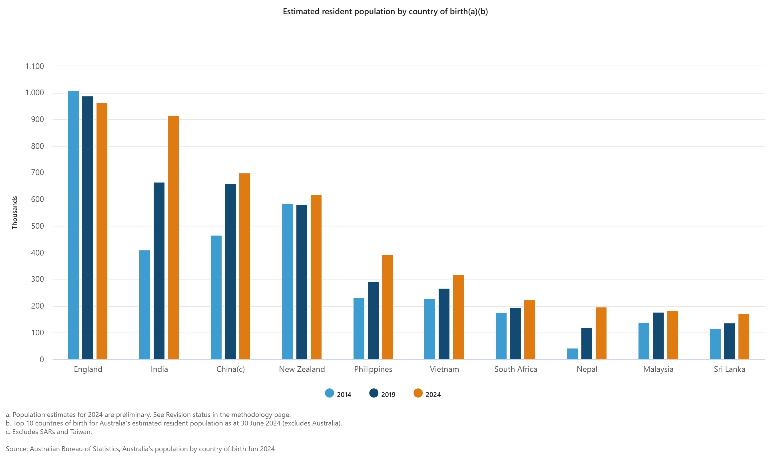

Resource #2: Harmony celebrations - https://www.harmony.gov.au/about
Harmony Week is an annual celebration of Australia’s cultural diversity and the benefits it brings to the Australian community. Harmony Week is held in March. This includes the United Nations International Day for the Elimination of Racial Discrimination (IDERD). It is an Australian Government initiative led by the Department of Home Affairs.
Since 1999, more than 80,000 Harmony Week events have been held across Australia in:
- childcare centres
- schools
- community groups
- churches
- businesses
- federal, state and local government agencies.

Harmony Week
Harmony Week is a time to celebrate that Australia is one of the most successful multicultural societies in the world. It is about inclusiveness, respect and belonging for all Australians, regardless of cultural or linguistic background, united by a set of core Australian values.

Our cultural diversity
Our cultural diversity is one of our greatest strengths and is at the heart of who we are. It makes Australia a great place to live.
Building on over 65,000 years of First Nations’ cultures, Australia has become home to migrants from nearly 300 different ancestries. Australia’s immigration history has helped build our modern nation.
An integrated multicultural Australia is an integral part of our national identity. All people who migrate to Australia bring with them some of their own cultural and religious traditions. They also take on many new traditions. Collectively, these traditions have enriched our nation.

Orange for Harmony Week
Orange is the colour chosen to represent Harmony Week. Traditionally, orange signifies social communication and meaningful conversations. It also relates to the freedom of ideas and encouragement of mutual respect. Australians can choose to wear something orange during Harmony Week to show their support for cultural diversity and an inclusive Australia.

Resource #3 – A fair go and Harmony Week
How does Harmony Week promote the following?
Mutual respect: Harmony Week encourages everyone to value and appreciate each other’s differences, such as culture, language, religion, and traditions.
Tolerance: Tolerance means being open-minded, patient, and accepting—even when someone is different from you.
Compassion for those in need: Compassion means caring about others and helping them when they need support. Harmony Week invites students to think about people in Australia who come from different backgrounds, including migrants and refugees.

Equality of opportunity for all: Equality of opportunity means everyone deserves a fair chance, no matter their culture, background, or identity.

Resource #4 – A Fair go and Harmony Week TEACHER COPY
How does Harmony Week promote the following?
Mutual respect: Harmony Week encourages everyone to value and appreciate each other’s differences, such as culture, language, religion, and traditions. | Mutual respect:  - sharing cultural stories, clothing, music, or food helps students see the worth in others  - activities promote understanding and respectful conversations  - it teaches students to treat everyone with dignity.
Tolerance: Tolerance means being open-minded, patient, and accepting—even when someone is different from you. | Tolerance includes:  - asking questions instead of making assumptions  - reducing stereotypes by replacing them with real knowledge  - building acceptance by showing that difference is normal and exciting.
Compassion for those in need: Compassion means caring about others and helping them when they need support. Harmony Week invites students to think about people in Australia who come from different backgrounds, including migrants and refugees. | Compassion includes:  - learning about the challenges people face when they move to a new country  - building empathy by helping students understand others’ experiences  - encouraging kindness and support for classmates who may feel left out or different.
Equality of opportunity for all: Equality of opportunity means everyone deserves a fair chance, no matter their culture, background, or identity. | Equality of opportunity includes:  - showing that every culture contributes to Australia’s identity  - reinforcing that everyone should feel welcome at school  - encouraging inclusive practices—making sure all students can participate in activities equally  - helping students understand fairness and inclusion as ongoing responsibilities

