2. Identifying personal attributes

Australian blueprint for career development
Career Management Competency
1 | 2 | 3 | 4 | 5 | 6 | 7 | 8 | 9 | 10 | 11 | 12

Learning intention
Students will be able to identify their personal attributes and understand how these can impact the way they think, feel, and behave.

Success criteria
Students can:
- identify a list of their personal attributes
- describe connections between their attributes and their success or achievements.

Resources
Worksheet – Attributes

Classroom organisation
- Whole class
- Pairs

Preparation
Print Attributes worksheet for each student.

Activity 1
- Introduce the term attributes and ask if students have heard this word used before. Discuss what their understanding of the word is.
Personal attributes are qualities or characteristics that define your personality and describe your approach to work or a situation.
- Students record this definition on the back of the worksheet – Attributes.
- Discuss the notion that attributes are not obvious. We come to know about a person’s attributes and their character through their behaviour and actions.
- Encourage students to think of attributes as a collective rather than singular. For example, you can be bold and funny, courageous and creative.

Activity 2
Students complete the worksheet – Attributes.

Reflection
Individually, students identify their positive attributes and describe how these have impacted on a recent situation.

Worksheet: Attributes
ATTRIBUTES
achiever | pleasant | curious | sensible | outgoing
bossy | jealous | intolerant | untrustworthy | greedy
mediator | consistent | balanced | inventive | generous
cheerful | unpredictable | vengeful | inconsiderate | mean
rude | focused | courageous | practical | perceptive
cooperative | careless | inflexible | patient | inventive
unkind | proactive | deceitful | skilled | understanding
arrogant | tactless | trustworthy | cruel | original
brave | likeable | sincere | sullen | capable
Attributes or characteristics can be POSITIVE or NEGATIVE.
- As a class, identify and circle the negative attributes in the table above.
- Form a pair and identify 3 positive attributes that you believe describe your partner. Write the attributes that your partner chooses to describe you in the ‘My partner’s choices’ cloud.
- Next, consider the 5 attributes you would choose for yourself and write them into the ‘My choices’ cloud.
- Compare the lists and discuss with your partner why they chose those attributes for you.
- Note any differences or similarities.

My choices
My partner’s choices

- A recent achievement  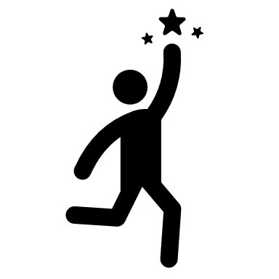 | Identify 2-3 attributes that you used to achieve this success
  - A recent achievement | Identify 2-3 attributes that you used to achieve this success

Use the table below to consider a recent achievement. Consider which positive attributes had an impact on this achievement.

