3. About me

# Australian blueprint for career development

|  |  |  |  |  |  |  |  |  |  |  |  |
| --- | --- | --- | --- | --- | --- | --- | --- | --- | --- | --- | --- |
| Career Management Competency | | | | | | | | | | | |
| 1 | 2 | 3 | 4 | 5 | 6 | 7 | 8 | 9 | 10 | 11 | 12 |

# Learning intention

# Students will identify their interests, values, personal attributes, and skills they need to develop further.

# Success criteria

Students can complete a mind map that highlights their interests, values, personal attributes, and skills they need to develop further.

# Resources

* Worksheet – Mind map, to display as an example structure
* Blank A3 paper
* Coloured markers

# Classroom organisation

* Small groups
* Individual

# Preparation

* Students will need to be able to access previous quizzes and worksheet results from lessons 3 and 4.
* Print Worksheet – Mind map for each student.

# Activity 1

Students have had the opportunity to complete several quizzes and worksheets. The results of these activities can be used as references for this activity.

* Discuss the importance of self-awareness with students.
* Students work alone to complete a mind map with as much information as they can. Encourage deep thinking and reflection. The mind map worksheet can be used as an example of structure.

# Activity 2

* Students exchange their mind map with a partner.
* Taking turns, students respond to their partner’s mind map. This may include:
  + asking follow up questions if they need more clarification
  + commenting on any interesting observations
  + making suggestions from what they know about their partner.

# Reflection

* Students reflect on the following quotes.
  + “*Find your mirror and take great notes.*”

- Bert McCoy

* + “*The most important conversations you’ll ever have are the ones you’ll have with yourself...”*

- David Goggins

* + “*I think self-awareness is probably the most important thing towards being a champion*.”

- Billie Jean King

* Students consider how much they know about themselves and how much more there is to know.

# Worksheet: Mind map

Being able to identify your interests, skills, values and attributes is essential knowledge for career decision making. Working through this self-knowledge mind map will help you when exploring courses and career pathways.

**What I already know about myself**

Interests or hobbies



Skills I need to develop

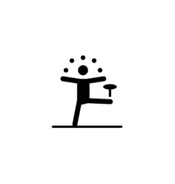

Skills I have

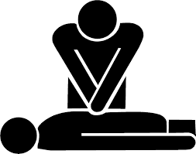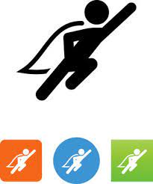

Personal attributes

Personal values

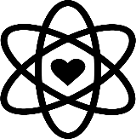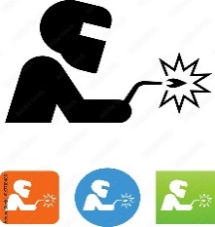

Jobs that interest me